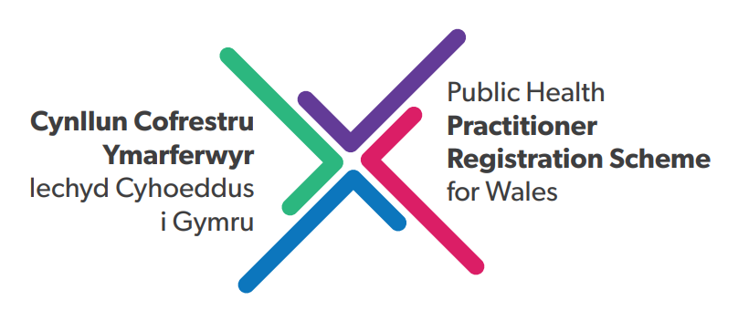
Application Form (2025)

Application Submission
To apply to the support programme you must:
- Read and fully understood the UKPHR ‘Guidance for Applicants, Assessors and Verifiers’ and viewed the ‘Introductory Day for Practitioner Registration’ on the UKPHR website
- Submit a completed application form and self-assessment form.
Please send completed signed forms to Peoplesupport.PHW@wales.nhs.uk
All applications must be completed and returned by Friday 30th May 2025.
Data protection statement
Privacy Notice (English)
Privacy Notice (Welsh)

Important Dates
Portfolio Skills Workshop 1 – 25th June – 9.30am – 1.30pm
Portfolio Skills Workshop 2 – 25th September – 9.30am – 1.30pm
Attendance at the above is compulsory. Please ensure you get approval to attend.

Section A: Applicant Details

Name:
Job title:
Organisation:
SFH level / current post banding: |  | Length of time in current post:
Practitioner experience: | Please provide a brief description of your public health practitioner work experience and no. of years experience at required level.
Practitioner experience: | CV included with your application? |  | YES / NO
Telephone number:
Email:
Have you completed the UKPHR Online Introductory Day for Practitioner Registration |  |  |  | YES / NO
Have you read the UKPHR ‘Guidance for Applicants, Assessors and Verifiers, Public Health Practitioner Registration’ |  |  |  | YES / NO

Personal statement (no more than 200 words) demonstrating your reasons for applying, any progress to date and your commitment to completing the portfolio / registering with UKPHR before end October 2026:

Section B: Declaration

I confirm that the information I have given is accurate and should I be accepted onto the scheme I agree to abide by its principles and participate fully.

Signed: |  |  | Date:
Print name:
Job title:

Section C: Employer Support

Do you have employer support for your application? | YES / NO
If yes, please include a short statement of support from your employer / line manager. (Line managers should be familiar with the ‘Guidance for Managers’ document, produced by the Public Health Practitioner Registration Scheme for Wales).

Employer / line manager approval: In supporting an application line managers will have read and fully understood the Public Health Practitioner Registration Scheme for Wales, ‘Guidance for Managers’ document.
Signed: |  |  | Date:
Print name:

