Assessment of Clinical Oral Risks and Needs (ACORN) Toolkit
DO IT WELL, DO IT ONCE A YEAR
Name |  | DOB |  | Date of Completion

Complete section 1 & 2 remotely– over the phone or using video call software

- Inherent Patient Risks from Medical, Social and Dental history
Relevant medical history which impacts on oral health and/or dental care planning.  Please specify …………………………………………………………………………………………………………. | ☐ Yes Yellow  ☐ No Green
Relevant social history which impacts on oral health and/or dental care planning  Please specify …………………………………………………………………………………………………………. | ☐ Yes Yellow  ☐ No Green
Relevant dental history which impacts on oral health and/or dental care planning  Please specify …………………………………………………………………………………………………………. | ☐ Yes Yellow  ☐ No Green

- Key Modifiable Behaviours and Protective Factors

Tooth Decay Specific Risks

0-7 years only: supervised tooth brushing with fluoride toothpaste before bedtime and one more time during the day? OR  >7 years: Brushes (self or carer) at bed time and one more time during the day with fluoride toothpaste? | ☐ Yes Green  ☐ No Amber
Consumes drinks other than water or milk outside of mealtimes more than once daily? (e.g. sports drinks, tea/coffee with sugar, fizzy drinks, etc.) And/or  Eats sugary snacks, sweets, etc. outside of mealtimes more than once daily? | ☐ Yes Amber  ☐ No Green

Periodontal Health Specific Risks (12+ only)

Smokes and/or use of tobacco products | ☐ Yes Amber  ☐ No Green
Brushes (self or carer) at bed time and one more time during the day? | ☐ Yes Green  ☐ No Amber
Uses (self or carer) inter-dental aids as advised by the dental team? e.g. interdental brushes | Yes/No

Other risks/protective factors

Household/family factors  Siblings and/or family members in the same household have active tooth decay? | Yes/No
Alcohol use above recommended limit  Hint: more than 14 units per week spread over 3 or more days and no more than  6 (female) and 8 (male) units in a single occasion. | Yes/No
Other risks (including dietary) or protective factors (e.g.↑ strength F toothpaste use)  Please specify …………………………………………………………………………………………………………. | Yes/No

Complete section 3 in surgery

3. Clinical Findings
Soft Tissues Findings, dentures and Level of Plaque (for all patients)
Please specify findings (e.g. USC 2 × 2 cm suspected mouth cancer on lateral border of tongue on the right hand side, satisfactory full upper partial lower acrylic dentures, etc.)

Level of Plaque: Low (up to 1/3rd of teeth/denture) OR Moderate (1/3rd – 2/3rd) OR High (>2/3rd)

Tooth Decay (for dentate only; tick the highest R>A>G)
Total number of teeth in mouth | N◦
No active tooth decay seen (arrested tooth decay= no active tooth decay) | Green ☐
Active tooth decay within enamel only | Amber ☐
Active tooth decay into dentine or beyond | Red ☐
If Red, total number of teeth with active tooth decay | dt | DT

Other Dental Need (for all patients)
e.g. Tooth surface loss, dental trauma, repair and maintenance (e.g. cusp fracture), removal of overhangs, denture replacement required, etc.  Diagnosis/diagnoses (please specify): | Tick one only  ☐ Red – dental treatment is required (e.g. repair of cusp fracture)  ☐ Amber – no treatment is required now but regular review is needed for monitoring  ☐ Green - no other need identified

Periodontal Health (Dentate and aged 12+ only)
BPE
BPE Score

Periodontal health (Tick the highest R>A>G)
GREEN | BoP < 10% of sites AND pocket depths ≤ 4mm AND no BoP at 4mm sites; | ☐
AMBER | BoP ≥10% of sites AND pocket depths ≤ 4mm AND no BoP at 4mm sites; */** | ☐
RED | Pocket depths ≥ 5mm OR ≥ 4mm with BoP.*/** | ☐
*in cases which aren’t AMBER or RED as described above, categorise as GREEN
**proceed to record a detailed periodontal examination; how to manage refer to the Principles of Care: Perio and relevant clinical guidance.
ACORN: DO IT WELL, DO IT ONCE A YEAR
ACORN DATA ENTRY ON FP17Ws: DO IT WELL, DO IT ONCE A YEAR
Reporting Caries and Perio on FP17W: AMBER = Amber from clinical findings Section 3 OR one of the key modifiable risk factors Section 2, BUT if there is active disease, Report RED on FP17W
Medical History | Social History | Dental History | Tooth decay | Total no. of teeth in the mouth | Dentinal decay  DT/dt | Periodontal health | Other dental need
Yellow or Green | Yellow or Green | Yellow or Green | Green, Amber or Red | Inputted as a number | Decayed teeth inputted as a number | Green, Amber or Red | Green, Amber or Red

Brief Guidance on Assessment of Clinical Oral Risks and Needs (ACORN) Toolkit

Introduction
The National Health Service (General Dental Services Contracts and Patient Charges) (Wales) Regulations 2026 states that:
A new patient assessment must include:
(a) completion of an ACORN assessment
Practices are expected to use this toolkit once a year as a part of the overall patient assessment (or at a longer interval if dental recall for a patient has been set longer than 12 months). Anything relevant but not captured through ACORN toolkit should be written on patient notes.
Reporting ACORN data points via FP17W is only required once a year regardless of how many times patients return to the practice for review and/or treatment.
Please ensure the toolkits are fully completed and retained securely as a part of the patient notes. Practices may be requested to submit a sample of completed anonymised ACORN toolkits as a part of the monitoring, quality improvement, research and evaluation.

Practices are expected to use the toolkit to:

- Understand what matters to patients;
- Effectively communicate level of risk and need to patients (or their carers) and work with patients in making them understand changes they can make to prevent dental diseases and maintain oral health;
- Agree on the oral health outcomes patients want to achieve;
- Utilise the principles of Shared Decision Making in formulating a preventive dental care and treatment plan’
- Monitor changes in the ‘risk and need’ of patients who receive ongoing care from the service.

We have tried to make the content of the toolkit self-explanatory and content of the toolkit as concise as possible.

The toolkit is designed to summarise the risk and needs of individual patients following a more detailed assessment of medical, social, dental history, oral health related behaviours e.g. consumption of sugary food and drinks, oral hygiene at home, smoking and alcohol use.

Brief explanation of the content
Inherent Patient Risks from Medical, Social and Dental History –
The objective of this section is for dental team members to consider findings from detailed medical, social and dental histories that have implication for oral health and/or dental care planning.
If there are implications, record Yes (Yellow) and specify details and if not record No (Green)

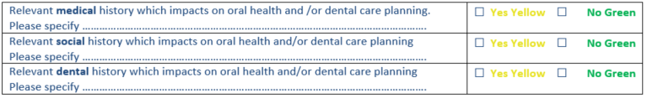

Dental team should specify the relevant history or finding on each area.

Medical history
Dental teams should take a detailed Medical History and update it on a regular basis.

Findings from medical history may be risks for oral health, e.g. poorly controlled diabetes is a risk for periodontitis, dry mouth (xerostomia) is a risk factor for tooth decay, many drugs have side effects on mouth, etc.

Findings from medical history may be relevant for dental care planning, e.g. a patient’s mental health condition/substance misuse/learning disability/latex allergy/uncontrolled epilepsy/cardiac conditions/frailty/many ongoing medical treatments, etc. are relevant for dental care planning

Social History

A patient’s adverse social circumstances, history and care needs are recognised as risk factors to oral health, e.g. a disabled person not able to carry out oral hygiene themselves. It is difficult for adults or children to establish good oral hygiene habits if they have challenging and chaotic home environment.

Relevance of social history on dental care planning can arise from a number of socioeconomic disadvantages, e.g. children in need/looked after children, homelessness, asylum seekers/refugees, travelling community, inability to attend for dental appointments in certain days/hours, dental charge as a barrier to attendance, etc.

Dental History
History or presence of dental phobia or anxiety, dental attendance only when in pain, history of failed attendances/child not brought previously to dental appointments, regular dental trauma, failed treatments due to high tooth decay rate, etc. are relevant for oral health and dental care planning.

Offer of an assessment and dental care to whole family should be made, if required, to improve dental attendance rate and to address oral health risk factors of the whole family.

Depending on the findings, dental teams may need to liaise more closely with other health and social care teams for safeguarding and or to provide preventive, proactive and co-ordinated high-quality care.

Some examples:

- A patient with dental phobia may require more time for assessment and prevention and referral for treatment under conscious sedation.
- Social, medical and dental history may reveal the complexity in organising and providing dental care for a patient. A number of teams outside dentistry may need to be involved to ensure patient receives the best prevention and dental care possible.
- In addition to parents, communication with a social worker may be required to understand why a child was not brought for dental examinations and/or treatment. See here for Was Not Brought Guidance.

Key Modifiable Behaviours and Protective Factors

Dental team members need to reflect if they are up to date on knowledge and competencies in behaviour change. Dental team members are encouraged to attend any courses on brief intervention and behaviour change. Many courses on brief interventions and behaviour change are available from Health Education and Improvement Wales (HEIW) and Learning@Wales.

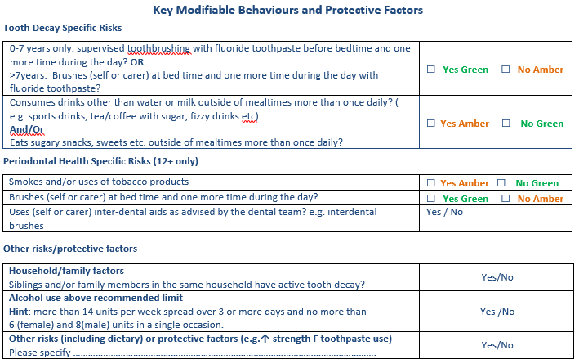
This section focuses on few key risk factors that have direct impact on two most prevalent oral diseases on dentate patients: tooth decay and periodontal disease.

Risks are categorised either as Amber (Present) or Green (not present).

This section also helps dental teams to consider other risks or protective factors. Additional risk factors are simply recorded on the toolkit as Yes/No and risks/protective factors not specified on the toolkit should be specified on the space provided on the toolkit or somewhere else in the patient notes

A comprehensive assessment of risk and protective factors provides dental team full picture of the risk and protective factors. This information is useful in behaviour change and agreeing the annual preventive dental care plan with the patient.

Dental team members should update their knowledge and skills in behaviour change (e.g. motivational interviewing technique) and implement the Delivering Better Oral Health: an evidence-based toolkit.

https://www.gov.uk/government/publications/delivering-better-oral-health-an-evidence-based-toolkit-for-prevention

Tooth Decay Specific Risks

Tooth brushing at bedtime and one more time during the day with appropriate strength fluoride toothpaste is important to prevent tooth decay. It is important dental teams to understand if tooth brushing (before bedtime and one more time during the day) has been established as a habit.

Some adults and children may require close support from a carer for many daily activities including tooth brushing and/or overall mouth care e.g. carers may need to brush a person’s teeth.

For younger children, it is important that parents (or an adult) start brushing their child’s teeth as soon as the first tooth erupts in the mouth. As the child grows and develops manual dexterity, they can be taught how to brush their teeth, but an adult still needs to supervise the tooth brushing so that all surfaces in all teeth are cleaned and more importantly to ensure all teeth surfaces comes in contact with fluoride in the toothpaste.

If such tooth-brushing habit (and therefore twice daily exposure to fluoride) has not been established, there is a risk that the patient will develop tooth decay. Presence of such risk has been categorised as ‘Amber’.

Sugary snacks and drinks
Consumption of sugary drinks, snacks and food outside mealtimes is a risk for tooth decay. Children (and the whole family) should be encouraged to swap any sugary drinks with plain milk and water. Dietary advice should be based on the Eat Well guide and Delivering Better Oral Health: an evidence-based toolkit.
https://www.nhs.uk/live-well/eat-well/the-eatwell-guide/

https://www.gov.uk/government/publications/delivering-better-oral-health-an-evidence-based-toolkit-for-prevention

Dental teams can access advice on prevention of tooth decay in children from Designed to Smile pages on the Public Health Wales website.

Periodontal Health Specific Risks
This section is to be completed for all aged 12 years and more.

Smoking
Smoking and/or use of tobacco products is a key risk factor for periodontitis (mouth cancer and many other diseases). For smokers, number of cigarettes smoked per day and number of years smoked should be recorded.
Dental teams should provide patients with brief intervention (BI) on smoking cessation, seek consent for referral and if consent provided, refer the patient to Help Me Quit so that they can receive free support in quitting. Professional Referral Form | Help Me Quit

Consequences, including low success rate of any periodontal treatment, of continued smoking (and/or use of tobacco products) should be explained to patients.

Tooth brushing
Effective removal of plaque by tooth-brushing twice a day is required to achieve good periodontal health, i.e. prevent gingivitis, periodontitis and stabilise active periodontitis.

Patients who have periodontitis may need to spend a lot longer than 2 mins to ensure effective cleaning.

Use of inter-dental aids
A dental team member may advise a patient with periodontal disease to use inter-dental aids, e.g. an inter-dental brush. Dental teams must show and explain to patients the right technique and type of inter-dental aid to be used to stabilise periodontitis (or to prevent periodontitis).

Other risks and protective factors

Questions on this section helps dental teams to analyse additional risk factors and protective factors in more detail. The Delivering Better Oral Health: an evidence-based toolkit is a useful resource for dental teams.

A patient who reports alcohol misuse could be advised to seek appropriate help from the General Medical Services or support services available in the locality. Chapter 12 of Delivering Better Oral Health toolkit provides useful information, including AUDIT-C tool for dental teams.

Clinical Findings
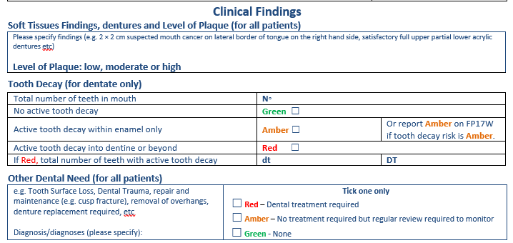

Soft Tissue Findings, Dentures and Levels of Plaque

Findings from a thorough intra-oral, extra-oral examination and examination of dentures, if any, should be recorded here. e.g. 2 cm by 2 cm suspected mouth cancer on lateral border of tongue on right hand, poorly fitting full upper acrylic denture, 2 cm by 3 cm white patch on hard palate etc.

Dental team members are encouraged to write on this section differential diagnoses or diagnosis e.g. Lichen Planus on buccal mucosa bilaterally, Chronic Hyperplastic Candidiasis etc.

Level of plaque present is an indicator of effectiveness of oral hygiene mainly tooth brushing. However, it should be remembered that many factors will influence level of plaque present at the time of examination, e.g. tooth brushing just before dental visit, dependency on carers/others to clean teeth/denture, etc.

Dental teams can record level of plaque as ‘low’, ‘Moderate’ and ‘High’, which has been defined as below.

Level of plaque | Categories (please tick one only)
No visible plaque present or plaque present on up to 1/3 of the remaining teeth/dentures | Low
Plaque present on at least one third of teeth but less than 2/3 of teeth/dentures | Moderate
Plaque present on 2/3 or more teeth/dentures | High

Tooth Decay (for dentate only)

On this section, dental team should record the total number of teeth in the mouth, the RAG rating for tooth decay for the patient and if the patient is classified as Red the number of deciduous teeth and/or permanent teeth that have active decay into dentine or beyond.

If an active tooth decay into dentine or beyond is identified, the reporting category on FP17Ws is Red.
If a patient has active tooth decay within enamel only and/or one or both of the key risks factors mentioned on the toolkit (lack of tooth brushing and sugar consumption as described) for tooth decay present, the reporting category on FP17Ws is Amber.
If a patient has no active tooth decay (and/or has arrested tooth decay only) and both risk factors (lack of tooth brushing and sugar consumption as described) are absent, the reporting category on FP17Ws is Green.
Other Dental Need

This section is intended to capture clinical treatment need or need to review oral health conditions that are not captured in sections under Tooth Decay and Periodontal Health.

Dental team should write down actual diagnosis/diagnoses on the toolkit

If there is a treatment need (e.g. repair of cusp fracture, denture replacement/repair etc.), such treatment need is categorised as ‘Red’ and appropriate box should be ticked. Only one box should be ticked.

e.g., Tooth Surface Loss, Dental trauma, repair and maintenance (cusp fracture), removal of overhangs required, denture replacement required,  Diagnosis/diagnoses (please specify): | Red – Dental treatment required  Amber – No Treatment required but regular review required to monitor  Green - None

Red > Amber > Green – Please choose the highest clinical need regardless of the number of conditions being present with different level of treatment/care need, e.g. If a patient’s clinical need is ‘Red’ because of cusp fracture, ‘Red’ is selected as clinical need even though the same patient may have requirement for regular review for another condition such as Tooth Surface Loss (TSL)/dental trauma.

Note: Treatment items provided by the dental team is captured through the FP17W.

Periodontal health
You are only required to report on FP17W for patients aged 12 years and over.
The dental teams should record their findings as follows.

GREEN: BoP < 10% of sites AND pocket depths ≤ 4mm AND no BoP at 4mm sites;

AMBER: BoP ≥10% of sites AND pocket depths ≤ 4mm AND no BoP at 4mm sites OR presence of Key modifiable Risk Factors (ineffective tooth brushing and Smoking).*

RED (ACTIVE DISEASE): Pocket depths ≥ 5mm OR ≥ 4mm AND BoP at these sites.*
*Proceed to record a detailed periodontal examination, BSP classification and guidance should help you
Scenarios that do not fit under AMBER or RED as described above, on FP17Ws report the periodontal condition of your patient as GREEN unless there are key risk factors (section 2 of the ACORN toolkit) e.g. smoking, not brushing twice a day effectively - then report AMBER.

