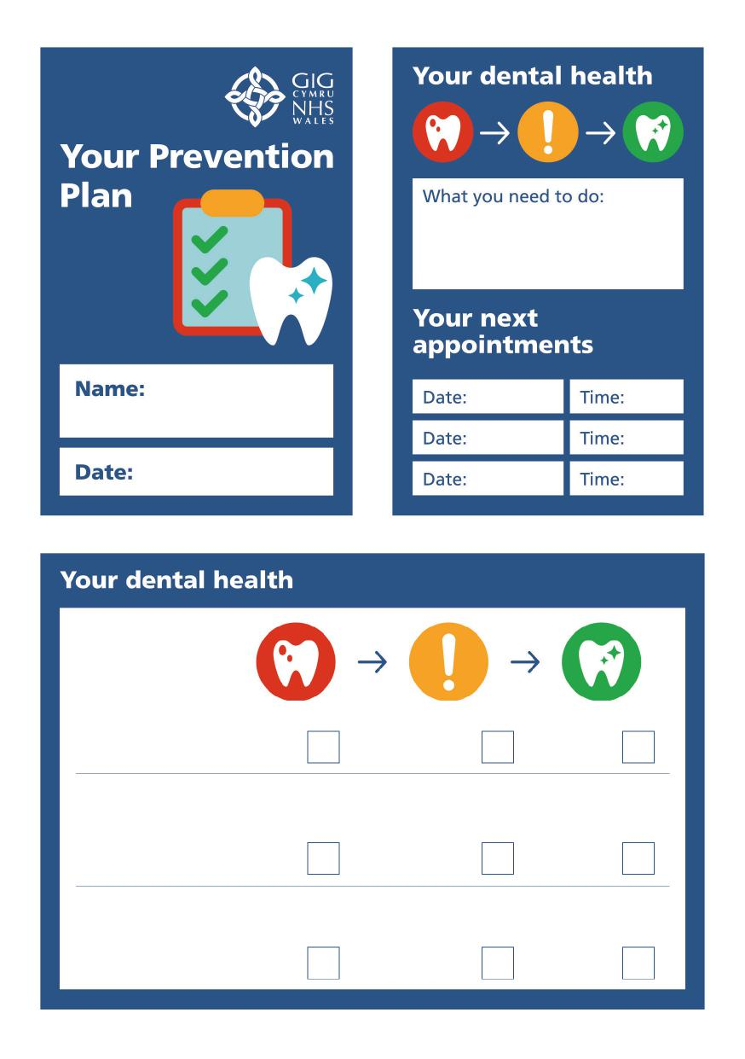
Tooth decay
You have active
tooth
decay
You have no active tooth decay
You are at risk of needing a filling in the future
Gum health
You have healthy gums! Keep doing what you are doing
Your gum health is stable but you need to follow our advice
on cleaning
You need treatment from us and better
cleaning by you
Other problems of the mouth
You need dental treatment/referral
You do not need additional treatment but we will review you
regularly to monitor
You have no other
dental need to be
concerned about

We have agreed that we will review progress you have made in your prevention plan in: ____________ months
We have also agreed that we will do another full assessment including a ‘check-up’ after: 12 months ☐ 18 months ☐ 24 months ☐
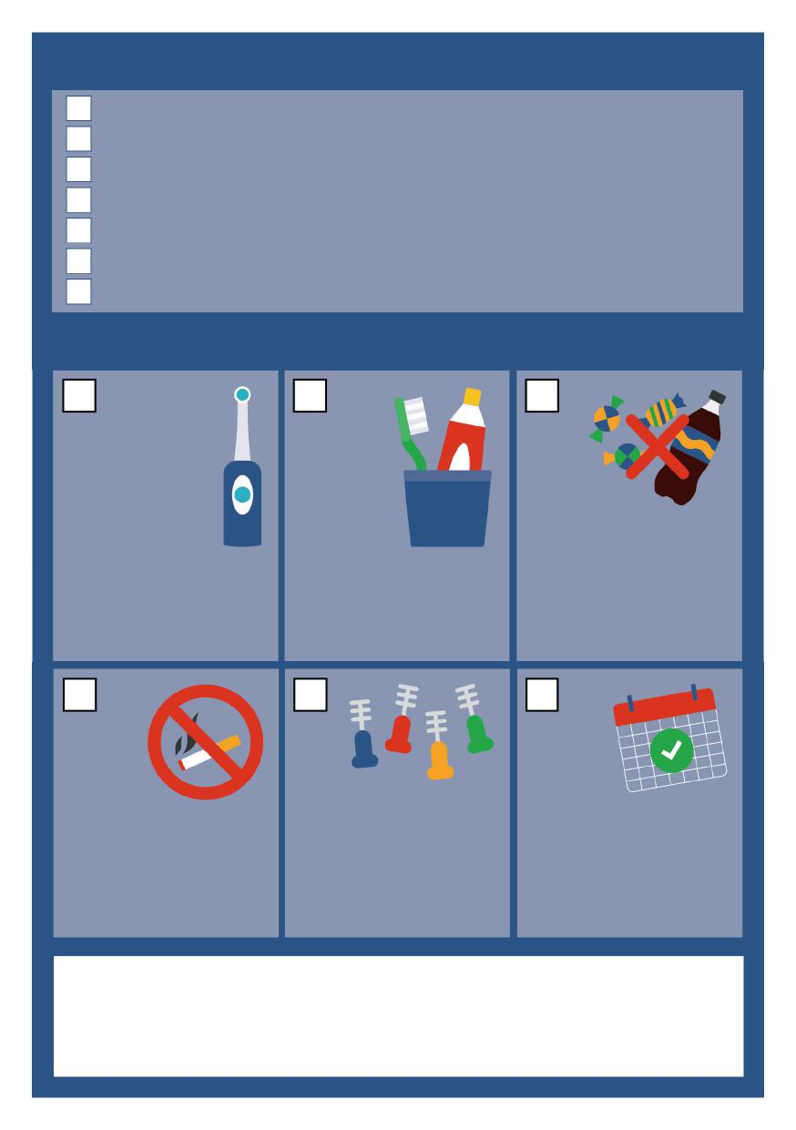
What we will do for you
Advice on what to eat or drink to improve your oral health
Advice and demonstration on cleaning your teeth
Smoking cessation advice and referral as agreed
Apply fluoride varnish (and fissure sealant if required)
Dental treatment as agreed
Advice on fluoride use & prescription for a high fluoride toothpaste or rinse
Other: specify
What we expect you to do/ continue doing
Brush twice per day, at night and one other time. Spit don’t rinse.
Keep sugary
food and drinks to mealtimes. Don’t eat or drink anything sugary in the hour before bed.
Use a family fluoride toothpaste (1,350 - 1,500 ppm fluoride)
Use support from Help Me Quit 0800 085 2219 www.helpmequit.wales
Use interdental brushes as shown and advised.
Attend your appointments when advised. Inform the practice if you cannot attend.

