


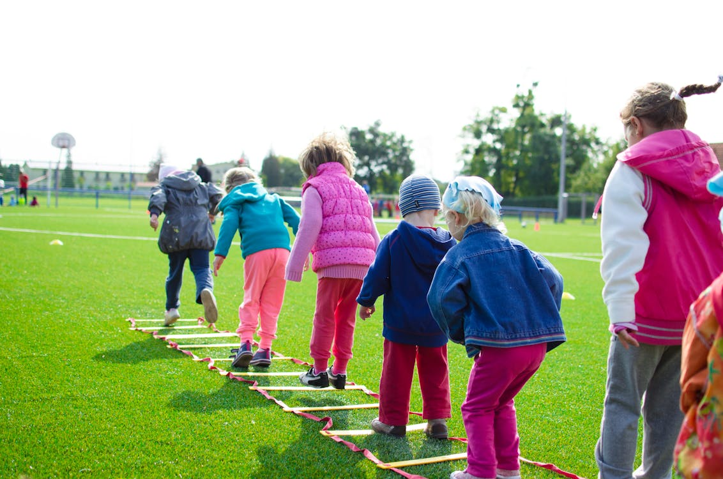

Child Measurement Programme 2024/25

This report summarises the data collected across Wales during the 2024/25 school year

Version 1.0
Mae’r ddogfen yma ar gael yn y Gymraeg/This document is available in Welsh

Contact
Llion Davies, Email: childmeasurementprogramme@wales.nhs.uk

Publication Details
Title: Child Measurement Programme 2024/25
Publisher: Public Health Wales NHS Trust
Date: 12 May 2026
ISBN: 978-1-83766-830-4
Website: https://phw.nhs.wales/services-and-teams/child-measurement-programme/

© 2026 Public Health Wales NHS Trust. Material contained in this document may be reproduced under the terms of the Open Government Licence (OGL) https://www.nationalarchives.gov.uk/doc/open-government-licence/version/3/ provided it is done so accurately and is not used in a misleading context. Acknowledgement to Public Health Wales NHS Trust to be stated. Copyright in the typographical arrangement, design and layout belongs to Public Health Wales NHS Trust.

Contents

Key points 3
Introduction 4
Acknowledgements 4
Methods 5
Part 1: General outputs 6
Wales level 6
Local health board comparisons 10
Local authority comparisons 12
Part 2: Local health board focused reports 13
Betsi Cadwaladr University Health Board 14
Powys Teaching Health Board 15
Hywel Dda University Health Board 17
Swansea Bay University Health Board 19
Cwm Taf Morgannwg University Health Board 21
Cardiff and Vale University Health Board 23
Aneurin Bevan University Health Board 25
More information 28
References 28

Key points

Highest participation recorded
- During the 2024/25 academic year, 28,512 children were measured resulting in a participation of 94.7%. This is the highest all-Wales participation since the programme began in 2013/14.

Highest prevalence of children with obesity recorded
- In Wales, the prevalence of children living with obesity was 12.8%. This was the highest all-Wales prevalence recorded since the programme began.

Over a quarter of children are living with overweight or obesity in Wales
- Over a quarter of children in Wales were living with overweight or obesity (27.3%). This was the highest all-Wales prevalence recorded since the programme began.

Prevalence of children with obesity higher in Wales than other UK nations
- The prevalence of children with obesity in Wales (12.8%) was higher than that reported for England (10.5%) and for Scotland (11.8%).

Prevalence of obesity higher where deprivation is greater
- The prevalence of children with obesity was approximately 75% higher in the most deprived fifth (15.6%) compared to the least deprived (8.9%).
- Children living in the least deprived fifth were less likely to be living with overweight or obesity compared to each of the other deprivation fifths.

Higher prevalence of underweight in boys compared to girls
- Boys were more likely to be underweight compared to girls with the prevalence of boys living with underweight at 1.2% compared to 0.6% for girls.

Introduction

This report summarises the key findings of the Child Measurement Programme (CMP) for Wales for the school year 2024/25. We are pleased to report, for Wales overall, 94.7% of eligible children were weighed and measured this year. The interactive dashboard with up to date CMP data tables, charts and maps can be found here.

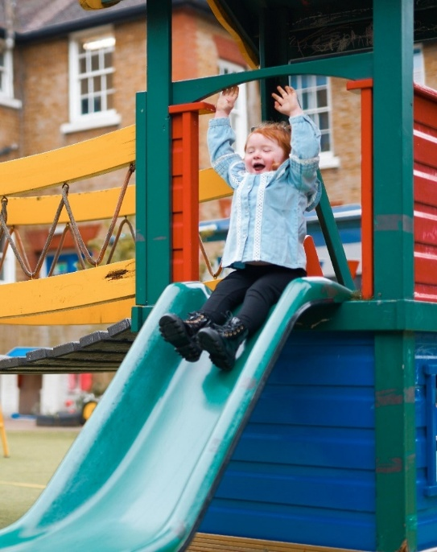
© 2023. Provided by Impact on Urban Health licensed via a CC BY-NC-ND 4.0 license
Children living with obesity are at increased risk of experiencing adverse health impacts and of continuing to live with obesity into adulthood.
Surveillance plays a key role in understanding trends over time, highlighting groups of children who may be at greater risk. This can inform effective prevention efforts and policy development aimed at improving health outcomes.

This edition of the report has been condensed, in response to stakeholder feedback, to emphasise key findings. We continue to provide Health Board specific sections.

Acknowledgements

Thank you once again to the school nursing teams, staff in schools, and of course the reception class children across Wales. We are also grateful to our stakeholders who have taken the time to provide feedback so that we can improve our outputs.

Methods

An updated historical and methodological technical document is available on the website.

Data have been refreshed to align with the 2021 Census geographies and the most recent classification lookups, which will result in differences from previously published figures. Figures can be compared to previous versions found in the historical reports and data, available here.

Records are included in the 2024/25 CMP for Wales if the child;
- is resident in Wales,
- attends a school in Wales,
- has a recorded sex,
- and was born in the period September 2019 to August 2020.

Children are excluded if;
- their measurement occurred outside the 2024/25 academic year,
- their height or weight recorded is an implausible measurement,
- their consent is withdrawn or
- they are unable to stand unaided.

Deprivation fifths are calculated using the Welsh Index of Multiple Deprivation (WIMD) 2025. When reporting data for Wales overall, national deprivation fifths are used. When reporting data at health board level, local deprivation fifths are calculated separately within each health board. Therefore, local deprivation fifths from different health boards are not directly comparable.

Prevalence is calculated using the age and sex-specific body mass index (BMI) centiles calculated using the British 1990 growth reference (UK90). The 95% confidence intervals for the prevalence rates were calculated using a method proposed by Wilson et al, 1927 (cited in Altman, 2000). BMI was calculated using a method proposed by Keys et al (1972).

The following epidemiological weight category thresholds have been assigned for surveillance purposes and include children living:

- with underweight: less than but not including 2nd centile.
- with healthy weight: 2nd centile up to but not including 85th centile.
- with overweight: 85th centile up to and not including 95th centile.
- with obesity: 95th centile and above.

Results are given in prevalence (%) of cohort and, when necessary, followed by the corresponding 95% confidence interval (95% CI) in brackets.

The prevalence ratios provide a measure of relative inequality within a health board or for Wales overall. Prevalence ratios are calculated by dividing the percentage of children with obesity in the most deprived area, by the percentage in the least deprived area. A larger prevalence ratio implies a larger inequality gap.

Primary Care Clusters (PCCs) are as of October 2024, using Census 2021 geographies.

Part 1: General outputs

Wales level

During the 2024/25 academic year, 28,512 children were measured resulting in a participation of 94.7%, the highest participation recorded since the programme began in 2013/14. Participation varied slightly between boys (94.0%) and girls (95.5%). One hundred and seventeen children were actively opted out of the programme by their parent/guardian this year, an increase from eighty-one children last year.

Prevalence of children in Wales for 2024/25:
with
Overweight
14.5%
with
Obesity
12.8%
with
Underweight
0.9%

with
Healthy weight
71.8%

The prevalence of children living with obesity in 2024/25 was 12.8% (95% CI 12.4 – 13.2). This is the highest all-Wales prevalence observed since the programme began. The prevalence of children with obesity this year was statistically significantly higher compared with 2023/24, which reported a prevalence of 11.8% (95% CI 11.5 – 12.2). The trend in the prevalence of children with obesity over time is shown in Figure 1. Caution should be applied when interpreting the recent trend due to the missing data during the pandemic period.

Figure 1:
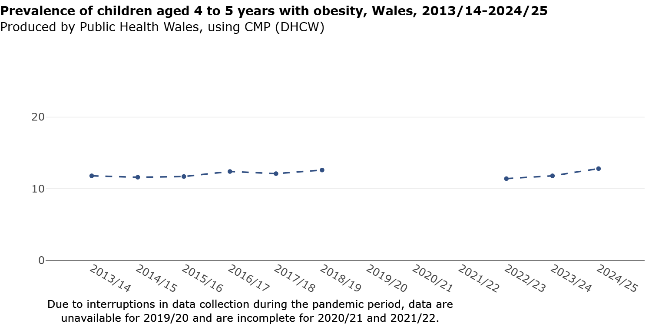

For Wales, the prevalence of children with underweight was 0.9% in 2024/25. This was similar to 2023/24 (1.0%) and 2022/23 (0.9%). Trends over a longer period of time demonstrate small year on year fluctuations in keeping with the relatively low numbers of children identified within this category.

Comparisons with UK nations
The prevalence of children with obesity in the England National Child Measurement Programme in 2024/25 was higher than the previous three years, at 10.5%. This was still lower compared to 12.8% in Wales.
Comparisons with Scotland are harder to interpret as children generally enter school when several months older than in England and Wales. Prevalence of Primary 1 children in Scotland with obesity was 11.8%.
At the time of writing the Northern Ireland Statistical Report on Children’s Health for 2024/25 was not available.

Sex
The prevalence of boys reported as living with obesity was 13.3% (95% CI 12.8 - 13.9), compared with 12.2% for girls (95% CI 11.7 - 12.8). While the confidence intervals overlap at their boundary and the difference has not been confirmed statistically, the gap in the estimates is noteworthy and may reflect a difference that could become more apparent with further monitoring.

The prevalence with overweight or obesity was similar in boys (27.5%) and girls (27.1%).
As observed in previous years, a statistically significantly lower proportion of girls were measured as having underweight (0.6%), compared with boys (1.2%).

Deprivation
The proportion of children in Wales with obesity by deprivation fifth is shown in Figure 2. Increasing deprivation was associated with a stepwise increase in prevalence of children living with obesity. Children in the least deprived fifth were statistically significantly less likely to be living with obesity compared with all other deprivation fifths.

Figure 2:
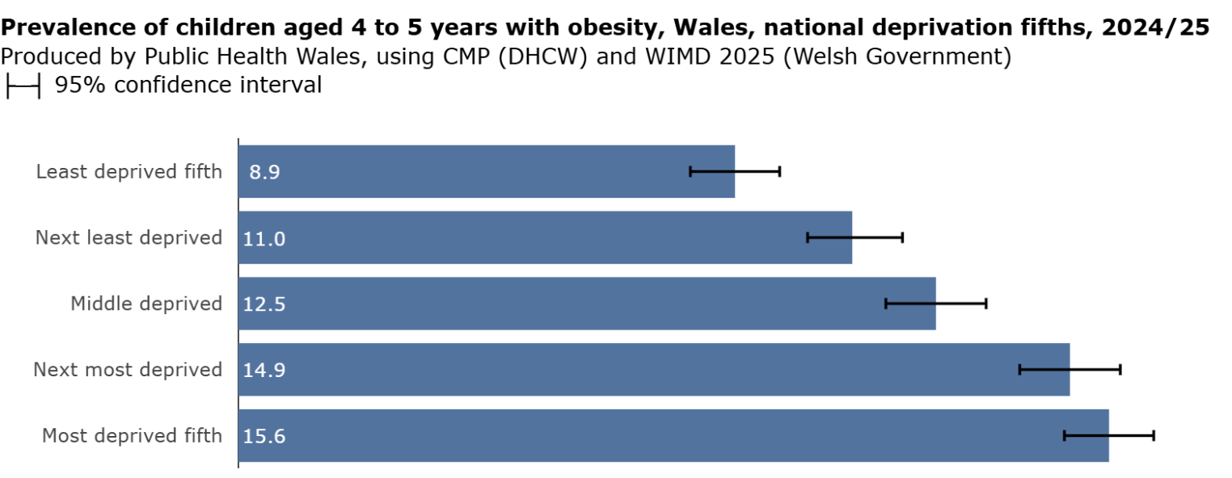

Weight data by deprivation and sex are summarised in Table 1. When considering deprivation according to sex, girls and boys in the most deprived fifth were statistically significantly more likely to be living with obesity compared to those in the middle to least deprived areas. Both boys and girls showed an increasing trend in prevalence with obesity as deprivation increased.

The prevalence of boys living with obesity was 9.5% in the least deprived compared with 15.7% in the most deprived fifth. For girls, this was 8.2% compared with 15.5% respectively.

Table 1: Wales level weight data by sex and deprivation, children aged 4-5 years, Child Measurement Programme, 2024/25

Wales deprivation fifth | With Overweight or |  | With Obesity
Wales deprivation fifth | Obesity prevalence % |  | prevalence %
 | Boys | Girls | Boys | Girls
Least deprived fifth | 23.0 | 22.0 | 9.5 | 8.2
Next least deprived | 26.4 | 24.3 | 12.2 | 9.8
Middle deprived | 28.3 | 27.3 | 13.0 | 12.0
Next most deprived | 28.6 | 29.8 | 15.6 | 14.2
Most deprived fifth | 30.3 | 30.4 | 15.7 | 15.5

Historical data for deprivation will differ from previous releases as data have been updated to reflect the latest 2025 edition of the Welsh Index of Multiple Deprivation. Additionally, this has resulted in trend data only being available from 2016/17. For more information see the technical guide.

The trend between the least and most deprived fifths is given in Figure 3. The deprivation gap for children with obesity, as reflected by the prevalence ratio, was 1.8 this year compared to 1.7 for the previous two years. This is broadly consistent with previous years, however ongoing monitoring will help determine whether a trend is emerging. Caution should be applied when interpreting the recent trend due to the missing data during the pandemic period.

Figure 3:
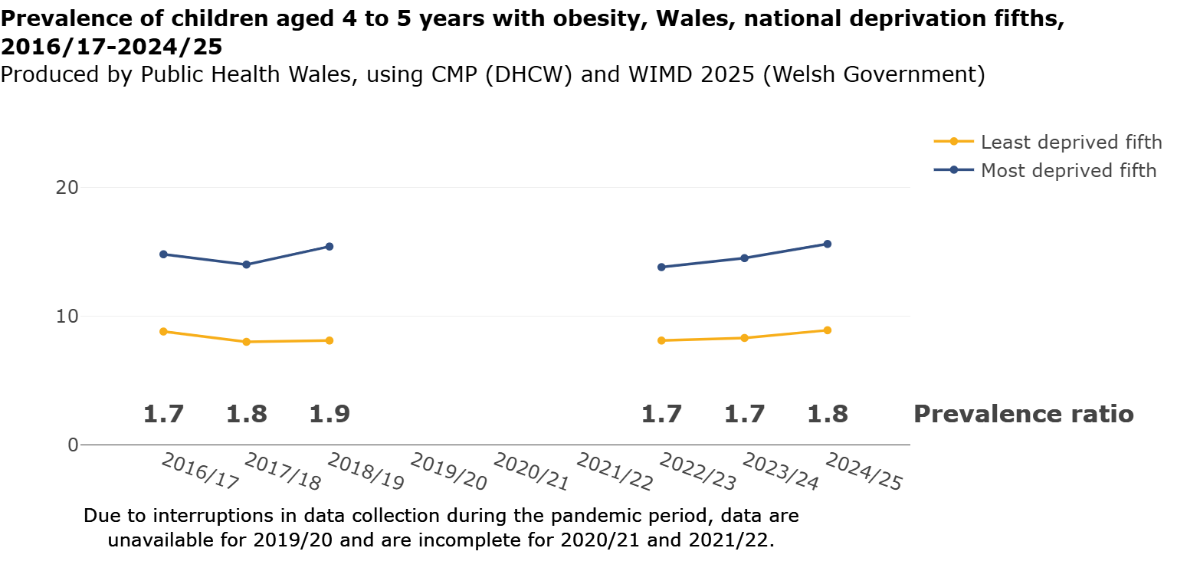

Ethnicity
Over a third of measured children were categorised as ‘Not known’ (34.3%). Due to the high proportion of missing data, estimates of prevalence by ethnicity must be interpreted with caution. Given the low numbers of children in categories such as ‘with underweight’, some categories were combined. Over half of the remaining cohort were categorised as ‘White’ (59.2%). Only 6.5% of the total cohort were categorised across the remaining ethnicity categories. For further detail on ethnicity breakdowns please refer to the data tables or dashboard.

Rurality
The prevalence of children living with overweight or obesity in rural areas was slightly higher at 28.2% (95%CI 27.2-29.2) compared with 27.0% (95%CI 26.4-27.6) in urban areas. However, as the 95% CIs overlap, we cannot confirm that this difference is statistically significant. Historical data for rurality will differ from previous releases as data have been updated to the 2021 Census rural/urban classification.

Local health board comparisons

With obesity
The breakdown for the prevalence of children living with obesity by local health board is given in Figure 4. The prevalence varies from 10.4% in Cardiff and Vale UHB to 13.9% in Hywel Dda UHB and Cwm Taf Morgannwg UHB. The prevalence of children with obesity in Cardiff and Vale UHB was statistically significantly lower than all other health boards except Powys THB.
The prevalence of children with obesity in Betsi Cadwaladr UHB was statistically significantly higher than the Wales estimate, and the Cardiff and Vale UHB estimate was significantly lower.

Compared to 2023/24, the prevalence point estimate for children with obesity was higher across every health board.

Figure 4:
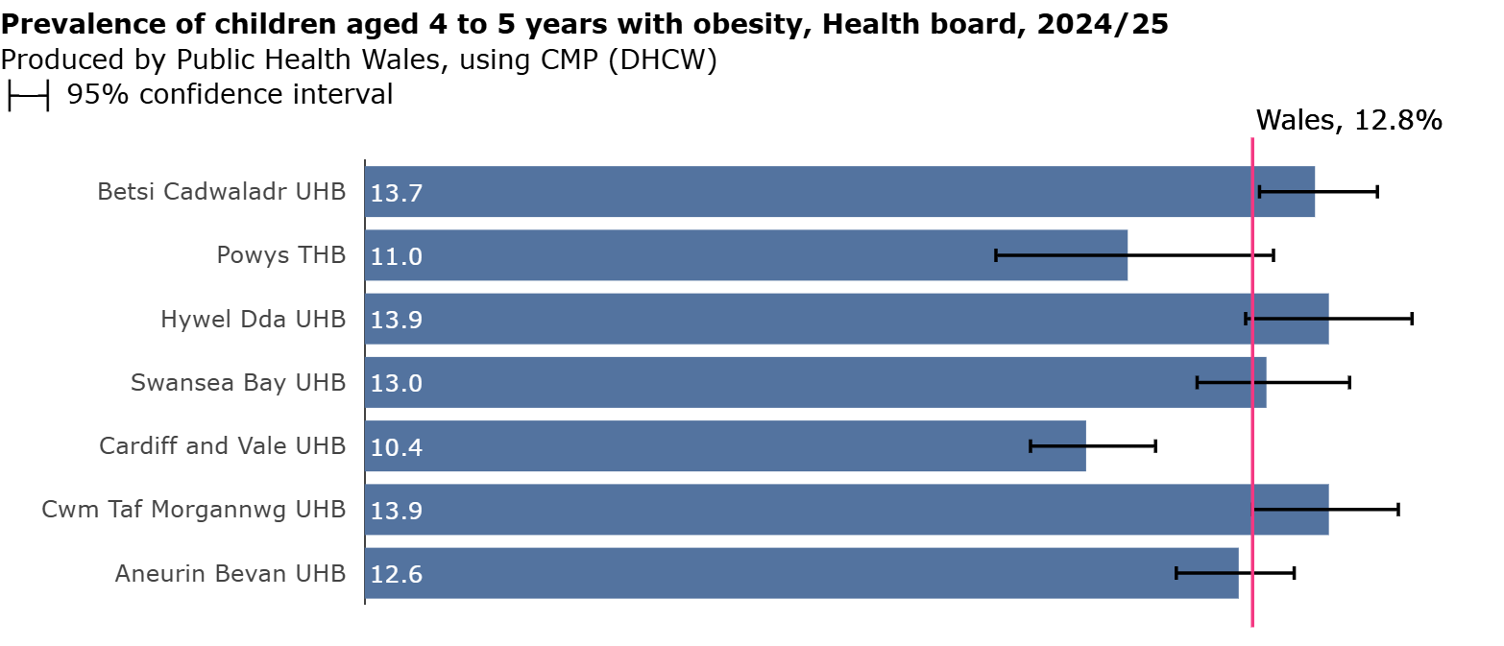

Overweight or obesity
The range of prevalence of children with overweight or obesity within health boards was 23.1% in Cardiff and Vale UHB to 30.1% in Hywel Dda UHB. The prevalence of children with overweight or obesity in Cardiff and Vale UHB was statistically significantly lower than all other health boards except Powys THB.
Betsi Cadwaladr UHB and Hywel Dda UHB reported a prevalence of children with overweight or obesity statistically significantly higher than the Wales estimate. Aneurin Bevan UHB and Cardiff and Vale UHB were significantly lower. See Figure 5.

Compared to 2023/24, the prevalence point estimate for children with overweight or obesity was higher across every health board.

Figure 5: 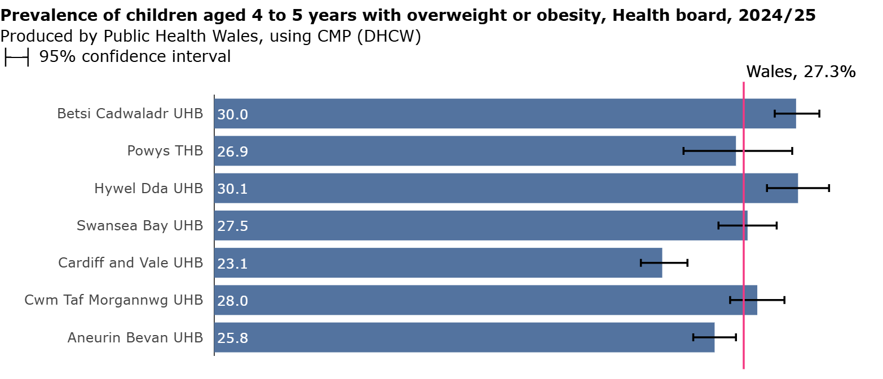

Local authority comparisons

The breakdown for children with obesity by local authority area is given in Figure 6. The prevalence of children with obesity ranged from 9.4% in the Vale of Glamorgan to 16.4% in the Isle of Anglesey. The prevalence of children with obesity in the Isle of Anglesey, Carmarthenshire and Bridgend were statistically significantly higher than the Wales value. In Cardiff, Vale of Glamorgan and Monmouthshire the prevalence was significantly lower.

Figure 6:
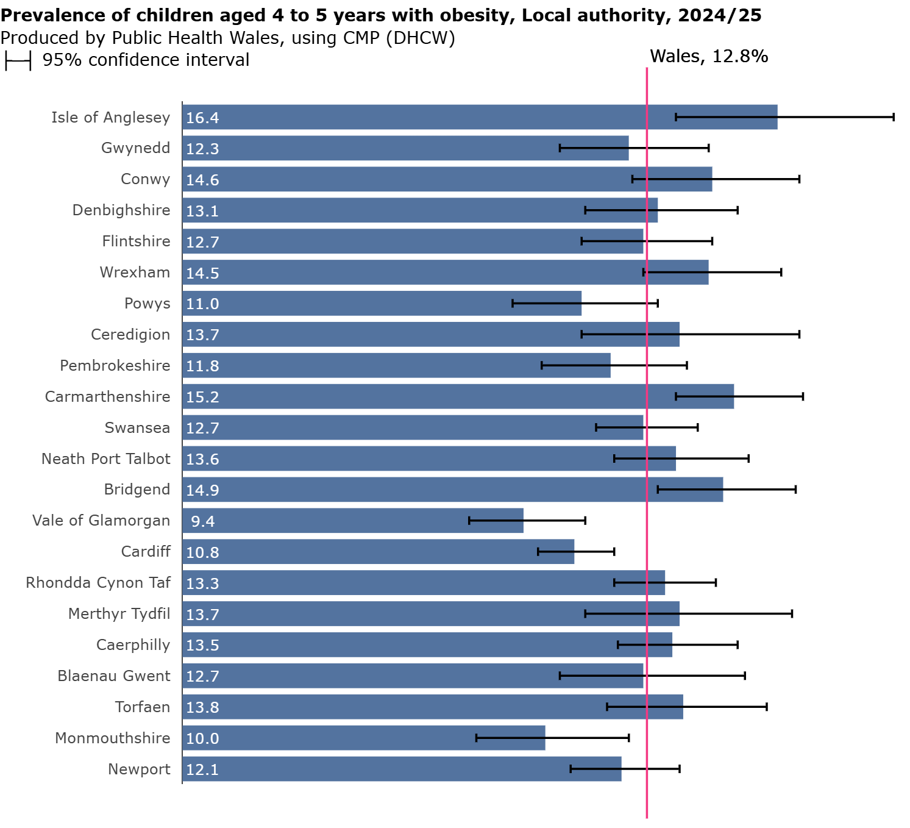

The proportions of children with overweight or obesity by local authority are given in Figure 7. Prevalence varied from 22.4% in the Vale of Glamorgan to 31.5% in the Isle of Anglesey. The prevalence of children with overweight or obesity in the Isle of Anglesey, Gwynedd, Wrexham, Ceredigion and Carmarthenshire was statistically significantly higher than the Wales value, and in Cardiff, the Vale of Glamorgan and Monmouthshire was significantly lower.

Figure 7:
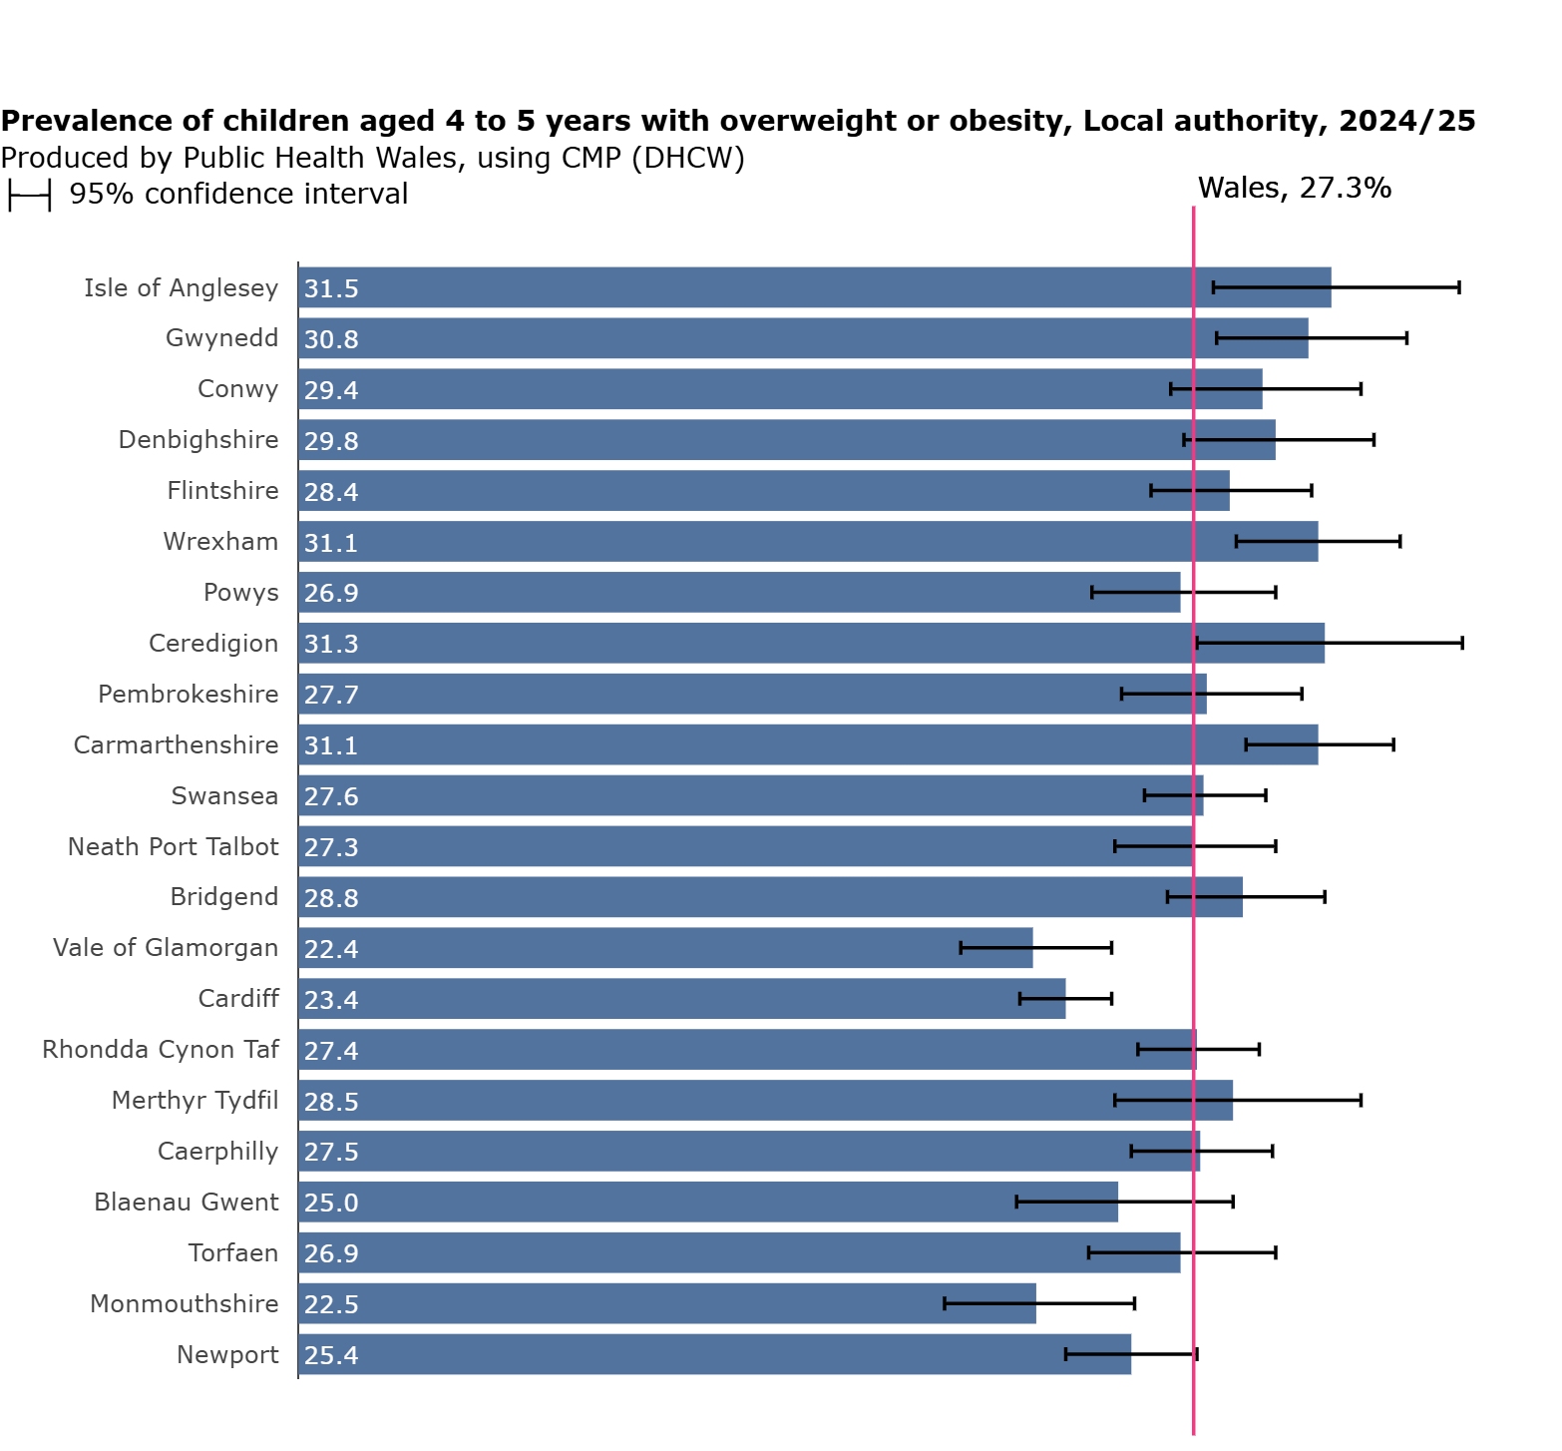

Part 2: Local health board focused reports

Betsi Cadwaladr University Health Board

A total of 6,152 children were measured in Betsi Cadwaladr University Health Board (UHB), resulting in a participation of 95.7% for 2024/25, which was similar to last year (95.4%).

Prevalence of children 2024/25;
with
Overweight
16.3%
with
Obesity
13.7%
with
Underweight
0.6%

with
Healthy weight
69.3%

*Percentages are rounded and may not sum to 100

With obesity
The prevalence of children with obesity in Betsi Cadwaladr UHB in 2024/25 was 13.7%, statistically significantly higher than Wales (12.8%). The health board result is higher than the figure last year (13.1%). The Isle of Anglesey had the highest prevalence of children with obesity of all local authorities in Wales at 16.4%.

With overweight or obesity
Thirty percent of children in the health board were living with overweight or obesity. This result was higher than last year’s result (28.0%) and statistically significantly higher than Wales (27.3%).

With underweight
The prevalence of children with underweight was 0.6%, compared with 0.7% for the previous year.

Sex
At health board level, the prevalence with obesity was similar among boys (13.9%) and girls (13.5%). In the Isle of Anglesey, prevalence of girls with obesity was 16.8%, statistically significantly higher than Wales.

Primary Care Clusters
The prevalence of children with obesity by cluster varied from 9.8% in Meirionnydd to 16.6% in Anglesey. The prevalence of the combined with overweight or obesity category ranged from 23.1% in South Flintshire to 33.4% in South Wrexham.

Deprivation
Within Betsi Cadwaladr UHB there was a statistically significantly higher prevalence of children with obesity in the most deprived fifth (17.0%) compared to the least deprived (9.3%). Deprivation at health board level uses local deprivation fifths.

The prevalence ratio provides a relative estimate for the gap between the least and most deprived fifths. There is variation over time, although it appears that this gap has increased in 2024/25 compared with previous years. However, this result should be interpreted with caution as there are not enough post pandemic data observations yet to confirm trends.

Figure 8:
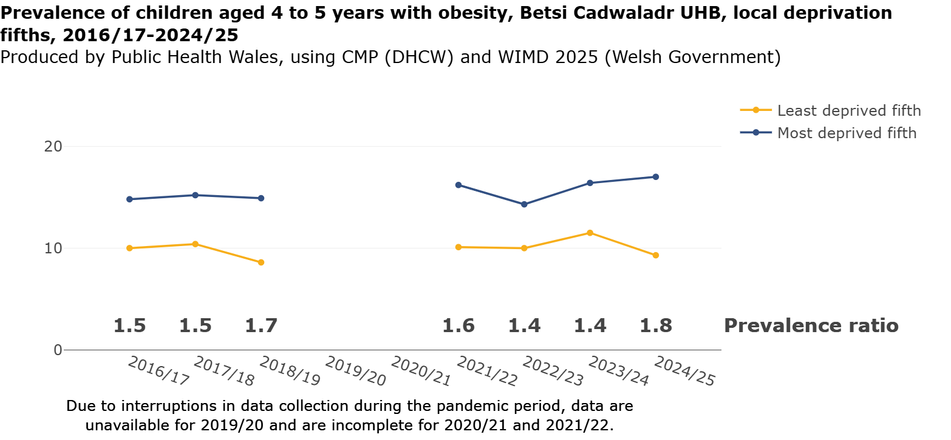

To explore further charts, maps, and detailed data tables, please refer to our data dashboard:
publichealthwales.shinyapps.io/ChildMeasurementProgrammeDashboard/

Powys Teaching Health Board

A total of 967 children were measured in Powys Teaching Health Board (THB), resulting in a participation of 93.9% for 2024/25. This was a decrease from 95.7% last year. Powys THB has a lower number of children measured and results will, therefore, have wider confidence intervals than seen in other health boards.

Prevalence of children 2024/25;
with
Overweight
15.9%
with
Obesity
11.0%
with
Underweight 0.5%

with
Healthy weight 72.6%

With obesity
The prevalence of children with obesity in Powys THB in 2024/25 was 11.0%, compared with 10.0% for the previous year.

With overweight or obesity
For the combined with overweight or obesity category prevalence was 26.9%, compared to 23.5% reported in 2023/24.

With underweight
The prevalence of children with underweight was 0.5%, compared to 0.9% reported in 2023/24. Powys THB has the lowest prevalence of children with underweight across Wales, however the wide confidence intervals should be noted (95% CI 0.2-1.2).

Sex
At health board level, the prevalence with obesity was similar for boys (11.3%) and girls (10.7%).

Primary Care Clusters
The prevalence of children with obesity by cluster ranged from 8.9% in Mid Powys to 12.4% in North Powys. For children with overweight or obesity prevalence varied from 24.3% in South Powys to 28.7% in North Powys.

Deprivation
Within Powys THB the prevalence of children with obesity by deprivation fifth ranged between 8.0% in the next least deprived fifth to 13.3% in the middle deprived fifth. Deprivation trends are harder to interpret for Powys THB as each deprivation quintile will contain relatively small numbers of children compared with other health boards. Deprivation at health board level uses local deprivation fifths, however it should be noted that the range of deprivation across Powys THB is relatively narrow compared to other health boards (WIMD, Welsh Government, 2025).

The prevalence ratio provides a relative estimate for the gap between the least and most deprived fifths. A change in the prevalence ratio from 1.4 in 2023/24 to 0.8 for this year was observed. This result does not hold with the general patterns observed across Wales. However, as noted above, the result should be interpreted with caution due to small starting numbers in the health board, reduced further upon sub categorisation to each deprivation fifth.

Figure 9:
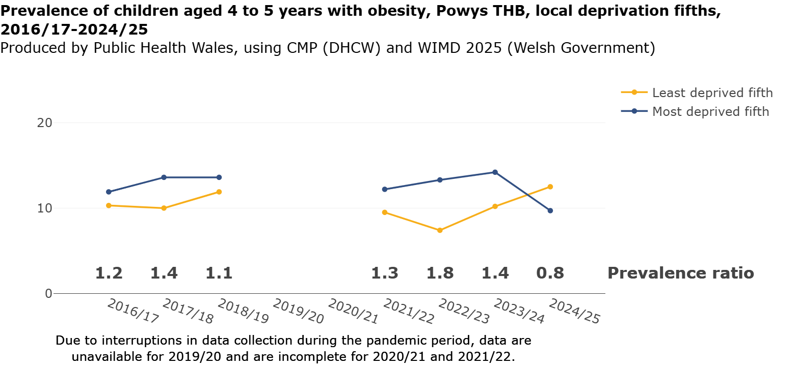

To explore further charts, maps, and detailed data tables, please refer to our data dashboard:
publichealthwales.shinyapps.io/ChildMeasurementProgrammeDashboard/

Hywel Dda University Health Board

A total of 3,157 children were measured in Hywel Dda University Health Board (UHB), resulting in a participation of 95.5% for 2024/25. This was a slight decrease from 95.7% last year.

Prevalence of children 2024/25;
with
Overweight
16.2%
with
Obesity
13.9%
with
Underweight
0.6%

with
Healthy weight
69.3%

With obesity
The prevalence of children with obesity in Hywel Dda UHB in 2024/25 was 13.9%. This is the highest prevalence among health boards alongside Cwm Taf Morgannwg. However, the 95% confidence interval does overlap with the overall Wales prevalence meaning that this difference may not be statistically significant. The health board result is higher than last year (13.2%). The prevalence of children with obesity in Carmarthen (15.2%) was significantly higher than the Wales prevalence.

With overweight or obesity
The prevalence of children with overweight or obesity was 30.1% and was statistically significantly higher than Wales. This result compares with 29.4% in 2023/24. In Ceredigion the prevalence was 31.3%, which was significantly higher than Wales.

With underweight
The prevalence of children with underweight was 0.6% compared to 0.8% in 2023/24. Due to small numbers, prevalence of children with underweight in Ceredigion and Carmarthenshire have been suppressed to prevent disclosure.

Sex
At health board level, the prevalence with obesity was higher for boys (15.3%) than girls (12.5%), however the confidence intervals overlap and therefore the difference has not been confirmed statistically.

Primary Care Clusters
The prevalence of children with obesity by cluster ranged from 10.8% in North Pembrokeshire to 16.3% in Amman/Gwendraeth.

Deprivation
Within Hywel Dda UHB the prevalence of children with obesity by deprivation fifth ranged between 10.0% in the least deprived up to 17.2% in the most deprived fifth. Deprivation at health board level uses local deprivation fifths.

The prevalence ratio provides a relative estimate for the gap between the least and most deprived fifth. There is variation over time, although it appears that this gap has increased in 2024/25 compared with last year. This result should be interpreted with caution as there are not enough post pandemic data observations yet to confirm trends.

Figure 10:
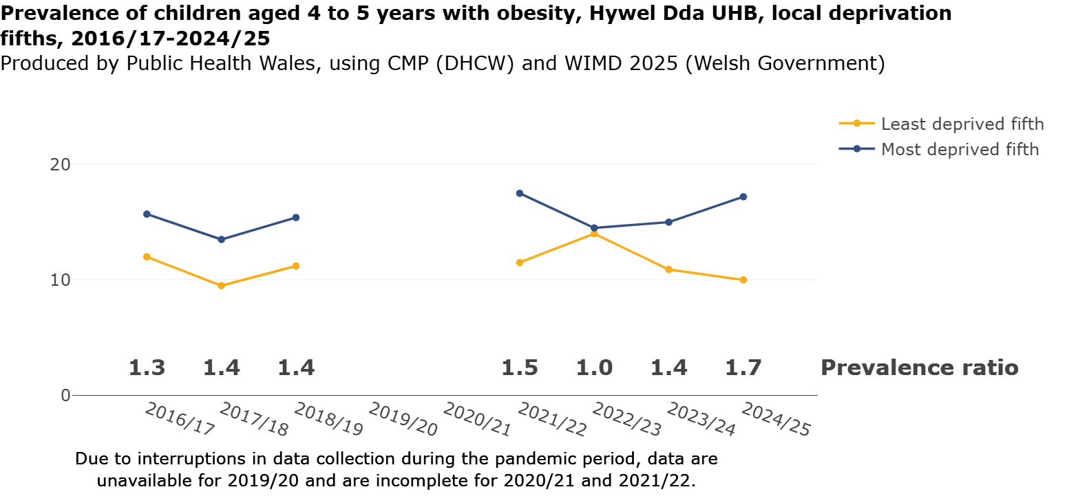

To explore further charts, maps, and detailed data tables, please refer to our data dashboard:
publichealthwales.shinyapps.io/ChildMeasurementProgrammeDashboard/

Swansea Bay University Health Board

A total of 3,412 children were measured in Swansea Bay University Health Board (UHB), resulting in a participation of 95.9% for 2024/25. This was a similar to last year (95.7%).

Prevalence of children 2024/25;
with
Overweight
14.4%
with
Obesity
13.0%
with
Underweight
0.7%

with
Healthy weight
71.8%

*Percentages are rounded and may not sum to 100

With obesity
The prevalence of children with obesity in Swansea Bay UHB in 2024/25 was 13.0%, compared with 11.6% for last year.

With overweight or obesity
The prevalence of children with overweight or obesity was 27.5%. This compares with 25.4% which was reported for the previous year.

With underweight
The reported prevalence of children in the health board measured with underweight was 0.7%, compared to 0.9% for the previous year.

Sex
At health board level, the prevalence with obesity was similar for boys (13.7%) and girls (12.4%). In Neath Port Talbot the prevalence of boys living with obesity was 15.3% compared with 12.0% of girls.

Primary Care Clusters
The prevalence of children with obesity ranged from 8.2% in the Upper Valleys to 16.7% in City Health. The Penderi cluster had the highest prevalence of overweight and obesity in the health board at 31.7%.

Deprivation
Within Swansea Bay UHB there was a statistically significantly higher prevalence of children with obesity in the most deprived fifth, 16.9% (95% CI 14.6 – 19.6) compared to the least deprived, 9.3% (95% CI 7.2 – 11.8). In the most deprived fifth 32.5% of children were living with overweight or obesity. Deprivation at health board level uses local deprivation fifths.

The prevalence ratio provides a relative estimate for the gap between the least and most deprived quintiles. There is variation over time, although it appears that this gap has widened in 2024/25 compared with last year. However, this result should be interpreted with caution as there are not enough data observations to confirm trends.

Figure 11:
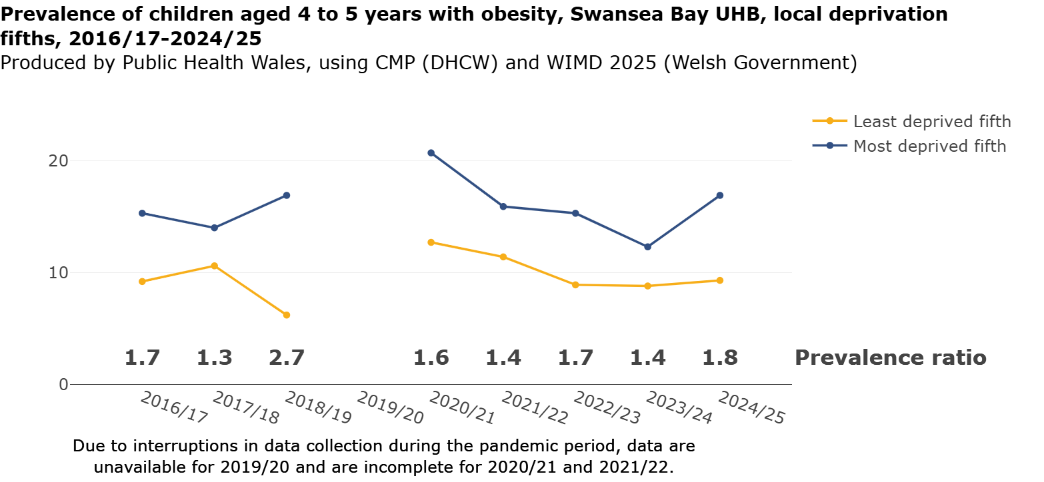

To explore further charts, maps, and detailed data tables, please refer to our data dashboard:
publichealthwales.shinyapps.io/ChildMeasurementProgrammeDashboard/

Cwm Taf Morgannwg University Health Board

A total of 4,162 children were measured in Cwm Taf Morgannwg University Health Board (UHB), resulting in a participation of 93.0% for 2024/25, this was similar to last year (92.4%). However, this was the lowest reported participation at a health board level.

Prevalence of children 2024/25;
with
Overweight
14.1%
with
Obesity
13.9%
with
Underweight
1.0%

with
Healthy weight
71.0%

With obesity
The prevalence of children in Cwm Taf Morgannwg UHB for 2024/25 with obesity was 13.9%, the joint highest amongst health boards in Wales. The figure for 2023/24 was 11.9%. Bridgend reported a prevalence of children with obesity of 14.9%, which was statistically significantly higher than the Wales value (12.8%).

With overweight or obesity
The prevalence of children living with overweight or obesity was 28.0% (95% CI 26.6 – 29.4) compared to 25.3% (95% CI 24.0 – 26.6) in 2023/24. The confidence intervals overlap at the boundary and therefore the difference has not been confirmed statistically.

With underweight
The prevalence of children with underweight was 1.0%. This result is the same figure as the last two years. Prevalence with underweight for Merthyr Tydfil was 1.6%.

Sex
At health board level, the prevalence with obesity was comparable for boys (14.7%) and girls (13.0%). The prevalence of boys with obesity increased to 14.7% from 11.3% last year. Prevalence of underweight for boys was 1.4% compared to 0.7% for girls.

Primary Care Clusters
The prevalence of children with obesity by cluster ranged from 7.9% in South Merthyr Tydfil to 18.2% in Bridgend North Network. Prevalence of children with overweight or obesity by cluster ranged from 24.9% in South Taf Ely to 31.6% in both Bridgend North Network and South Cynon.

Deprivation
Within Cwm Taf Morgannwg UHB there was a statistically significantly higher prevalence with obesity in the most deprived fifth, 19.3% compared to the least deprived, 9.5%. Deprivation at health board level uses local deprivation fifths.

The prevalence ratio between the most and least deprived was 2.0, with those in the most deprived fifth reporting approximately twice the prevalence of obesity compared to the least deprived fifth. The relative prevalence ratio has increased compared with the previous two years which reported ratios of 1.9 and 1.7 respectively. However, this result should be interpreted with caution as there are not enough data observations to confirm trends.

Figure 12:
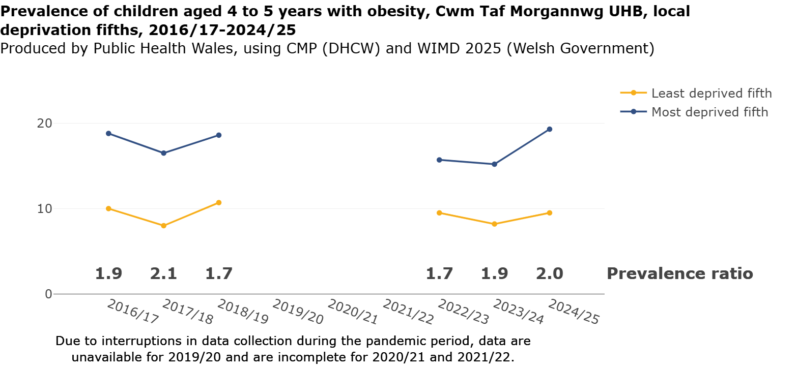

To explore further charts, maps, and detailed data tables, please refer to our data dashboard:
publichealthwales.shinyapps.io/ChildMeasurementProgrammeDashboard/

Cardiff and Vale University Health Board

A total of 4,756 children were measured in Cardiff and Vale University Health Board (UHB), resulting in a participation of 93.5% for 2024/25. This was a decrease from 95.7% last year.

Prevalence of children 2024/25;
with
Overweight
12.7%
with
Obesity
10.4%
with
Underweight
1.6%

with
Healthy weight
75.3%

With obesity
The prevalence of children with obesity in Cardiff and Vale UHB in 2024/25 was 10.4%. This result is comparable to last year at 9.8%. The prevalence of obesity for both local authorities within the health board is statistically significantly lower than seen in Wales for 2024/25 (12.8%).

With overweight or obesity
The prevalence of children with overweight or obesity was 23.1% (95% CI 22.0 – 24.4), higher than last year’s result, 20.9% (95% CI 19.7 – 22.0). The prevalence was the lowest reported for a health board and was statistically significantly lower than the Wales figure (27.3%). The confidence intervals overlap at the boundary and therefore the difference has not been confirmed statistically.

With underweight
The prevalence of children categorised as having underweight in the heath board was 1.6%, statistically significantly higher than Wales (0.9%). However, this result is comparable to the previous year (1.4%). Comparison by local authority shows a prevalence of 0.8% in the Vale of Glamorgan compared with 1.8% in Cardiff. Further information on underweight children in Cardiff local authority is available on the CMP website here; Underweight Prevalence in Cardiff and Wales - Public Health Wales.

Sex
At health board level, the prevalence with obesity was 11.3% for boys and 9.6% for girls. Prevalence of underweight for boys was 2.0%, compared to 1.1% for girls. In the Vale of Glamorgan, the prevalence of boys with obesity was 10.5% compared to 8.3% for girls.

Primary Care Clusters
The prevalence of children with obesity by cluster varied from 6.4% in Western Vale to over double in Cardiff South West (13.7%). The clusters with the highest prevalence of overweight or obesity were Cardiff South West (27.9%) and Cardiff East (27.6%).

Deprivation
Within Cardiff and Vale UHB there was a statistically significantly higher prevalence with obesity in the most deprived quintile, 14.8% (95% CI 13.0 – 16.9) compared to the least deprived, 7.0% (95% CI 5.5 – 8.9). For the with overweight or obesity category prevalence ranged from 19.1% in the least deprived fifth to 29.1% in the most deprived. Deprivation at health board level uses local deprivation fifths.

The prevalence ratio provides a relative estimate for the gap between the least and most deprived quintiles. For 2024/25 the prevalence ratio was 2.1, this was lower than recent years. However, this result should be interpreted with caution as there are not enough data observations to confirm trends.

Figure 13:
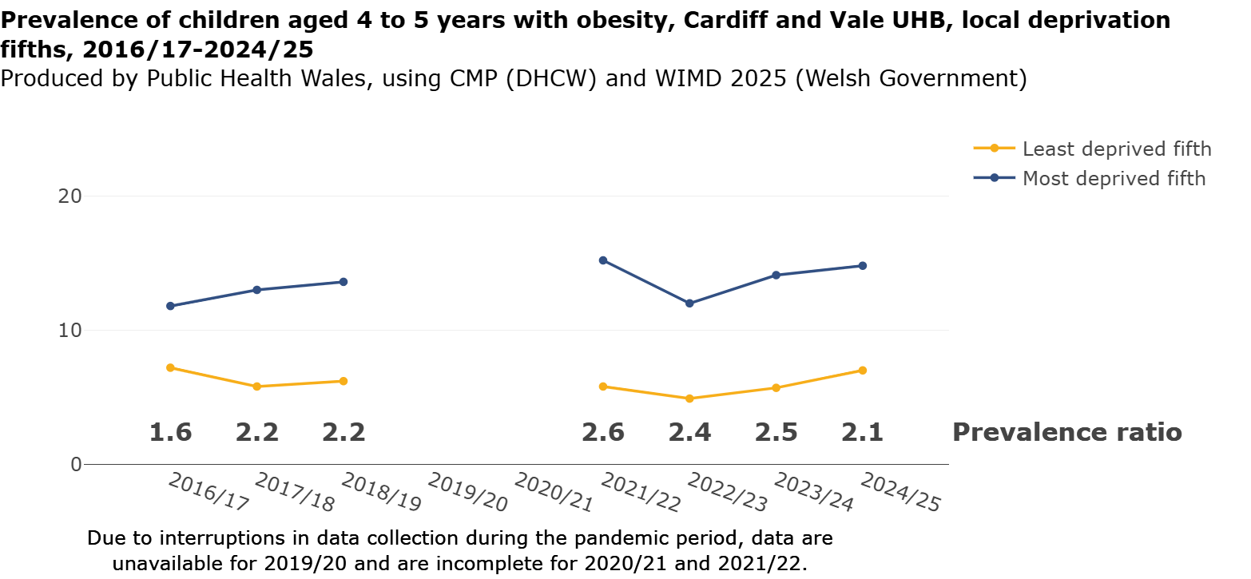

To explore further charts, maps, and detailed data tables, please refer to our data dashboard:
publichealthwales.shinyapps.io/ChildMeasurementProgrammeDashboard/

Aneurin Bevan University Health Board
A total of 5,906 children were measured in Aneurin Bevan University Health Board (UHB), resulting in a participation of 94.9% for 2024/25. This was an increase from 91.6% last year.

Prevalence of children 2024/25;
with
Overweight
13.2%
with
Obesity
12.6%
with
Underweight
0.9%

with
Healthy weight
73.3%

With obesity
The prevalence of children living with obesity in Aneurin Bevan UHB in 2024/25 was 12.6%, compared to 11.9% in 2023/24. The prevalence of obesity in Monmouthshire (10.0%) was statistically significantly lower than Wales (12.8%).

With overweight or obesity
The prevalence of children living with overweight or obesity was 25.8%, which was statistically significantly lower than the Wales figure. In 2023/24, the prevalence was 25.0%. When comparing at local authority level, Monmouthshire (22.5%) was the only local authority within the health board with a prevalence that was significantly lower than Wales.

With underweight
The prevalence of children with underweight was 0.9%. This result was the same figure as last year. Although variation between local authorities has been reported for underweight in previous years, there was not much variation reported in 2024/25 (0.9 – 1.1%). Due to small numbers, prevalence of children with underweight for Blaenau Gwent and Monmouthshire have been suppressed to prevent disclosure.

Sex
At health board level, the prevalence with obesity was similar for boys (12.6%) and girls at (12.5%). Newport (10.9%) reported a statistically significant lower prevalence of boys living with obesity than Wales, while Monmouthshire (8.4%) reported a significantly lower prevalence of girls living with obesity than Wales.

Primary Care Clusters
The prevalence of children with obesity ranged from 8.1% in Monmouthshire South to 14.2% in both Torfaen South and Caerphilly North.

Deprivation
Within Aneurin Bevan UHB, the prevalence with obesity was highest in the next most deprived fifth at 14.9%, compared with 9.5% in the least deprived fifth. Deprivation at health board level uses local deprivation fifths.

This year the prevalence ratio for obesity between the most and least deprived was 1.5, compared to 1.8 for the previous year. However, this result should be interpreted with caution as there are not enough data observations to confirm trends.

Figure 14:
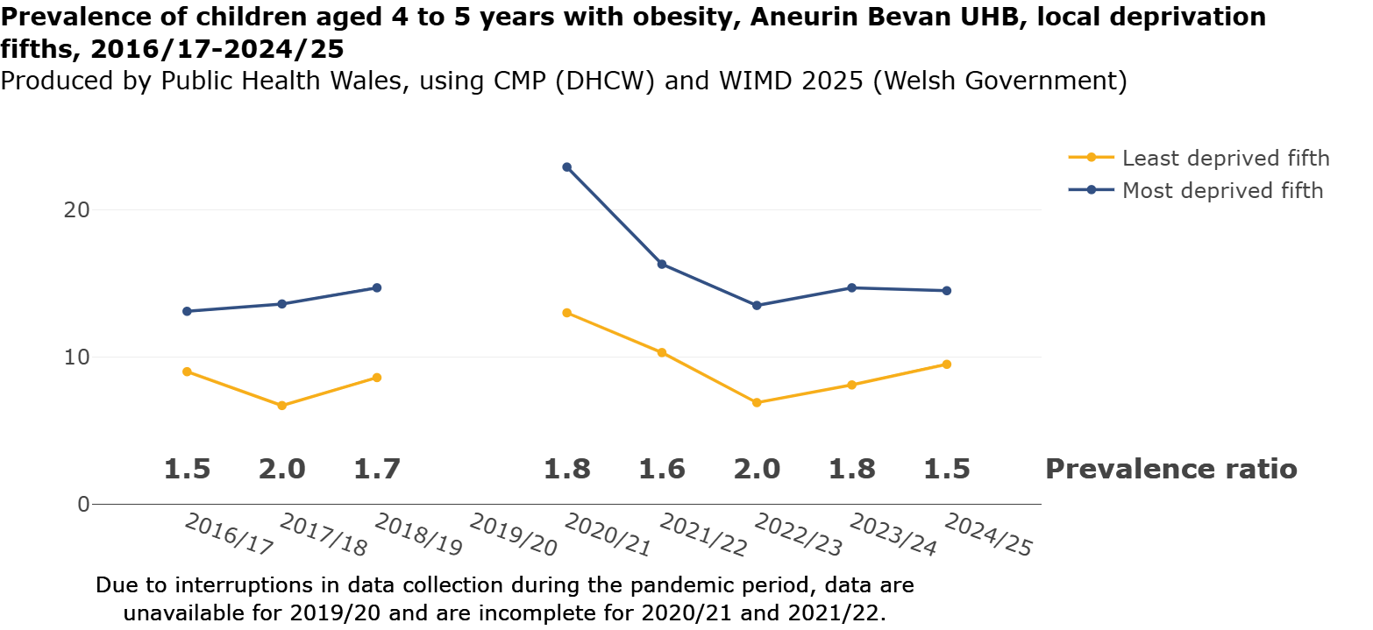

To explore further charts, maps, and detailed data tables, please refer to our data dashboard:
publichealthwales.shinyapps.io/ChildMeasurementProgrammeDashboard/

Production Team
- Llion Davies, Consultant in Public Health Medicine
- Abi Mathison-Pope, Programme Manager
- Simon Campbell, Programme Support Officer
- Mari Ann Jones, Advanced Public Health Intelligence Analyst
- James Beasley, Public Health Intelligence Analyst
- Nathan Lester, Head of Observatory & Cancer Analysis Team
- Hugo Cosh, Principal Public Health Intelligence Analyst
- David Tucker, Congenital Anomalies Registration Information Service Manager
- Rachel Bath, Consultant in Public Health
- Suzanne Wood, Consultant in Public Health Medicine
- Hayley Owen, Administration Support
- Peace Willie, Digital Clinical Safety Officer
- Anna Jones, Chair, All Wales School Nursing Leads
- Susan Carmichael, Principal Public Health Practitioner, Aneurin Bevan UHB
- Translation by NWSSP

More information
This report provides a summary of the analysis of the child measurements taken for the Child Measurement Programme in Wales. Comprehensive information displayed as tables can be found on our website at Child Measurement Programme NHS Wales. For more information about healthy weight in children, please refer to health information for parents resources via this link: https://phw.nhs.wales/topics/every-child-health-information-for-parents/.

These booklets provide a trusted source of health and well-being information for expectant and new parents in Wales.

References
Altman DG et al (2000) Statistics with confidence.2nd ed. BMJ Books: London. pp46.

Dinsdale H, Ridler C and Ells LJ (2011) A simple guide to classifying body mass index in children. Oxford: National Obesity Observatory.

Keys A et al (1972) Indices of relative weight and obesity. J Chronic Dis 25:329-43.

National Child Measurement Programme, England, 2023/24 School Year, NHS England. Available at: National Child Measurement Programme - NHS England Digital

Primary 1 Body Mass Index (BMI) statistics Scotland – School year 2023 to 2024, Public Health Scotland. Available here: Primary 1 Body Mass Index (BMI) statistics Scotland - School year 2023 to 2024 - Primary 1 Body Mass Index (BMI) statistics Scotland - Publications - Public Health Scotland

Welsh Index of Multiple Deprivation (WIMD) 2025, StatsWales, Welsh Government. Information available at: Welsh Index of Multiple Deprivation (gov.wales)

Gweithio gyda'n gilydd
i greu Cymru iachach
Working together
for a healthier Wales

