Call for action
 | Read this  letter
 | Share
 | Discuss

Vaccination and immunisation information for preschool managers

Vaccination saves lives, helping prevent up to 5 million deaths every year. It is a key measure in keeping children healthy and giving them the best start in life.
Nurseries and preschools play a valuable role in preventing outbreaks of disease by promoting childhood vaccination.
We want to help you make sure all children and staff at your preschool have been given up-to-date information and are fully vaccinated in line with recommended routine vaccinations.
Information for parents and guardians | Information for staff
You can see the parents and guardians’ letter here.  Action  1. Share with parents and guardians.  2. Ask them to read the letter, fill in the form and return it to you. | You can see the preschool staff letter here.  Action  1. Share with your staff.  2. Ask them to read the letter, fill in the form and return it to you.  3. If any member of staff has missed their vaccinations, consider creating a plan of action with them.
Why?
These letters will give you a record of children’s and staff’s vaccination history.
If there is an outbreak of disease, having access to these vaccination details will allow you to respond quickly and efficiently.
Scan me for more information about vaccination and immunisation 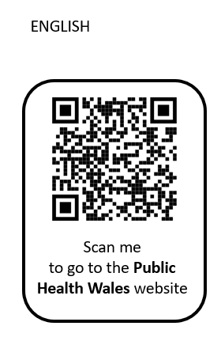

What else can I do?
You can display resources to share information about vaccination and immunisation. You can download, and order for free, leaflets and posters about vaccination and immunisation from:
phw.nhs.wales/health-information-resources
There are useful contacts here.
The Healthy and Sustainable Pre-School Scheme, which promotes health and sustainability in preschools in Wales, is available to support you. For more information, see: https://phw.nhs.wales/services-and-teams/welsh-network-of-healthy-school-schemes/
Thank you for your support in making sure the children and staff in your care are up to date with their vaccinations.

