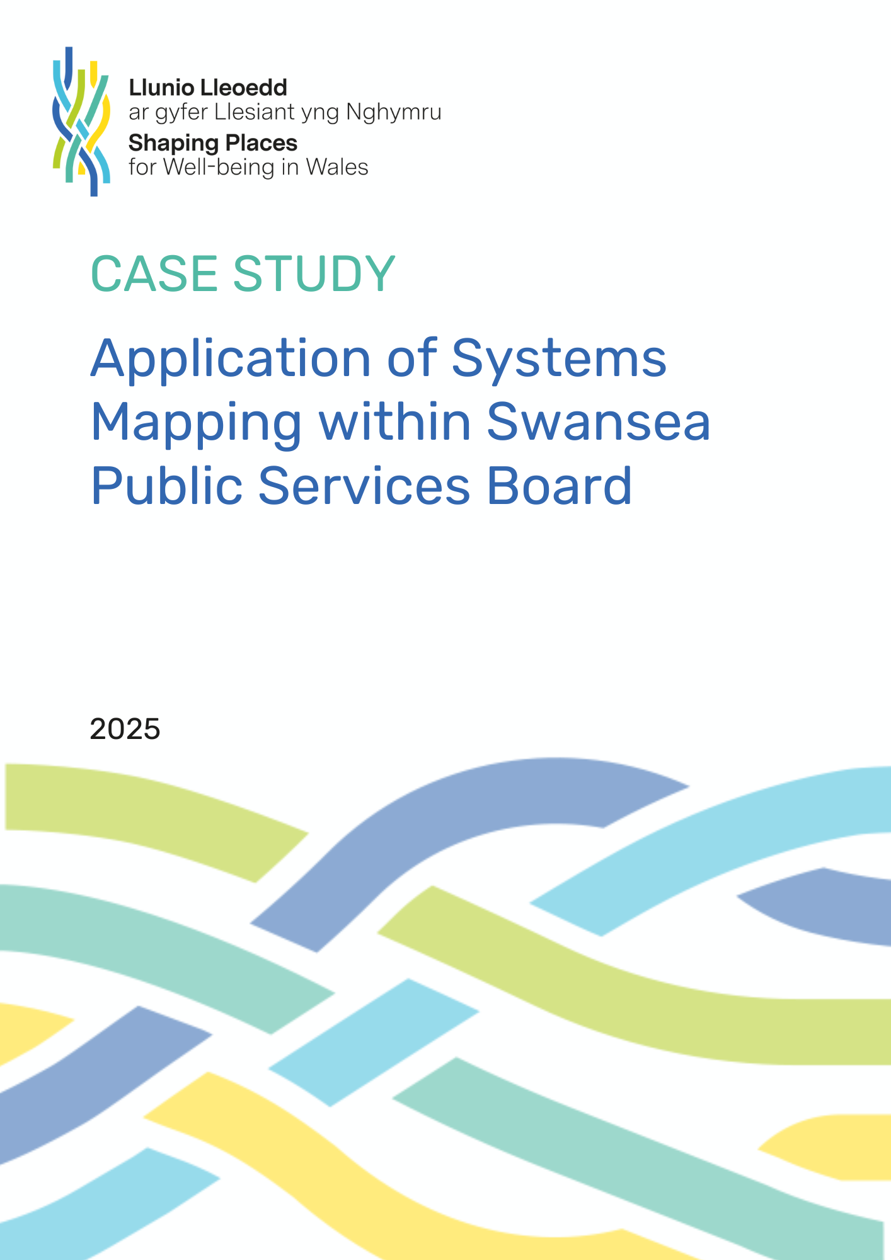

Systems Mapping Case Study – Swansea Public Services Board
- Background
Systems mapping is a range of approaches that help us to understand the parts and relationships between the parts in a system-of-interest. It enables participants to take a more holistic approach, identifying key connections, dependencies, and opportunities for improvement.
- Situation
Following participation in a series of systems mapping workshops led by the Shaping Places for Well-being in Wales (SPWW) team, a learning group member from Swansea Public Services Board (PSB) used diagramming and systems mapping to explore the interconnections between five objectives in their Well-being Plan:
- Transforming Early Years Services
- Live Well, Age Well – Human Rights City
- Climate Change and Nature Recovery
- Strong Communities
- Developing Swansea’s Integrated Cultural Offer
The workshop was designed to help Swansea PSB apply systems thinking to complex challenges that involve multiple partners.
- Methodology
The focus was on developing high-level systems maps for each of the five objectives, whilst identifying interrelationships, gaps and opportunities for further collaboration. The PSB was keen to strengthen their partnership approach through identifying synergies across the five priority objectives. System Mapping Approach Using an online collaborating tool, a pre-workshop activity helped to identify outcomes of interest for each of the objectives (measures or variables that workshop participants considered important to the PSB and its partnerships) and high-level factors which influence the outcomes (i.e. things that workshop participants thought were causally related to the outcomes).

- Participants were split into five groups based on their role and PSB objective most relevant to their areas of work. Each group had a facilitator, who guided participants through a series of activities and ensured all participants voices were heard. On each group’s table activities were undertaken using stickies and a mapping diagram.

Illustration of mapping activities

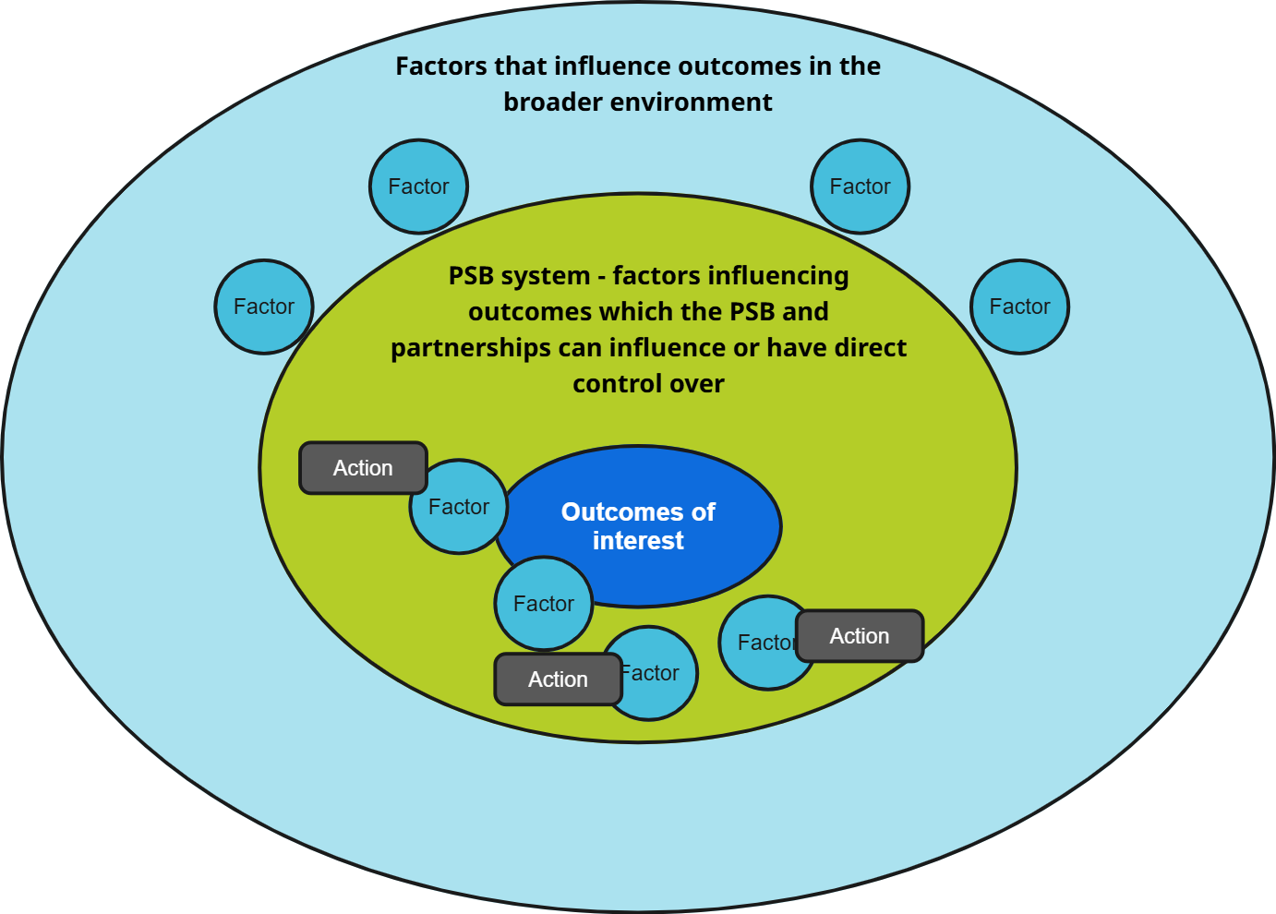

- Initially, each group reviewed and agreed the outcomes of interest identified in the pre-workshop activity.

- Each group then mapped high level factors that they felt influenced the outcomes of interest. They were then asked to place those factors that the PSB had the greatest influence upon, nearest to the outcomes of interest.

- Each group then mapped the current actions being taken by the PSB and their partnerships against the factors. The activity was then repeated for proposed actions in 2025/26 and potential gaps identified and discussed.

- The 2025/26 actions for each objective were then transferred to a large diagram on a wall. Through a facilitated discussion all workshop participants came together to consider:

  - interconnections between actions and relationships between partners delivering the actions;
  - where there were strong connections, no connections but links needed to be made and weak connections that needed strengthening;
  - resource implications and where alignment could be improved.
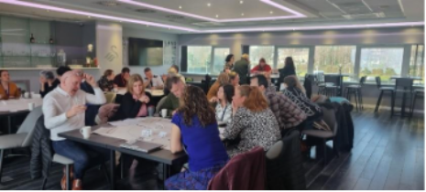
- Impact
The insights gained from this workshop provide a structured pathway for developing the PSB’s actions over the remainder of the 2023-28 Well-being Plan.
“The Swansea PSB Systems Mapping Workshop (March 2025) demonstrated the power of systems thinking in improving service integration, multi-agency collaboration, and long-term planning. By mapping interdependencies, we have identified opportunities to strengthen partnerships, align resources, and create lasting positive change for Swansea’s communities. The insights gained from this workshop provide a structured pathway for developing the PSB’s actions over the remainder of the 2023-28 Wellbeing Plan.”
(Swansea PSB and SPWW Learning Group member, March 2025)
Following on from the system mapping workshop, the following recommendations were made:
- Develop a PSB-wide data-sharing system to improve service coordination and reduce duplication.
- Embed human rights across all the objectives: Ensure human rights impact assessments are fully integrated into all major PSB policies and decision-making frameworks.
- Develop a Unified Community Engagement Platform: Establish a ‘One PSB’ digital hub to coordinate public consultations and feedback across agencies.
- Expand workforce training programmes: Establish joint training across PSB partners to enhance skills in early intervention, digital inclusion, and climate resilience.
- Leverage Geographic Information System (GIS) Mapping for service delivery: Implement GIS-based mapping to visualise service hubs and identify gaps in provision.
- Align PSB actions with the Local Development Plan (LDP): Ensure that PSB planning aligns with Swansea’s long-term development strategy, supporting resilient and thriving communities.

- Conclusion
The Swansea PSB workshop is an example of how high-level systems mapping activities can be used to engage with multiple perspectives and enhance collaboration across partners that contribute to delivering the PSB’s well-being plan objectives, supporting strategic planning and resource optimisation.
- Link to resources:
Shaping Places for Wellbeing in Wales

