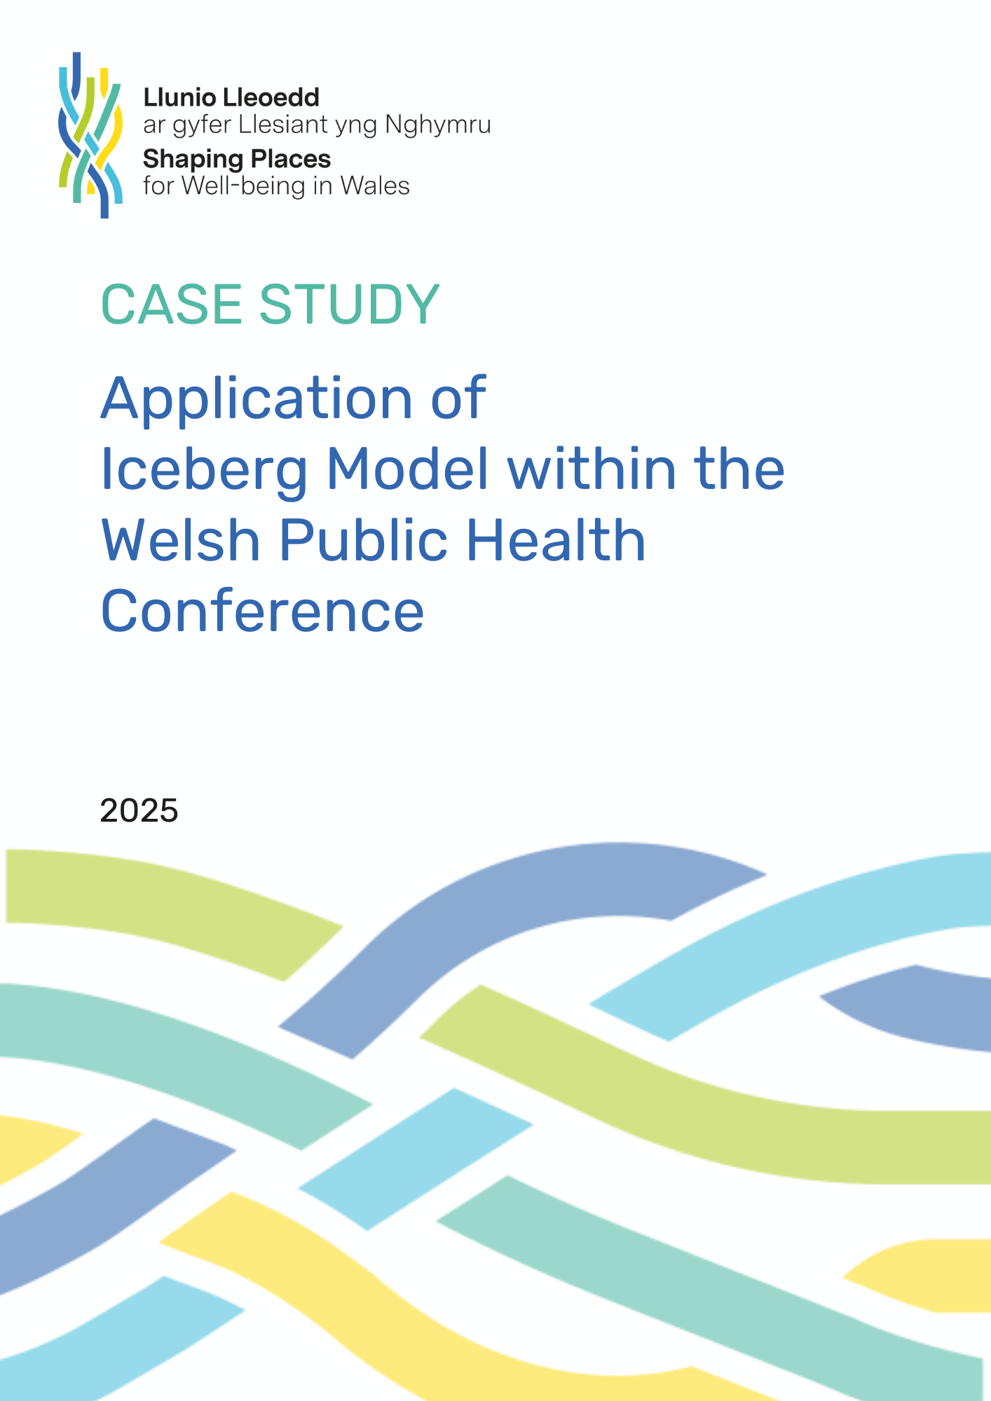

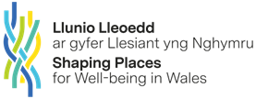


Iceberg Model Case Study
- Background / context
The Iceberg Model is a simple visual tool which can be used to explore a situation or system-of-interest, to illustrate how the surface-level events to which we often react, are underpinned by less visible patterns, structures, and beliefs. These less visible structures cause visible events to keep repeating.
- Situation
The Iceberg Model workshop was facilitated at the Welsh Public Health Conference in October 2025. The Welsh Public Health Conference was attended by around 400 delegates, with attendees from the public, private, academic and third sectors, with a theme of “action today, for a healthier nation tomorrow.”
The Wider Determinants of Health Unit and Shaping Places for Well-being in Wales team hosted a workshop in which 50 delegates had the opportunity to explore and gain experience of utilising systems thinking tools to explore ‘wicked’ issues.
The workshop; Looking beneath the surface of wicked problems: acting now for a healthier tomorrow, was designed to enable attendees to look at the root causes of ‘wicked’ issues, and to examine the degree to which they or their organisation could take action to address these issues, and to reflect upon how they could apply these tools in practice.
3. Approach
The session was introduced by Marie Brousseau-Navarro, Deputy Commissioner and Director for Health, Office of the Future Generations Commissioner. The Future Generations’ Office and Wider Determinants of Health Unit team have developed strong links through workstreams and the Shaping Places Programme respectively, to develop systems thinking capacity aligned to the five ways of working.
“Improving well-being in Wales now and for the long-term requires us to think and behave differently. The methodologies presented today will help do this exactly by identifying and targeting the root causes of our challenges and by enabling us to see clearly what we must do to influence outcomes. This aligns with the sustainable development principle mandatory for the public service in Wales.”
(Marie Brousseau-Navarro, Deputy Commissioner and Director for Health, Office of the Future Generations Commissioner, October 2025.)
Following a brief presentation and overview of ‘wicked’ problems, the Iceberg Model was explained. A health care facilitator from the Cardiff Third Sector Council, who is currently a member of the Shaping Places for Wellbeing in Wales Programme, presented a case study. He talked through his approach to working with third sector organisations, explaining how he uses the Iceberg Model to engage diverse perspectives, to ensure that stakeholder voices are represented in consultations.
In small groups, workshop participants were then asked to choose one of three ‘wicked’ problems which affect health and well-being: children being driven to school, disability employment, or continued traffic-related poor air quality in disadvantaged neighbourhoods. Through working collaboratively, participants practiced using the Iceberg Model to consider the different levels of the problem, from surface level down to the deepest mental models, beliefs and assumptions, which may be driving structures, process, patterns and surface level behaviour.
Delegates were then asked to work back up the model in reverse, considering interventions to address each of the issues.
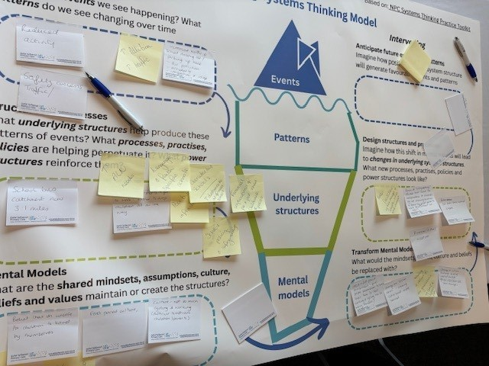
4. Feedback on using the Iceberg Model
Workshop participants were asked to describe their experience of using the model and any insights they had gained. Although most participants were new to using the Iceberg Model they reported finding it simple to use, insightful and helpful.

Using the model prompted deeper reflection on personal and professional influence, active citizenship, and advocacy. Participants recognised opportunities to effect change, explore root causes, and celebrate progress. The approach supported mindset shifts, highlighted structural versus perceived barriers, and reinforced the value of lived experience. It was seen as a practical tool for leadership, policy work, and knowledge mobilisation, encouraging flexible thinking and actionable solutions.

- Impact and influence

In addition to practicing using the Iceberg Model, at the end of the workshop several participants identified actions they were going to take forward. These included:

- advocating for policy changes, such as introducing food and cooking in schools
- Developing a co-production policy for Wales.
- Using the Iceberg Model in their work context (e.g. engaging GPs on social determinants, supporting Community Health Pathways, and incorporating the model into student training and interactive conference sessions)

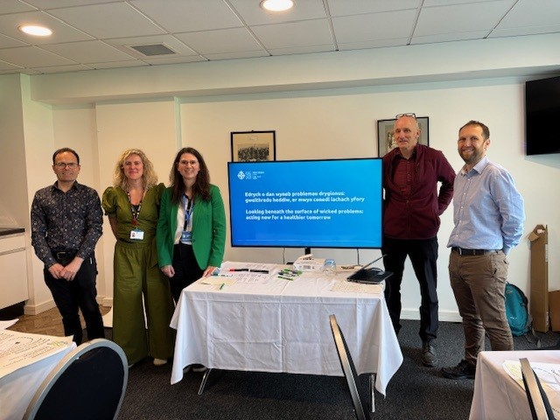

- Conclusion
This hands-on workshop provided an opportunity for professionals from across the public sector, voluntary organisations, academia, policy and practice to use a systems thinking tool to explore three ‘wicked’ problems and identify what processes, structure and mindsets would need to change to address these problems
- Link to resources:
Shaping Places for Wellbeing in Wales
An introductory systems thinking toolkit for civil servants - GOV.UK
Systems Practice Toolkit - NPC

