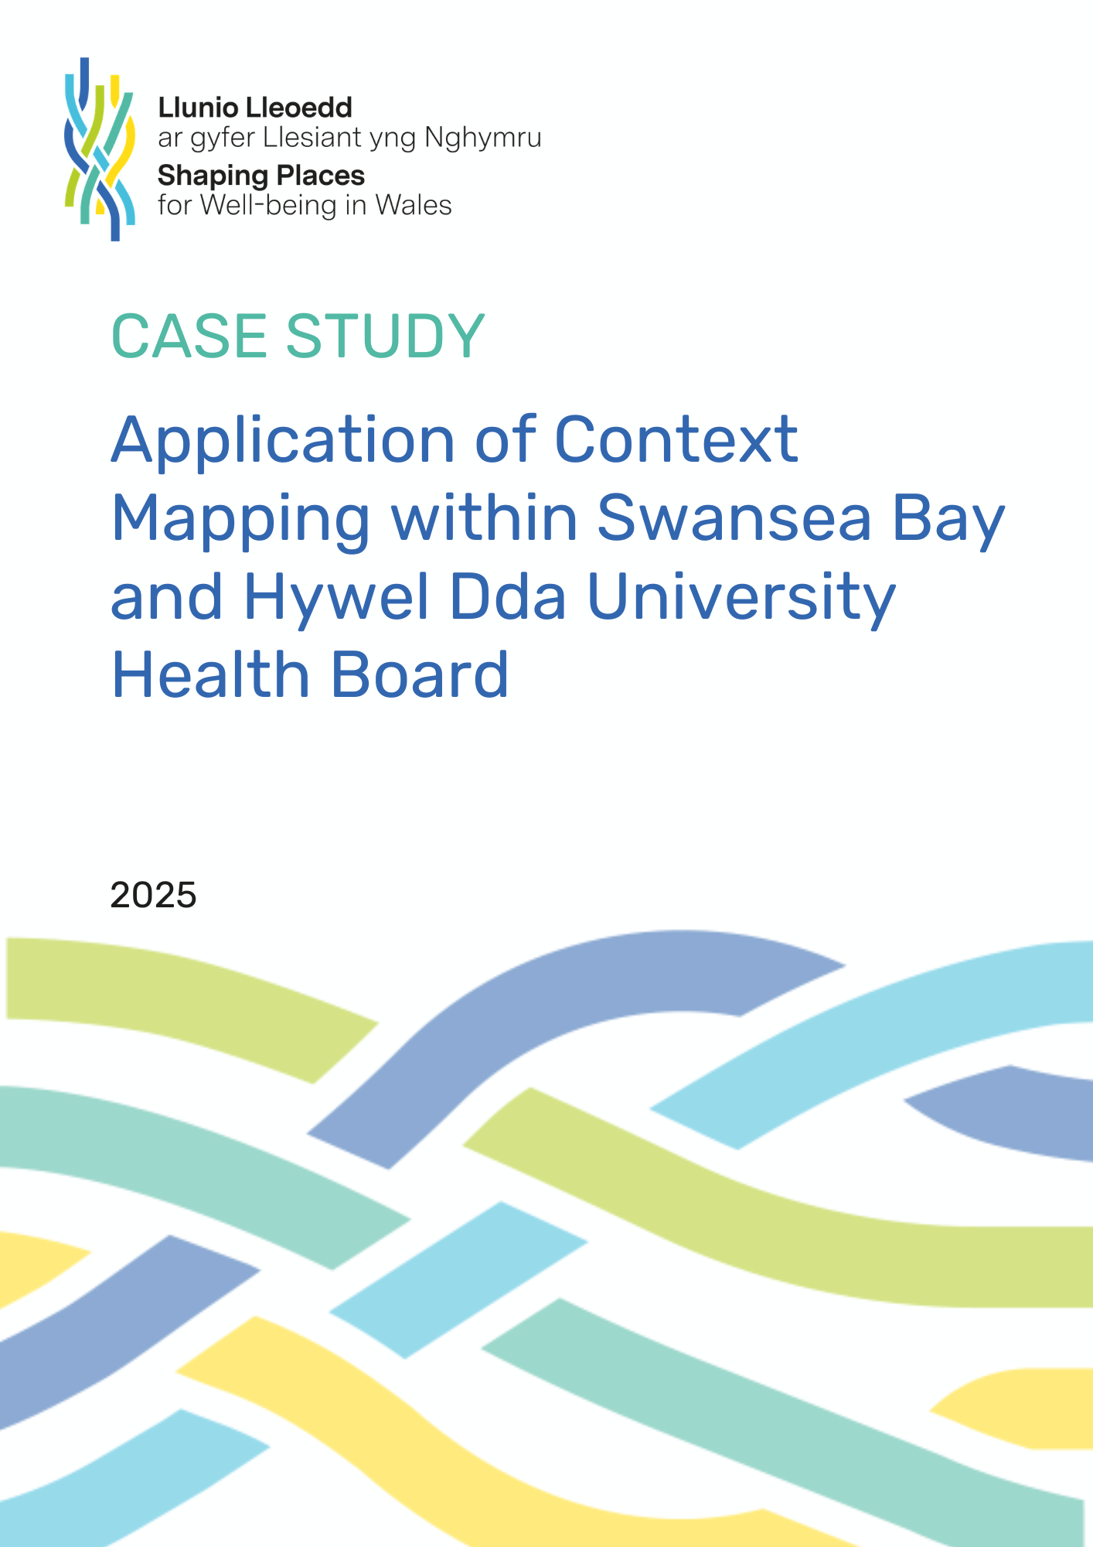
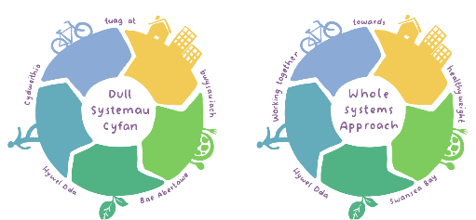
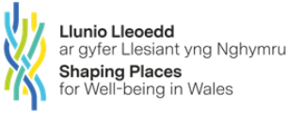

Case study: Context mapping / Sphere of influence

- What is context mapping?
Context mapping (also known as Sphere of Influence) is a tool that helps decision makers prioritise action on an issue by considering what is under their organisations or partnerships control. It can also help decision makers to consider other stakeholders they may need to involve where they do not have direct control.

- Situation
The Shaping Places for Well-being in Wales Programme supports learning group members across Public Services Boards (PSBs)in Wales, including members of the regional Whole Systems Approach to Healthy Weight team (HWHW WSA).
The HWHW WSA team works across the Swansea Bay and Hywel Dda University Health Board areas and implements the ‘Leadership and Enabling Change’ theme of the Healthy Weight Healthy Wales Strategy (2019). Over the past 18 months a series of workshops have been held with PSBs and key partners across the region through which access to food has been prioritised as an area of focus. In October 2025, the team facilitated a participatory workshop between Swansea and Neath Port Talbot PSBs to identify a defined area of focus within access to food, for both PSBs to collaborate and take action towards in coming years.

- Methodology / approach

The Shaping Places for Well-being in Wales programme developed an Applied Systems Thinking Approach Tools and Methods Guide which was utilised to inform the workshop design. Thirty-eight representatives from the PSBs participated in the workshop and were divided into four groups, each with a facilitator.. During previous workshops across the region, stakeholders have been asked “What would you like the food environment across the region to look like in 2050?” Based on insights received and in anticipation of the workshop, a draft illustration was developed and shared during session 1, for discussion and feedback. Following on from this, and as the second part of session 1, stakeholders were asked to identify enablers which they felt would help us to clarify the vision. An array of insightful input was collected, which was themed into 12 enablers. The Sphere of Influence systems thinking tool was introduced during session 2 and participants were asked to utilise the tool, to identify which of the 12 enablers were under the direct control of the PSBs, which they were able to influence, and which were important but could not be influenced by the PSBs. Across all four groups three enablers were identified which participants felt PSBs could directly control or influence.

- Feedback

The Sphere of Influence tool generated insightful discussion between stakeholders. Some of the four groups had placed the 12 enablers identified during session 1 in different areas of the sphere, which caused some people to be surprised. This generated curiosity and discussion amongst all, ensuring the diverse perspectives of participants were shared and heard. Using this systems thinking tool also provided a useful means of establishing a refined area of focus.

- Results

By utilising the Sphere of Influence, the 12 enablers were narrowed down to three [enablers] which were under the direct control or the PSBs can influence.
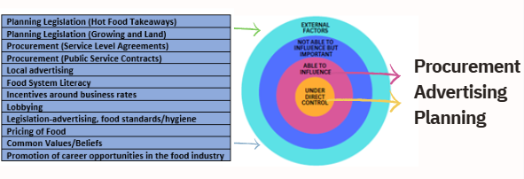

The Sphere of Influence tool contributed to establishing a refined area of focus during session 3, when participants were asked “What should the priority area of focus be for the PSBs in relation to access to food?” Participants were given three votes to spend as they wished on advertising, food procurement and/or planning, with food procurement receiving the most votes and agreed as the key, joint area of focus of the PSBs moving forward.

- Impact and influence
By using the Sphere of Influence, participants gained a greater understanding of the enablers for change and the level of influence that the PSBs has upon them. Activity following the event includes Neath Port Talbot and Swansea PSBs agreeing food procurement as a focus in their transition to a sustainable and resilient food system with nutritious food for all.

- Conclusion
The Sphere of Influence is a useful, relatively quick and easy systems thinking tool to use. Participants at the workshop seemed to like and understand its purpose, and its use facilitated the identification of an area of focus within access to food.

- Link to resources
Shaping Places for Wellbeing in Wales
Applied Systems Thinking Approach Tools and Methods Guide

