User Guide
This dashboard presents findings of The School Health Research Network’s (SHRN) Student Health and Wellbeing Surveys in Secondary Schools across Wales from 2017, 2019, 2021/22, 2023 & 2025. The dashboard allows users to view interactive charts and tables to visualise SHRN data down to a local authority level where possible. Users can download a full data download, images of the charts created, and a data download of the indicator selected.
Below is a user guide that explains the dashboard and its features accompanied by a working example.

Features of the Dashboard
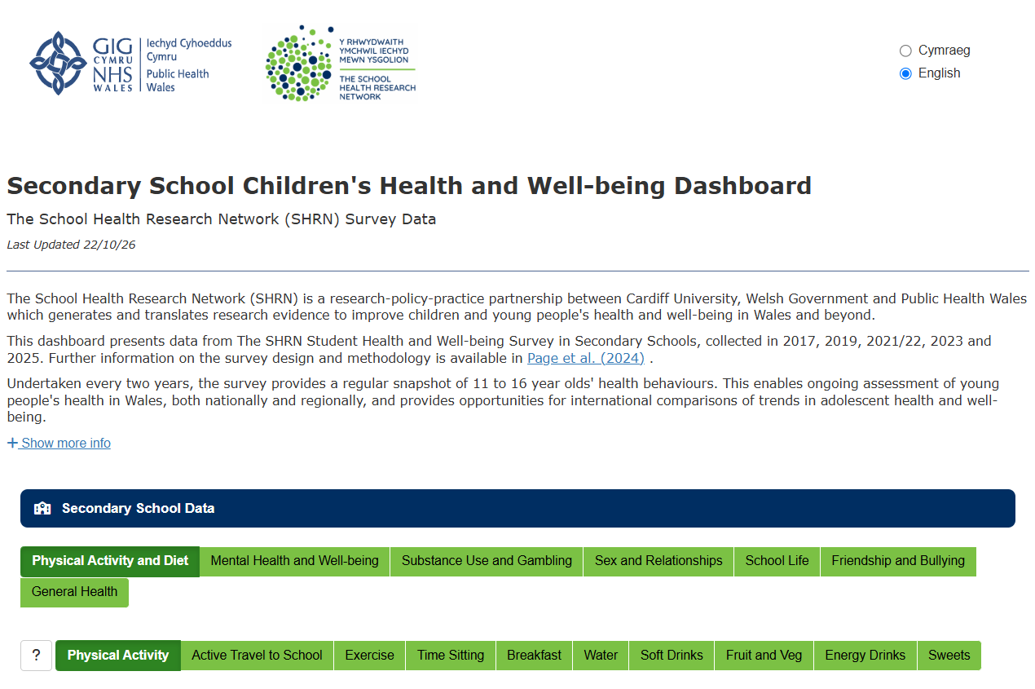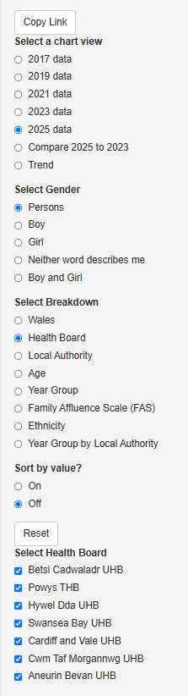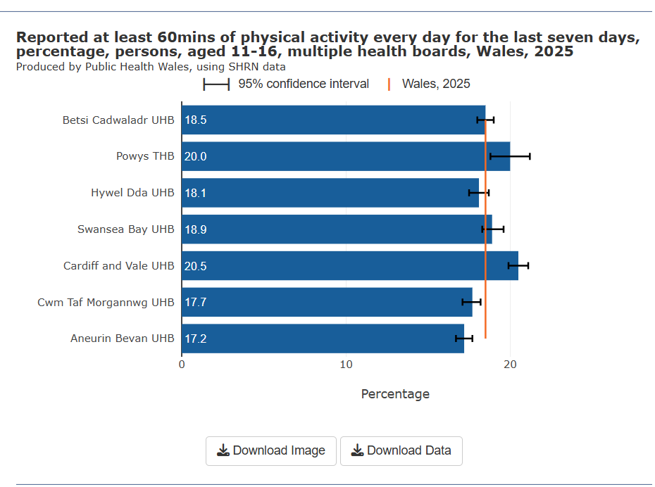
Select indicator
Select English or Welsh
Select topic
Copy link of the chart breakdown selection
Select Gender
Select single year, compare year or a trend here.
Select breakdown
Select which Breakdowns you want to display.
Download the Chart Image or Chart Data here.
Chart appears here.
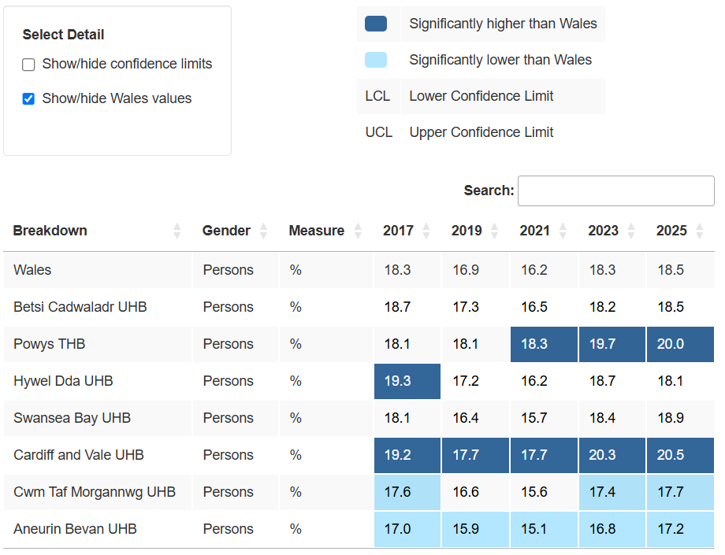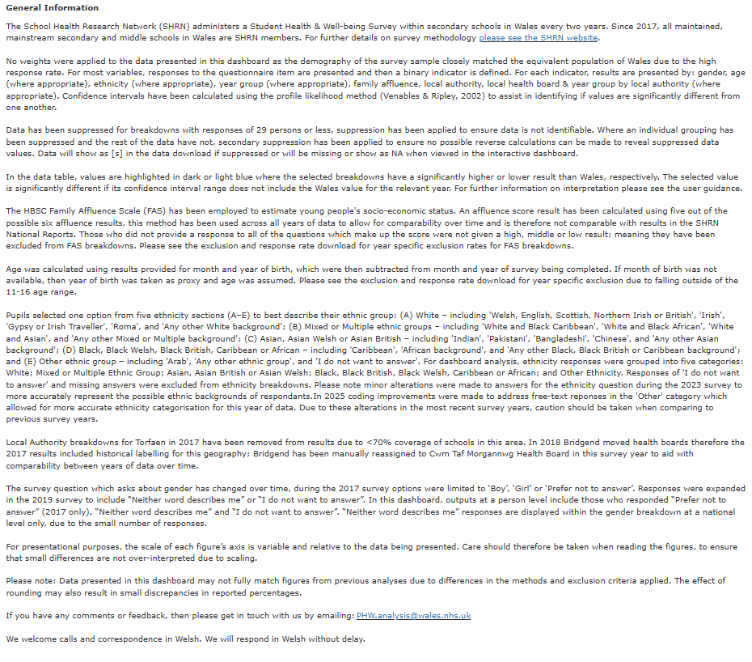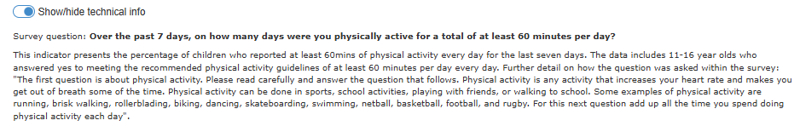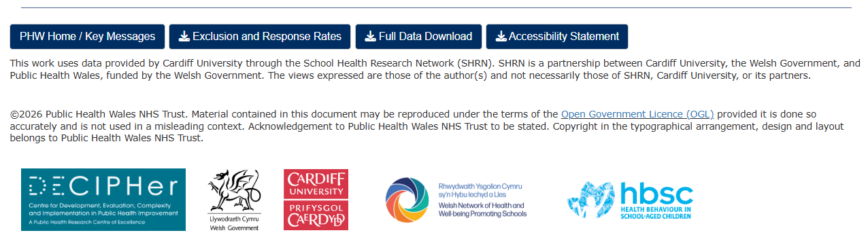
Table displaying data shown in the above chart.
Show/hide confidence limits and Show/Hide Wales values.
Technical guide can be found below
Buttons that link key messages, the accessibility statement, a download of exclusion and response rates, and a full data download.

Using the dashboard – Example:
Buttons linking to Key messages, Accessibility statement, an excel download of exclusion and response rates, and a full data download.
To look at how the amount of time sitting has changed over four survey years for males and females, while considering the impact of the Family Affluence Scale (FAS), follow these steps:
- Choose the right topic: At the top of the screen, click on the green tab labelled ‘Physical Activity and Diet’.
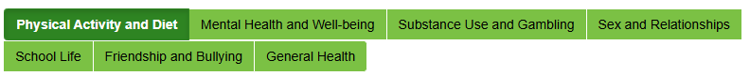
- Select the Time Sitting data: From the tabs below, click on ‘Time Sitting’.
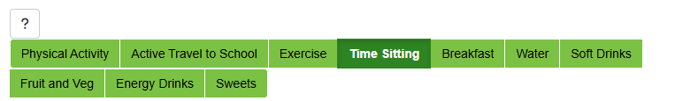
- View the data over time: On the left-hand side, under ‘Select a chart view’, choose ‘Trend’ to see changes over the years.
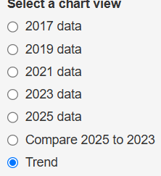
- Include both genders: In the ‘Select Gender’ section, pick ‘Boy and Girl’.
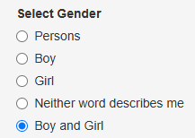
- Break it down by family affluence: Under ‘Select Breakdown’, choose ‘Family Affluence Scale (FAS)’ to look at how this factor influences the data.
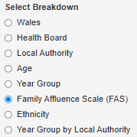
- Focus on high and low affluence groups: You will now see the Wales average line. To compare, tick the boxes for ‘High’ and ‘Low’ to display those groups.
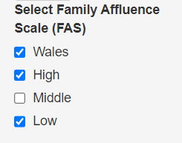
A chart should display:
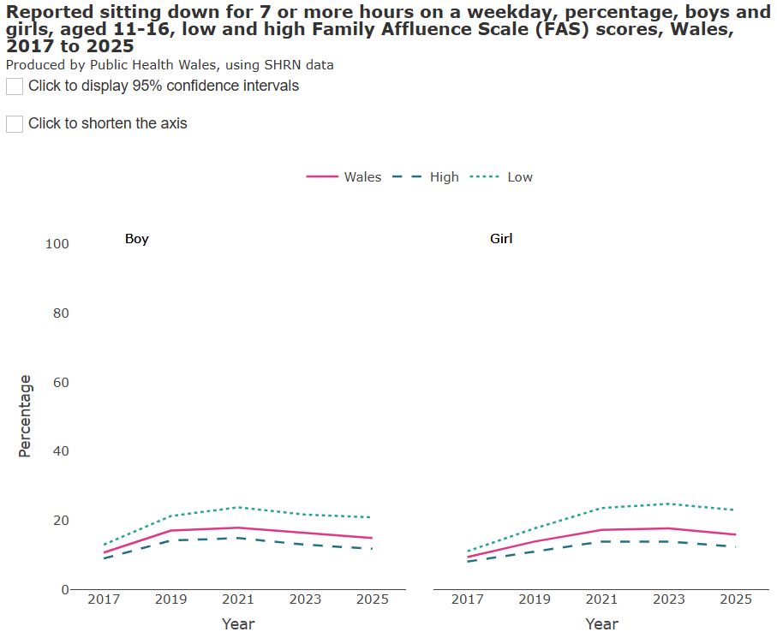
If you’d like to see confidence intervals, click the box in the top left of the chart.
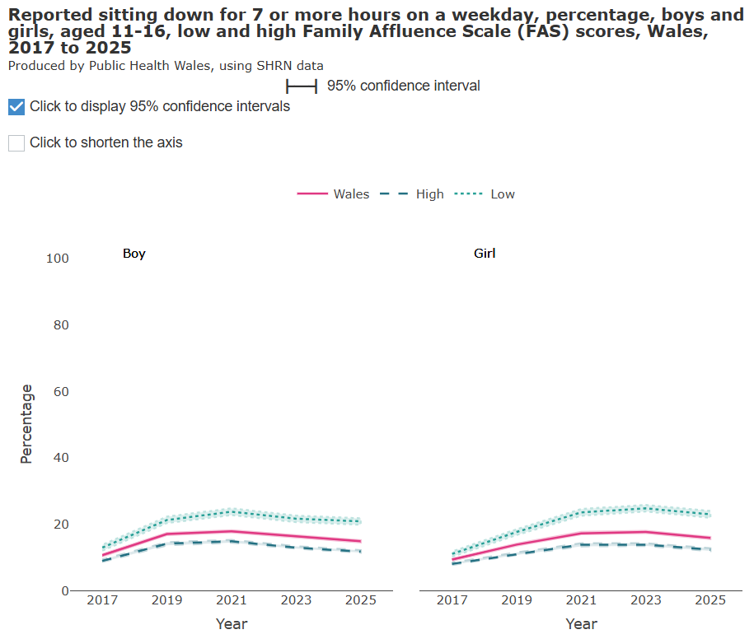
If you’d like to zoom into the trend chart, click the box in the top left of the chart labelled ‘Click to shorten the axes’. This shortens the percentage scale to less than 100% to assist with visualising differences between groups.
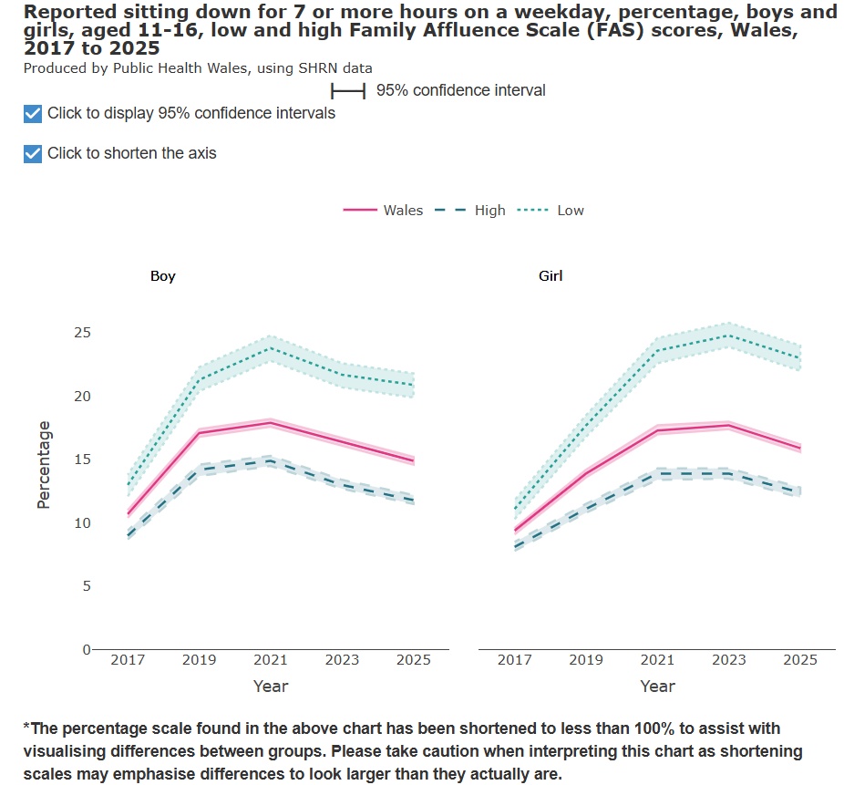
You can also double-click the chart to zoom in more. If you want to focus on a specific part, click and drag a box over that area. To go back to the normal view, double-click the chart again.
To caveat, zoomed in trend and bar charts can exaggerate trends and differences so always be cautious when showing or interpreting zoomed-in charts.
If you would like to focus on one line on the trend chart, you can unselect and select the lines you do or do not want on the trend chart directly from the chart legend. This will not affect the breakdown selection you made on the breakdown section.
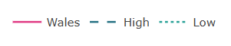
To try this out, unselect the ‘Wales’ and ‘High’ line from the legend by clicking on them.
You should be left with a trend chart with showing only the ‘Low’ FAS score. This is useful if you quickly want to spot check the specific line referring to your wanted breakdown without changing the original breakdown selection of your chart.
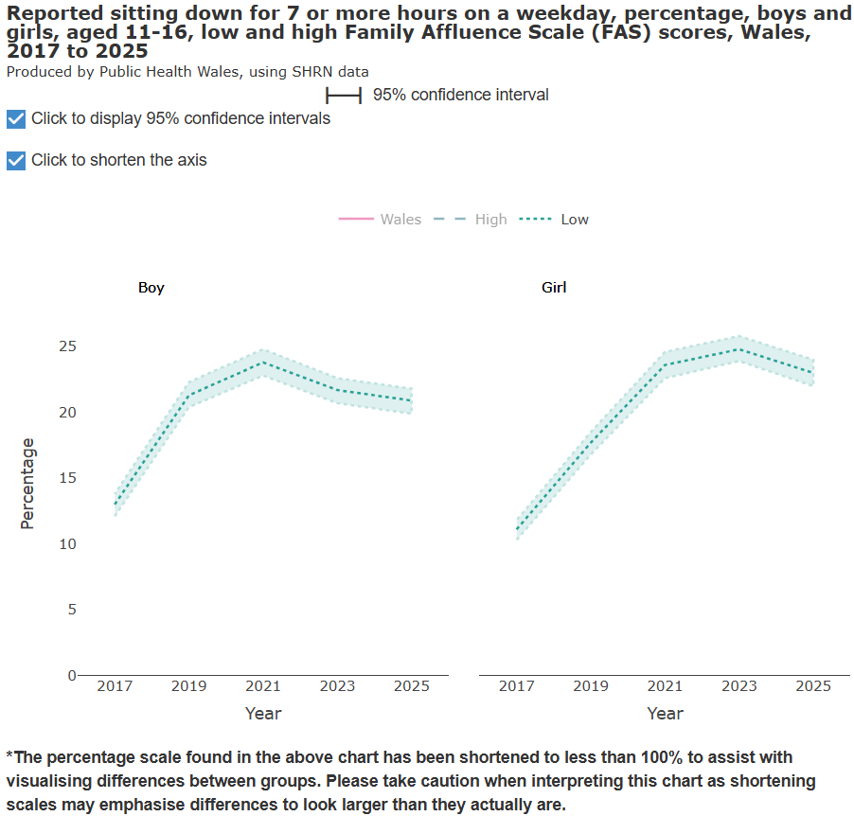
- Download the chart for your presentation: If you’d like to use the chart in a presentation, click the ‘Download Image’ button just below the chart.
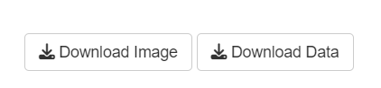
- Check the data more closely: Scroll down to view the full data table for more detailed numbers without having to leave the dashboard. By selecting the ‘Show/hide confidence limits’ tick box and deselecting the ‘Show/hide Wales value’ box, you can remove the Wales value and display the upper and lower confidence intervals.
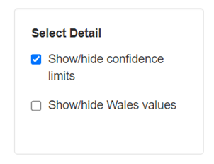
Example without Wales values and confidence intervals:
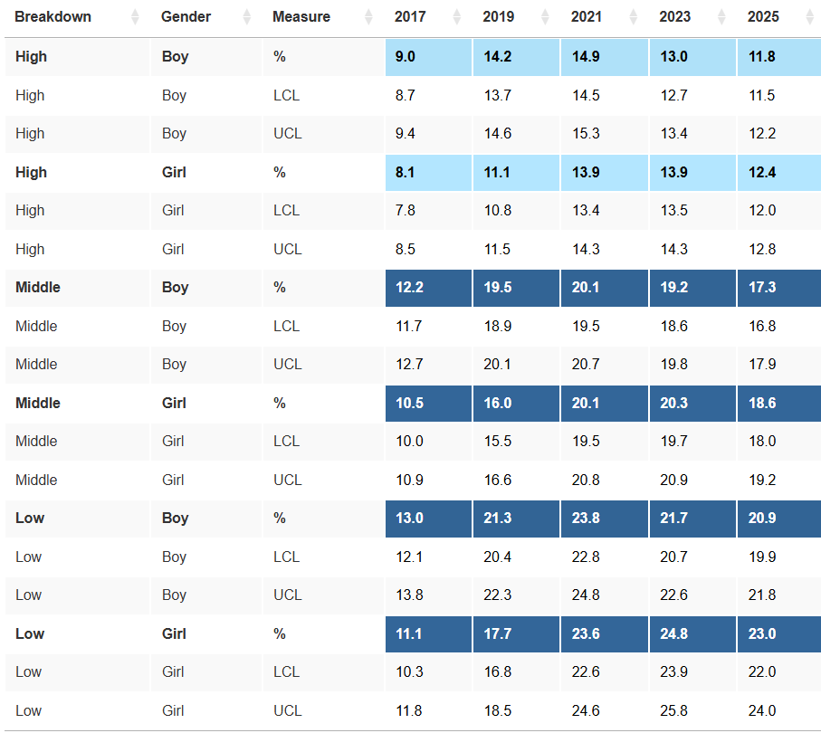
Example with Wales values and no confidence intervals:
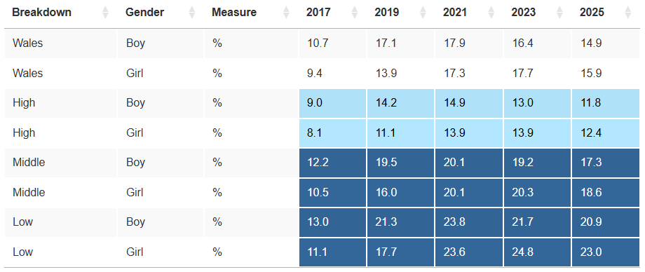

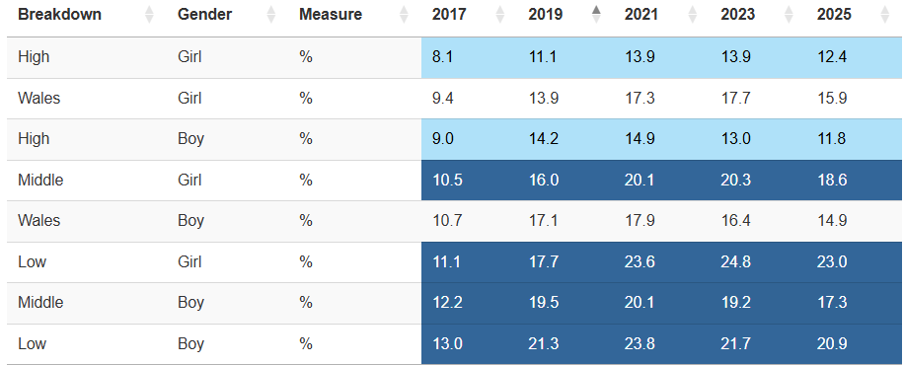You can also sort by value using the arrows highlighted below next to your chosen year.

Alternatively, you can download the data in an excel file, click the ‘Download Data’.

- Quickly share you’re the same chart you are viewing using the ‘Copy Link’ button: You can share a link to the chart and table you've selected so far - up to the point where you've chosen the 'Select Breakdown' option.
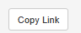
When you have pasted the URL link to your address bar, the below window will pop up. To take you to the same chart view, click on ‘Go to this view’.
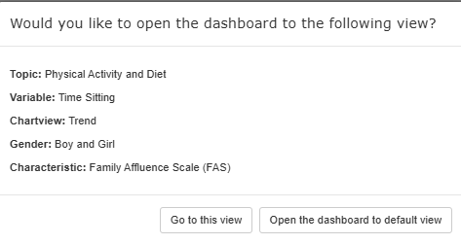
If you have any comments or feedback, then please get in touch with us by emailing: PHW.analysis@wales.nhs.uk

Dictionary:
Gender: Select whether you want to see data for persons, males, females, neither word describes me or both males and females. Gender is used in place of sex as this breakdown is based off a question asking about gender, not sex at birth. Please note due to small numbers, neither word describes me is only available for breakdowns at a Wales level.
Breakdowns: Choose how you’d like the data broken down and pick the specific areas you want to focus on.
- Geographies: Wales, Health Board and Local Authority level.
- Age: calculated using the results provided for month and year of birth, which were then subtracted from month and year of survey being completed. If month of birth was not available, then year of birth was taken as proxy and age was assumed.
- Year Group: The year group the student was in when participating in the survey.
- Family Affluence Scale (FAS): The HBSC Family Affluence Scale (FAS) has been employed to estimate young people's socio-economic status, based on a set of questions which measure the material conditions of the household in which young people live. An affluence score result has been calculated using five out of six of the affluence score results due to one of the six questions making up the scale result not being an appropriate measure in 2021 due to pandemic restrictions. This method has been used across all four years of data to allow for comparability over time and is therefore not comparable with results in the SHRN National Reports. Those who did not provide a response to all of the questions which make up the score were not given a high, medium or low result; meaning they have been excluded from FAS breakdowns. For more information on FAS, see here.
- Ethnicity: Pupils selected one option from five ethnicity sections (A–E) to best describe their ethnic group: (A) White – including 'Welsh, English, Scottish, Northern Irish or British', 'Irish', 'Gypsy or Irish Traveller', 'Roma', and 'Any other White background'; (B) Mixed or Multiple ethnic groups – including 'White and Black Caribbean', 'White and Black African', 'White and Asian', and 'Any other Mixed or Multiple background'; (C) Asian, Asian Welsh or Asian British – including 'Indian', 'Pakistani', 'Bangladeshi', 'Chinese', and 'Any other Asian background'; (D) Black, Black Welsh, Black British, Caribbean or African – including 'Caribbean', 'African background', and 'Any other Black, Black British or Caribbean background'; and (E) Other ethnic group – including 'Arab', 'Any other ethnic group', and 'I do not want to answer'. For dashboard analysis, ethnicity responses were grouped into five categories: White; Mixed or Multiple Ethnic Group; Asian, Asian British or Asian Welsh; Black, Black British, Black Welsh, Caribbean or African; and Other Ethnicity. Responses of 'I do not want to answer' and missing answers were excluded from ethnicity breakdowns. Please note minor alterations were made to answers for the ethnicity question during the 2023 survey to more accurately represent the possible ethnic backgrounds of respondents. In 2025 coding improvements were made to address free-text reponses in the 'Other' category which allowed for more accurate ethnicity categorisation for this year of data. Due to these alterations in the most recent survey years, caution should be taken when comparing to previous survey years.
- Year Group by Local Authority: This breakdown enables users to view survey results by both school year group and local authority. It has been included to maintain consistency with previous PDF reports, which featured this level of detail.
Caveat: Important considerations regarding the data contained in your selected chart will appear under the image.
A confidence interval (CI) gives a range of values within which we expect the true value to fall. In the data table, values are highlighted in dark or light blue in the data table where the selected breakdowns have a significantly higher or lower result than Wales, respectively. The selected value is significantly different if its confidence interval range does not include the Wales value for the relevant year. For example, if the 2021 Wales value is lower than the confidence interval range for a local authority in 2021 then the local authority value is significantly higher than the Wales value, the converse is also true for significantly lower than Wales values. If the confidence interval overlaps with the Wales value, then the difference is not significant and therefore not highlighted in the data table.

