Context
URGENT PRIMARY CARE PATHFINDER
Fact sheet 1

Policy

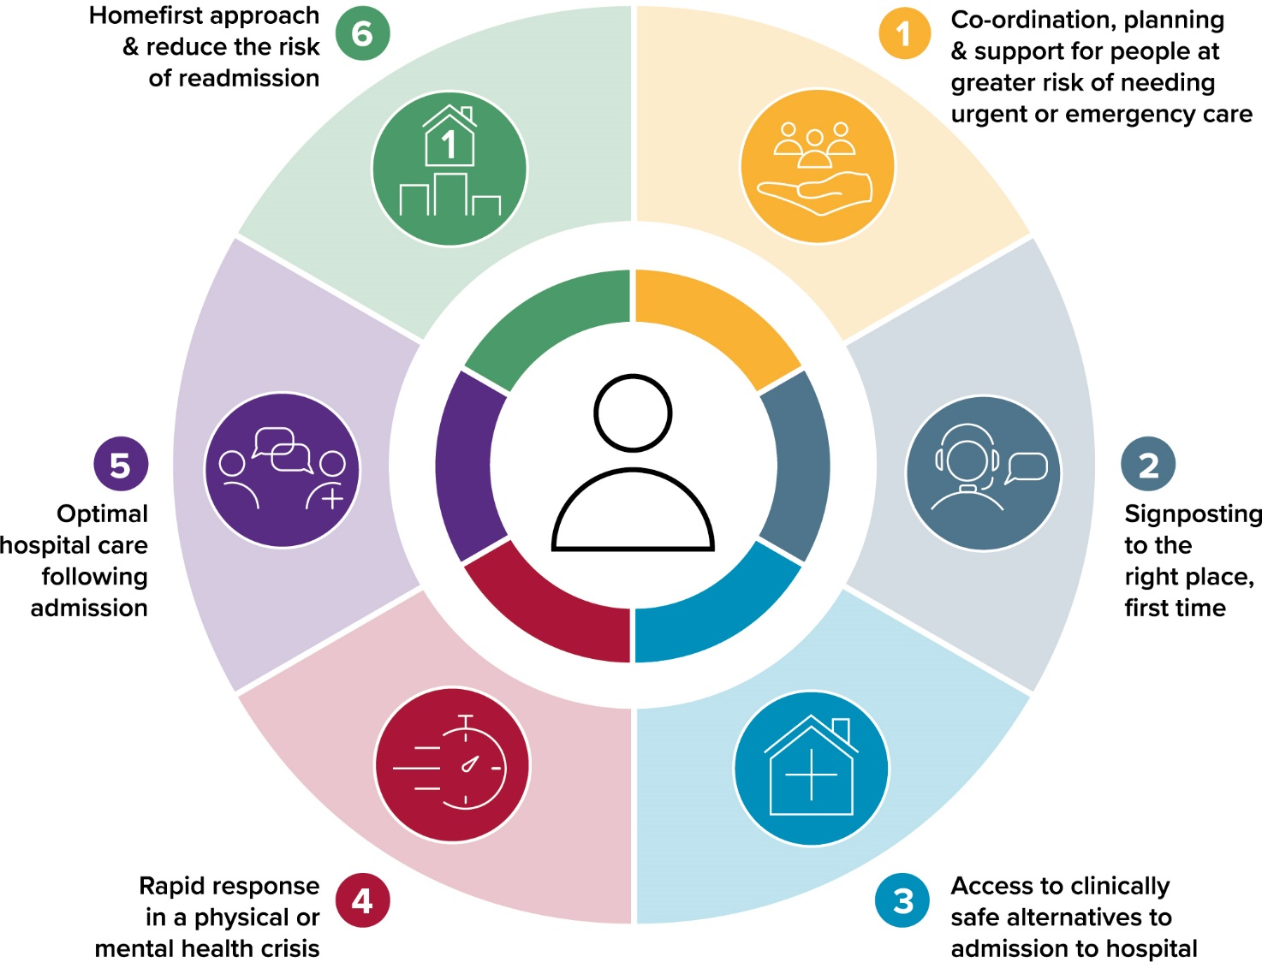

Illustration 1 – the six goals for urgent
and emergency care

The Welsh Government strategic aim is to provide the right care, in the right place first time for people who have a need for urgent or emergency care, through consistent delivery of ‘six goals’ (illustration 1).

This approach aligns with the commitments of Prudent Healthcare (2016), A Healthier Wales (2018), the Programme for Government (2021), and the National Clinical Framework (2021), delivering:

- A whole system approach where seamless support, care or treatment is provided as close to home as possible;
- Services designed around the individual and around groups of people, based on their unique needs and what matters to them, as well as quality and safety outcomes;
- A system where, people only present at or are admitted to hospital when it is essential, with hospital services designed to reduce the time spent in hospital;
- A shift in resources to the community that enable hospital-based care (when needed) to be accessed more quickly; and
- The use of digital change and technology to support high quality services.
Our vision for urgent and emergency care is also founded on the five ways of working, in the Wellbeing of Future Generations Act. They set out:

- A longer-term vision for designing an integrated urgent and emergency care model along with short to medium term action requiring collaborative planning across health, social care and the third sector to optimise outcomes;
- Public involvement, which has been key to shaping the six goals and will remain fundamental to the delivery of personalised care and the co-design of new models of care;
- A strong focus on preventive activity with the aim of keeping people well and maintaining independence.

Strategic Programme for Primary Care
The six goals approach seeks to encourage design, testing and scaling of models of care that enable people to prevent escalation of care and to access the right care, in the right place, first time. The Welsh Government will enable delivery through a £25m national six goals fund, connecting national programmes that will support delivery of the goals and establishment of four national enabling work-streams.
URGENT PRIMARY CARE PATHFINDER
Fact sheet 1

Policy

The Strategic Programme for Primary Care 24/7 Group (with system-wide representation) has identified the design of a 24/7 Urgent Care model as one of its priorities. This aligns to goals 1 - 3 of the six goals.

Changing demographics and patient behaviours has resulted in a year-on-year increase in patient demand, causing growing pressure on key points in the urgent and emergency care system. This additional strain can result in negative consequences for patient experience and outcome, and result in risk of potential harm.

In order to overcome some of these challenges, the Urgent Primary Care Centre ‘Pathfinder’ work seeks to enable people with urgent primary care needs to access advice, assessment and care closer to home and safely avoid the need to present elsewhere in the system. The aim is to provide a multidisciplinary primary care offering, enabling better management of demand, avoiding hand-offs and multiple entry points for a seamless, safe and positive patient experience.

For further information please contact: SPPC@wales.nhs.uk

This work is aligned with existing work streams including the national rollout of the 111 programme, the development of local remote streaming hubs or secondary points of access and same day emergency care.
Health Boards and clusters have developed two delivery models for the pathfinders allowing for local variation to meet the changing needs of the local population:

- Cluster or multi-cluster based urgent primary care centres delivered by local general practice workforce with some models linked to third sector mental health support; and

- 24/7 urgent primary care centres staffed by a mixture of professional staff with the appropriate skills.

The Welsh Government has recently allocated funding to health boards to further develop this work.

