Ref: | Proactive college/uni letter for new Students
Date: | Sept 2026
Private & Confidential
Name:
Address:

Post Code:

Dear Student,

Re: Your general health whilst studying at colleges and university in Wales

Welcome to your college and university studies. As you embark on the next chapter of your lives your health should be a priority whilst you study. We advise you to undertake the following steps before your starting date at college/university to keep yourself well.

- Register with a local General Practitioner (GP)/Doctor
It is important that you register with a GP (local family doctor) as soon as possible at your new town or city of study. Remember that registering with a GP and seeing them when you are ill is free of charge. GP Surgeries can also offer translation services if you need them.
Do not wait until you are unwell or need other emergency care to do this. A list of local GPs and advice about registering can be found at 111.wales.nhs.uk/localservices/gpinformation

- Check your vaccinations
You should have received:
- 1 dose of the Teenage 3-in-1 booster – which offers protection against tetanus, diphtheria and polio – usually given around 13/14 years of age
- 1 dose of the MenACWY vaccine – which offers protection against disease caused by meningococcal groups A, C, W and Y – usually given around 13/14 years of age.
- 1 dose of the HPV vaccine – which offers protection against human papillomavirus – usually given around 12/13 years of age
- 2 doses of the MMR vaccine – which offers protection against Measles, Mumps and Rubella – usually given before you start school
- For the 2026/27 academic year, all new students starting university or college for the first time and born on or after 21/7/2001, should receive two doses of the Meningococcal B (MenB) vaccine. This helps protect against meningococcal group B disease.
Some students may also require additional vaccines. If you think you may have missed any vaccinations, ask your doctor or local vaccination team to arrange this for you. Your local vaccine contacts are available icc.gig.cymru/cysylltiadau-brechu

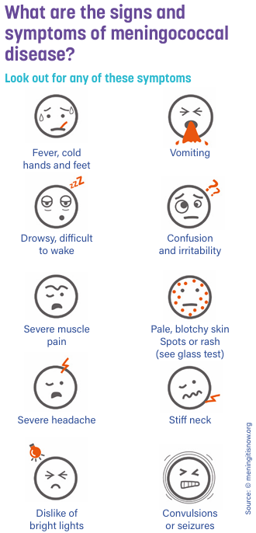
It is still important to know the signs and symptoms of meningitis and sepsis even if you are up to date with your vaccinations. This is because no vaccine is 100% effective and there are other bacteria that can also cause these illnesses.
The risk of getting an infection is greatest in the first few weeks of your first term, particularly for meningococcal infection. It is important that you are vaccinated at least two weeks before starting college or university as it can take a few weeks for your body to build protection.

Further information can be found at:
- icc.gig.cymru/brechlynnau/brechu-i-fyfyrwyr
- www.meningitisnow.org

- Be TB aware
If you have come to the UK from a country where there is a high prevalence of Tuberculosis (TB), then you may already have been referred for TB screening before travelling to study. You may need to provide proof of your TB health before your Visa application.
Further information can be found at www.gov.uk/tb-test-visa

You may have had a vaccination against TB, called the BCG vaccine. However, this does not provide 100% protection against TB. It is very important for you to be aware of the signs and symptoms of TB. These may include:
- Unexplained loss of weight
- Fever
- A general and unusual sense of tiredness and feeling unwell
- Loss of appetite
- Night sweats
- Cough (only with respiratory TB)
- Coughing up blood (only with respiratory TB)
If you have or develop any of these symptoms, it is important that you go to your GP for an urgent assessment. You can take this letter with you. Further information on TB can be found at www.tbalert.org

We wish you well in your education.

With many thanks,
Yours sincerely,

