Stakeholder analysis
The purpose of a stakeholder analysis is to outline the key stakeholders and their needs for the project. It is important to have a clear understanding of each stakeholder and what they are expecting from the project from the start.
Use the template below to assess each of your stakeholders to identify how you will engage and involve them through the life of the project.
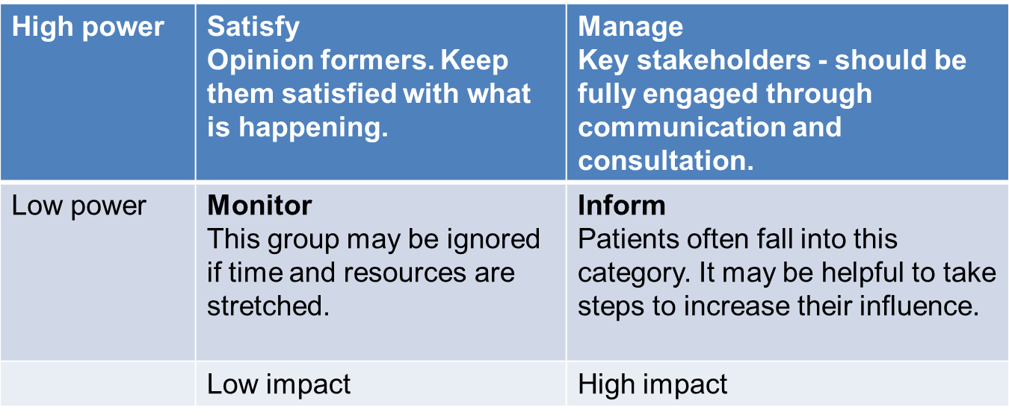
It is also worth working through this checklist to help with the process:

Managing stakeholders checklist
Identification | Notes
Who are the key stakeholders?

Which are internal and which external?

What information do you need to know about each stakeholder?

Where and how will you gather information?

What is their interest?

What do they want to gain?

How will the project affect them?

What knowledge can they contribute?

What is the stakeholders authority?

Could they adversely affect the project's progress?

How will the project affect their operations?

Once this information has been gathered you can execute the following action plan:
- Compile the list of stakeholders
- Assign responsibility of key stakeholders to project manager
- Assign responsibility of other stakeholders to team members
- Carry out regular review of stakeholder list and update accordingly
- Make sure all stakeholders have a list
- Arrange regular meetings with stakeholders to keep them informed of progress
- Make use of any appropriate skills or experience
- Include them in the decision-making process if appropriate

