


Healthy Days at Home Wales (HDAHW)

User Guide
November 2023
SECTION ONE: BACKGROUND PRINCIPLES
Agreed Principles of Data Collection for Healthy Days at Home Wales Suite of Measures.

Healthy Days at Home Wales (HDAHW) is a suite of population-based quality measures which can provide a way of measuring/comparing health and care systems across Wales and can also be adapted to reflect local priorities. The tool has already been validated in the US and the intention now is to use the principles and mechanisms to tailor it to the Welsh NHS and health care environment thus providing a whole system, whole national snapshot of population health.

Below are the key Principles used to develop the initial Healthy Days at Home Wales (HDAHW) suite of measures.
- Select an unremarkable year for the baseline (ideally pre Covid).
- Reporting set up to provide annual returns with an option for monthly returns where applicable.
- Minimum baseline data to be collected by all health boards included:
  - Mortality Days: Total number of days in the target year after an individual has died.
  - Inpatient Days: Total number of days an individual has been admitted to hospital for, this includes short stays such as Medical Assessment Units, Step up/Step down encompassing all community bedded units, community hospitals and individually commissioned beds, clinical decision units as well as long term admissions.
  - Home Health Visits: (If not available weight as zero) This includes profession specific and multi-professional scheduled and unscheduled visits i.e., rapid assessments. Encompassing district and community nurse attendances, Frailty assessments and Community Resource Team visits etc.
  - Emergency Department Visits: The number of attendances recorded at Accident and Emergency and/or Minor Injury Units in the target year. Each attendance counts as a day unless the overall attendance exceeds 24 hours in which case the hours round up to days.
  - NHS Number: (Collected where available) Individual anonymity is maintained as this information is for data collection purposes only and will not be visible on the HDAHW dashboard.
  - GP Practice: To enable trend mapping which may support future commissioning of services. Limited access to this level of granular detail may be available for specific dashboard users.
  - Cluster: To enable trend mapping which may support future commissioning of services and support evaluation exercises for collaborative Cluster working and development.
  - Age: To enable trend mapping for identification of age-related themes and support commissioning of services where suitable.
  - LSOA: Reporting the individuals’ level data against Lower Layer Super Output Areas will improve reporting of small area statistics for comparison against larger demographic areas.
  - WIMD: Reporting the individuals’ level data against the Welsh Index of Multiple Deprivation will improve reporting of trend mapping in relation to socioeconomic factors.
- The local dashboards hold the same baseline data as the national dashboard.
- Sources for the ten baseline data elements (noted above) to be identified and links established.
- Health Boards may wish to collect additional data to support local population-based planning.
- A system with a HDAHW score of +365 – would suggest that for the total population, NO treatment or care received by residents occurred outside of their home.
- A system with a HDAHW score of -365, would suggest that for the total population, EVERY DAY involved some form of treatment or care outside of their home.

Principles of Weightings for Healthy Days at Home Wales Suite of Measures.

- Days are counted as whole numbers, not fractions or decimals.
- Where more than one event occurs in one day, only 1 event will be counted and the intervention with the highest negative rating applies (see points 4 to 6) However in some cases it may not be possible to separate the two interventions (eg Outpatient Department appointment followed by emergency hospital admission).
- A ‘weighting’ is the multiplication factor applied to the number of days attributed to a specific component of the formula.
- A weighting can be positive or negative:
- Positive weighting suggests desirable outcome for the individual.
- Negative weighting suggests a less desirable outcome for the individual.
- A weighting can be an integer or a decimal: e.g., +2, -1.6, or +0.5

The choice of Weighting Model to be applied to the information within the Healthy Days at Home Wales Dashboard is flexible and at the discretion of the end-user. The Dashboards come pre-loaded with 4 of the example weightings noted on the next page but in reality, the filters and weightings can be adjusted by the end-user to present the Healthy Days at Homes Wales score against the weightings desired by the user, and this will be reliant on the question the user wants answered.

For example,

Does the user want to see a generalised Healthy Days at Home Wales score based purely on how many days in a 365 reference period a citizen did not require any interventions whatsoever, in which case they would select the basic formula of -1 for ANY intervention.

If the user wants to compare Healthy Days at Home Wales scores before and after application of a new initiative or service as part of an evaluation exercise to see if the intervention put in place has actually had a positive impact on the Healthy Days at Home Wales scores of the citizens in a particular demographic. Then they would use a formula which positively weights the preferred intervention.

The applications of this resource are endless and can cover all aspects of health and wellbeing across the whole system not just primary ad community settings.

Use of the word ‘Healthy’

Please note: the use of the word’ Healthy’ is in deference to the original Healthy Days at Home US Model and in no way assumes a day without health interventions is a healthy one.

The HDAHW suite of Measures has been developed using a ‘good enough’ approach and with this in mind it is noted that the HDAHW scores should not be used in isolation as a method of gauging population health but rather as part of a myriad of tools to answer the questions being asked by the user.

Examples of Weighting Models that could be applied:

Model 1: USA Model
The original formula published in the peer reviewed article, consisting of components with their original weightings.

What does this tell us? This is the published formula fitted to the US healthcare system.

Model 2: Crude USA/Wales Model
The service components of the original formula published in the peer-reviewed journal mapped to the Welsh service equivalents, and these given the same weightings as in the USA model.

What does this tell us? This reports the published formula as applied to services to Wales, and whilst may provide comparisons with the USA system, the difference in services reflects the different priorities of an insurance system versus NHS Wales
Model 3: Crude Welsh model with negative weightings
The service components of the original formula published in the peer-reviewed journal mapped to the Welsh service equivalents, and these weighted on the basis that any intervention is negative (including interventions delivered at home)

What does this tell us? The report reflects the effectiveness of the system to support a population to stay at home without intervention
Model 4: Crude Welsh model with mixed weightings
The service components of the original formula published in the peer-reviewed journal mapped to the Welsh service equivalents, and these weighted on the basis that any intervention in hospital is negative, and any intervention delivered at home is positive.

What does this tell us? The report reflects the effectiveness of the system to support a population to stay at home with community interventions
Model 5: Crude Welsh model with positive community integers
The service components of the original formula published in the peer-reviewed journal mapped to the Welsh service equivalents, and these weighted on the basis that any intervention in hospital is negative, and any intervention delivered at home is a positive integer.

What does this tell us? The report reflects the effectiveness of the system to support a population to stay at home with community interventions valued as equivalent to Healthy Days
Model 6: Localized model with additional variables and/or weightings to suit local circumstances
The service components of the original formula published in the peer-reviewed journal mapped to the Welsh service equivalents, plus any new variables relevant to local inquiry, and these weighted according to local opinion.

What does this tell us? The report reflects the effectiveness of the system to support a population to stay at home with community interventions valued as agreed locally

SECTION TWO: DASHBOARD APPLICATION AND NAVIGATION

How to apply the dashboard to Local Health Board Data

The Healthy Days at Home Wales Health Board Dashboards have been developed locally following a Power BI template, a table definition, and screenshots of the schema of the prototype developed by Swansea Bay University Health Board. The location of the underlying data associated with the reports was identified and constructed following the dataset description below.

Dataset description:

- Year: year where the intervention occurred
- Normalized population: direct method of standardization for the age-group adjusted rate per 1,000 population: Formula = (population in LSOA per age band / total population in LSOA) * 1000

- Patient’s information:
  - Anonymized NHS number
  - Sex: Male, Female, Not specified
  - Age
  - Age band: <16, 16-18, 18-65, 75+
  - Post code

- GP practice information:
  - GP practice: code of the last GP practice where the patient was registered in that year.
  - GP practice name
  - Cluster

- Deprivation information:
  - Wimd 2014: wimd index of the Welsh Index of Multiple Deprivation (update 2014)
  - Wimd rank for the specific health board.

- Location information:
  - Electoral ward code
  - Output area
  - Country
  - Unitary Authority
  - LSOA code
  - LSOA name
  - LSOA ONS name
  - LA area wimd: Local area
  - Latitude
  - Longitude
  - Easting
  - Northing
  - Gridref

- Healthy Days at Home components:
  - Mortality days
  - Inpatient days
  - Emergency department visits
  - Community Intervention days
  - Step up / Step down days.
  - HDAHW: calculated column. Formula: HDAHW = 365 - (inpatient days + emergency department visits + mortality days + community intervention days + step-up/step-down days)

Calculated Measures:
- Weighted HDAHW. Formula: HDAHW = 365 - ([inpatient days * weight] + [emergency department visits * weight] + [mortality days * weight] + [community intervention days * weight] + [step-up/step-down days * weight])
- Average weighted Community intervention days
- Average weighted ED visits
- Average weighted Inpatient days
- Average weighted Mortality days
- Average Step up / Step down days
- Average HDAHW: average of HDAHW using current filters.
- Avg: average of HDAHW excluding filters.
- Measures for the SPC control chart:
  - Total HDAHW moving range.
  - Total LCL
  - Total UCL
  - Total XMR

How to use HDAHW Dashboards from an end user point of view

The Healthy Days at Home Wales dashboards can only be accessed once the dashboard owner has granted permission.

Requirements:
- Internet connection
- Latest version of Microsoft Edge or another compatible internet explorer

All the dashboards are comprised of standard pages including; Cover page, Formula page and an Overview page. When the user loads the dashboard of choice, the Cover page will show in the screen as below (example – National HDAHW Dashboard).

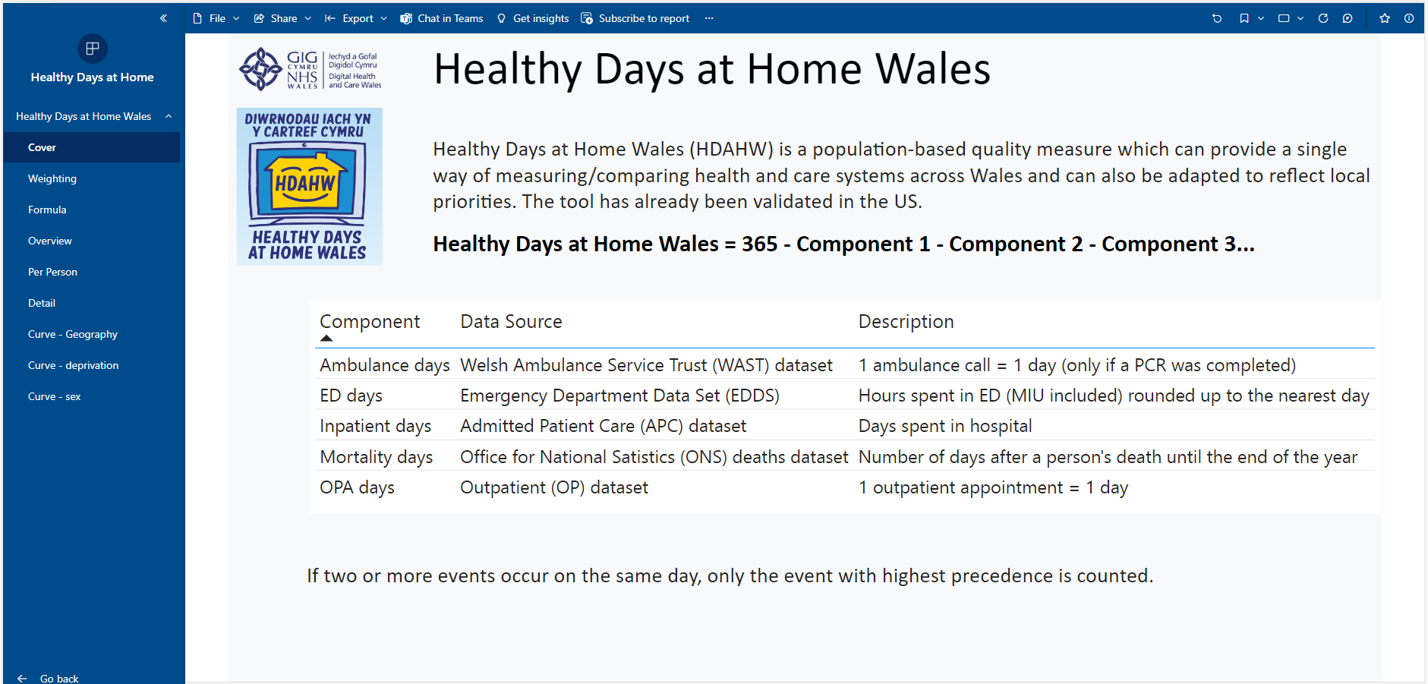

To access each of these pages, go to the Pages panel at the left of the screen, and click on the specific page you want to view. Below is a summary of the standard pages.

Cover page
This page contains information about the calculation of the Healthy Days at Home Wales and the specification of each of its variables or components. It also contains a list of observations and caveats.

Formula page
This page outlines the pre-set formulas as nationally agreed and the weightings. These weightings can be adjusted by moving the toggle against each component.

Overview page
This is the main page of the dashboard on which the user can visualize the impact that different weightings have on the score. Once again, the toggles are available and if adjusted a warning notice appears to flag this.
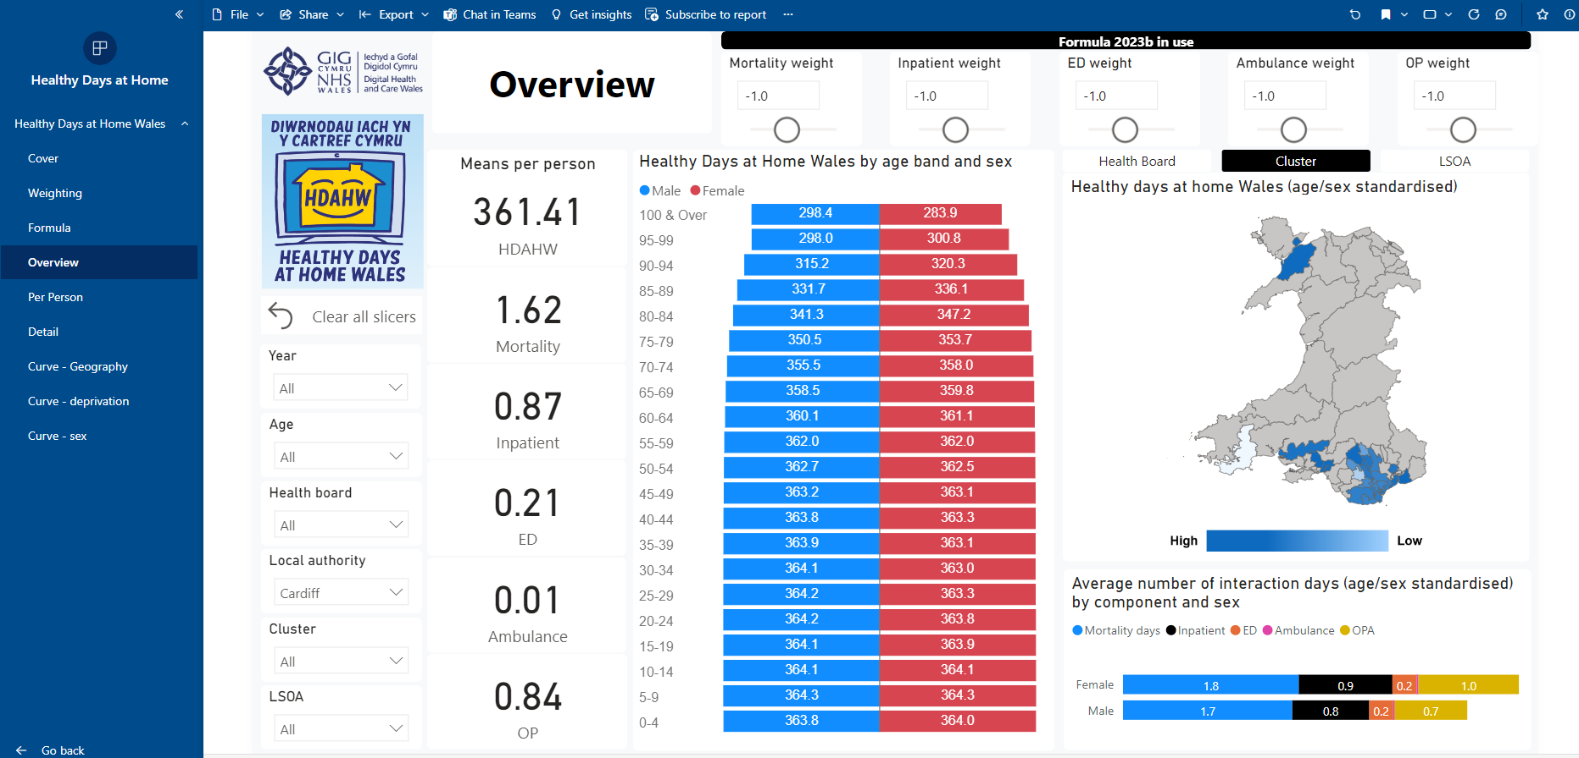

Page Components:

Slicers allow the user to manipulate the view to suit their needs.

- Year selector: calculates the Healthy Days at Home Wales score based on the interventions which happened in the year selected. By default, this is set to three years.
- Age selector: filters the population based on the selected age groups. By default, the system selects all the population for the visualizations.
- Health Board selector: filters the population based on the selected Health Board area. By default, the system selects all the population for the visualizations.
- Local Authority selector: filters the population based on the selected Local authority. By default, the system selects all the population for the visualizations.
- Cluster selector: filters the population based on the selected Cluster. By default, the system selects all the population for the visualizations.
- LSOA selector: filters the population based on the selected Lower Super Output Area. By default, the system selects all the population for the visualizations.
- Means per person: Displays the average of the HDAHW score and the weighted HDAHW measure. This is useful to visualize the overall change of the variable weightings over the HDAHW.
- The Age and Sex chart: visualizes the number of patients per age groups and sex and it interacts with the selected age groups in the Age selector and the selected region in the map. This chart is useful to visualize the distribution of the population groups.
- Map: visualizes the variation of the Healthy Days at Home Wales in each are dependent on the slicers or views applied. Darker colors represent higher HDAHW while lighter colors represent lesser HDAHW. Gray color are locations where there is no data to display.
- On hover, the map shows the Cluster or Health Board area, the average of the actual weighted and Standardised HDAHW score, calculated based on the selected weightings.

]
Health Board Healthy Days at Home Wales Dashboards

The Health Board Healthy Days at Home Wales Dashboards will vary in visualization but maintain the same baseline, national agreed formulas.

Access to Health Board Healthy Days at Home Wales Dashboards is based on the user being an employee of/or holding a NADEX for that Health Board.

Information presented on the Health Board Healthy Days at Home Wales Dashboards may be more detailed than the National Days at Home Wales Dashboard in which case there may be slight variation in the scores. There is also a ‘sandbox’ facility in the Health Board Healthy Days at Home Wales Dashboards to enable new data sets and formulas to be tested out in a safe environment with the opportunity to present to the National Healthy Days at Home Wales Project Group for possible national implementation.

And Finally

The Healthy Days at Home Wales Dashboards are expected to evolve. As they are used and applied, and more data sets and formulas are added, the suite of measures will become more nuanced and adaptive to answer the questions the users want to pose in the future.

Acknowledgements:

Dr Alastair Roeves National Clinical Lead for Primary and Community Care
Divya Christopher Business Intelligence Partner, SBUHB
Sara Garcia Advanced Information Analyst, SBUHB
Rhian Dawson County Director for Carmarthenshire, HDUHB
Chiquita Cusens National Nursing Lead for Primary and Community Care
Kerrie Phipps National AHP Lead for Primary and Community Care
Samantha Jeffries Project Manager, Strategic Programme for Primary Care

