Assessment of risk

A risk assessment matrix is a tool used to assess the risks during your project planning phase of the project. It is used to identify and capture the likelihood of project risks, as well as to evaluate the potential damage or interruption caused by those risks.

The matrix provides a visual representation of the risk analysis and categorises risks based on their level of probability and severity or impact. This tool is a simple, effective way to get an overview of the project risks in a way that’s easily understood by all team members and key stakeholders.

The first step in developing a risk matrix is to make a list of all the likely risks you can identify in your project. The next step is to take the list of risks and add the likelihood that the risk may occur. In the example below, risk likelihood is divided into five categories:
- Certain – definitely will happen
- Likely – likely to happen
- Moderate – some chance of happening
- Unlikely – small chance of happening
- Rare – not at all likely to happen

Next, look at each risk and determine its impact to the business if it were to happen. Risk impact can be divided into four categories:
- Catastrophic organisation may not recover
- Major - causes major disruption to the organisation
- Moderate – organisation is affected but no major disruption is caused
- Minor – effects are felt but do not seriously affect the organisation
- Insignificant – little to no effect on the organisation

Based on the likelihood and impact of each risk. place each risk into a Risk Matrix and give a score based on the multiplication of the impact and likelihood.

Example of a risk matrix
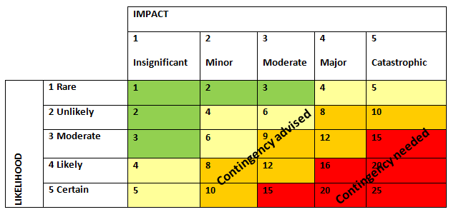

A template risk matrix for completion along with a risks and issues log can be accessed here

