[Date] NHS Number:
Address Line 1
Address Line 2
Address Line 3
Address Line 4

Dear [Name]

You are due for your COVID-19 and flu vaccinations

[Add appointment information here]

If you cannot attend or have any questions about your appointment, you can:
- Phone us on (XXXX) between (insert working hours)
- Email us at (XXXX@wales.nhs.uk)
Rydym yn croesawu e-byst a galwadau ffôn yn Gymraeg. Byddwn yn ymateb yn Gymraeg yn ddi-oed. We welcome emails and phone calls in Welsh. We will respond in Welsh without delay.

Why are these vaccines important?
COVID-19 and flu are viruses that can lead to serious illness and even hospital care. Getting vaccinated is a simple and safe way to protect yourself and the people around you.

Why am I being invited for these vaccinations?
You are being offered the COVID-19 and flu vaccines because you are in a group at higher risk of becoming seriously ill from these viruses. To see the full list of who is eligible, please visit:
- phw.nhs.wales/fluvaccine
- phw.nhs.wales/covidvaccine

Even if you’ve been vaccinated before, your protection fades and virus strains change over time. That is why you’re being invited for another dose.

Do the vaccines work?
The vaccines are safe, effective and can help make these illnesses milder if you do catch them. Millions of doses of the COVID-19 and flu vaccine have been safely given in the UK.

Please make every effort to attend your appointment to stay protected this autumn and winter.
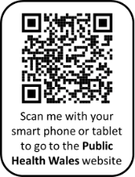
If you would like more information, you can:
- visit the Public Health Wales (PHW) website at
phw.nhs.wales/vaccines
- scan the QR code;
- speak to the healthcare staff at your appointment; or
- visit the [Health Board] website at [insert web link]

Yours sincerely,
The Booking Team
[Date] NHS Number:
Address Line 1
Address Line 2
Address Line 3
Address Line 4

Annwyl [Name]

Mae'n bryd i chi gael eich brechiadau ffliw a COVID-19

[Add appointment information here]

Os na allwch fynd i’ch apwyntiad neu os oes gennych gwestiynau am eich apwyntiad, gallwch:
- Ffonio ni ar (XXXX) rhwng (insert working hours)
- Anfon e-bost atom (XXXX@wales.nhs.uk)
Rydym yn croesawu e-byst a galwadau ffôn yn Gymraeg. Byddwn yn ymateb yn Gymraeg yn ddi-oed.

Pam mae'r brechlynnau hyn yn bwysig?
Mae’r ffliw a COVID-19 yn feirysau sy’n gallu arwain at salwch difrifol a hyd yn oed at ofal ysbyty. Mae cael eich brechu yn ffordd syml a diogel o amddiffyn eich hun a'r bobl o'ch cwmpas.

Pam rydw i'n cael fy ngwahodd i gael y brechiadau hyn?
Rydych chi'n cael cynnig brechlynnau ffliw a COVID-19 am eich bod mewn grŵp sydd mewn mwy o berygl o fynd yn sâl iawn oherwydd y feirysau hyn. I weld y rhestr lawn o bwy sy'n gymwys, ewch i:
- icc.gig.cymru/brechlynffliw
- icc.gig.cymru/brechlyncovid

Hyd yn oed os ydych wedi cael eich brechu o'r blaen, bydd eich amddiffyniad yn pylu a bydd mathau’r feirysau'n newid dros amser. Dyna pam eich bod yn cael eich gwahodd am ddos ​​arall.

Ydy'r brechlynnau'n gweithio?
Mae'r brechlynnau'n ddiogel, yn effeithiol a gallant helpu i wneud yr afiechydon hyn yn rhai ysgafnach os byddwch yn eu dal. Mae miliynau o ddosau o frechlynnau ffliw a COVID-19 wedi cael eu rhoi'n ddiogel yn y DU.

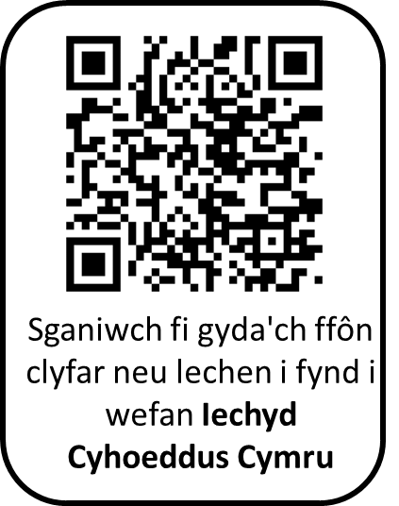
Gwnewch bob ymdrech i fynychu'ch apwyntiad i gynnal eich amddiffyniad yr hydref a'r gaeaf hwn.

Os hoffech ragor o wybodaeth, gallwch wneud y canlynol:
- mynd i wefan Iechyd Cyhoeddus Cymru (ICC) yn
icc.gig.cymru/brechlynnau
- sganio’r Cod QR;
- siaradwch â'r staff gofal iechyd yn eich apwyntiad; neu
- ewch i wefan [Health Board] yn [insert web link]

Yn gywir,
Y Tîm Trefnu Apwyntiadau

