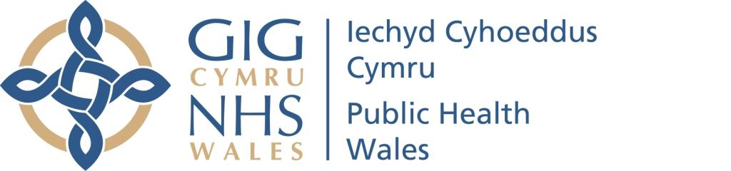

Public Health Wales

Screening Equity Strategy 2022-2025
Date: June 2022 | Version: WEBSITE v1
Authors:
Bethan Bowden, Specialty Registrar in Public Health
Heather Ramessur, Lead Screening Engagement Specialist
Sikha de Souza, Consultant in Public Health
Publication/ Distribution:
Public Health Wales Screening Division
Local Public Health Teams within Local Health Boards through the Screening and Inequities Group
HPSS Directorate leadership Team
Wider stakeholders on request

Our Vision
Our vision, across the national screening programmes in Wales, is that everyone eligible for screening has equitable access and opportunity to take up their screening offer using reliable information to make a personal informed choice. The purpose of this strategy is to identify how through collaborative working with our partners in Local Health Boards; the Third Sector and the people of Wales we can achieve this ambition.
Whether or not to take part in screening is a choice for the individual that is consistent with their values and unique circumstances.¹ However, some people do not actively make a decision to decline screening but are unable to take up their offer due to a range of interlinked barriers. These barriers may include logistical or physical challenges driven by economic or environmental factors that reduce access to locations where screening is taking place. Other people may not have received information in appropriate formats or languages to ensure that they have the necessary knowledge to make an informed choice. Others may not consider preventative screening as part of their social norm or cultural identity. These barriers may be relevant at a national or local level and may be specific to a programme or relate to a community or individual.
Screening saves lives, reduces complications and enables choice through early identification and treatment of health conditions.^{2,3,4} When screening is not taken up equally across population groups this will result in a disparities in health outcomes across those groups leading to health inequalities.⁵ As the differences in health outcomes can be attributable to the wider determinants of health including social, economic or environmental barriers, these differences can be avoidable.⁶ When worse health outcomes exist that are unfair or unjust the term inequities⁷ is used.
To understand and address these challenges will require an increased focus on targeting people most at risk of harms and where uptake of screening is low. This will be informed by greater understanding through improved data collection so innovative and evidence based approaches can be used to tackle the unfair and unnecessary barriers that exist. This will help us achieve our ambition of equitable access and opportunity for screening for all.

Our Screening Programmes
Screening aims to detect early stages of disease or prevent disease occurring. Through identification of people at higher chance of having a health condition more effective treatment options can be offered or information provided to inform decision making about their future care.⁸ Screening can also reduce the chance of developing a serious condition, preventing ill-health and the harm that would have otherwise occurred.
Public Health Wales (PHW) coordinates the delivery of eight national screening programmes in Wales that offer screening tests throughout the lifecourse from pregnancy to older adults.⁹ Each screening programme offers a test to a defined population group. This contributes to the long term strategic priority of PHW to achieve a healthier future for Wales by supporting the development of a sustainable health and care system focused on prevention and early intervention.¹⁰ Delivering excellent services for population screening programmes is a key theme in the PHW Our Strategic Plan 2022-2025¹¹ and supports the enablement of better population health and reducing health inequalities through preventative and sustainable measures.
The population-based national screening pathways in Wales are:
- Breast Test Wales
- Bowel Screening Wales,
- Cervical Screening Wales
- Diabetic Eye Screening Wales
- Newborn Bloodspot Screening Wales
- Newborn Hearing Screening Wales
- Wales Abdominal Aortic Aneurysm Screening Programme
- Antenatal Screening Wales clinical network coordinated by PHW

Our values and principles
Creating a culture of positive action where equality of opportunity is at the forefront of our work will have significant benefits to our people and our services. This aligns with NHS Wales’ values and principles of person-centred care, prevention and well-being and working in partnership with value for all who work in NHS services.¹²
Public Health Wales is fully committed to the NHS Wales core values through:
- Reducing inequities faced by some groups and communities in Wales
- Working with others to build more cohesive communities
- Involving people who reflect the diversity of our communities.
The PHW Strategic Equality Plan 2020-2024¹³ sets out five equality objectives that include actions for Public Health Wales as an employer. Whilst all objectives are equally important the Screening Division, as an external providers of healthcare services to communities in Wales, is committed to progressing equality objectives four and five:
- Access to our services and our environment
- Listening, learning and responding
Five ways of working
Addressing health inequities will require coordinated action across the health and care system as local, regional and national partners work collaboratively to improve health outcomes. This will include local communities, third sector organisations, local authorities and health and social care. The five ways of working within the Wellbeing of Future Generations (Wales) Act 2015 identify the approach that can be taken when developing, implementing and evaluating our screening services. This includes:
- Long term
- Prevention
- Integration
- Collaboration
- Involvement¹⁴

Understanding Inequities
Health inequities can exist across a range of characteristics or dimensions. This includes wider determinants of health such as the conditions in which we work, live and play as well as individual factors including unhealthy behaviours that increases risk. Access and experience of services due to discrimination can also lead to different health outcomes. Consideration needs to be given to people who have protection under equality legislation, individuals from the most deprived areas of Wales and individuals from under-served & inclusion groups.
Protected characteristics under the Equality Act 2010
The Public Sector Equality Duty (PSED) established by the Equality Act 2010¹⁵ places a responsibility on public bodies and others carrying out public functions to ensure that they consider the needs of all individuals in their day-to-day work in shaping policy and delivering services, and in relation to their own employees. The general duty of the PSED places responsibility on public bodies to pay due regard to the need to:
- Eliminate unlawful discrimination, harassment and victimisation and other conduct prohibited by the Act
- Advance equality of opportunity between people who share a protected characteristic and those who do not
- Foster good relations between people who share a protected characteristic and those who do not
People who have protected characteristics are offered legal protection as set out in the Equality Act (2010). Nine protected characteristics have been described as detailed in figure 2.
As a public body there is a legal requirement to ensure that screening services are provided in accordance with the Equality Act and ensure equal access and opportunity for people who share a protected characteristic.

Figure 2: Protected Characteristics under the Equality Act 2010
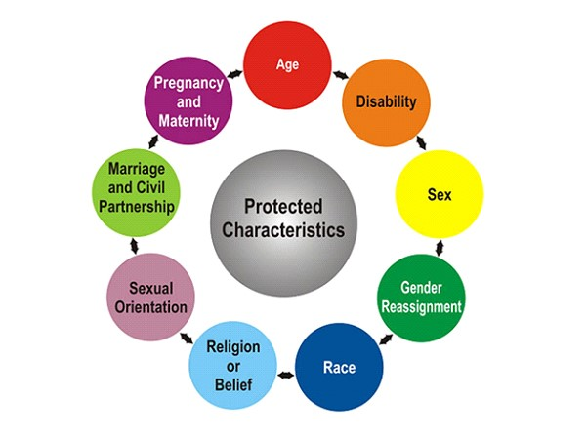
Source: https://myuni.swansea.ac.uk/media/cultural-awareness.jpg
Socio-economic disadvantage
A social gradient in health outcomes exists with the more disadvantaged the person’s social position, the worse their health. In Wales, people from more deprived communities have reduced life expectancy and live more years in poor health in comparison with people living in the least deprived areas.¹⁶ The introduction of the Socioeconomic Duty in Wales in March 2021 means that public bodies, including Public Health Wales, have to think about how strategic decisions can improve inequality of outcome for people who suffer socio-economic disadvantage. The duty is:
- When making decisions of a strategic nature about how to exercise its functions, have due regard to the desirability of exercising them in a way that is designed to reduce the inequalities of outcome which result from socio-economic disadvantage.
As a public body, consideration of equality for people at socio-economic disadvantage is a legal requirement.

Under-served groups
Under-served or Inclusion groups refers to those who are socially excluded or experience stigma and discrimination which reduces access and experience of existing healthcare services. This will include people experiencing homelessness, asylum seekers and refugees, people with substance misuse and people with mental and physical ill health.
There is intersectionality across people experiencing health inequities with people with a protected characteristic such as a disability also living in socio-economic disadvantage.

Understanding inequities in screening uptake
Each screening programme has identified minimum service standards to ensure that the most people will benefit within effective and efficient programmes. The consistent high standard of service delivery across screening programmes ensures that everyone across Wales is offered the same high quality service. However, providing an equal service to all will not support those people from under-served groups who may require additional support to take up their offer of screening. The people of Wales are not all the same including having different barriers and enablers for screening, different levels of health literacy and varying communication needs.
Many of the diseases that are screened for in Wales such as cervical cancer and bowel cancer are not distributed equally across the population with higher cancer incidence in our more deprived communities.¹⁷ People from South Asian communities are more likely to have type 2 diabetes in comparison with people of White ethnicity.¹⁸ Equal uptake of screening can help to address this difference through early identification with improved outcomes following treatment. Unfortunately, the offer of a screening test is not taken up equally by everyone in Wales. Those at greatest risk of health harms from the condition are less likely to take up the screening offer, exacerbating existing health inequities.
To understand our diverse population we have explored uptake by age, gender and local area deprivation derived from postcodes to understand uptake across these determinants. Differences in uptake have been observed by all of the factors listed above.

Uptake by deprivation
People in the more deprived communities in Wales have lower uptake of screening than people in the less deprived communities. Figure 3 demonstrates decreasing uptake in linear trend from the least deprived quintile to the most deprived quintile. This trend is consistent across all the adult screening programmes in Wales in 2018/19. The inequality gap in uptake in Bowel Screening Wales was 17.3% from the least deprived to the most deprived communities, 15.9% in Breast Test Wales, 11.5% in Cervical Screening Wales, 12.8% in AAA screening programme, and 3.2% in Diabetic Eye Screening Wales.
Figure 3: Uptake/coverage by deprivation quintile by screening programme, 2018-19
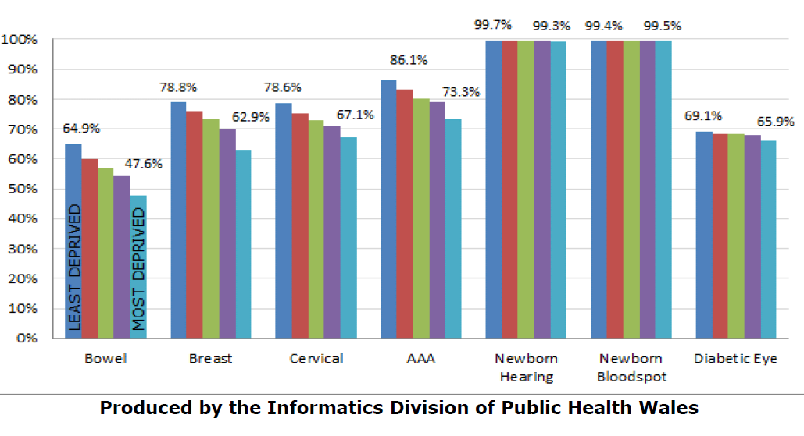
There is no inequality in uptake in the newborn programmes between the least and most deprived communities in Wales. The variation in uptake between programmes demonstrates that the difference is not pre-determined and could potentially be reduced through improved access and opportunity and understanding of screening services.

Uptake by gender
Bowel Screening Wales invite participants who identify as both male and female for screening with no eligibility criteria based on gender. In 2020/21 uptake of screening for invited participants varied by gender. Uptake is lower in men at 66.1% compared to 68.1% in women. This inequality gap of 2.0% has declined slightly from 3.1% in 2017/18 (table 1).
Table 1: Bowel Screening Uptake (%) by gender
 | 2020/21 | 2019/20 | 2018/19 | 2017/18
Total | 67.1 | 61.5 | 55.7 | 53.4
Male | 66.1 | 60.4 | 54.1 | 51.8
Female | 68.1 | 62.6 | 57.2 | 54.9
Inequality Gap | 2.0 | 2.2 | 3.1 | 3.1
The Diabetic Eye Screening Wales programme also invites people registered with their GP as both male and female with no eligibility criteria based on gender. However, the data for 2020/21 is significantly impacted by the response to the pandemic and therefore cannot be used to explore an inequity gap. This will be explored in the future as the programme recovers.

Uptake by age
Cervical Screening Wales, Breast Test Wales, Bowels Screening Wales and Diabetic Eye Screening Wales are interval screening programmes with participants invited repeatedly over a defined time period and defined time interval. Uptake of these adult interval population screening programmes can vary by age group invited with younger age groups having lower uptake in comparison to older age groups.
In 2020/21 in Cervical Screening Wales uptake of screening for invited participants is lowest amongst the youngest women invited (those aged 25-29 years) at 63.4%. This compares to the average across all ages of 69.5%. Uptake of screening invitation was highest at 77.2% in women aged 50-54 (figure 4).
Figure 4: Uptake (%) of cervical screening invitation by 5 year age groups, 2020/21

In 2020/21, uptake of breast screening through Breast Test Wales is lower in younger age groups in comparison with older groups. The lowest uptake is seen in those aged 50-54 at 62.5% in comparison with women aged over 55 where uptake is 69% or higher (Figure 5).

Figure 5: Uptake (%) of breast screening invitation by 5 year age groups, 2020/21

Continued low uptake in younger women will result in lower overall coverage of breast screening as women who respond to their first invite are more likely to continue to attend recall appointments. Priority should be given to encouraging first participation in screening as past screening history indicates future screening engagement.
Uptake by age is currently being explored in the Bowel Screening Wales programme with uptake lower in those aged 60-64 years at 65.8% compared to 69% and 68.1% for the 65-69 year age group and 70-74 years age group respectively.

Uptake by ethnicity
Ethnicity data is not routinely recorded within the screening programme. However we know from published literature¹⁹⁻²¹ and from community knowledge gained locally from engagement work, that uptake is lower amongst ethnic minority communities. This inequity can be attributed in part to cultural barriers that are specific to those communities. Accessible information is another potential barrier for people who do not have English as their first language.
Disparities in uptake by ethnicity exist within England and Scotland screening programmes. Preliminary findings from a PHW knowledge directorate project using SAIL linked data on ethnicity has shown a similar trend in Wales. People from Asian ethnic group and Unknown ethnic groups had the lowest uptake at 50.8% and 47.5% respectively in comparison to people from White ethnic groups at 60.2%. It should be noted however, that the White ethnic group includes people who may consider themselves part of a minority ethnic group in addition to White British ethnicity such as White East European communities and people from Gypsy, Roma and Traveller communities.
Further analysis is planned to understand the uptake of screening within the Cervical Screening programme.

Other populations
We cannot quantify the full extent of inequity within our screening programmes because we don’t have the required data available. However, experience from our engagement team and published literature tells us that screening inequities affect specific communities, and affect them for different reasons.
As examples:
- Inequity for people in long term care is influenced by our service delivery models and difficulties in accessing screening, similarly for people who are in prison
- Inequity for the trans community is influenced by how we invite people and availability of information and resources to support informed choices
- Inequity for people with specific communication needs, for example the deaf community, is influenced at different stages of the pathway by both information resources and by how we deliver our service
- Inequity for people with learning disabilities is influenced by our relationships with partner organisations who support people to make choices and access health services as well as our information resources

Inequities across the screening pathway
The aim of screening programmes is to improve health outcomes through prevention of disease occurrence or early diagnosis to improve the impact of the disease on health and wellbeing. Screening is delivered across a whole pathway from initial offer of screening test to definitive treatment. Understanding equity of uptake for the offer of screening as the first step in this pathway is vital. However, once entered on screening pathway people need to continue to progress along the clinical pathway of diagnostic tests and interventions to ensure positive outcomes.
To improve health outcomes through screening we need to consider inequities that can occur potentially occur at any point along the screening pathway including diagnostic tests and treatment. Evidence from other screening programmes in the UK and Europe indicates that uptake of diagnostic tests²² and treatment²³ is inequitable. Through collaborative working with NHS Wales clinical partners in Local Health Boards we need to further our understanding of inequities in the wider clinical pathway in Wales. This will help us realise the full impact of preventative healthcare at reducing health harms for those at greatest risk of the conditions being screened for.

Impact of Covid-19 pandemic response
On 13 March 2020 Welsh Government announced plans to suspend non-urgent outpatient appointments and non-urgent surgical admissions and procedures in order to redirect staff and resources to support the response to Covid-19. Following this announcement, Welsh Government agreed the recommendations of Public Health Wales to temporarily pause some of the population based screening programmes. The temporary pause affected: Breast Test Wales; Cervical Screening Wales; Bowel Screening Wales; Diabetic Eye Screening Wales and Wales Abdominal Aortic Aneurysm Screening. The Antenatal Screening Programme, Newborn Bloodspot Screening Programme and Newborn Hearing Screening Programme were not paused and have continued to be offered throughout the pandemic.
From June 2020, a phased, prioritised approach for reinstating population-based screening programmes was undertaken by the Screening Division. Each programme identified defined groups within their eligible population who should have their screening invitation prioritised during the restart in order to reduce potential harm and impact from the effect of the pandemic.
All the programmes are now working on the next phase of recovery. For some this still involves catching up on the backlog of people waiting to be screened. All programmes are working with health board partners to ensure safe and timely pathways for those people who need onwards referral. The screening test has remained the same but the pathways were adapted to be Covid-secure. These additional measures along with a decrease in venues being available to us, have meant that capacity at screening clinics is reduced compared to before the pandemic. Bowel Screening Wales and Cervical Screening Wales have recovered their programmes having now invited all eligible participants from their backlog. However, both programmes along with all other screening programmes still experience challenges in delivering the screening pathway due to limited capacity within out-patient services.
In order to catch up with those people waiting to be screened there is a real focus in the division on operational delivery including looking at ways to maximise clinic efficiency and reduce the number of people who do not attend. Whilst a focus on efficiency is important during our recovery, we must be aware of the effect on uptake across all our communities of changes in service delivery. We need to consider the effect on inequity of our new ways of working including with specific communities and under-served groups that we know had previously been less likely to uptake screening, and groups disproportionately affected by the pandemic.
The Covid-19 pandemic has exacerbated existing health inequities with certain groups including people from deprived communities, people from ethnic minority groups, older people and people with mental health conditions disproportionately affected. Future plans for recovery within screening must carefully consider the impact on these groups, who are already known to have lower uptake of screening. As we move forward into new ways of working consideration around reducing inequities must be at the forefront of our approach.

What we are doing to tackle inequity
Tackling inequity has always been a key priority for the screening division. We report regularly on uptake by deprivation quintile and have explored inequity by different characteristics as part of project work and ongoing community work led by our Screening Engagement Team.

Screening Engagement Team
The Screening Engagement Team (SET) is key enabling team within screening division, working across all programmes. The team had focused on localised community working however, following the impact of the pandemic and the changing ways of engaging with communities, this has led to a change in approach. The team will be concentrating on supporting All-Wales initiatives and projects that will influence and impact on a large scale. SET will be working across programmes using a system leadership approach through engaging and building relationships with communities and partners who can embed addressing inequities within their ways of working. When working with stakeholders there will be a focus in working with people and communities who share protected characteristics or groups that are underserved.
The Screening Engagement Team have undertaken a stakeholder engagement scoping exercise to ascertain how community stakeholders had adapted their ways of working in response to the pandemic and explore the barriers to screening for people disproportionately affected by Covid-19. This project has provided insights into how communities across Wales have been impacted by Covid-19. It has also illustrated how community organisations have adapted their ways of working to maintain essential service delivery and highlighted how they wish to receive information about the NHS screening programmes. The insights from this project will inform how SET undertakes community engagement going forward and will support the development of timely and accessible public information to reduce fears and improve confidence amongst communities disproportionately affected by Covid-19.

Development of Public Information
Each programme has a public information group (PIG) and a representative from each sits on a divisional group (Core PIG). We aim to have consistent messaging and consistent use of language both within and across our programmes. To support this there is clear documentation that sets out what is expected of our public information in terms of the development and review processes, the design and the way things are presented, and the style of language and way of expressing things.
A key part of our divisional Public Information strategy is ensuring that our general information is accessible and in clear plain English, and that we also have specific accessible formats for all of our resources including large print, audio, BSL and Easy Read. The Public Information pathway for each screening programme is being reviewed to identify any gaps in provision of accessible information so appropriate action can be taken to ensure consistent availability of accessible information.
Engagement with stakeholders is built in as part of our information development and review processes. This is often led by the Screening Engagement team who have contacts in key community groups including some with protected characteristics and where we know that uptake has been low.

Health Equity Assessment
Action taken by programmes to address uptake may inadvertently widen the inequities gap if not carefully considered and assessed. Therefore when planning services, strategies and public health interventions broader consideration in terms of impact assessment will need to be considered.
To assist programmes in undertaking impact assessments a practical toolkit for undertaking Equality Health Impact Assessments (EqHIA) has been developed. This tool will assist programmes and teams when considering implementing policy, service changes or modernisation plans in assessing possible impacts on different population groups. The EqHIA tool supports the development of mitigating actions that can be considered to address potential negative impacts. This can then inform a planned change.
LINK for those internal to PHW

Our approach to inequity in recovery phase and beyond
As services are reinstated and rebuilt following the impact of the Covid-19 pandemic, addressing screening inequities is a key focus within the PHW Strategic Plan: 2022 to 2025. Our approach identified in this Strategy will reflect how the Division and partners will work to achieve this to 2025.
Our aim is to enable all eligible participants to make informed choices about screening. This is complex, influenced by language, community, cultural and economic factors impacting on behaviour, as well as physical access to services. To address existing screening inequity our approach will focus action in five key areas (figure 6). These key areas build upon our existing strengths and assets within the screening division and wider partner network.
Figure 6: Strategic Screening Inequity Approach

- Communication

We will support people to make personal informed decisions about taking part in screening by providing evidence based information for the public that is accessible in format and content. Information will be made available in large print, easy read and BSL formats. Web pages will make use of ReadSpeaker text-to-speech accessibility software. We will work with our communities to understand if minority language translations of communications are required and their preference for written or video formats. Our findings will inform the PHW corporate approach to provision of public information in minority languages. If minority languages are required we will ensure that that there is a consistent approach across all programmes in developing required communications; quality assurance of translations; governance of updating and reviewing available literature and monitoring the use of translated resources by members of the public.
We acknowledge that availability of accessible information is only part of the solution, we also need to ensure that we work to support the development of communication preferences as part of Accessibility Standards to ensure that people receive the right communication for them the first time. This will involve supporting the work undertaken by Public Health Wales as part of their Strategic Equality Plan to influence rapid development and implementation of innovative digital solutions for NHS Wales.
Working with our communication team we will develop a strategic communications plan at population and community level. This will require messages for the general population on the purpose of screening, the safety of the services and importance of attending a screening appointment or performing a screening test when you are called. We will build on our collaboration with “Help Us to Help You” to share key messages of the importance of preventative approaches to staying well. We will continue to develop and support evidence-based national awareness campaigns such as #LoveYourCervix. Communications campaigns will be targeted primarily at audiences from C2DE and ethnic minority communities, and they will be informed by audience insight. We will share our resources and expertise to build trust in screening and the screening programmes in Wales to increase motivation to participate. Communications campaigns will be evaluated so that we can measure their impact, gauge public sentiment towards Wales’ screening programmes and identify emerging themes within public discourse.
As part of our strategic communication plan, key messages will be developed to ensure that consistent clear communication can be shared through our partners. We will focus on developing digital content such as infographics and animations that can overcome health literacy barriers seen with text based materials. Learning from the Covid-19 vaccination programme, we will develop digital content that can be easily shared through social media platforms including WhatsApp to ensure that our messages can be delivered through the channels that our population groups most frequently access. Key messages will be needed for each of our programmes to reflect the different population cohorts and pathways that are involved.
We will also develop targeted messages for communities, particularly those where it is identified that uptake is low or trust in the screening programmes is low. This will require listening to the concerns of communities and being responsive to their needs. This will be a two-way conversation with individuals, groups or communities, listening to and learning from each other. Our role is to translate the evidence base and scientific knowledge into clear messages to inform their decision-making. Where possible, communications materials will be co-produced by people from the relevant target audience.
Communication approaches will be evidence driven, using findings from national engagement work undertaken by the Screening Engagement Team and work by external partners including Cardiff University with the CABS study. We will work closely with colleagues in the Behavioural Science and Public Information team in PHW to use their expertise to inform our core communications with our populations.
- Engagement & Community
Barriers and enablers for screening vary across population groups. We need to work collaboratively with communities so that we can understand the reasons that people make the choices that they do. We will work with communities where screening uptake is low, where health harms from the conditions screened for are high and with under-served communities that are known to have worse health outcomes. This will take time and resources to ensure real involvement and integration through sustainable networks.
We will build on existing engagement work, strengthening previous in-depth work with LGBTQ+ community, Gypsy Traveller communities and people with Learning Disabilities. We will seek out further partnerships with organisations representing under-served groups and community groups who may have previously been closed to healthcare engagement. We will be flexible in understanding how communities change and adapt and who we can and should be working with. This will require us to regularly update and review our stakeholder analysis and development of a user involvement strategy for the division.
We will support the development of a citizens’ panel within PHW to include service users of screening and representatives of under-served groups. This must include people with different pre-existing knowledge and understanding of screening to reflect the health literacy of our population groups. We will work with the citizens’ panel so they can influence the approach to addressing inequities within the screening division and at an organisational level. We will ensure that we feedback to those involved so they can understand the impact of their contribution on the development of services and how this has led to positive changes for their communities.
We will work through the SET and LHB partners to develop networks of community champions. These champions, as trusted voices within our communities, can review our messages for acceptability and then support the onward dissemination and sharing. We need to provide these community champions with practical and pastoral support so they feel appropriately informed and confident to speak as a trusted voice on screening. This will require adapting to different methods of communication, so they are appropriate for the communities. When needed we will provide buddying of professional expertise from PHW with community members to align community and professional voices’.
- Collaboration
We will collaborate to continue building a screening network. This includes the Screening Division programmes; Local Health Board Public Health teams; Primary Care delivering and supporting screening programmes; Third Sector partners promoting screening and linking us with under-served groups and our NHS Wales secondary care colleagues undertaking diagnostic tests and treatments to complete the screening pathway. We will need to work collectively and cohesively as a system to drive the necessary improvements to result in improved outcomes for people.
This will involve supporting existing networks such as the Screening Division Inequities Group with representation from across all screening programmes and the Screening and Inequity Group that facilitates partnership working across the Screening Division and Local Health Board partners. Within these Groups we will work in an agile and flexible manner to promote the role of screening as an effective preventative public health service with renewed focus on empowering action to address existing inequities.
As system leader for screening in Wales, the Screening Division will support collaboration through improved access to the professional expertise within the Division. To support data and information sharing that can then inform targeted action, we will produce regular updates for our partners in Local Health Boards. This will include current screening data for their area, including uptake and coverage by demographic factors that we know impact on screening such as economic disadvantage and ethnicity.
People experience inequities throughout the screening process, including at uptake of screening offer, attending diagnostic investigations and undertaking curative treatment.²³ If a participant does take up their screening offer but cannot receive treatment for their high risk result improvement in health outcomes and reduction in health inequities will not be seen. To maximise the benefit across the whole screening pathway we will work with our LHB colleagues not only within public health and primary care to support uptake of the offer of screening but also secondary care and diagnostic colleagues so that patients can continue in a timely way along the screening pathway. This will include feedback and data on challenges across the screening pathway such as in diagnostic investigations waiting times and delays for definitive treatment acknowledging the integrated structure of Local Health Boards at providing care for their populations.
To strengthen collaboration and involvement we will develop our “Screening Information for Professionals” webpages on our website. This will enable us to collate and share research, guidance, service evaluations and community engagement with professional partners to ensure our collective action has the greatest impact in improving uptake across communities. Each programme has a unique cohort of the population and delivery model, however, there will be common barriers that will require consideration across all programmes. The disproportionate effect of Covid-19 on different populations has increased focus on addressing inequity. There are also opportunities for screening to learn from what is happening elsewhere such as within the vaccination programme to drive uptake across all communities. Evaluations of interventions undertaken locally can be shared on this platform so learning can be collected across the system.
To effectively involve our partners in the planning, delivery and evaluation of our programmes we will develop a better understanding of our current interactions with our partners. This will support a consistent dialogue from the Screening Division rather than multiple approaches from different programmes. Primary Care colleagues are critical to the success of screening through supporting uptake and providing a trusted voice to endorse screening activities. We can build on non-responder work with GP clusters such as GP endorsement of non-responder letters in bowel screening to encourage participation and increase uptake.²⁴ The approach will be locally-led, using different methods to contact individuals including letter, phone or text, based on practice resources and understanding of their population.
- Access and delivery models (operational)
During our recovery phase there has been a renewed focus on increasing efficiency and maximising clinic utilisation. This is to ensure that the maximum number of people are seen within limited capacity clinics. However, we must balance improved operational efficiency with unintended impacts on accessibility to under-served groups. Undertaking Equality Health Impact Assessments (EqHIA) during the planning stage of all changes to service delivery will ensure that we understand any potential negative consequences and can mitigate against them. For example, when considering expansion of screening venues or hubs so that accessibility of venues within communities such as for public transport routes are considered. Such service delivery changes should also be robustly evaluated including measures of inequity within the evaluation.
To incorporate EqHIA into regular practice within the Screening Division, training and support in using the tool will be provided. This will include peer-led support within the Screening Inequity Group for review of EqHIA across programmes. This will support the quality assurance of the EqHIA and also provide an opportunity for shared learning and experience across the screening division. Evaluation of the EqHIA tool will also be undertaken to ensure that this remains fit for purpose and a useful and additive resource for programmes to improve the delivery of their service.
As screening is a pathway, each programme will undertake analysis of the end-to-end user journey to consider barriers at different stages of the screening pathway. Barriers can exist at any stage of the screening journey, but an initial approach will consider the three steps of cohort identification, provision of information and access to services (figure 7). Due to the different service delivery models of each screening programme, this will be undertaken at programme level. However, key themes are anticipated to be identified that will require addressing at a Divisional level.
Figure 7: Inequities in screening pathway
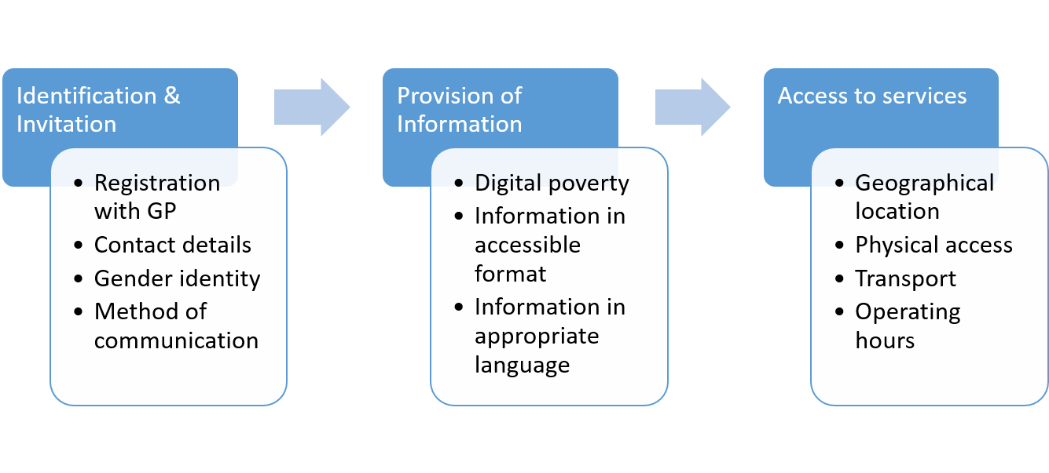Each screening programme needs to be accessible to people with multiple methods of communication possible. This will support people in digital poverty, people who work anti-social hours, people with caring responsibilities during working hours, people with sensory impairments who may not be able or comfortable to conduct telephone calls and people with mental health concerns who experience anxiety through direct communication. We will ensure that each programme has both email and telephone methods of communication for participates to contact with questions and queries.
We need to account for diversity in the way that we deliver screening ensuring that reasonable adjustments are put in place when required, delivering a flexible programme to meet the needs of all individuals. Providing the same service to everyone will not address inequities as individuals such as with protected characteristics will require additional support so they can access the same service. Screening programmes need to ensure that they are not disadvantaging people such as those with physical disabilities in accessing their services. This may be through difficulties undertaking home testing kits due to physical condition or in physical accessing a screening venue. Participants need to be aware of how to contact screening teams to be provided with the necessary support.
- Data and Research
Our renewed our focus on screening inequity following the changes in our ways of working in the Covid-19 pandemic must be informed by data and intelligence. This must be shared in a timely and reliable method within our programmes, division and to our partners. Our current routine data collection includes information on demographic characteristics that are known to be impacted by inequity of uptake including age, gender as registered with GP and LSOA which informs deprivation quintile. Our future reporting will collate this into an annual Screening Inequity report. This can be used to inform action by programmes within the Division and for our partners including Local Health Board colleagues in Public Health and Primary Care.
Feedback from our partners tells us that in addition to annual reporting there is a need for more timely, real time data. We will work to develop a data dashboard to provide more rapid provision of information that can inform local action. This will use measures for uptake over shorter time frames to balance the timeliness of reporting with robustness of data monitoring that will be available within the annual report.
Emerging evidence in Wales is showing that people from minority ethnic groups have lower uptake of screening than people from White ethnicity. This reflects findings in England and Scotland that demonstrated an inequality gap in screening uptake between ethnic groups. However, understanding screening uptake in ethnic minority communities is limited by poor ethnicity ascertainment within routine data collections within Wales. We will support the national work undertaken by colleagues in DHCW to improve recording of ethnicity within routine data and work with our clinical teams to ensure that ascertainment of ethnicity is gathered as part of routine data collection during all patient interactions. This may require additional training and support for staff so they feel confident to ask people their ethnicity and the importance of why this helps to provide inclusive services for people from minority ethnic backgrounds.
We need to develop routine processes for producing monitoring data on ethnicity in addition to other demographic factors that will be presented within our inequity reports. Due to small numbers of people from minority ethnic communities within older age groups and geographical regions, consideration of the frequency and granularity of publication of data is required. Our approach will be to provide initially screening uptake by ethnicity for Bowel Screening Wales and Cervical Screening Wales programmes due to their larger younger population age cohorts. As our data collection systems and data linkage improves this will be expanded to the other adult population screening programmes of Breast Test Wales, WAAASP and Diabetic Eye Screening Wales.
We are also conscious that our data collection is limited for under-served groups such as people experiencing homelessness, Gypsy and Traveller communities and asylum seekers and refugees. Our existing data collection methods do not collect this information. We will work through our Screening Engagement Team with groups and organisations that work with under-served groups to develop and design data collection tools that will provide insights into uptake within these groups. This may include qualitative feedback from participants and communities.
The purpose of gathering data is to inform our action, so that we can identify population groups where uptake is low and provide targeted support and interventions for these groups. We will also work to further our understanding of inequity in uptake at different stages of the clinical pathway. This will help us and our partners to focus our efforts on where inequity is greatest and where targeted interventions can have the greatest impact.
We need to develop evaluative frameworks that will enable consistent review of interventions so that the impact on screening uptake can be monitored. As part of ensuring that action to address inequity is embedded within all our programmes we will work with programme leads to formulate and define screening equity indicators as a routine measure to evaluate the effectiveness of our screening programmes.

Our commitments
To sustain action to address tackling inequities a Screening Inequity Framework has been developed. This identifies a series of commitments to progress action across our key areas.
Communication
Our commitment is to:
- Provide information on screening in an accessible format, using appropriate language so that each individual can make their own informed personal choice
- Provide clear, consistent messages to the public about the purpose of screening and how screening can improving health outcomes using digital and traditional media formats
- Develop tailored messages for groups and communities where specific barriers are identified to address concerns preventing uptake
Community and Engagement
Our commitment is to:
- Build sustainable networks with people from local communities, the Third Sector and statutory organisations to support community engagement activities
- Understand barriers to taking up screening in communities of low uptake, working with community advocates and champions to build trust.
- Involve service users and people from underserved groups, with different levels of screening health literacy, in a citizen panel to inform and support the approach to addressing inequities across the division and organisation
Collaboration
Our commitment is to:
- Support our partners as system leader in screening with data, resources and expertise.
- Develop a shared learning space for evidence based resources to inform locally-led community approaches to addressing screening inequities.
- Extend our collaboration with primary care in their role as supporting and delivering screening programmes using their endorsement as trusted voices for their patients
Service delivery
Our commitment is to:
- Map users’ journeys to identify gaps and opportunities for proactive action to improve access to screening and remove unnecessary barriers.
- Ensure reasonable adjustments are made through positive action, including provision of multiple options for people with disabilities to communicate with programmes
- Adopt a consistent approach to Equality health impact assessments which ensures operational changes improves service provision for underserved and inclusion groups
Data and monitoring
Our commitment is to:
- Produce and publish an annual equity report to enable access to meaningful screening inequities and uptake data that can inform action.
- Develop a sustainable approach to monitoring uptake by minority ethnic communities and other underserved groups, supporting local and national approaches to improve data collection
- Ensure accountability for action to reduce screening inequities through the introduction of inequity outcome measures and indicators for all screening programmes

Governance and accountability
Addressing inequity is a cross-programme theme in the Division, embedded as part of our usual ways of work and way of thinking. This is reflected as a key theme within the PHW Strategic Plan 2022-2025 to continue our work to address inequality in screening uptake. As key objectives within the Strategic Plan this will be monitored through divisional and team meetings and project plans with overall accountability to the screening division Senior Management Team. To support this, as identified within the data and monitoring commitments, will be the development and embedding of inequity measures as part of the routine performance indicators for screening programmes.
To drive change and accountability across all programmes, a named lead will be identified for each programme to take forward action on inequity. Each programme is unique with a different population due to sex and age criteria with different recall periods for participants. Therefore, each programme will clarify the vision and aim of the inequity workstream within their programmes under a common framework.
The Screening Division is accountable for the delivery of screening programmes in Wales however, screening is undertaken through a range of healthcare partners and supported by enabling functions such as the Screening Engagement Team. Local health boards are also accountable for the wellbeing of their populations that are supported by preventative approaches such as through population-based screening. Local Health Board teams are key partners in engagement work through collaborative community focused initiatives but can support sustainable screening delivery through primary care and consideration of the whole pathway with accessible and timely investigations and treatments undertaken in secondary and tertiary care centres. The recent formation of a Screening & Inequity group for the Screening Division and Local Health Board Public Health Teams will be supported with PHW Screening Division committing to providing ongoing secretariat support. This group will also facilitates two way communication and a space for shared learning.
We will monitor our progress to achieving our vision of equitable access and opportunity for screening through the development of a Screening Equity Action Framework. The action framework will use the behavioural science theoretical framework of the COM-B model for behavioural change.²⁵ This approach considers a persons’ Capability, Opportunity and Motivation to undertake specific health behaviours such as undertake a screening test. Capability factors may relate to lack of knowledge of cancer and the purpose of cancer screening which may be exacerbated by language barriers or low health literacy. Capability factors can also relate to the lack of skills to undertake the test such as within a home based screening test. Opportunity factors may relate to the physical barriers such as distance and transport to attend a screening venue or practical barriers such as lack of registration with a GP or frequent changes in contact information preventing the receiving of an invitation offer. Motivational factors may relate to emotional responses to screening such as fear or embarrassment or beliefs of risk perception relating to themselves or others within their community.
We aim to be deliberately ambitious in scope and scale, requiring action across the key themes by a wide range of partners. However, this is building on existing assets and strengths within teams to now rapidly address the challenge of inequity within screening.

References
- UK National Screening Committee. 2018. Guidance for the development, production and review of information to support UK population screening programmes. Available online at: https://www.gov.uk/government/publications/uk-national-screening-committee-information-development-guidance
- Petro et al. 2004. The cervical cancer epidemic that screening has prevented in the UK. Lancet. 364: 249-256
- The Independent UK Panel on Breast Cancer Screening. 2013. The benefits and harms of breast cancer screening: an independent review. British Journal of Cancer. 108: 2205-2240
- Jodal et al. 2019. Colorectal cancer screening with faecal testing, sigmoidoscopy or colonoscopy: a systematic review and network meta-analysis. BMJ Open
- Mosquera I et al. 2020. Inequalities in participation in colorectal cancer screening programmes: A systematic review. Eur J Public Health. 2020;30(3):416–25.
- The Marmot Review. 2010. Fair Society: Healthy Lives. Strategic Review of Health Inequalities in England post 2010. Fair Society, Healthy Lives (instituteofhealthequity.org)
- Public Health England. 2020. PHE Screening inequalities strategy https://www.gov.uk/government/publications/nhs-population-screening-inequalities-strategy/phe-screening-inequalities-strategy
- NHS Screening. 2022. NHS Screening. Available online at: NHS screening - NHS (www.nhs.uk). Last accessed 17/01/2022
- Public Health Wales. 2022. Screening. Available online at Screening - Public Health Wales (nhs.wales). Last accessed 17/01/22.
- Public Health Wales. 2018. Working to achieve a healthier future for Wales: Long Term Strategy 2018-30. Available online at; Long Term Strategy_English.indd (nhs.wales)
- Public Health Wales. 2022. Our Strategic Plan 2022-2025. Available online at: IMTP-2022---2025-v1-010422.pdf
- NHS Wales. 2016. NHS Wales Core Principles. Available online at: NHS_Core Principles_leaflet.pdf (wales.nhs.uk)
- Public Health Wales. 2020. Working to achieve a healthier future for Wales: Our Strategic Equality Plan and Objectives 2020-2024. Available online at: strategic equality plan 0220.indd (wales.nhs.uk)
- Future Generations Commissioner for Wales. Well-being of Future Generations (Wales) Act 2015. Well-being of Future Generations (Wales) Act 2015 – The Future Generations Commissioner for Wales
- UK Government. 2010. Equality Act 2010. Available online at: https://www.legislation.gov.uk/ukpga/2010/15/contents
- Public Health Wales Observatory. 2019. PHOF Life expectancy at birth, 2015 to 2017. PHOF 2017 Characteristics - Area | Tableau Public
- Public Health Wales. Cancer Incidence in Wales, 2002-2018. Data for FY2018, persons aged 60-74 [Internet]. 2021. Available from: https://phw.nhs.wales/services-and-teams/welsh-cancer-intelligence-and-surveillance-unit-wcisu/cancer-incidence-in-wales-2002-2018
- Goff LM. 2019. Ethnicity and Type 2 Diabetes in the UK. Diabetic Medicine. 36:8 PP927-938
- Bansal N et al. 2012. Major ethnic group differences in breast cancer screening uptake in Scotland are not extinguished by adjustment for indices of geographical residence, area deprivation, long-term illness and education. Br J Cancer. 2012;106(8):1361–6
- Szczepura et al. 2008. Breast and bowel cancer screening uptake patterns over 15 years for UK south Asian ethnic minority populations, corrected for differences in socio-demographic characteristics. BMC Public Health.
- Kerrison RS et al. 2021. Ethnic inequalities in older adults bowel cancer awareness: findings from a community survey conducted in an ethnically diverse region in England. BMC Public Health. 2021
- Hoeck S, van de Veerdonk W, I De Brabander. 2020. Do socioeconomic factors play a role in nonadherence to follow-up colonoscopy after a positive faecal immunochemical test in the Flemish colorectal cancer screening programme. European Journal of Cancer Prevention. 29 (2), pp 119-126
- Mansouri D, McMillan DC, Grant Y, Crighton EM, Horgan PG. The Impact of Age, Sex and Socioeconomic Deprivation on Outcomes in a Colorectal Cancer Screening Programme. PLoS One. 2013;8(6)
- Wardle J et al. 2016. Effects of evidence-based strategies to reduce the socioeconomic gradient of uptake in the English NHS Bowel Cancer Screening Programme (ASCEND): four cluster-randomised controlled trials. 387: 10020, pp751-759
- Michie S, van Stralen M, West R. 2011. The behaviour change wheel: A new method for characterising and designing behavioural change interventions. Implementation Science. 6 (42) The behaviour change wheel: A new method for characterising and designing behaviour change interventions | Implementation Science | Full Text (biomedcentral.com)

