



 |  |  |  |  | Name of Meeting  Board
Date of Meeting
26 March 2025
Agenda item:
3.3
Performance and Insight Report - February 2025
Executive lead: |  |  | Huw George, Deputy Chief Executive/ Executive Director Operations and Finance
Authors: |  |  | Angela Williams, Deputy Director Operations and Finance; Neil Stoodley, Head of Financial Intelligence, Value and Impact; Ioan Francis, Head of Performance
Contributors: |  |  | Directorate submissions approved by relevant Director
Approval/Scrutiny route: |  |  | Business Executive Team
Purpose
Our refreshed Performance and Insight Report focuses on delivering actionable insights and assurance whilst identifying areas for further improvement across the following key sections;
- Governance and Accountability, including:
  - People Governance; Financial Governance; Board and Corporate Governance; and Clinical Governance, Quality, Safety and Improvement
- Service Delivery, including:
  - Health Protection and Screening Services; Health and Wellbeing (monthly); Policy and International Health; Data, Knowledge and Research (bi-monthly)
- Strategy and Delivery, including:
  - Progress against our Strategic Plan Milestones, Strategic Change Programmes and Inequalities
The report is designed to be read in conjunction with the Performance and Assurance Dashboard.
Recommendation:
APPROVE | CONSIDER |  |  | RECOMMEND |  | ADOPT | ASSURANCE
The Board is asked to:
- Consider and Receive assurance on the organisation’s performance and governance arrangements, progress against delivering its strategy including delivery/recovery of key services and programmes

Link to Public Health Wales Strategic Plan

Public Health Wales has an agreed strategic plan, which has identified seven strategic priorities and well-being objectives.

This report contributes to the following:
Strategic Priority/Well-being Objective |  | All Strategic Priorities/Well-being Objectives
Summary impact analysis

Equality and Health Impact Assessment |  | An Equality and Health Impact Assessment is not required. Equality and Health Impact Assessments will be completed as part of delivery of the specific actions within the Plan.
Risk and Assurance |  | Our Strategic Risks are detailed within Our Strategic Plan and progress reported in a separate Board paper.
Health and Care Standards |  | This report supports and/or takes into account the Health and Care Standards for NHS Wales Quality Themes
 |  | All themes
 |  | Governance, Leadership and Accountability
Financial implications |  | An update on the organisation’s financial performance is enclosed and in the accompanying Finance Board Report.
People implications |  | An update on the organisation’s people performance is enclosed.

Purpose

Our refreshed Performance and Insight Report focuses on delivering actionable insights and assurance whilst identifying areas for further improvement.

The Performance and Insight Report is designed to be read in conjunction with the Performance and Assurance Dashboard (PAD).

The PAD provides data visualisations, trend information and more detailed visual analysis on a full suite of performance indicators.

In addition to the Performance and Insight Report and the PAD, Public Health Wales also produces a Directorate and Divisional Dashboard (DADD) which provides a more granular level of detail and drilldown for directorates and divisions to be able to monitor and manage their performance against a number of performance indicators. The DADD does not form part of our performance reporting to Board.

This report also provides the mechanism for The Business Executive Team to approve change requests for our Integrated Medium Term Plan milestones. This is covered in section 3 of the report including a direct link to the change request PAD dashboard which contains further information about each change request submitted for approval.

Structure of The Report

The report is made up of three sections:

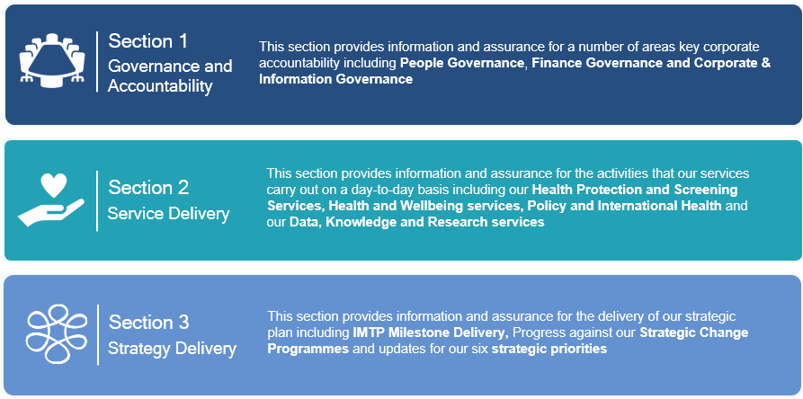

Each of the three sections comprises of a summary performance indicator table, a high-level Overview for each governance theme, focusing on compliance against our statutory, mandated or other key reporting requirements. Where required, governance themes may be supported by an In Focus section. This section aims to provide additional assurance to our Board where challenges in our performance have been identified, and the actions set out to address underperformance and drive improvement.

Enhanced navigation is provided throughout the report, and access to all governance themes can be made via the hyperlinked icons in the banner at the top of each page. In addition access to relevant In Focus areas or additional documents and dashboards within the PAD is through the buttons accessible within the report. Examples of icons are provided below:




Performance update at Month 11
This section focuses on key areas of delivery where we have seen, or continue to see, challenges in achieving required performance levels. The Executive Team and Board are signposted to the relevant section of the Insights Report for additional assurance. Areas of performance to highlight at month 11 include:
- Sickness absence 12-month rolling rate remains above target at 4.3% in February, unchanged from last month. In-month sickness absence has fallen by 1.26% to 3.94% during the latest period. The current absence rate is comparable to that of February 2024. It is anticipated that a reduction in absences related to seasonal viruses will be seen as we move into Spring. The People & OD team continue to monitor sickness absence data, provide ongoing advice and support to the wider organisation, as well as learning and development opportunities. These include one-to-one HR clinic support, on-site visits to engage with managers and a new ‘all in one’ guide available on the intranet. Further details are provided on pages 7-8.

- Freedom of Information (FOI) response compliance declined slightly in January with 2 requests from 21 exceeding the 20-working day timescale to respond (up from 1 request from 12 falling outside target during the previous period). The two requests out of compliance required further confirmation of the information held before release. Two additional requests were paused as they required clarification from the information requestor which extended the deadline and were therefore compliant. FOI compliance remains a key focus area for the organisation as challenges with very complex and time consuming FOI requests continue to affect response times (Additional assurance including an update on progress related to previous FOI requests to follow).

- Incident closure rates falling outside of target slightly increased in February 2025. From a total of 219 open incidents, 56 have been open for longer than the 30 working day target, up by 2 since January. The number of incidents remaining open for <60 days (down from 43 to 41incidents), between 61 – 120 days (up from 6 to 10 incidents) and incidents remaining open for >120 days (remained at 5 incidents) remained in line with last month. A total of 173 incidents were closed in January, up from 170 in January. Sustaining improvement in incident closure rates remains a significant challenge for certain parts of the organisation. Two externally reportable Early Warning Incidents were also reported in February (Breast Test Wales and Corporate Safeguarding). Further details are provided on pages 13-15.

- Breast screening assessment waits within 3 weeks (11.1% down from 26.3% and timeliness of Bowel Screening colonoscopy within 4 weeks (15.2% down from 19.7%) have both shown a decline in performance over the latest period, and remain below respective 90% national standards. Progress for breast screening assessment waits has been impacted by equipment issues as part of the All-Wales PACS replacement programme which resulted in no reading able to be undertaken for a week. A summary of steps being undertaken to support improvements in performance across both screening programmes are detailed on page 19 (Detailed In focus pages to follow).

- Strategic Plan milestone delivery remains positive overall with 107 milestones having been completed and the majority of the remaining milestones (80%) on track to be delivered by the end of March 2025. Whilst this indicates strong progress in executing our plan as at month 11, it should be noted that with 96 milestones still to be delivered in the final month of the financial year, there is considerable pressure on all Directorates to deliver in March 2025. A significant number of these fall within the following priority areas: Supporting a sustainable health and care system, Delivering excellent public health services and our Enabling delivery areas of the organisation. Further details are provided on pages 36-43.

Performance improvement work
As part of the phase 3 performance improvement work, initial discussions have taken place between the Performance Team and Nursing, Quality and Integrated Governance Directorate with a view to strengthen reporting of the Information Governance and Clinical Governance information within Section 1 of the Insights Report. This will support the organisation’s focus on Freedom of Information compliance and Incident Closure rates to drive improvements in performance. A review of the existing dashboards will also be undertaken as part of this work in the lead up to month 1 2025/26 reporting, ensuring the Executive Team and Board receive the most insightful performance data to support effective decision making.

Strategic Plan - Requests for change for approval
Four Strategic Plan milestone requests for change have been submitted in month 11 as set out in Annex A below for consideration by the Executive Team.

Conclusion
The Board is asked to:
- Consider and Receive assurance on the organisation’s performance and governance arrangements, progress against delivering its strategy including delivery/recovery of key services and programmes

ANNEX A – Strategic Plan Milestones

Requests for change submitted for approval at month 11

Directorate & Priority Area | Milestone | Status | Original Delivery Date | Request for Change Submitted for Approval | Cause, Impact and Next Steps
Health Protection & Screening Services  Excellent public health services | In collaboration with partners including the Food Safety Agency, Border Control Agency and local authorities, confirmed the service requirements for ports and borders in Wales from our Food, Water and Environment laboratories. |  | 30/03/2025 | Close milestone | Cause: No update from Port Health and no further development from WG. Unable to progress with planning service delivery and still awaiting clarification from colleagues in local council Port Health  • Port Health unclear on the ask from PHW at this present time.  • Previous administration plans for the border control is under review and still no clear direction on the service requirements from Port Health to PHW  • New labour government plan to re-visit/re-negotiate the arrangements for veterinary/biosecurity checks at the border and no timeline on when this will resolve.  • Four nations discussions taking place to try and establish interim arrangements.  • Holyhead construction facility is continuing but not in a position to establish a team to check on incoming products in the absence of government funding is established.  • BCP facilities in Pembroke and Fishguard are not being taken forward until government funding has been achieved.  Impact: Uncertainty in service planning for PHW so unable to plan how we will deliver what is required  Next steps: Continued further proactive engagement to understand the next steps and timescales from Port Health.
Health Protection & Screening Services  Excellent public health services | Transferred Grange Hospital Hot Lab to Aneurin Bevan University Health Board responsibility |  | 30/03/2025 | Close milestone | Cause: Still awaiting confirmation from ABUHB for decision – current MoU in place. PHW unable to determine outcome or progress through DMT until a Health board decision has been reached. ABUHB still not clear on immediate strategy or direction internally.  Impact: Potential uncertainty for staff on future direction  Next Steps: Reviewed scope of this deliverable has been included in 25/28 IMTP and continued engagement from PHW to support decision making process
Research, Data & Digital  Enabling delivery | To have delivered a replatform of Newborn screening system and have delivered our components of RISP and have secured funding for the next stages of our digital routemap covering health protection and breast screening. We will also understand the future of the ICNet system |  | 30/03/2025 | Date Change to 29/06/2025 | Cause: Issues with infrastructure requiring upgrades to continue with replatforming  Impact: Delays to end delivery date and funding required  Next Steps: New infrastructure being procured and supplier on hold ready for re-engagement in March.
Operations & Finance  Enabling delivery | All platform infrastructure prepared/agree and user and performance testing undertaken to transition Abdominal Aortic Aneurysm and Bowel screening services to two new digital services |  | 30/03/2025 | Date Change to 29/06/2025 | Cause: Testing was delayed and DHCW unable to support putting this live in March. BSIMS analyser testing has been completed and was successful.  Impact: Unable to deliver this financial year.  Next Steps: Replan to Q1 2025-26 based on DHCW availability.

