 |  |  |  | Name of Meeting  Audit and Corporate Governance Committee
Date of Meeting
16 March 2023
Agenda item:
5.3
Audit Recommendations Tracker
Executive lead: |  | Liz Blayney, Acting Board Secretary and Head of Board Business Unit
Authors: |  | Liz Blayney, Acting Board Secretary and Head of Board Business Unit
Approval/Scrutiny route: |  | Liz Blayney, Acting Board Secretary and Head of Board Business Unit
Purpose
The Business Executive Team receives the Audit Action Log to track progress against agreed management actions in response to the recommendations of audit reviews.

The purpose of this report is to provide an update to the Audit and Corporate Governance Committee for assurance, to highlight and bring to the Committees attention the amendments made to the Audit Action Log, which were approved by the Business Executive Team on 07 March 2023.
Recommendation:
APPROVE | CONSIDER |  | RECOMMEND |  | ADOPT | NOTE
The Committee is asked to
- Consider the progress updates and proposed amendments to the Audit Action Log, and take assurance on the progress with the implementation of actions from Audit activity.
- Note the amendments to the Audit Action Log, approved by the Business Executive Team on 07 March 2023. (Appendix 1a) (summarised in Section 3.1 of this report)
- Note the completion of the actions detailed in Appendix 1b (summarised in Section 3.2), approved by the Business Executive Team on 07 March 2023.

Link to Public Health Wales Strategic Plan

Public Health Wales has an agreed strategic plan, which has identified seven strategic priorities.

This report contributes to the following:
Strategic Priority | 7 - Building and mobilising knowledge and skills to improve health and well-being across Wales
Summary impact analysis

Equality and Health Impact Assessment | An EHIA is not required for this report. It should be noted that many of the areas of work reported on are likely to have had EHIAs undertaken.
Risk and Assurance | A number of individual audit reviews and actions are referenced in the Board Assurance Framework and Risk Registers.
Health and Care Standards | This report supports and/or takes into account the Health and Care Standards for NHS Wales Quality Themes
Health and Care Standards | Governance, Leadership and Accountability
Financial implications | The report has no direct financial implications, although individual updates may include details of impacts.
People implications | The report has no direct people implications, although individual updates may include details of impacts.

Purpose / situation

The Business Executive Team receives the Audit Action Log to track progress against agreed management actions in response to the recommendations of audit reviews.

The purpose of this report is to provide an update to the Audit and Corporate Governance Committee for assurance, to highlight and attention to the amendments made to the Audit Action Log, which were approved by the Business Executive Team on 07 March 2023.

Background

The Audit Action Log enables the tracking of progress against agreed management actions. The Audit and Corporate Governance Committee has oversight of the log, to receive assurance on progress and timeliness of the implementation of actions identified through audit activity.

The Business Executive Team are responsible for monitoring the Audit Action Log and approve any changes to deadline dates, and the closure of any completed actions. The Audit Action Log is be reported to the Business Executive Team a minimum of quarterly for monitoring and to approve any changes to deadline dates, and the closure of any completed actions. The Executive Lead for each report will and will liaise with their team and update the log quarterly, to in accordance with the timescales set.

The Audit action Log is then to be reported in full to the Audit and Corporate Governance Committee at least twice yearly, along with a covering report highlighting any risks / issues, and a summary of changes since the last review.

Updates to the Audit Action Log

Arrangements are in place to ensure that the Executive Lead provides progress updates on a quarterly basis. The Executive Lead liaises with their team to ensure updating of their actions in accordance with the timescales set.

The Audit Tracker attached to this report (Appendix 1) incorporates all updates provided up to 28 February 2023.

3.1 Revised Implementation Date

At the meeting on 07 March 2023, the Business Executive Team approved the following requests for a revised implementation dates for the actions (Appendix 1a):

Audit Review and Ref. | Report Rating | Management Action  (abridged) | Original date | Revised implement-ation date
IT Business Continuity | Reasonable | Management note the finding and will update the documentation with lessons learned as part of the pandemic. | 31 Aug 21 | 28 Feb 23
Concerns and Grievance  Final Report | Reasonable | Guidance will be produced and made available to staff via the Intranet page and for managers via training opportunities. | 31 May 22 | 31 Oct 22
Review of Quality Governance Arrangements | N/A | Relating to the process for Local Directorate Procedures, and SOPS, guidance on the appropriate governance arrangements within Directorates will be developed to ensure a consistent approach to the development, dissemination, and testing compliance of Local Procedures. This will be developed in conjunction to the current work being undertaken in this area within the Integrated Governance Model. | 1 Oct 22 | 31 Dec 22
Review of Quality Governance Arrangements | N/A | The Trust has successfully implemented the majority of the Once for Wales Concerns Management (Datix Cloud) System but, as with the rest of NHS Wales, is awaiting test release of the Risks Module. This is scheduled for September 2022 with implementation due in January 2023. The roll out of the Risks module will include user training for a system which is expected to be more intuitive and easier to use. In the interim, a training needs analysis to improve the consistency of the use of the current Datix Risks Module will be carried out. | Nov 22 | 31 Mar 23
Review of Quality Governance Arrangements | N/A | An implementation plan has been developed for several improvement deliverables to the Quality and Clinical Audit programme. Key objectives include: Facilitating the sharing of learning from completed audits across the organisation: • In the interim, the staff intranet (SharePoint) will be used | Aug 22 | 30 Nov 22
Review of Quality Governance Arrangements | N/A | Review current assurance mechanisms for Service User Experience, to ensure our systems provide for the amplification of citizen voice and capturing learning and improvements in line with the requirements of the Quality & Engagement Act | 1 Oct 22 | 31 Mar 23

3.2 Actions Completed and Approved for Closure

At the meeting on 7 March 2023, the Business Executive Team approved the following actions be closed. Please note that summary details are provided below and for further information reference should be made to the Audit Action Log provided as Appendix 1b.

`Audit Review | Action(s)
Taking Care of the Carers | 444
Review of Quality Governance Arrangements | 448, 449, 450, 451, 452, 453, 454, 463, 473
Local Public Health Teams | 478, 479, 480
Network and Information Directive (Cyber Security) | 481, 482
Information Governance Toolkit | 484, 486, 487
Workforce Sickness Absence Monitoring | 490, 491, 492, 493, 494, 495, 496, 497
Audit of Accounts | 498, 499
 | The action plans put in place to address the various audits recommendations have long-term implications for the organisation, its governance and the provision of its services.
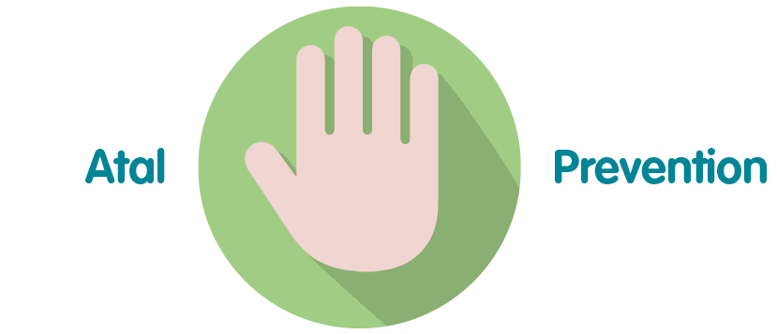 | The action plans put in place to address the various audits recommendations strengthen the governance and provision of its services.
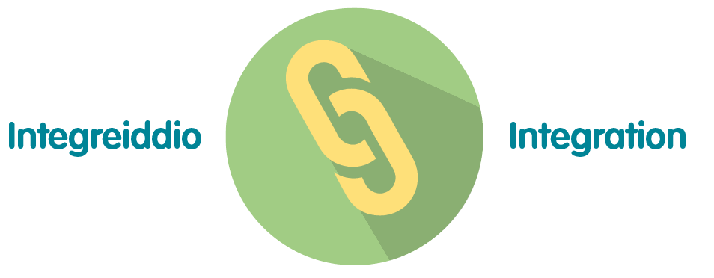 | The action plans put in place to address the various audits recommendations strengthen the governance and provision of its services.
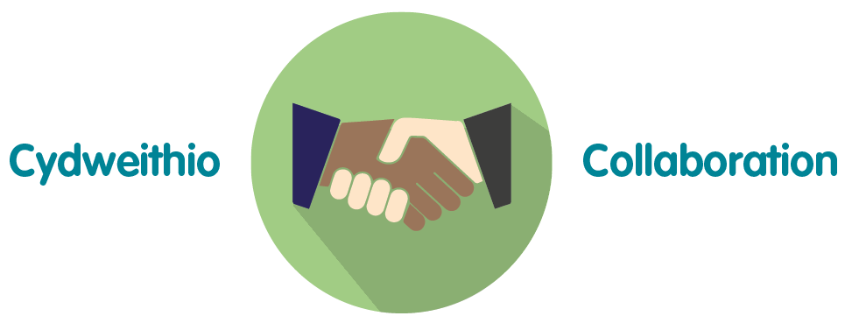 | The management responses to audit reviews were developed in collaboration with staff across the organisation.s
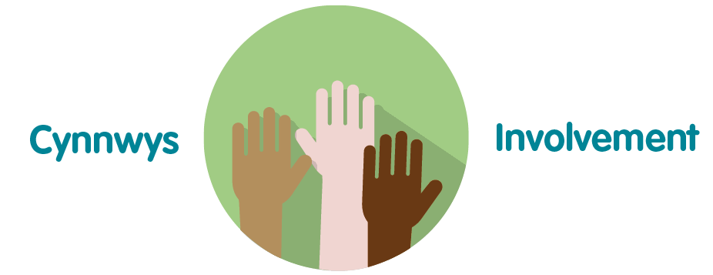 | Responses have been provided by staff in the relevant areas across the organisation.

Recommendation

The Committee is asked to
- Consider the progress updates and proposed amendments to the Audit Action Log, and take assurance on the progress with the implementation of actions from Audit activity.
- Note the amendments to the Audit Action Log, approved by the Business Executive Team on 07 March 2023. (Appendix 1a) (summarised in Section 3.1 of this report)
- Note the completion of the actions detailed in Appendix 1b (summarised in Section 3.2), approved by the Business Executive Team on 07 March 2023.

