 |  |  |  | Name of Meeting  Audit and Corporate Governance Committee
Date of Meeting
5 May 2021
Agenda item:
5.1
Internal Audit Action Log
Executive lead: |  | Helen Bushell, Board Secretary and Head of Board Business
Authors: |  | Liz Blayney, Deputy Board Secretary and Board Governance Manager
Approval/Scrutiny route: |  | N/A
Purpose
The Audit and Corporate Governance Committee receives the Internal Audit Action Log to track progress against agreed management actions in response to the recommendations of internal audit reviews.

The purpose of this report is to draw attention to the amendments made to the Internal Audit Action Log since it was last received by the Committee at its meeting on January 2021.
Recommendation:
APPROVE | CONSIDER |  | RECOMMEND |  | ADOPT | NOTE
The Committee is asked to:
- Consider the amendments to the Internal Audit Action Log
- Approve the request for revised implementation dates in Section 3.1.
- Approve the completion of the actions detailed in Section 3.2.

Link to Public Health Wales Strategic Plan

Public Health Wales has an agreed strategic plan, which has identified seven strategic priorities.

This report contributes to the following:
Strategic Priority | 7 - Building and mobilising knowledge and skills to improve health and well-being across Wales
Summary impact analysis

Equality and Health Impact Assessment | An EHIA is not required for this report. It should be noted that many of the areas of work reported on are likely to have had EHIAs undertaken.
Risk and Assurance | A number of individual internal audit reviews and actions are referenced in the Board Assurance Framework and Risk Registers.
Health and Care Standards | This report supports and/or takes into account the Health and Care Standards for NHS Wales Quality Themes
Health and Care Standards | Governance, Leadership and Accountability
Financial implications | The report has no direct financial implications, although individual updates may include details of impacts.
People implications | The report has no direct people implications, although individual updates may include details of impacts.

Purpose / situation

The Audit and Corporate Governance Committee receives the Internal Audit Action Log to track progress against agreed management actions in response to the recommendations of internal audit reviews.

The purpose of this report is to draw attention to the amendments made to the Internal Audit Action Log since the committee last received it at its meeting on 19 January 2021.

Background

The Audit and Corporate Governance Committee is responsible for maintaining oversight of the planned activity and results of internal audit.
This includes scrutiny of ‘the adequacy of executive and managements response to issues identified by audit, inspection and other assurance activity’.
In order for the Committee to discharge its responsibilities, it needs to receive assurances on the implementation of all recommendations made by internal audit during their review and that the management actions in response to these recommendations are completed. One way that the Committee receives assurance is via the Internal Audit Action Log.
The Action Log enables the tracking of progress against agreed management actions and enables the committee to receive assurance and make decisions based on the update information provided. The revision and completion of any internal audit action requires the approval of the Committee, as does the extension of an agreed timescale.

Updates since the Audit and Corporate Governance Committee meeting held on 15 January 2020

Arrangements are in place to ensure that the Executive Lead provides progress updates on a quarterly basis. The Executive Lead liaises with their team to ensure updating of their actions in accordance with the timescales set.

The Internal Audit Action Log attached to this report (Appendix 1) incorporates all updates provided up to 20 April 2021.

These are shown in red text.

3.1 Requests for Revised Implementation Date

The Committee is asked to approve the following requests for a revised implementation dates for the actions:

Audit Review | Report Rating | Management Action  (abridged) | Original date | Request for revised implementation date
Management of Alerts Follow up Audit | Reasonable assurance | The medical device register should be completed and presented to the appropriate committee for approval as soon as practically possible. Management should decide which business area will maintain the register to ensure that it is kept up to date. | April 2021 | June 2021

3.2 Actions Proposed for Completion

The following actions are proposed for completion. Please note that summary details are provided below and for further information reference should be made to the Internal Audit Action Log provided as Appendix 1.

Audit Review | Action(s)
Processing information under Section 251 of the National Health Service Act 2006 | 417
Diabetic Eye Screening Wales Review 2017/18 | 261
Annual Quality Statement Final Report 2020/21 | 408
Welsh Risk Pool (WRP) Claim Process | 410
Data quality and integrity within performance reports | 411
Financial Systems | 413,414, 415, 416

Well-being of Future Generations (Wales) Act 2015
This report contributes to the following Public Health Wales well-being objectives:
Goal 1 - Build capacity and support system change
Goal 3 - Support the NHS to deliver high quality, equitable and sustainable services

This work has been put together following the five ways of working, as defined within the sustainable development principle in the Act, in the following ways:

 | The action plans put in place to address the various audits recommendations have long-term implications for the organisation, its governance and the provision of its services.
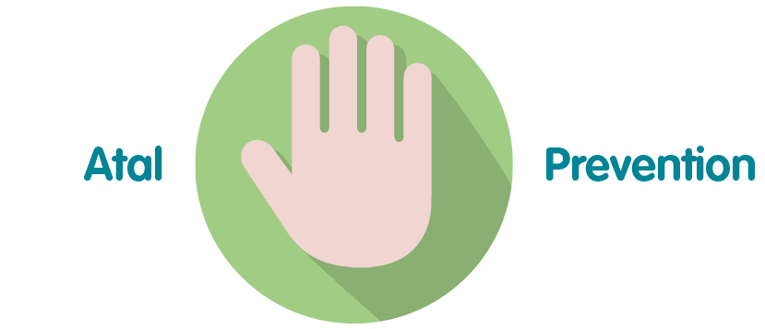 | The action plans put in place to address the various audits recommendations strengthen the governance and provision of its services.
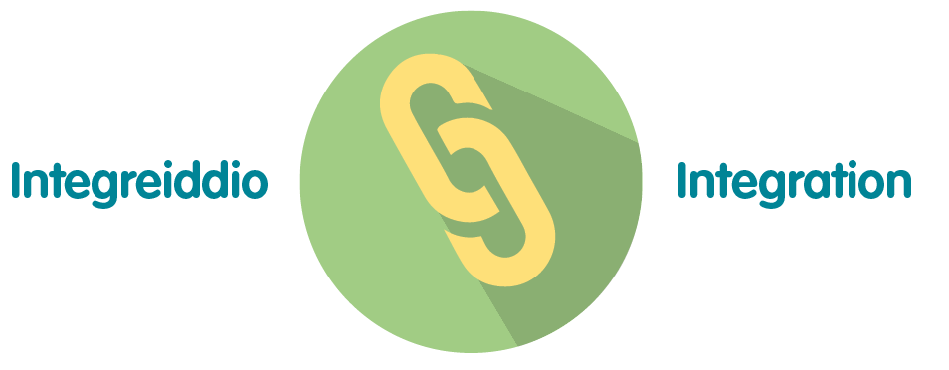 | The action plans put in place to address the various audits recommendations strengthen the governance and provision of its services.
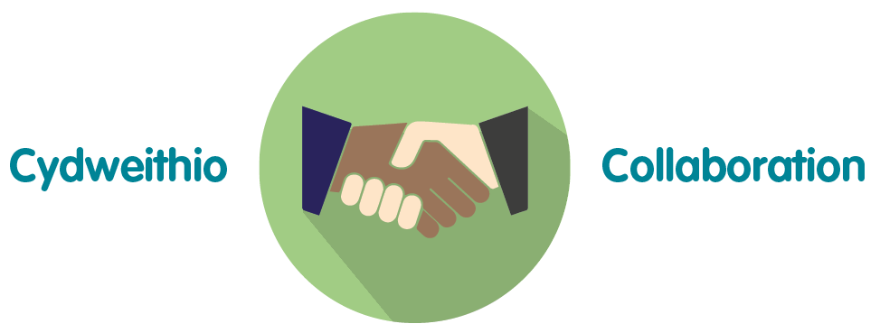 | The management responses to audit reviews were developed in collaboration with staff across the organisation.
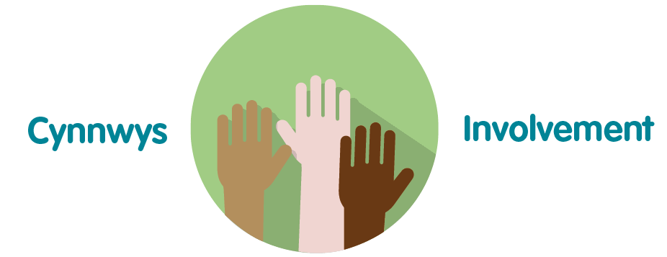 | Responses have been provided by staff in the relevant areas across the organisation.

Recommendation

The Committee is asked to:
- Consider the amendments to the Internal Audit Action Log (Appendix 1).
- Approve the request for revised implementation dates in Section 3.1. (Appendix 1)
- Approve the completion of the actions detailed in Section 3.2. (Appendix 3)

