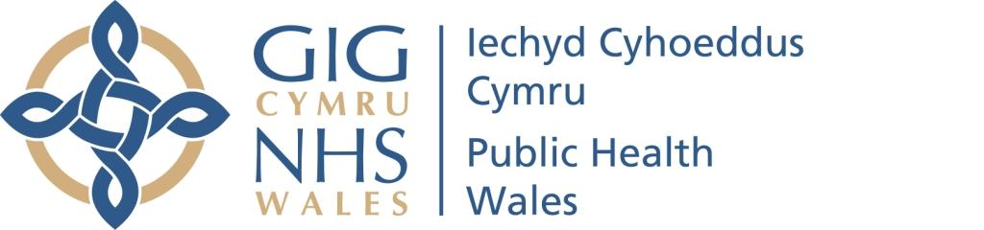

Report of the Chief Executive
Board Meeting September 2020

- COVID-19 Test Trace Protect General Update
Maintaining and continuing our response to the COVID-19 pandemic and the Test Trace Protect Protect programme remains the key priority for the organisation.
A number of outbreaks and incidents have steadily continued to emerge across the country and a verbal update on them will be provided at the meeting.

The last few weeks have been particularly busy across all of our key COVID-19 functions as the incidence of COVID-19 has increased in Wales and particularly in particular local authority areas. We have worked closely with the respective health boards and local authorities in areas where incidents and outbreaks are occurring. This has included our National Health Response Team, our surveillance teams, our microbiology service and our communications team. This has involved the teams chairing various incident meetings, undertaking rapid turnaround, surge laboratory testing to support the management and containment of the incident/outbreak as appropriate and providing ongoing technical advice to the Welsh Government and other partners in relation to this phase of the pandemic.

Our World Health Organization Collaborating Centre and Policy and International Health Team continue to assess the international learning from COVID-19 and also assess the impact that it is having on the broader population health and well-being of our population. This has resulted in Mark Bellis, our Director of Policy and International Health and World Health Organization Collaborating Centre, delivering a number of sessions and presentations to the NHS Wales Executive Board, various officials across the Welsh Government and the Welsh Government Cabinet.

- Public Health Wales Data Breach
On the afternoon of Sunday 30 August 2020, Public Health Wales inadvertently published a report on a public facing website which contained personal data relating to 18,105 people who had tested positive for Covid19 since February 2020. Although the website was public facing, it is not one generally accessed by members of the public, but by trusted partners. After being alerted to the breach the document was removed at 0955 the following morning (31 August) and in the time it was available it is understood that it was viewed 56 times.
In the majority of cases (16,179 people) the information consisted of people’s initials, date of birth, geographical area and sex meaning that the risk they could be identified is low. However, for 1,926 people living in nursing homes or other enclosed settings such as supported housing, or residents who share the same postcode as these settings, the information also included the name of the setting. The risk of identification for these individuals therefore is higher but is still considered low.
In the time that it was in the public domain, it is understood that the dashboard was viewed 56 times. This does not mean however that 56 people viewed it, it is feasible that any one person will have viewed it multiple times and so the number of people who actually viewed it is likely to be less than 56.
A full risk assessment was carried out in accordance with the General Data Protection Regulations and the incident was reported to the Information Commissioner on the 2 September. The incident was also reported to the Improving Patient Safety Team at Welsh Government on the 2 September.
Although the data published was assessed as being low risk, specialist legal advice was also sought on 2 September.
Having considered the risk assessment and legal advice, and our strong commitment to being an open and transparent public body, a proactive public statement was issued on the 14 September 2020 at 14:00 and a number of press interviews were subsequently held. Questions and answers relating to the data breach were available on the website and an email and phone number were also made available for people who wanted further information or discussion.
In the meantime, immediate steps have been taken to prevent a similar incident from happening again:
- the dashboard was removed from the public facing list of available dashboards
- the Standard Operating Procedure has been updated to separate the internal and external dashboard processes and to include additional checks on the hosting servers
- the initials, DOB and closed setting name were removed from the underlying data so even if incorrectly published again, there would not be a similar data breach
- we have reinforced the importance of information governance principles to surveillance teams when publishing data.
We have also engaged with our health board and local authority partners to keep them up abreast of progress as part of the Joint Data Controller Agreement that is in place.
An external, independent investigation has been commissioned and commenced into the full circumstances surrounding the data breach and any lessons to be learned. This will be reported to the Board when concluded.
On behalf of the Executive, I would like to take the opportunity once more to apologise profusely for this breach of people’s personal details. We have already taken immediate action to prevent it happening again and the investigation will provide further detail as to how it occurred, whether further actions are required and what lessons must be learnt

3 Update on Population Screening Programmes
Following the Welsh Government’s announcement in March of plans to suspend non-urgent outpatient appointments to redirect resources to support the response to Coronavirus pandemic, the Welsh Government agreed the recommendations of Public Health Wales to temporarily pause some of the population based screening programmes. The Chief Medical Officer’s approval was conditional on the situation being reviewed in eight weeks.
The temporary pause affected Breast Test Wales, Cervical Screening Wales, Bowel Screening Wales, Diabetic Eye Screening Wales and Wales Abdominal Aortic Aneurysm Screening. The Antenatal Screening Programme, Newborn Bloodspot Screening Programme and Newborn Hearing Screening Programme were not paused given the significant implications for newborns.
As the numbers of COVID-19 cases started to reduce in May, plans to reinstate the screening programmes were proposed and supported by Public Health Wales and the relevant Welsh Government leads. The approach taken was to set out the criteria required to restart screening, to take a risk assessed approach to prioritise the cohort of participants requiring their offer and to safely phase the programmes restart.
A detailed restart plan was agreed and implemented. Cervical Screening restarted sending invitations at the end of June firstly to women on early repeat as priority. Bowel Screening Wales restarted sending invitations in August, Breast Test Wales started inviting high-risk women to attend screening in August, Wales Abdominal Aortic Aneurysm Screening started inviting surveillance men in August and Diabetic Eye Screening Wales started inviting high risk participants in September. All of the screening programme have now been reinstated.
The screening test remains the same but the pathways have been adapted to be COVID-19 secure. This has included triaging the participants to ensure that they do not have symptoms or should be self-isolating, requesting the participants to wear face covering, infection prevention control measures, redesigning the pathway to reduce contact and maintaining social distancing between participants. This has meant that the capacity of the screening clinics has reduced and this will have an impact on the time it will take to recover the programmes fully.
A vital element of the planning for the restart of screening has been the ongoing operational dialogue between the screening programmes and their local health board counterparts. In addition, each health board has nominated a key strategic lead who is engaged at a high level to provide a point of escalation and to ensure that the reintroduction of screening activity does not create service bottlenecks within the referral services.
Contingency plans for the screening programmes, in anticipation of a second wave or local spikes of COVID-19, have been agreed. The recommendation is to continue with the reinstatement and delivery of screening services, taking into account that changes to service delivery would need to be considered if local or national increases in cases caused change in one or more of the criteria defined for safe screening service.
One of the key constraints currently is the reduction in the availability of clinic venues to deliver the service. Diabetic Eye Screening Wales, Wales Abdominal Aortic Aneurysm Screening and elements of Newborn Hearing Screening Wales programmes are reliant on local health board venues as the screening teams bring equipment to deliver a local service health board residents. Previous to the pandemic, Diabetic Eye Screening delivered services at 137 venues and now have access to only 24 venues and Aneurysm Screening delivered services at 71 venues and now has access to only 26 venues. Improving access to venues is vital to be able to offer services to those that have had their screening delayed by the pandemic. The screening team are continuing to engage with partners to seek alternative venues to address this although it remains challenging.

Recommendation

The Board is asked to receive this information.

Tracey Cooper
CHIEF EXECUTIVE

