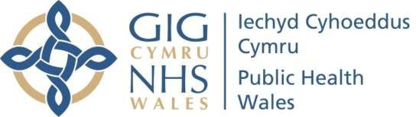
Name of Meeting Board
Date of Meeting
26 January 2023
Agenda Item
4.3

Corporate Policies and Procedures – Annual Compliance Report
Executive lead: | Liz Blayney, Acting Board Secretary and Head of Board Business Unit
Author: | Reanne Reffell, Acting Board Governance Manager
Liz Blayney, Acting Board Secretary and Head of Board Business Unit
Business Executive Team (Circulated on 13 January 2023)

Approval/Scrutiny route:
The report provides the Board with an update on the status of the Corporate policies, procedures and other written control documents across the organisation.

Appendix 1 (a-f) is an extract taken from the Corporate Policy, Procedures and Other Written Control Documents register and shows the status of documents as of 10 January 2023.

Purpose

Recommendation:
APPROVE | CONSIDER | RECOMMEND | ADOPT | Assurance
The Board is asked to:
- Take assurance on the prioritisation and progress being made to review policies, procedures and other written control documents.

Link to Public Health Wales Strategic Plan

Public Health Wales has an agreed strategic plan, which has identified seven strategic priorities and well-being objectives.

This report contributes to seven of the strategic priorities and well-being objectives.

Summary impact analysis
Equality and Health Impact Assessment | An Equality and Health Impact Assessment is not required in support of this report. An impact assessment should be undertaken for each of the respective policies when they are  developed or reviewed.
Risk and Assurance | A risk assessment has been undertaken for each policy which has passed its review date. These are captured in the accompanying register (see Appendix 1) and a summary is  detailed below.
Health and Care Standards | This report supports and/or takes into account the Health and Care Standards for NHS Wales Quality Themes  Governance, Leadership and Accountability
Financial implications | Not applicable
People implications | Not applicable

Purpose / situation

The report provides the Board with an update on the status of the policies, procedures and other written control documents (policies) across the organisation.

Appendix 1 (a-f) is an extract taken from the central Policy and Control Document Register and shows the status of documents as at 10 January 2023.

Background

The Board approved a new organisation-wide Policy and Written Control Documents Policy and Procedure in July 2022. All new/revised documents are now developed and approved in accordance with the provisions and processes set out in these documents.

The procedure specifies that the Register will be reported annually to the Board, and the relevant sections reported to Board committees Bi-Annually. This provides the Board and Committees with assurance that required policies, procedures and other written control documents are being developed and maintained.

The Business Executive Team Meeting consider a compliance report on a quarterly basis.

Each of the Committees review the an extract of the register on a Bi-Annual Basis, to consider those within the remit of the Committee.

Description/Assessment

  - Status of policies and other written control documents

There are 144 policies and other written control documents on the Corporate Policy, Procedures and Other Written Control Documents register.

As of 10 January 2022, 63 (45%) policies/procedures are in date,
77 (55%) policies are due for review (and therefore out of date). 17 Policies, Procedures and Other Written Control Documents have been approved since the last update to the Business Executive Team (15 September 2022).

For all of the policies due for review, the decision updates are provided within appendix 1, broken down by Directorate for ease of reference:

 |  | Total | In date | Out of Date
Appendix A | Board Business Unit | 10 | 5 | 5
Appendix B | Health Protection and Screening | 7 | 4 | 3
Appendix C | Knowledge | 2 | 2 | 0
Appendix D | Operations and Finance | 37 | 9 | 28
Appendix E | People and Organisational Development | 40 | 16 | 24
Appendix F | Quality, Nursing and Allied Health Professionals | 48 | 27 | 21
 |  | 144 | 63 | 81

Of the 81 that are currently out of date:
- 39 are in the progress of being reviewed, and are scheduled for approval between now and the end of March 2023. The dates of the relevant meetings have been included in the updates provided.

- 9 are pending the development of an all wales policy. All Wales Policy review scheduled is currently being agreed by the Welsh Partnership Forum for the following:
  - Disciplinary policy and procedure (All Wales)
  - Capability Policy (All Wales)
  - Special Leave Policy (All Wales)
  - Recruitment and retention protocol (All Wales)
  - Menopause Policy (All Wales)
  - Organisational Change Policy (All Wales)
  - Social Media Policy (All Wales)
  - Standing Orders (Welsh Government to issue)
  - Reserve Forces Training and Mobilisation Policy (All Wales)

Executive colleagues responsible for the policies due for review are aware and taking active steps to ensure policies/procedures are reviewed and appropriate approval sought.

Work is ongoing to review the overall policy list with each lead to review the number of policies on the register and look to reduce and combine where possible.

Policy review status | Policy not yet approved but low risk presented | Policy not yet approved and moderate risk presented. | Policy not yet approved and high risk presented. | Risk assessment awaited | Number of Policies
Date passed - action underway | 74 | 7 | 0 | 0 | 81

3.3 Well-being of Future Generations (Wales) Act 2015

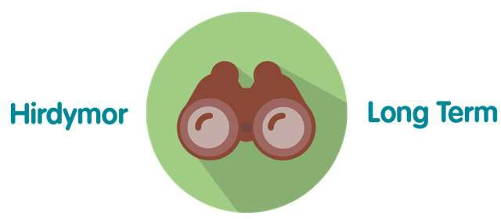
Organisational policies, procedures and written control documents provide the organisation with long-term controls for risks.

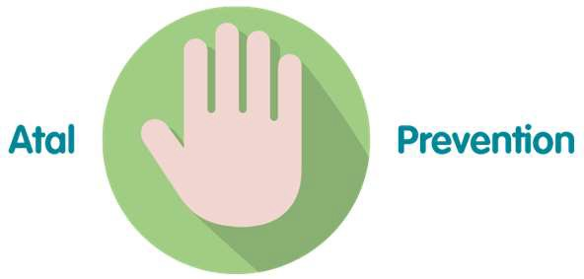
Organisational policies, procedures and written control documents provide staff within instruction and guidance, to prevent non- compliance.
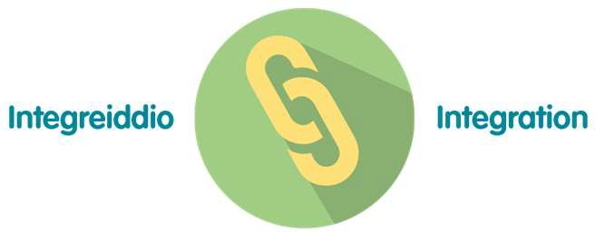
A number of policies, procedures and written control documents are interdependent with one another. Content is cross-referenced and integrated as appropriate.
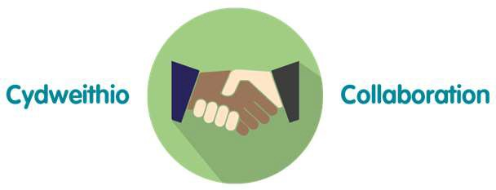
All policies, procedures and written control documents (and associated EHIAs) are developed on a collaborative basis.

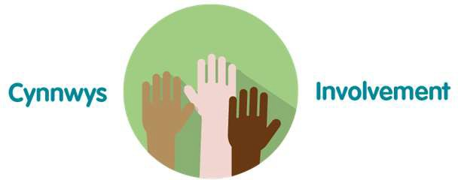
During development and review policies and written control document are made available to Public Health Wales staff so that they can provide comment for consideration

- Recommendation

The Board is asked to:

- Take assurance on the prioritisation and progress being made to review policies, procedures and other written control documents.

