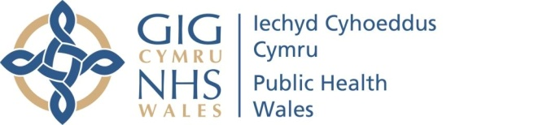 |  |  |  |  | Name of Meeting  Board
Date of Meeting
26 January 2023
Agenda item:
4.2
Performance and Insight Report

Executive lead: | Huw George, Deputy Chief Executive/ Executive Director Operations and Finance
Contributors: | Huw George, Deputy Chief Executive and Executive Director of Operations and Finance; Meng Khaw, National Director of Screening & Health Protection; Neil Lewis, Director of People and Organisational Development; Rhiannon Beaumont-Wood, Executive Director of Quality Nursing and Other Allied Health Professionals; Angela Fisher, Deputy Director of Finance; Ioan Francis, Head of Performance
Approval/Scrutiny route: | Business Executive Team (16 January 2023)
Purpose
Our Performance and Insight Report focuses on delivering actionable insights whilst identifying areas for further improvement across the following key performance themes;

- Maintaining a healthy and sustainable workforce
- Achieving value and impact through innovation
- Delivering organisational wide quality and access to high quality services
- Improved population health and well-being

The report is designed to be read in conjunction with the Performance and Assurance Dashboard and Public Health Rapid Overview Dashboard.

In line with our agreed IMTP accountability conditions with Welsh Government, Annex A outlines Public Health Wales’ quarter 3 2022/23 update against key activity and forecast data within the NHS Wales Minimum Dataset.

Recommendation:
APPROVE |  | CONSIDER |  | RECOMMEND |  | ADOPT | ASSURANCE
The Board is asked to:

- Discuss and scrutinise the paper and provide feedback and comments;
- Note the proposed approach to fulfil our mandated reporting requirement for the remainder of 2022/23 to ensure compliance with the NHS Wales Performance Management Framework.
Link to Public Health Wales Strategic Plan

Public Health Wales has an agreed strategic plan, which has identified seven strategic priorities and well-being objectives.

In order for Public Health Wales to deliver the strategic plan, effective performance management arrangements need to be in place to monitor and report on progress against achieving our strategic priorities to improve health outcomes. This intelligence is used to draw the Board’s attention to areas of underperformance and is fundamental for effective and efficient decision making.

This report contributes to the following:
Strategic Priority/Well-being Objective |  |  | All Strategic Priorities/Well-being Objectives
Summary impact analysis

Equality and Health Impact Assessment |  |  | An Equality and Health Impact Assessment is not required. Equality and Health Impact Assessments will be completed as part of delivery of the specific actions within the Plan.
Risk and Assurance |  |  | Our Strategic Risks are detailed within Our Strategic Plan and the Implementation Plan for the Test Trace Protect Strategy.
Health and Care Standards |  |  | This report supports and/or takes into account the Health and Care Standards for NHS Wales Quality Themes
 |  |  | All themes
Financial implications |  |  | An update on the organisation’s financial performance is enclosed
People implications |  |  | An update on the organisation’s people performance is enclosed

- Purpose / situation

Our Performance and Insights Report focuses on delivering actionable insights whilst identifying areas for improvement across the following key performance themes;
  - Maintaining a healthy and sustainable workforce
  - Achieving value and impact through innovation
  - Delivering organisational wide quality and access to high quality services
  - Improved population health and well-being

This approach supports the Board and its Committees in discharging their responsibilities. The reporting of the four key themes will see us align to the Welsh Government’s A Healthier Wales quadruple aims and key measures set out in the 2022/23 NHS Wales Performance Framework.
The report is designed to be read in conjunction with the Performance and Assurance Dashboard (PAD) and the Public Health Rapid Overview Dashboard. The themes are demonstrated throughout this month’s report and are also reflected in the PAD.
Annex A outlines Public Health Wales’ quarter 3 update against key activity and forecast data within the NHS Wales Minimum Dataset (MDS). The MDS forms an important part of our agreed IMTP accountability conditions with Welsh Government in 2022/23.

- Background

Access to high quality, timely and robust performance information is essential in providing assurance to our Executive Team and Board on our ongoing COVID-19 recovery, delivery of public health services and functions, and our role in improving population health and well-being.
Having strengthened our performance arrangements over the last 12-24 months through the successful development of the PAD we recognised the need to strengthen the accompanying Performance and Insight Report.
The December 2022 PAD can be accessed using the following Link, or by navigating from specific areas of interest in the report by selecting the following symbol , thus enabling direct access to the latest available performance information.
In addition, during the June 2022 Board development session we identified the need to bring forward the latest data from the Public Health Rapid Overview Dashboard.
- Description/Assessment

Key points to consider in this month’s Performance and Insight Report are:
- Good progress continues to be reported in the delivery of our Strategic Plan milestones at month 9. 38.6% (140) milestones on track, 54.3% (197) milestones complete, 2.8% (10) of milestones have the potential to fall behind schedule and 4.4% (16) rated red and behind schedule. 30 milestones were completed in month 9.
- Sickness absence increased from 4.19% to 5.39% in December 2022 following a stable period over the last four months, with the 12-month rolling sickness absence at 4.51%. The highest rates of sickness absence were within Screening (8.04%), Microbiology (6.95%) and the NHS Wales Collaborative (5.4%).
- Approximately 47% of Public Health Wales staff have received the flu vaccine with uptake among front-line slightly lower at 46.4% (up from 43% and 41.3% respectively last month). Around 53% of staff have received the COVID-19 booster with uptake at over 58% for front-line staff.
- Staff appraisal compliance saw a slight decrease to 69.1% in December 2022, following the recent improving trend. Compliance remains below the 85% Welsh Government target.
- The Annual Equality and Annual Workforce Diversity Reports were published at the end of 2022. The reports show an increase in the number of Black Asian and Minority Ethnic Staff, LGBTQ+ staff and Disabled staff in the organisation.
- Our cumulative reported position at month 9 2022/23 is a net surplus of £261k (£35k in-month), with an anticipated breakeven position at year-end. The surplus is a combination of higher than anticipated bank interest and variances across a number of Directorates against spending plans at month 9.
- Our capital funding for 2022/23 totals £6.827m with year to date spend at £3.222m. Our current capital allocation is pending an adjustment to reflect the transfer of the LINC and RISP programmes to Digital Health and Care Wales (DHCW) on 1 January 2023 totalling £1.433m. Of the £3.605m remaining, £1.564m of additional orders have already been placed and £0.880m will transfer to DHCW.
- Performance for our year to date Public Sector Payment Policy is above the statutory target at 96.33% (96.13% in month 9) and is expected to remain above target. Year to date agency spend as a percentage of total pay equates to 3.3% with a year-end forecast of 3.3%.
- No significant COVID-19 incidents or outbreaks have been reported this month although multiple Omicron variants are co-circulating. The recent uptick in hospital admissions (mainly in 60+ age groups) appears to have plateaued. Turnaround compliance for non-rapids and rapids were 86% and 90%, respectively.
- Screening recovery plans continue to be progressed and active mitigation undertaken to maintain service provision despite ongoing strike action. Whilst business continuity plans have been effective, there was an increase in rejected bowel screening kits due to the length of time taken to reach the laboratory.
- Breast Screening has continued to implement the equipment replacement programme and four of the new mobiles have been received and operational. The other mobiles are planned to be received by end of March 2023, and will help with recovery as it reduces the breakdown of old mobiles.
- Latest mandatory childhood vaccination data reported within the COVER 144 report showed that for children aged 1, uptake of the “6 in 1” vaccination remained below 95% at 94.7%, compared to 94% last quarter. In children reaching five years of age this quarter, coverage of two doses of MMR was 90.0%.
- One No Surprises incident was reported in December 2022 related to an issue providing cervical screening history for participants who move between Wales and England. Manual records have been provided in the interim, and regular meetings are taking place to resolve which are being led by England. NHS Digital are working to develop an automated electronic method.
- The Strategic and Corporate Risk Registers continue to be monitored and updated to determine the risk scores, controls and actions. The latest delivery confidence assessment has been provided in the report and further work will be undertaken to ensure mitigating actions are up to date and being progressed.

Further insights from the Performance and Assurance Dashboard can be found on page 2 – Key Performance and Insights Summary.
Performance and Assurance Dashboard (not publically available)
https://phw-tableau.cymru.nhs.uk/t/CorporateAnalyticsPreProduction/views/RecoveryDashboardLandingPage/LandingPage?:linktarget=_self&:embed=yes#1

Public Health Rapid Overview Dashboard (not publically available)
Public Health Rapid Overview Dashboard

- Annex A- NHS Wales Minimum Dataset 2022/23

In line with agreed IMTP accountability conditions, Public Health Wales is required to provide regular updates against key activity and forecast data in 2022/23.
The NHS Wales Minimum Dataset has been updated and contains the following updates at Quarter 3 2022/23:

- Ministerial Priorities measures
- Workforce YTD and forecast
- Test Trace Protect – testing capacity
- Screening YTD and forecast
- Microbiology (tests related to sexual health) YTD and forecast

Updates have not been provided for other parts of the NHS Wales Minimum Dataset as they are either not applicable to Public Health Wales or have been captured as part of the latest Finance MMR submission, in line with guidance received from Welsh Government.
The updated NHS Wales Minimum Dataset was submitted to Welsh Government in line with the agreed deadline following the Business Executive Team meeting on 16 January 2023.

- Well-being of Future Generations (Wales) Act 2015

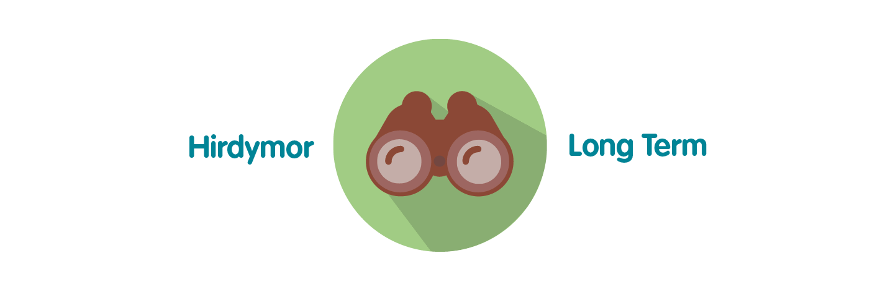 | Ensures Public Health Wales is able to successfully monitor the delivery of its functions; assess areas of underperformance; and can use this intelligence and knowledge to aid decision making.
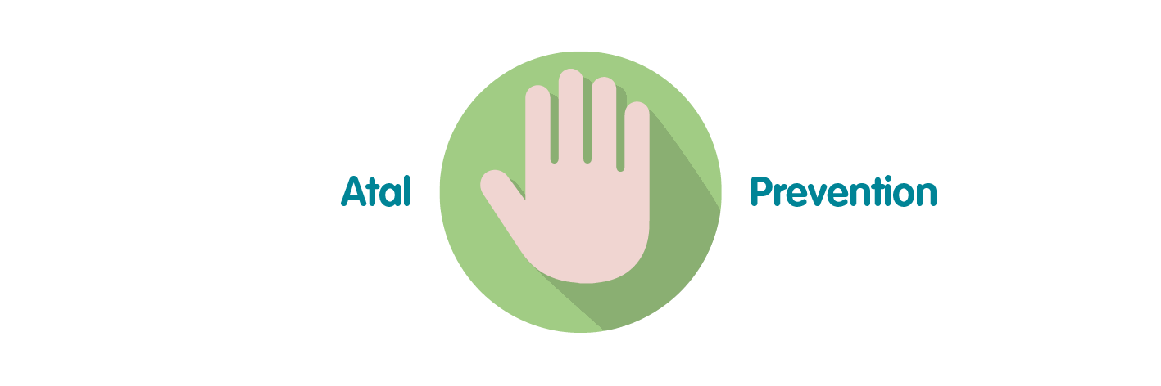 | Effective and efficient decision making by senior managers, Executive Team and the Board is paramount to successful performance of the organisation in order for it to achieve its purpose, whilst preventing the potential to cause harm through underperformance.
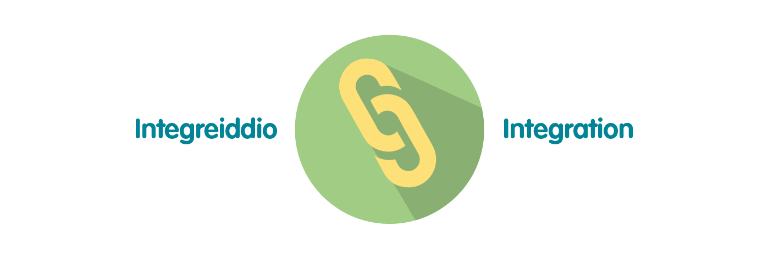 | The development of Public Health Wales’ Long Term Strategy and Integrated Medium Term Plan has been grounded in collaboration and integration across our workforce. To demonstrate that the organisation is achieving what it set out to achieve over the short, medium and long term, high quality monitoring and reporting of information is essential through the integrated performance report. This approach has been reflected in the approach to the pandemic response.
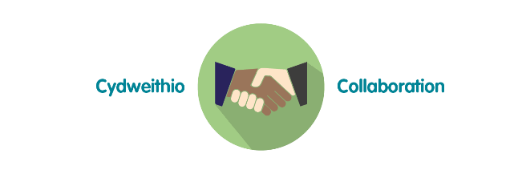 | Reporting of data and information through the integrated performance report requires collaboration across the organisation to ensure timely delivery of key service, quality, workforce and financial data. The potential for the development of business intelligence tools will require close working relationships with Directorates and especially Informatics to maximise potential.
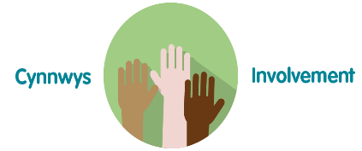 | To ensure compliance with the Welsh Audit Office Structured Assessment, agreeing and reporting Division / Directorate level performance measures will require involvement across the full breadth of the organisation. Monitoring and reporting against the strategic plan will involve working closely with staff to ensure accurate and timely intelligence for the Executive Team and Board.
- Recommendation

The Public Health Wales Board is asked to:

- Discuss and scrutinise the paper and provide feedback and comments;
- Note the update to Public Health Wales’ activity and forecast data within the NHS Wales Minimum Dataset which forms part of our agreed IMTP accountability conditions with Welsh Government for 2022/23.

