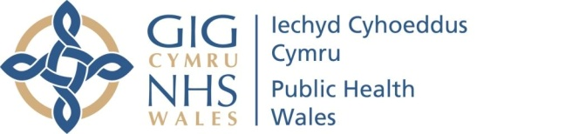 |  |  |  | Name of Meeting  Board
Date of Meeting
24 November 2022
Agenda item:
3
Public Health Merit Award (Badge)
Executive lead: |  | Rhiannon Beaumont-Wood, Executive Director of Quality & Nursing
Author: |  | Rebecca Fogarty, Engagement & Collaboration Manager
Approval/Scrutiny route: |  | Rhiannon Beaumont-Wood, Executive Director of Quality & Nursing  Business Executive Team information circulated (17.11.22)
Purpose
This paper provides information on the Public Health Merit Award scheme, which has been coproduced with partners in established youth organisations. The aim of the scheme is to equip children & young people with the public health skills and knowledge to make informed decisions to protect and improve their own health, thus protecting and improving the health of the community and narrowing health inequalities.
The scheme has made good progress, with a curriculum now being piloted by our delivery partners (St John Ambulance, Scouts Cymru and the Army Cadets). Upon completion of the curriculum, young people will be awarded with their Public Health badge, which has been designed in collaboration with young people.
This paper accompanies a short video capturing the perspectives of different stakeholders in the project, including the voice of young people who have been part of the first cohort undertaking the programme.
Recommendation:
APPROVE | CONSIDER |  | RECOMMEND |  | ADOPT | ASSURANCE
The Board is asked to:
- To consider and endorse the approach of the public health merit award scheme and the co-productive approach taken throughout.

Link to Public Health Wales Strategic Plan

Public Health Wales has an agreed strategic plan, which has identified seven strategic priorities and well-being objectives.

This report contributes to the following:
Strategic Priority/Well-being Objective | 3 - Promoting healthy behaviours
Strategic Priority/Well-being Objective | 5 - Protecting the public from infection and environmental threats to health
Strategic Priority/Well-being Objective | 2 - Improving mental-well-being and building resilience
Summary impact analysis

Equality and Health Impact Assessment | EHIA attached.
Risk and Assurance | n/a
Health and Care Standards | This report supports and/or takes into account the Health and Care Standards for NHS Wales Quality Themes
Health and Care Standards | Theme 1 - Staying Healthy
Health and Care Standards | Choose an item.
Health and Care Standards | Choose an item.
Financial implications | The financial implications are laid out in section 3.3 of the paper.
People implications | No impact

Purpose / situation

This paper provides information on the Public Health Merit Award scheme, which has been coproduced with partners in established youth organisations. The aim of the scheme is to equip children & young people with the public health skills and knowledge to make informed decisions to protect and improve their own health, thus protecting and improving the health of the community and narrowing health inequalities. Children & young people will work through a curriculum with their youth leaders and when they can demonstrate they have achieved all of the assessment criteria, they will be awarded with a public health badge.
The scheme has made good progress. The co-production of the curriculum has been led by St John Ambulance and it is now being piloted by our delivery partners (St John Ambulance, Scouts Cymru and the Army Cadets). The badge has been designed in collaboration with young people, through a design competition which has been judged by PHW Young Ambassadors.

Background

In the context of the pandemic, health literacy and awareness of the role of public health institutes has increased. Young people have experienced a historic public health event at an early stage in their lives and there is an opportunity to build on this to equip and empower young people to play their role in protecting and improving public health.

Through established youth organisations, there is a route to provide an age-appropriate, interactive introduction to public health through a Public Health Merit Award. There are examples of how this would work internationally, notably the Public Health Merit Badge from the Boy Scouts of America. There are elements of public health in a number of existing badges in Welsh youth organisations, but feedback from these indicates that there would be value in a specific public health badge to bring together and reinforce public health knowledge and skills.

Description/Assessment

Progress to date

- A steering group made up of representatives from Public Health Wales, St John Ambulance, Scouts Cymru and the Army Cadets has overseen the project so far. Internally, we have sought the views of colleagues within a number of directorates, including WHO CC, Health & Well-being and Public Health Services to inform the format and content of the curriculum.

- The curriculum is attached. It has been co-produced between St John Ambulance & Public Health Wales, with advice from other Steering Group members to ensure it is appropriate for use in a range of youth settings. It aims to provide a broad introduction to public health topics in an age-appropriate, interactive and engaging way. In particular, the project element is designed to encourage some element of peer-to-peer or community sharing that will broaden the impact of the course.

- Our delivery partners have identified suitable groups of young people to be ‘early adopters’ of the merit award scheme, in a range of settings. This includes a residential event with the Army Cadets which took place during October half-term, day events planned for the autumn with St John Ambulance and groups meeting regularly with both Scouts Cymru, and into 2023, St John Ambulance.

- The curriculum and other project materials will continue to be developed following feedback from young people and youth leaders who complete the award as part of this pilot phase.

- A promotional video featuring young people and the project’s partners has been developed by PHW Communications to:
  - Promote the merit award to young people as an exciting opportunity to gain vital skills and knowledge to enable them to promote public health and make a difference in their community.
  - Illustrate the breadth of the field of public health and the potential impact that enabling and empowering young people as advocates for public health could have on improving their own health, that of their communities and addressing health inequalities.
  - Drive youth leaders and young people to the published curriculum to increase uptake of the merit award.

- Addressing health inequalities is an important aspect of the project. The Equality & Health Impact Assessment identified the risk of widening health inequalities in groups who are under-represented in established youth organisations. Our delivery partners have told us about their strategies to increase the diversity of their membership, including recruitment strategies and in some cases grant funding available to widen access to people in a lower socio-economic position. We have also designed the curriculum in a user-friendly format to encourage its use in other youth settings in the future e.g. community groups.

Evaluation

- Investment has been secured to finance an external evaluation led by an academic partner. This will ensure a rigorous evaluation that will guide the next phase of the scheme’s roll-out.

- Steering Group members collaboratively developed a logic model to identify key outcomes that will be the focus of the evaluation.

- At this early stage in the project, it is anticipated that this will focus on:
  - Participation, including barriers and reach across different population groups (e.g. deprivation, ethnicity, additional learning needs etc.)
  - Acceptability of the curriculum
  - Learning
  - Motivation
  - Personal development/behaviour change

- The findings of this evaluation will inform any further improvement to the scheme before wider roll-out to make it accessible to any youth setting in Wales.

- It is planned in the wider roll-out that the curriculum will be freely available on the Public Health Wales website, subject to those who wish to download it supplying basic contact information. This will enable us to reach out to users to undertake ongoing quality assurance and further evaluation as the project develops.

Financial implications

- To date, all partners have taken part in this project free of charge.

- Investment funding of £20,000 has been secured to undertake a rigorous, independent evaluation of the pilot phase.

- Public Health Wales would look to provide an initial batch of badges for award. These are more cost-effective if bought in large quantities. For example, one supplier has provided the following costs:

Number of badges | Cost per badge | Total cost
100 | £1.19 | £119
500 | £0.52 | £260
1000 | £0.39 | £390
5000 | £0.32 | £1600

Well-being of Future Generations (Wales) Act 2015

This work has been put together following the five ways of working, as defined within the sustainable development principle in the Act, in the following ways:

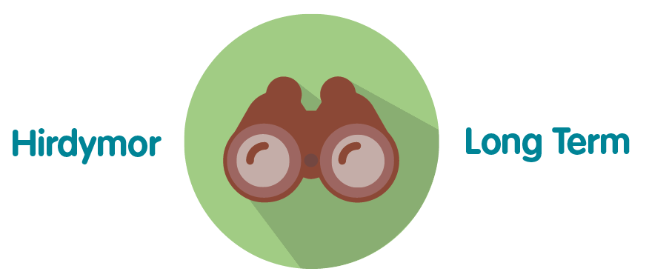 | Working with delivery partners we have created a merit award scheme that is flexible and adaptable to future contexts. Youth leaders of the future will be able to work with the curriculum without the need for in-depth training. This means it will be available to children and young people in the long-term without any need for major investment.
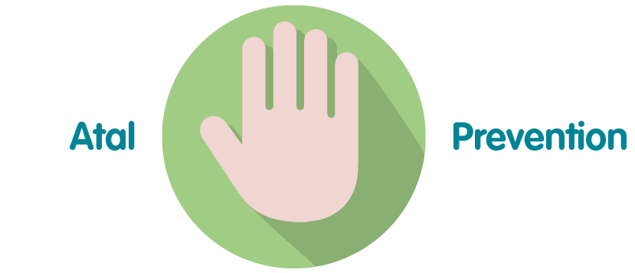 | The merit award scheme offers the opportunity to reach people early in their lives with important public health information and messages. This offers an important opportunity for prevention, such as raising awareness of the importance of physical activity, or the risks of drug or tobacco use at an early age, and embed healthy behaviours that are crucial for prevention.
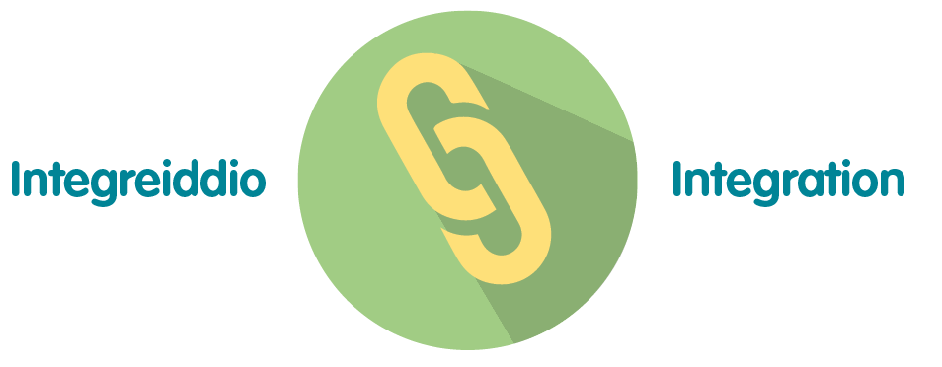 | The merit award looks at public health holistically, including elements from across multiple public health topics and domains. The curriculum also interfaces naturally with other youth merit awards, demonstrating the links between public health competencies and other skill areas e.g. Environmental Conservation, First Aid, Physical Activity badges.
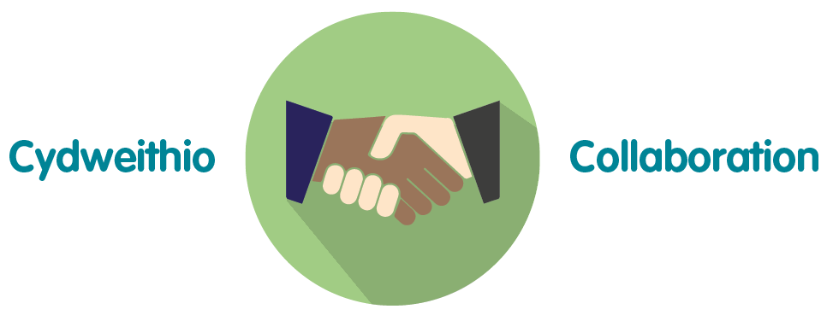 | We have worked with three established youth organisations in the development of this scheme, who are expertly placed to advise on working with children and young people and the opportunities for engagement presented by existing youth structures.
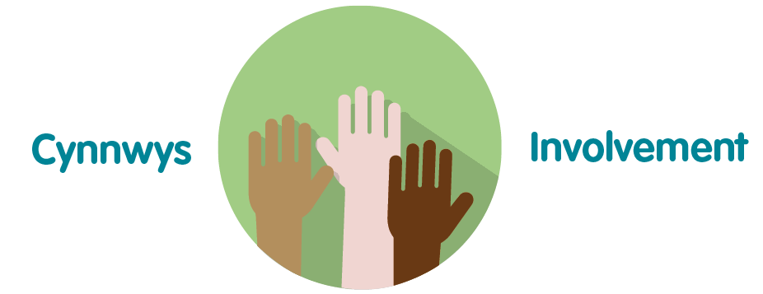 | We have involved children and young people in the design of the badge. Their feedback will be integral to iterative improvements in the curriculum and learning materials.

Recommendation

The above paper provides information on the progress on the public health merit award scheme to date and plans for its future roll-out.

The Board is asked to:
- To consider and endorse on the progress of the public health merit award scheme and the co-productive approach taken throughout

