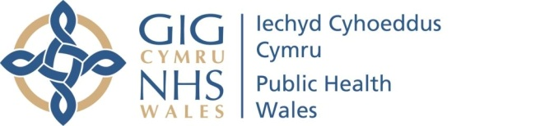 |  |  |  | Name of Meeting  Board
Date of Meeting
28 January 2021
Agenda item:
3.8.2. 28012021
Gender Pay Gap Report
Executive lead: |  | Neil Lewis, Acting Director of People and Organisational Development
Author: |  | Sarah Morgan, Head of Employee Experience
Approval/Scrutiny route: |  | Neil Lewis, Acting Director of People and Organisational Development.  The Business Executive Team approved the report to be sent to the Board on the 6 January 2021.
Purpose
The purpose of this paper is to provide background explanation to accompany the Gender Pay Gap Report 2019-20 and request approval of the report.

The last report was approved by the People and Organisational Development Committee in February 2020; as the Committee has been temporarily suspended owing to the COVID-19 pandemic, the report is being provided to the Board.
Recommendation:
APPROVE | CONSIDER |  | RECOMMEND |  | ADOPT | NOTE
The Executive Team is asked to:
- Approve the Gender Pay Gap Report 2019-20

Link to Public Health Wales Strategic Plan

Public Health Wales has an agreed strategic plan, which has identified seven strategic priorities.

This report contributes to the following:
Strategic Priority | 7 - Building and mobilising knowledge and skills to improve health and well-being across Wales
Strategic Priority | Choose an item.
Strategic Priority | Choose an item.
Summary impact analysis

Equality and Health Impact Assessment | An EQIA is not required as the plan is focused on Equality, and no decision is required.
Risk and Assurance | As a Public Body, we are legally obligated to publish information about our Gender Pay Gap. Failure to do this would link to risk number 727:There is a risk that Public Health Wales will not comply with its statutory and regulatory obligations to such a degree that it fails to achieve its strategic priorities
Health and Care Standards | This report supports and/or takes into account the Health and Care Standards for NHS Wales Quality Themes
Health and Care Standards | Theme 6 - Individual Care
Health and Care Standards | Theme 7 - Staff and Resources
Health and Care Standards | Choose an item.
Financial implications | Translation costs are included in the existing budget.
People implications | Addressing the Gender Pay Gap could see more women working in higher grades and recruiting more men into lower grades although this will be a longer term focus.

Purpose / situation

The purpose of this paper is to provide background explanation to accompany the Gender Pay Gap Report for 2020 and request approval of the report.

Background

In March 2017, the Gender Pay Gap Reporting Regulations came into force, requiring organisations with 250 or more employees to publish and report specific figures about their gender pay gap. Although these regulations were enforceable for organisations in England, Public Health Wales, along with several other organisations in Wales, took the step to publish their Gender Pay Gap information in order to be open and transparent.

The figures are published retrospectively, therefore the first time they were published was in March 2018, and again in March 2019 and March 2020. They were also published on the Government’s Gender Pay Gap Portal.

Description/Assessment

The attached Gender Pay Gap Report contains Gender Pay Gap figures covering the mean and median hourly rate for men and women in the organisation.

It also covers data on the breakdown of men and women by grade, and the numbers and percentages of men and women in each quartile of the pay scale.

The report explains the actions taken within the past year to address the pay gap, along with details of future plans to further tackle the gap. A comparison table for the past 4 sets of annual figures has been included in the report.

The paper reflects that the gap has widened in the past year from a mean pay gap of 20.9% in March 2019 to 21.9% as of March 2020. The increase in the Gender Pay Gap figures for this year can be explained by the increase of just over 2% of men in the highest Quartile (Q4), and the reduction of just over 2% of women in Quartile 4 since last year. The other three quartiles have not changed significantly this year.

Since being initially presented to the Business Executive Team (BET) in December 2020, a number of additional actions have been identified to take forward in the next year to address the Gender Pay Gap. Focus Groups are being arranged in February 2021 with our Staff Networks in order to further understand the barriers and challenges faced by women in the organisation when they are considering promotion or career progression. An action plan will be drawn up to address the findings from the sessions. In addition to this, a Mentoring Programme was launched in January 2021 aimed initially at the Staff Networks, but will be extended to non-Network members who belong in one of the staff groups that are covered by the Networks. There is also a development programme for Women who are new to Management or who are aspiring to take on a management role which is offered by Academi Wales. The next cohort start in March 2021 and we will be encouraging staff who fit with this criteria to take up the offer.

Well-being of Future Generations (Wales) Act 2015

This report contributes /will contribute to the following Public Health Wales well-being objectives
- Goal 3 - Support the NHS to deliver high quality, equitable and sustainable services
- Goal 7 - Strengthen our role in global health and sustainable development
Choose an item.

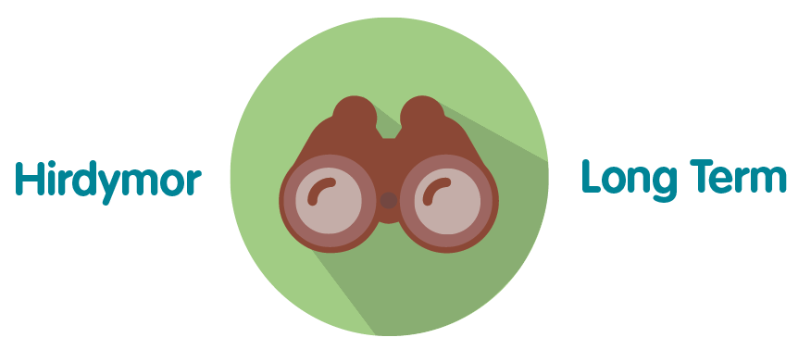 | The report sets out work that has been undertaken, as well as work planned to continue in a sustained way in the future
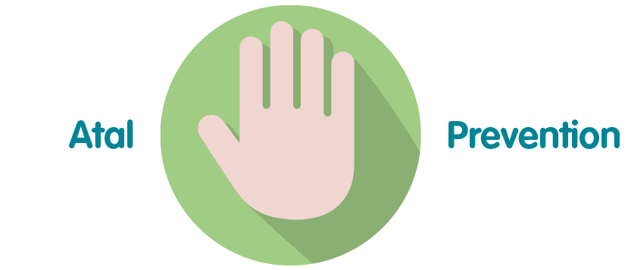 | Taking action to address the Gender Pay Gap will prevent the gap from widening and help us to achieve fairer pay and structures.
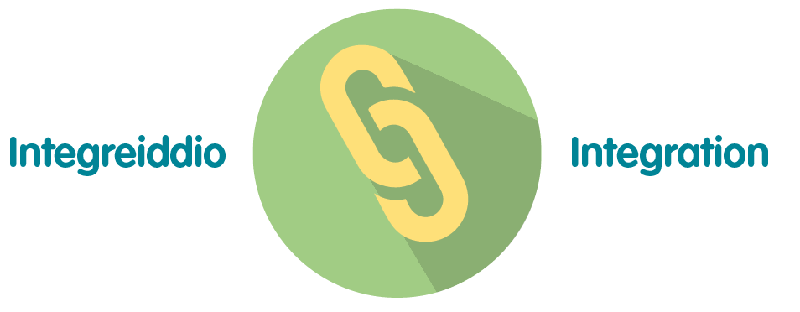 | The work focuses on all of the Well-being goals, in particular, a more equal Wales.
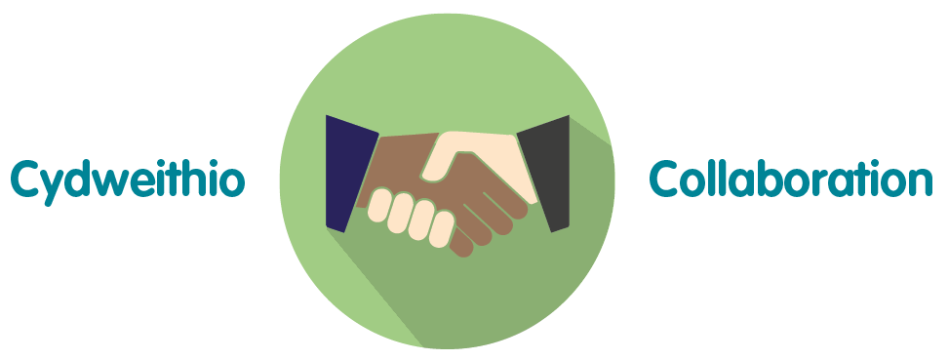 | There are examples given in the report showing collaborative working between different parts of the organisation.
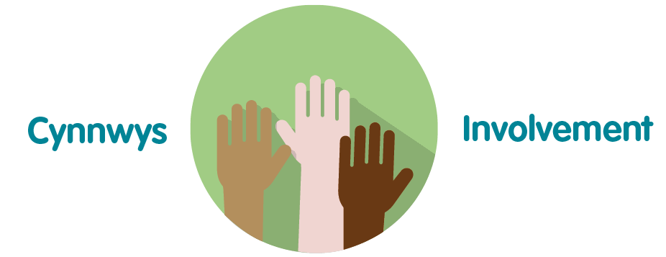 | The action plan on the Gender Pay Gap was developed following a round table discussion with the Staff Diversity Networks.

Recommendation

The Board is asked to:

- Approve the Gender Pay Gap Report 2019-20.

