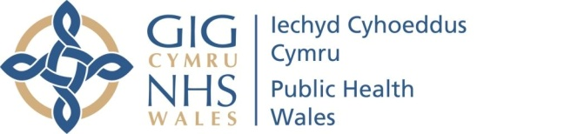 |  | Name of Meeting  Board
Date of Meeting
28 January 2021
Agenda item
3.6b 260121
Report from the People Advisory Group

Chair | Lead Executive Director |  | Date of meeting
Mohammed Mehmet,  Chair of the People Advisory Group and Non-Executive Director | Neil Lewis,  Acting Director – People and Organisational Development |  | 26 January 2021

Summary of key matters considered by the Group and any related decisions made.
The group considered the following matters:

Staff vaccination
- Received an update about the approach to staff vaccination, the implementation plan and the level of vaccination so far (573).
- Explored the complexities of securing and organising the staff vaccination programme at a national level and working with the seven Health Boards.
- Considered the approach to staff vaccination, the implementation plan in place and that the organisation was on track to vaccinate staff priority groups 1 to 4 (in line with JCVI guidance) by the middle of February.

Workforce Update – Resilience, Wellbeing and Recruitment
Key matters considered were:

Staff Wellbeing and Engagement
- Considered the approach being taken to staff survey action plans through the Wellbeing and Engagement Partnership Group.
- Discussed the staff surveys (PHW and NHS wide), and discussed some of the possible reasons for a reduced response rate. Also noted the priority response areas in the organisations action plan against the survey results.
- Discussed the range of other wellbeing initiatives, and the importance of evaluating their value on an ongoing basis.
- Discussed the increase in staff absence, and the actions being taken to address this noting that whilst absence levels were increasing, it was a steady expected increase and not of significant concern at this stage.
- Discussed the personal risk assessment (compliance currently 64%) and how to increase the volume of staff completing the assessments with their managers.
- Considered the approach to staff engagement and the various mechanisms in place, beyond staff surveys.
Recruitment
- Considered the current status of staff recruitment in the health protection context, the critically assessed posts and the approach to ensuring resilience.

Resilience
- Discussed the key messages being given to staff in the context of wellbeing, taking annual leave, time for caring responsibilities including staff with school aged children. The CEO had also reinforced these messages consistently in her monthly ‘Ask Tracey’ live Q&A sessions.

Health Protection Business Case
- Discussed the workforce planning approach to integrating a number of addition staff should the Health Protection Business case be successful.

Key risks and issues/matters of concern of which the board needs to be made aware:
The Group highlight the following matters for the Board’s attention:
- That assurance was taken in relation to
  - the approach to staff vaccination, the implementation plan in place and that the organisation was on track to vaccinate staff priority groups 1 to 4 (in line with JCVI guidance) by the middle of February.
  - the range of wellbeing initiatives in place;
  - the ongoing recruitment of new staff;
  - the planned workforce approach to the integrated additional health protection capacity into the organisation (business case).
Focus for the next meeting:
- Future working arrangements (home working / remote working / office bases);
- Staff survey action plans;
- Personal (staff) risk assessments;
- Staff engagement – the effectiveness of mechanisms in place, what the engagement tells us and how engagement turns into action.

