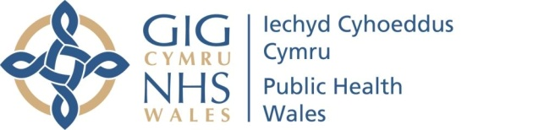 |  | Name of Meeting  Board
Date of Meeting
26 November 2020
Agenda item
3.4b 261120
Report from the People Advisory Group

Chair | Lead Executive Director |  | Date of meeting
Mohammed Mehmet,  Chair of the People Advisory Group and Non-Executive Director | Neil Lewis,  Acting Director – People and Organisational Development |  | 13 November 2020

Summary of key matters considered by the Group and any related decisions made.
The group considered the following matters:

Purpose of the Group / Terms of Reference
- The group discussed the approved terms of reference, and ensured it was familiar with its role.

Workforce Update – Resilience, Wellbeing and Recruitment
Key matters considered were:

Staff Wellbeing and Engagement
- Highlighted the challenges of redeployment, and discussed the volume of staff who were now in different roles from what they were recruited for.
- Discussed the staff surveys, and discussed some of the possible reasons for a reduced response rate.
- Discussed the employee assistance programme, and the occupational health service.
- Discussed the range of other wellbeing initiatives, and the importance of evaluating their value.
- Discussed the increase in staff absence, and the actions being taken to address this.

Recruitment
- Considered the high number of new staff being recruited, and reviewed the induction arrangements, noting that 181 of the 220 FTEs were now recruited.
- It was noted that this volume would normally be over a 3-4 year period, not in a few months.
- Recognised the important role of staff retention and discussed actions in place to support this.
- Discussed the challenge of integrating a large number of addition staff should the Heath Protection Business case be successful.

Resilience
- Discussed the measures being taken including regular management check ins, management of annual leave, and the importance of staff having clear roles and responsibilities.

Key risks and issues/matters of concern of which the board needs to be made aware:
The Group highlight the following matters for the Board’s attention:
- That assurance was taken in relation to the recruitment of new staff.
- That assurance was taken in relation to the range of wellbeing initiatives in place.

Focus for the next meeting:
- New working arrangements (home working / remote working / office bases)
- Staff survey results and action plans
- Review of relevant internal audit actions relating to the Groups remit.

