Appendix 3
Quick Display Screen Equipment guidance for non DSE and hotdesk users
FIGURE 1: WORKSTATION LAYOUT
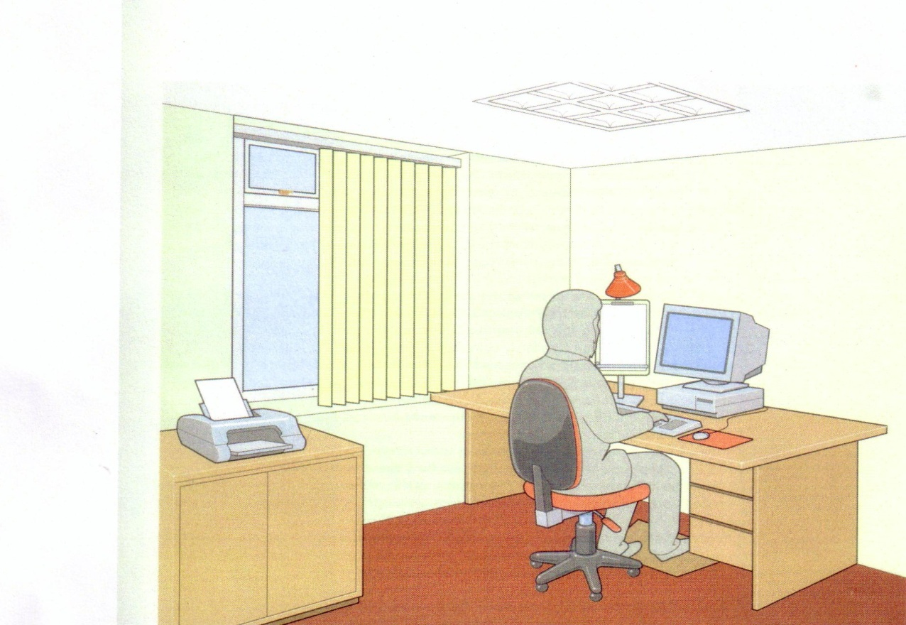

Adequate Lighting
Adequate contrast, no glare or distracting reflections
Adequate leg room
Window covering if needed to minimise glare
Screen: stable image, adjustable, readable, glare/reflection-free
Keyboard: usable, adjustable, detachable, legible
Work surfaces: with space for flexible arrangement of equipment and documents; glare free
Chair: stable and adjustable – please ensure that chair is adjusted from sitting position
Footrest if user needs one

FIGURE 2: SEATING AND POSTURE
Note particularly the position of the arms and hands, footrest and the movement of the back of the chair. This is the optimum position and should reduce the risk of injury.

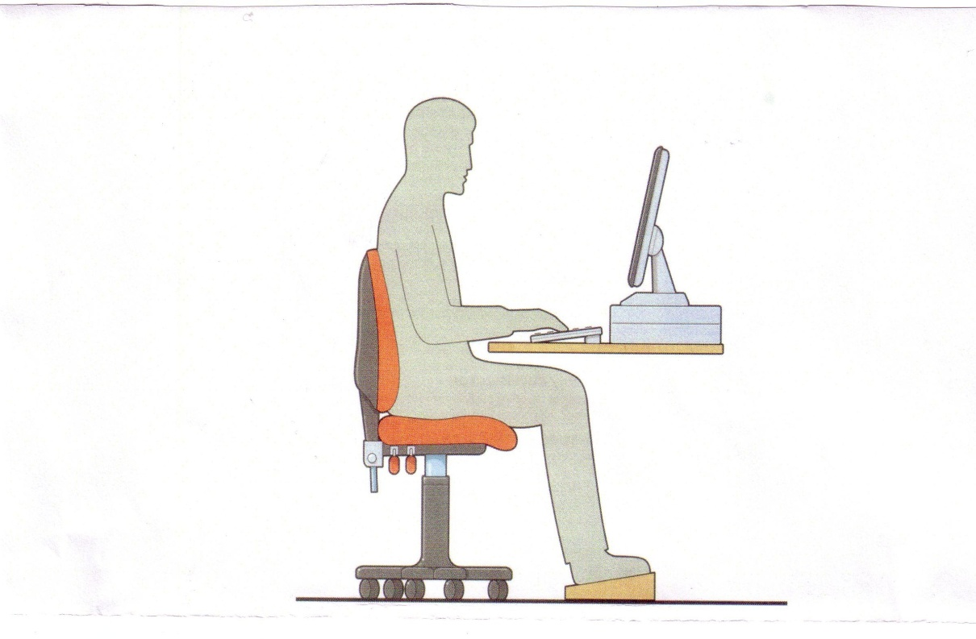
Seating and posture for typical office/laboratory tasks

Seat back adjustable
Good lumbar support
Seat height adjustable
Adequate leg room
Forearms approximately horizontal
Adjust wrists to ensure not excessively bent (up, down or sideways)
Screen height and angle to allow comfortable head position
Space in front of keyboard to support hands/wrists during pauses in keying
If you have any concerns please discuss with your line manager

