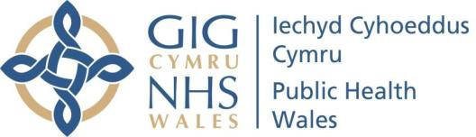 |  | Reference Number: PHW/SCD03  Version Number: 3  Date of Next review: 22 August 2022
DEATH IN SERVICE GUIDELINES
Introduction and Aim

The death of an employee can be a traumatic experience for those who are left to deal with the loss of a colleague. The information provided here is intended as guidance to ensure that processes are put in place as effectively and sensitively as possible for both colleagues and the next of kin, during this difficult and emotional time.

It should be noted that these guidelines do not cover Death in Service for Pensions
Linked Policies, Procedures and Written Control Documents
Incident Reporting Policy; Incident Reporting Procedure; Special Leave Policy; Health & Safety Policy; Dying to Work Charter; Guidance for managers on supporting employees diagnosed with a terminal illness
Scope
This procedure applies to all employees of Public Health Wales (Public Health Wales)
Equality and Health Impact Assessment | Integrated Assessment Tool (EHIA) completed.
Approved by | Executive Team (approved during COVID-19 Pandemic - changed approved by Neil Lewis)
Approval Date | 22 August 2020
Review Date | 22 August 2022
Date of Publication: | 7 October 2020
Accountable Executive Director/Director | Neil Lewis, Interim Director of People and Organisational Development
Author | Joanne Preece, Senior HR Advisor
Disclaimer
If the review date of this document has passed please ensure that the version you are using is the most up to date either by contacting the document author or the Board Business Unit

Summary of reviews/amendments
Version number | Date of Review | Date of Approval | Date published | Summary of Amendments
1 | 26  October 2017 | 30 July  2010 | 30 July  2010 | Current Procedure in Place.
2 | 19 March  2020 | 19 March  2018 | 16 May  2018 | - Reformat  - Objectives included in section 1  - Inclusion of provisions for:  - Roles & Responsibilities  - Nominated Person  - Condolences to be sent to the next of kin on behalf of Public Health Wales Emotional support for staff  - Death in Work
3 | 05 August 2020 |  |  | - Inclusion of provision for:  - Language preference of next of kin  - Reference to ‘Dying to Work Charter’ which seeks greater security for terminally ill workers  - Supporting flowchart  - Appendix 1 – Ways to support management of a Bereavement in the workplace plus additional support services for signposting  - Appendix 2 - Checklist for the Family Liaison nominee & line manager

Introduction

The death of an employee can be a traumatic experience for those who are left to deal with the loss of a colleague. The information provided here is intended as guidance to ensure that processes are put in place as effectively and sensitively as possible for both colleagues and the next of kin, during this difficult and emotional time.

The objectives of this procedure are therefore to:

  - Support managers and colleagues in the event of an employee’s death. It is essential that these situations are handled in both a sensitive and effective way to prevent any additional distress for relatives and colleagues.

  - Support managers to make this situation as uncomplicated as possible, and to ensure that consistency is applied in all cases. As this process will not be the norm, these guidelines act as a guide on the steps to be taken and the responsibilities of managers and other staff involved.

  - Recognise the impact that the death of an employee can have on staff and to identify support available for the manager and colleagues to help in dealing with their loss.

  - Prevent additional distress for the next of kin by ensuring they are treated in a respectful and sympathetic way, whilst also ensuring practicalities are dealt with.

Roles and Responsibilities

  - Chief Executive

The Chief Executive will ensure appropriate condolences are expressed at a senior level from Public Health Wales to the next of kin and deceased member of staffs’ team. Consideration should be given whether the letter should be in Welsh / English / other language / Braille or other method as appropriate.

Line Manager

The Line Manager is likely to be the first person within Public Health Wales to be informed of the death of a member of staff. It is therefore the Line Manager’s responsibility to notify key parties in a timely manner, including the relevant senior management, payroll, People and Organisational Development, and colleagues. Line Managers will be supported in this by their Line Manager and People and Organisational Development.
There may be occasion upon which there is prior notification that the staff member is dying. In such cases as appropriate, maintain periodic contact with the employee / identified relative. In such circumstances, the line manager should seek guidance from People & OD and support should be given in line with the Welsh ‘Dying to Work’ charter and follow the guidance on supporting employees with a terminal illness.

People and Organisational Development

People & OD will provide support to the relevant line manager in the care of them and their staff during this time, including the provision of advice on the process with regard to the administration of a death in service.

Occupational Health Service

The Occupational Health Service is available for members of staff who feel they need support and to provide advice to Line Managers This can be accessed either via a self- referral or by a managerial request.

Payroll / Pensions

The Payroll department are responsible for ensuring the timely administration of payment of salary and pensions, where appropriate, pension administration.

  - Health & Safety
Health & Safety should be contacted immediately for them to undertake an urgent investigation if someone died as a result of a work related incident.

Procedure

  - Death at Work

If an employee has died as a result of a work related activity the Incident Reporting Policy applies.

If this scenario occurs the Line Manager must contact their Head of Service/Director, and the Chief Risk Officer immediately so that an immediate and appropriate action can be taken and an urgent investigation can be undertaken.

Notification from the Next of Kin or Other
In the event of the death of a member of staff, it is important that all appropriate personnel are informed. The route by which the notification reaches Public Health Wales cannot be controlled but thereafter it is the responsibility of the Line Manager and People & OD to coordinate the dissemination of information.

Whoever receives notification of the death should provide assurance to the caller that someone from Public Health Wales will be in contact.

The Line Manager should advise their Head of Service/Director and People & OD, providing details of the employee, their service, next of kin information, and date of death.

Dealing with the Next of Kin

Departments should nominate an appropriate and reasonably senior member of staff to be the point of contact within the service to avoid confusion at a distressing time for both the next of kin and colleagues (Family Liaison nominee).

In the first instance the Family Liaison nominee should contact the next of kin, to introduce themselves as the point of contact, expressing Public Health Wales's condolences, offer support and advice, with sensitivity to any religious or cultural beliefs or practices. Establish what the next of kin’s preferred language and any communication needs. Respond appropriately to the requests of the next of kin, bearing in mind the need to be respectful and considerate towards any religious or cultural beliefs or practices.

At an appropriate time, this person will need to deal with questions, provide information and assist with what will be sensitive matters including:

    - Establishing when the funeral is to take place and asking whether colleagues of the deceased are welcome to attend
    - Advising Public Health Wales and colleagues about letters of condolence, floral and other tributes
    - Arranging for personal possessions to be forwarded or collected and for the return any departmental equipment, etc.
    - Providing information about outstanding salary payments and death in service benefits
    - Communicating the next of kin’s preferred language

Notifying Colleagues

The Line Manager, together with their Head of Service/Director, and with support from People & OD, should determine the most appropriate way to notify colleagues of the employee’s death.

It is advisable to:

    - Inform those closest to the employee first
    - Communicate the news in a private environment if possible
    - Allow staff time to grieve and attend the funeral
    - Deal sensitively with distressed staff - offer support to staff that may be adversely affected by the death
e.g. through the Care First employee assistance programme or other agency, Occupational Health, flexible working etc.

It is also important to ensure that those employees who are temporarily away from work e.g. on holiday or on maternity leave, where it is thought to be appropriate, are communicated with.

Colleagues should also be advised of the name of the nominated contact and the wishes of the next of kin in relation to contact.

Notifying the Chief Executive or Chair

The Divisional or Executive Director shall notify the Chief Executive or Chair of the employee’s death and provide details of the employee and their service with us.The Chief Executive will arrange for a letter of condolence to be sent to the next of kin on behalf of Public Health Wales.

Notifying Payroll and Pensions

On notification from the service, People & OD should contact both Payroll and Pensions to advise that they have received relevant information from the Line Manager in relation to the death of an employee.

The Line Manager should complete a termination form, recording the reason as ‘death in service’, final timesheet (if applicable) including any outstanding overtime payments and identify any remaining annual leave. This should be forwarded to the People & OD Department without delay. The Line Manager should inform payroll of any language preference, if applicable. Please note: the Line Manager should not record any overtaken leave on the termination form.

Upon receipt of initial information and confirmation of the funeral date from the Line Manager and People & OD, Payroll will:

    - Suspend employees pay in ESR from date of death
    - Identify if pension benefits are payable
    - After the funeral, contact next of kin, regarding payments due in respect of NHS Pension Scheme benefits
    - They will arrange either a meeting or provide telephone assistance to complete relevant documentation and relevant information;
    - Follow appropriate payroll and pension procedures as necessary.

Notifying the Communications Team

The Line Manager should advise the communications team of the employees death, including date of death, department and area of work.
All calls, correspondence or queries in person relating to the death in service must be dealt with in a confidential and sensitive manner.

Where there is likely to be press interest or it is appropriate for staff obituary, press releases etc. please contact a member of the Communications team immediately to brief them on the circumstances and agree a strategy for dealing with queries.

No information should be given to any external enquirer; instead they should be referred to the Communications team.

Following the Funeral

Following the funeral the Family Liaison nominee should contact the next of kin to advise them of the procedure which will be followed by the Payroll and Pension Department, in respect of outstanding payments and pension entitlements.

The Line Manager will need to identify work related items
e.g. lease car, mobile telephone, laptop, keys etc. which had been issued to the deceased employee, which must be returned to Public Health Wales.

The Family Liaison nominee should make arrangements regarding the return of the employee’s personal effects to the next of kin and the return of the work related items as noted above.

Further Considerations

Line Managers will also need to:

    - Arrange for the member of staff’s email account to be assigned to them so that messages can be dealt with in an appropriate way and a sensitive out of office message put on.
    - Ensure that the employee’s details are removed from circulation lists, rotas etc.
    - Go through the member of staff’s calendar to check for meetings, training courses or events.
    - In situations where there has been long term sickness, inform Occupational Health so that any appointments are cancelled and no further correspondence is sent.

The Funeral

  - Public Health Wales Representation

It might be seen as appropriate for a Director or Senior Manager to represent Public Health Wales at a senior level by attending the employee’s funeral. The Family Liaison nominee should discuss this with the family and assess whether or not it is appropriate. If so, the Director/Senior Manager’s PA should be informed in good time to arrange attendance.

Colleague Attendance

Colleagues wishing to attend a funeral can do so by submitting a Special Leave request. Line Managers may also wish to consider other flexible arrangements. It might be appropriate for the Service to nominate a representative who would attend the funeral.

In case of several team members attending, special dispensation can be sought from People & OD to waive the completion of numerous Special Leave forms for attendance at the funeral. For all queries on Special Leave please refer to the Special Leave Procedure or contact HR.

Support for Colleagues

Colleagues of the employee may experience problems in coming to terms with the death. Recovery of individuals and teams can be aided by providing support as soon as possible after the incident.

Employee Assistance

Grief is a normal emotional reaction to loss, in many cases the most supportive actions in the immediate aftermath of a death is peer support – colleagues sharing their grief with colleagues – and not professional help. However, if a staff member feels that their grieving is prolonged or they feel that the intensity of their emotions has not reduced with time, they can refer themselves to the Care First employee assistance programme or Occupational Health.

Sharing Information

The sharing of information will provide comfort to employees. It is therefore important to ensure that as much information is provided to employees, in as timely a manner as possible ensuring employees are provided with as much information as possible.

If managers or the nominated contact are unable to get the required information they can simply communicate this to employees as this will be more comforting than being told nothing.

Suggest an area where colleagues can go to take time out

This suggestion allows all affected employees a chance to discuss the loss and share stories about the deceased. This aids the mourning process as it allows employees to deal with their shock.

Providing a private area also gives employees a place to go if they become tearful whilst working. This can stop them feeling like they are on display to others in the workplace.

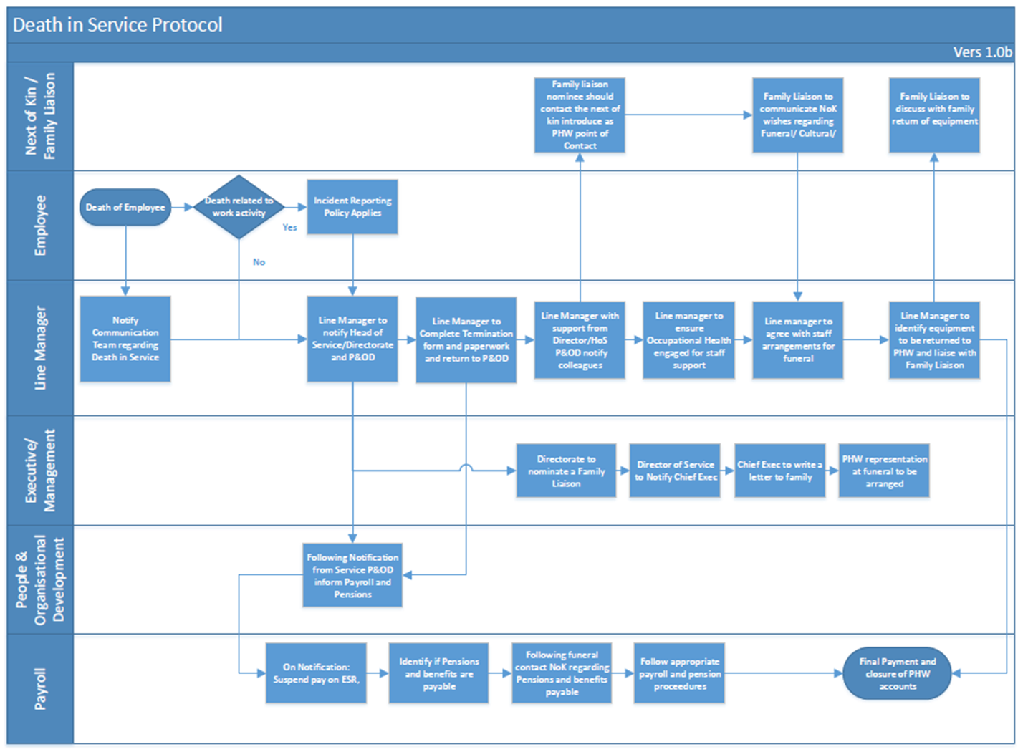
Appendix 1

Ways to Support Management of a Bereavement in the Workplace

Approach

Bereavement in the workplace can be challenging to manage. Employees may need to take time off unexpectedly, find their performance is impacted, or be temporarily unable to perform certain roles.

However, a compassionate and supportive approach demonstrates that the organisation cares about and values its people; helps build commitment, and reduces sickness absence.

Every Bereavement is Different

Showing compassion, empathy and being mindful that we all grieve differently is vital to any member staff feeling supported and valued at a difficult time.

Listening, expressing understanding and patience will encourage staff to access support and challenge the stigma around asking for help.

An employer has a duty of care to employees generally and should take into account the effect bereavement might have on the employee in undertaking their duties.

The relationship with the person who died, and the circumstances of the death will all have an impact on the employee, particularly if the death was sudden or traumatic.

It is often difficult for bereaved employees to judge how they will feel in the workplace; sometimes grief is not expressed at the time of the event but can be triggered by anniversaries, certain events, meetings etc.

Don’t make assumptions that you know how someone is feeling and what they need - enquire with compassion and empathy.

Communicate

Communicating the news of the death to other employees is key and the method of communication should be personal and sensitive. There may be areas of the organisation, for example the team where the person who died worked, that are particularly affected and they may need more support.

Be mindful that some employees may be affected more than others and may need time to talk individually. Find a quiet and uninterrupted space to talk and ensure when you have arranged this that you have the time to listen.

Maintain an open dialogue with employees, being both sensitive and mindful of how grief and loss can also trigger an employee’s previous experience of loss both inside and outside of the workplace. Be aware that some staff will not want to talk.

Be open to revising and reviewing the situation and keep the team updates as appropriate (taking into consideration the wishes of the family).

Monitor your own response to the situation and how you are managing the loss, seek support for yourself if needed and discuss any concerns with your line manager.

Consider the wishes of the individual, team and family to acknowledge, commemorate and remember the person. Take into account religious or cultural beliefs.

Remember to offer information and signposting to in-house support and external support organisations.

Support Information and Services in PHW

Employee Assistance Programme - Care First: 0800 174319

PHW Staff Intranet Resources:

Employee Wellbeing page

COVID-19 Staff Information page/HR Information

COVID-19 Staff Information page/managers toolkit

COVID-19 Staff Information page/staff wellbeing includes a supportive wellbeing resources quick guide

Occupational Health - Welsh Ambulance Service NHS Trust (WAST) 0300 321 4700

This service is provided by WAST for all PHW staff with the exception of staff in Microbiology Division, who receive OH support from the health boards. Full list of contact details for Microbiology Division is located on the staff Intranet page

NHS and Social Care Coronavirus Life Assurance Scheme 2020 Wales. Further information on the scheme is available via the following link:

https://www.nhsbsa.nhs.uk/nhs-and-social-care-coronavirus-life-assurance-scheme-2020-wales

People & OD Team: peoplesupport.phw@wales.nhs.uk

External Support Information and Services:

Cruse Bereavement Care – offers support through a network of local services and helpline

https://www.cruse.org.uk/get-help/about-grief/bereavement-at-work

0808 808 1677

Mind – Provides information on Bereavement, where to go for support, and suggestions for helping yourself and others through grief

https://www.mind.org.uk/information-support/guides-to-support-and-services/bereavement/about-bereavement/

Samaritans – Confidential support helpline for NHS Wales and Social Care Workers,

Free confidential call line in English (7am – 11pm, 7 days a week): 0800 484 0555

Free confidential call line in Welsh (7pm-11pm initially, 7 days a week): 0808 164 2777

Appendix 2

Checklist for the nominated person (Family Liaison nominee):

To be followed in conjunction with the full procedure outlined in the guidelines

☐ Contact next of kin to make introduction as the point of contact, expressing PHW’s condolences

☐ Establish when the funeral is to take place and the arrangements

☐ Establish the next of kin’s language preference

☐ Advise PHW’s and colleagues about letters of condolence, floral and other tributes

☐ Arrange for personal possessions to be forwarded or collected and the return of any equipment

☐ Provide information about outstanding salary payment and death in service benefits

☐ Establish with the next of kin whether it is appropriate for a Director or Senior Manager to represent PHW at a senior level by attending the employee’s funeral

☐ Following the funeral, advise next of kin that a member of staff from NHS Payroll/Pension will arrange a meeting or provide telephone assistance to complete relevant documentation in respect of outstanding payments and pension entitlements

Checklist for the Line Manager:

To be followed in conjunction with the full procedure outlined in the guidelines.

☐ Notify key parties including relevant senior management, payroll, People and OD following notification of the death of an employee, including their service, next of kin information, and date of death

☐ With support of the Head of Service/Director and People and OD, determine the most appropriate way to notify colleagues of the employee’s death

☐ Advise the communications team of the employee’s death, including date of death, department and area of work

☐ Arrange with Informatics for the member of staff’s email account to be assigned to them so messages can be dealt with in an appropriate way

☐ Ensure that the employee’s details are removed from circulation lists, rotas etc.

☐ Check member of staff’s calendar to cancel meetings, courses, events etc.

☐ If member of staff had been on long term sickness, ensure any appointments made with Occupational Health have been cancelled

☐ Manage requests from colleagues of the deceased wishing to attend the funeral, referring to the Special Leave Procedure or advice from People and OD

☐ Share and signpost available information and support services to work colleagues of the deceased

☐ Complete a termination form, final timesheet (if applicable) including any outstanding overtime payments and identify any remaining annual leave and forward to People & OD. Any overtaken annual leave should not be recorded on the termination form

