Annual leave user guide
How to book annual leave, special leave and bank holidays on ESR
Employees
All annual leave requests must be booked via ESR. Your manager must approve the leave before you take it.
ESR will send you a notification email to confirm whether your manager has approved your request so monitor the notifications inbox on ESR
Annual leave is booked in hours. The number of requested must reflect the contacted hours or shift pattern you work.
Bank holidays are included in your annual leave entitlement balance so you must book any Bank Holidays that fall on your normal working days in the same way as annual leave. You should do this at the start of the annual year – 1 April.
The Bank holidays from 1 April 2019 to 31 March 2020 are:
19 April 2019 Friday Good Friday
22 April 2019 Monday Easter Monday
6 May 2019 Monday Early May bank holiday
27 May 2019 Monday Spring bank holiday
26 August 2019 Monday Summer bank holiday
25 December 2019 Wednesday Christmas Day
26 December 2019 Thursday Boxing Day
1 January 2020 Wednesday New Year’s Day
Managers
You should check your notifications inbox and respond to annual leave requests in good time, ensuring you have adequate cover in your teams.
Managers are responsible for regularly checking that annual leave has been requested and recorded accurately on ESR and that they match each employee’s contracted hours or shift pattern.
You should monitor ESR regularly to make sure employees are managing their annual leave / bank holiday entitlement properly and are not over- or undertaking them. You must also ensure they are don’t have excessive annual leave remaining at the end of the leave year.
• Encourage staff to submit holiday dates as far in advance as they can • Remind them periodically how much leave they have left

- Ask anyone who has not taken or submitted any holiday dates - for instance, by the middle of the year – to nominate holiday dates as a matter of urgency
Hints and tips
- Managers can only amend or delete absences that are in the future. Only the ESR Support Team can correct historic absences.
- Full-time and part-time staff must all book annual leave in hours – make entries in decimals not minutes eg 30 minutes = 0.5 hours.
- Once a request has been approved, you can update or delete it up until the start date of the leave you want to amend. Any amendments will be sent to your manager for approval.
- If your approver doesn’t action a leave request within 28 days it will be sent back to you and you will need to forward it to someone else for approval or send a new request.
- Your entitlement balance will only be updated once your manager has approved your request.
- If you have a leave request with a status of Pending Approval, you can remove it within 60 days of making the request. You can do this by accessing the All Actions Awaiting Attention section in the ESR Navigator.
- If you think your annual leave entitlement has been calculated incorrectly contact the ESR Support Team

Requesting Annual Leave
Click the Create Annual Leave link in the My Annual Leave area of your ESR homepage.
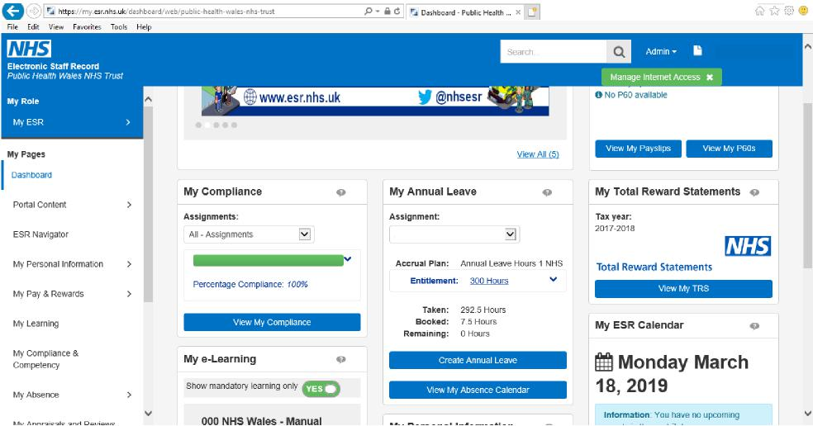
Click the dropdown arrow in the Absence Type field.
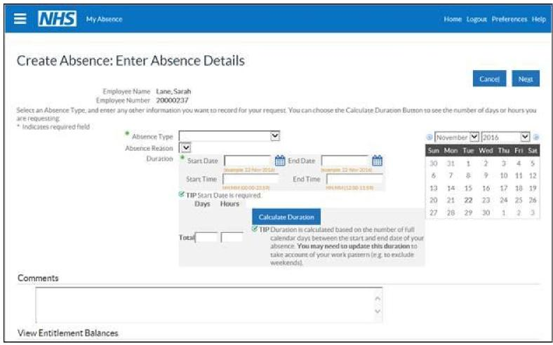

Click the appropriate annual leave absence type from the list. In most cases it will be ‘Annual Leave Hours 1’ but if you have more than one assignment you should select the corresponding absence type for each separate assignment e.g. Primary Assignment – Annual Leave Hours 1, Secondary Assignment – Annual Leave Hours 2 etc.

For Special Leave please select Special Leave Increasing Balance then the Absence reason from the drop down list.
The Absence Category and Absence Reason fields will automatically populate.
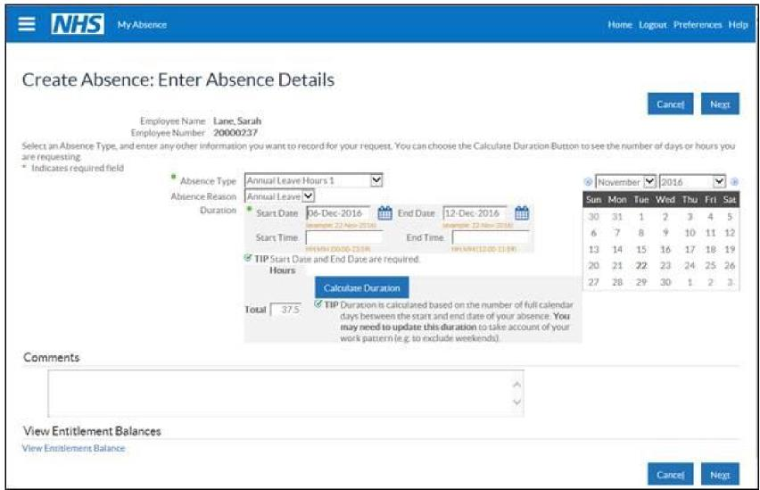
Enter the Start Date of the absence
Enter the End Date of the absence.
Click the Calculate Duration button to calculate the number of hours duration of the absence. This automatically defaults to 7.5 hours for a normal working day, 37.5 hours for a working week. If your contracted hours are more or less than 7.5 hours a day you will need to manually enter the hours worked in the Total box.
You can use the Comments to Approver field to provide further details within the notification.

Reminder: If you are booking more than one week’s annual leave, you will need to book each week separately. If not, ESR will automatically deduct the weekends from your annual leave entitlement.
Click the Next button.
A warning message appears if you have altered the standard working hours.
Click the Next button.
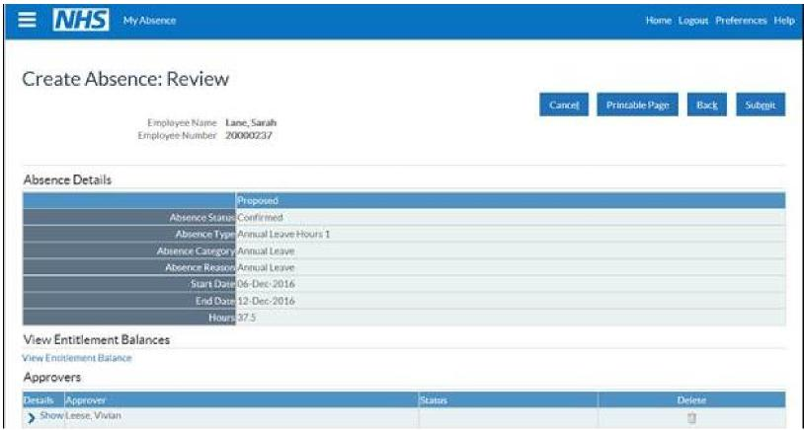
Review the details you have entered and click the Submit button to send your changes for manager approval.

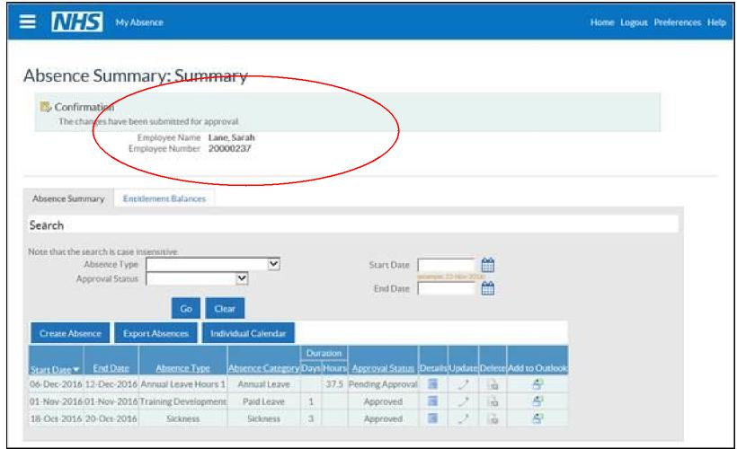
ESR displays a confirmation message to show the changes have been submitted for manager approval.
Further Information
- Gross Accrual = what annual leave you started with
- Net Accrual = what annual leave you have remaining
- Any purchased Annual Leave will be added to your Net Accrual by the Payroll team.
- You don’t have to enter start and finish times for a period of annual leave. More importantly, make sure the correct amount of hours are entered in the hours box.
- To correct an annual leave balance, the manager should contact the ESR Support Team with the entitlement balance to override the accrual plan.

