Reference Number: PHW18/TP01
Version Number: 2
Date of next review: 19 January 2024
recovery of salary overpayments / underpayment pROCEDURE

Introduction and Aim

This procedure supports the Recovery of Salary Overpayments and Salary Underpayment policy and sets out how the Trust will manage any errors in salary payments to ensure that all staff and managers understand the process that will be followed.

Supporting Procedures and Written Control Documents

Other related documents are:
- Recovery of Salary Overpayments/Underpayments Policy
- Public Health Wales Standing Financial Instructions
- Counter Fraud Policy
- Claiming Travel and Subsistence Expenses
- NHS Terms and Conditions of Service Handbook

Scope

The procedure applies to all Public Health Wales staff, currently or previously employed, including Medical, Dental and those on Honorary Contracts who have or will receive a payment through the Public Health Wales payroll.

Equality and Health Impact Assessment | An Equality, Welsh Language and Health Impact Assessment has been completed and can be viewed on the policy webpages
Approved by | Audit and Corporate Governance Committee
Approval Date | 19 January 2021
Review Date | 19 January 2024
Date of Publication:
Group with authority to approve supporting procedures | N/A
Accountable Executive Director/Director | Huw George, Deputy Chief Executive and Executive Director of Operations & Finance
Author | Martyn Pennell, Head of Financial Reporting & Control (V2 updated by Jane Matthews, Head of Financial Reporting & Control)

Disclaimer

If the review date of this document has passed please ensure that the version you are using is the most up to date either by contacting the document author or Corporate Governance.

Summary of reviews/amendments
Version number | Date of Review | Date of  Approval | Date published | Summary of Amendments
V1 | 2.5.19 | 2.5.18 | 4.5.18 | Changes to policy dated 20/03/2013:  - Updated references to reflect PHW structure/NWSSP support;  - Clarified individual/departmental responsibility and reporting requirements;  - Simplified process of recovery, setting out:  - General Principles  - Repayment Periods  - Recovery from current employees  - Recovery from former employees  - Debt Recovery Procedures  - States standard repayment periods and authorisation requirements;  - Provides standard letter templates
V2 | 19.01.23 |  |  | Changes to procedure dated 02/05/18:  - Updated job titles and departments to reflect any revisions since last version;  - Amendment of the wording included in Salary Overpayments Recovery Stage 3 Letter (see appendix 6) to include a link to the Recovery of Salary Overpayments Policy and to advise that the debt collection agency may share data with Third Party Agencies and Credit Reference Agencies.  - Finance letters in appendices now include contact e-mail address.

Table of Contents |  | Page
1. | Introduction | 4
2. | Aims and Objectives | 4
3. | Scope | 4
4. | Legislative and National Initiatives | 5
5. | Definitions | 5
6. | Causes of Overpayment/Underpayment | 5
7. | Roles and Responsibilities | 5
8. | Process for the Recovery of Overpayments | 8
9 | Process for the Repayment of Underpayments of Salary | 11
10. | Training and Communication With Staff | 11
11. | Monitoring and Auditing | 11
12. | Information Governance Statement | 11

Appendices
Appendix 1 | Payroll Services Letter to Current PHW Employee
Appendix 2 | Salary Overpayments Recovery Stage 1 Letter to Current PHW Employee
Appendix 3 | Payroll Services Letter to Former PHW Employee
Appendix 4 | Salary Overpayments Recovery Stage 1 Letter to Former PHW Employee
Appendix 5 | Salary Overpayments Recovery Stage 2 Letter
Appendix 6 | Salary Overpayments Recovery Stage 3 Letter
Appendix 7 | Line Manager Notification of Overpayment

- Introduction

Public Health Wales will endeavour to pay staff promptly and accurately to ensure that the correct salary is paid. However there will be occasions where, for various reasons, this may not have been possible, resulting in an overpayment or underpayment to a member of staff.

Recovery of any overpayment is allowed in law, provided that the employee was not given an expectation of entitlement for the payment.

The purpose of this procedure is to describe the process for recovering an overpayment of salary from an employee or ex-employee and to ensure that all monies due to Public Health Wales are recovered in a timely, fair and reasonable manner; and to provide guidance to staff regarding overpayments and underpayments.

For Medical and Dental staff, no deductions will be taken from the salary other than those required by law without written consent, as stated in the Contract of Employment.

- Aims and objectives

Public Health Wales has a legal right to recover an overpayment when it arises from a mistake of fact. Mistakes of fact are where the payment was inconsistent with the facts (e.g. through clerical error, computer input, or procedural errors). Money paid out under a mistake of fact is recoverable in law. These payments are made in good faith and are deemed to be correct at the time of issue. When monies are to be recovered, Public Health Wales will aim to do so in a timely, fair and reasonable manner.

The objectives of this procedure are to ensure that:

- All Public Health Wales employees are aware of the processes for the recovery of any salary overpayment or repayment of salary underpayment that may occur.
- All debts resulting from a salary overpayment are recorded and managed appropriately.
- Public Health Wales adopts a consistent approach when dealing with any error and that all staff, whether currently or previously employed, are treated fairly.

- Scope

The procedure will apply to all Public Health Wales staff, currently or previously employed, including Medical, Dental and those on Honorary Contracts who have or will receive a payment through the Public Health Wales payroll.

- Legislative and National Initiative

This procedure complies with the following legislation:
- The Employment Rights Act 1996
- The Equality Act 2010
- Theft Act 1968
- National Minimum Wage Act 1998

- Definitions

Under this procedure the definition of an overpayment is where an employee is paid an amount in excess of their contractual roles and responsibilities, or has received payment for expenses in excess of those to which they are entitled.

The definition of an underpayment is where an employee is paid below their contractual roles and responsibilities or has received payment for expenses below those to which they are entitled.

- Causes of Overpayment/Underpayment

The likely causes of salary errors include, but are not limited to;
- A termination form not being completed, received or actioned in time.
- Late or no notification of sickness absence/unpaid leave.
- Staff not returning from maternity leave
- Staff having overtaken their annual leave entitlement when leaving employment.
- A processing error
- A late change of notification that affects pay
- Incorrect salary banding
- Incorrect application of payment for enhancements
- Incorrect application of payment for allowances
- Incorrect application of payment of expenses.
- Unreported enhancements or overtime.

- Roles and Responsibilities

Line Managers, Employees, Payroll, People and Organisational Development and Finance all have responsibilities in ensuring due process is undertaken.

Line Manager Responsibilities

It is the responsibility of all Managers to process the appropriate pay related documentation promptly, to meet payroll deadlines. To ensure that all timesheets, termination forms, staff changes forms, on-call claim forms and/or expense forms have been completed appropriately, and to ensure all such documentation is verified and authorised.

Preventative measures are:

Termination Forms (via ESR Manager Self-Serve) should be completed as soon as the termination date of the employee is known. Usually this would be when the employee hands in their resignation to their manager. When no notice is given, Payroll should be notified immediately by email.

Payroll Instruction Forms (via ESR Manager Self-Serve) – should be completed as soon as that change is known.

The Line Manager will receive notification of all overpayments (See Appendix 7) and will be required to assist in the recovery of overpayments by supporting the Payroll Department with explanations of overpayments and encouraging co-operation from the employee.

Where recurring issues are identified, e.g. repeated delays in completing termination forms from a single department/directorate/manager, the issue will be escalated through the appropriate channels.

Public Health Wales Employees

It is the responsibility of all employees to ensure that they receive and then check their pay-slips to confirm that they are being paid correctly and at the correct rate/pay band.

It must also be noted that where an individual identifies that he/she has been or may have been overpaid, then he/she also has a duty to inform their line manager and to contact Payroll to inform them of the possible overpayment.

When dealing with the request for repayment of outstanding monies, a claim of ignorance, by the member of staff, in that he/she did not receive or check any pay-slip, will not be accepted as a defence.

NHS Wales Shared Services Partnership Payroll Services Department

Payroll will be responsible for recovery of all salary overpayments. For current employees of Public Health Wales they will manage any deductions from salary, as per this procedure, for the recovery of payroll overpayments.

In addition, they will also provide general guidance on how pay information is displayed on a payslip, to assist staff in checking and/or understanding the entries on their payslip.

The calculation of any overpayment identified must be taken from the originating date of the overpayment and not the date that it was identified.

Where payroll have identified that an employee would have reasonably known that an overpayment has occurred, it is the responsibility of the Payroll Manager to refer the matter to Public Health Wales (People and Organisational Development and Finance), and/or the Local Counter Fraud Specialist, as appropriate, for advice.

Payroll will notify line managers of overpayments made to assist in the recovery of all monies overpaid and to reduce the risk of a reoccurrence.

People and Organisational Development

People and Organisational Development may identify an overpayment as a result of an incorrectly completed payroll form. In such cases further investigation will be undertaken in order to ascertain whether or not an overpayment has been made and if so, the Payroll and Finance departments will be notified.

People and Organisational Development will also assist Payroll and line managers, by providing advice and also support in the event of any dispute.

Public Health Wales Finance Team

The PHW Finance team may identify an overpayment as part of the normal monthly monitoring process. In such cases further investigation will be undertaken in order to ascertain whether or not an overpayment has been made and if so, People and Organisational Development and Payroll will be notified.

Public Health Wales Accounts Receivable (AR) Team

The AR Team within Finance will take responsibility for recording the debt in the Trust’s Financial Accounts by raising an invoice to the individual. The Team will also be responsible for the on-going management of the debt in line with this salary overpayment procedure.

Deputy Director and Head of Finance

The Deputy Director and Head of Finance (DDoF) is responsible for monitoring overpayments and repayments made. The DDoF will provide regular updates to the Audit and Corporate Governance Committee on the level of salary overpayments on the financial accounts.

- Process for the Recovery of Overpayments

General Principles

The process for the recovery of a salary overpayment will depend upon:
- When the overpayment was identified;
- Whether the individual is a current or former Public Health Wales employee.

Further information on each separate process is given in sections 8.3 and 8.4 below.

The individual can request all documentation relating to the overpayment, and further explanation from Payroll and/or their Line Manager at any point in the process.

Where the individual disputes the amount or validity of the overpayment and the query cannot be resolved by telephone, a meeting must be arranged between the individual, their line manager, a member of the People and Organisational Development and Payroll departments together with a Finance representative. All relevant documentation must be provided to each of the parties prior to the meeting taking place.

The employee/ex-employee will have the right to be accompanied at the meeting by a Staff Representative or a friend/colleague, not acting in a legal capacity. The Trust will suspend the debt recovery process until this meeting has taken place and the outcome known.

If the overpayment case has been referred to Public Health Wales Nominated Local Counter Fraud Specialist for further investigation into the circumstances surrounding the overpayment, then the employee concerned will be informed, in writing by the Payroll Manager. The letter will include reference to the fact that by receiving and retaining money from the overpayment, that he/she was not entitled to and also that he/she had made no effort to contact Public Health Wales to stop the payments being made or notify Public Health Wales of the overpayment, it was therefore being considered that he/she may have committed the criminal offence of Retaining a Wrongful Credit, contrary to Section 24 of the Theft Act 1968.

In such circumstances where it is subsequently proven that prima facie evidence of fraud exists, Public Health Wales would be perfectly within its right to demand payment in full of monies owed.

Repayment Periods

Repayments made through payroll deductions will automatically be over a maximum period not exceeding the original overpayment period or 12 months, whichever is shorter.

Repayments not made through payroll deductions should normally be made in one single payment. However, this may be extended, on request, to a maximum period not exceeding the original overpayment period or 12 months, whichever is shorter.

Where the repayment profile causes significant financial hardship, consideration will be given to a recovery period which exceeds this maximum. Any extension to the repayment period is at the discretion of the Deputy Director and Head of Finance and each request will be considered on a case by case basis.

The Trust reserves the right to require the immediate repayment of any balance should an individual fail to make the agreed payments. Should an individual have difficulties in making repayments they should contact the Finance department at the earliest opportunity.

Recovery of Overpayments from Current Public Health Wales Employees

Where an overpayment of salary is identified up to one day after the stated pay day, Payroll will automatically deduct the full value of the overpayment in the next pay period. The individual will be notified within two working days by telephone and in writing of any deduction together with a brief explanation of how the overpayment occurred. The person’s Line Manager will also be advised of the overpayment.

Where an overpayment of salary is identified more than one day after the stated pay day the Payroll department will contact the individual to discuss the overpayment and options for recovery. Where the balance due cannot be recovered in full in the next pay period the employee will receive notification in writing from:
- The Payroll Manager, who will provide details of the overpayment along with a suggested repayment period, instalment amount and date of first repayment. Unless the individual contacts the Payroll Department within 14 days it is assumed that they agree with the deductions being made from their salary, and repayment will commence on the stated date. A template for the letter is included in Appendix 1.
- The Accounts Receivable (AR) Team, who will record the overpayment on the Trust’s financial Accounts and will send the individual an invoice for the full value. If the individual agrees to deductions being taken from their salary then no further action is required. However, if they do not wish to repay the balance through payroll deductions they must contact the AR Team to make payment using one of the other methods specified on the invoice. A template for the letter is included in Appendix 2.

Where an employee leaves Public Health Wales any outstanding salary overpayment is to be repaid on termination. Where possible, this should be recovered from the final payment made to the employee. Any remaining balance will be invoiced by the Accounts Receivable Team.

Failure to make the agreed repayments will be managed through the recovery Procedures outlined in paragraph 8.5.

Recovery of Overpayments from Former Public Health Wales Employees

Where an overpayment of salary is identified for former employees of Public Health Wales they will receive notification in writing from:
- The Payroll Manager, who will provide details of the overpayment. A template for the letter is included in Appendix 3.
- The Accounts Receivable Team, who will record the overpayment on the Trust’s financial accounts and will send the individual an invoice for the full value. A template for the letter is included in Appendix 4.

Failure to make the agreed repayments will be managed through the recovery Procedures outlined in paragraph 8.5.

Debt Recovery Procedures

The Trust’s policy is that all debtor invoices must be paid within thirty days. However, the individual can request a longer repayment period, subject to the guidance in paragraph 8.2. Any extension to the payment terms must be requested within thirty days of the invoice, or the date any dispute is resolved, if later.

If the invoice remains outstanding one month after it has been issued and no agreement to pay by instalments has been received by the Trust a second reminder will be sent (Appendix 5).

If the invoice remains unpaid one month after the second reminder has been sent, a third and final reminder is sent stating that if payment is not made within fourteen days the debt will be referred to a debt collection agency. The letter also states that the individual will be liable for any costs incurred as a result of this action (Appendix 6).

- Process for the Repayment of Underpayments of Salary

Underpayments are generally corrected in the next available month following receipt of the correct documentation. However where the employee will suffer financial hardship as a consequence of the underpayment a manual payment may be made. The Deputy Director and Head of Finance should be contacted in the first instance to discuss whether this is possible.

Further information is available on the Finance page of the Public Health Wales Intranet site, including a list of all Payroll contacts.

- Training and Communication with Staff

Information on the policy and procedure will be provided to via the Public Health Wales intranet site.

- Monitoring and auditing

The policy lead will monitor and audit the policy to ensure it is compliant with current legislation, to ensure it is implemented, and ensure that the policy is being adhered to.

- Information Governance Statement

This policy and procedure has no additional Information Governance implications other than those that would normally be extended to communications between employer and employee regarding Finance. Any communications regarding overpayment should be sent under a confidential banner and any records created should be kept in accordance with financial record retention rules.

Appendix 1 – Payroll Services Letter to Current Public Health Wales Employee

Appendix 2 – Salary Overpayments Recovery Stage 1 Letter to Current Public Health Wales Employees

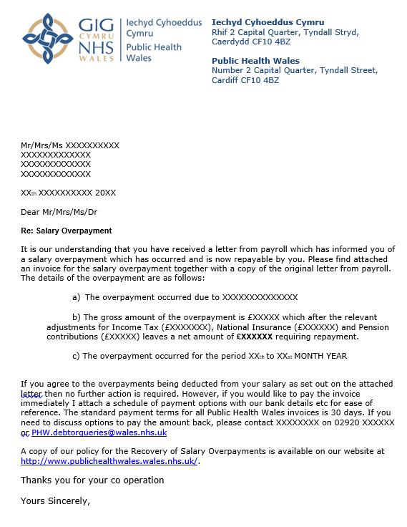

Appendix 3 – Payroll Services Letter to Former Public Health Wales Employee

Appendix 4 – Salary Overpayments Recovery Stage 1 - Letter to Former Public Health Wales Employee

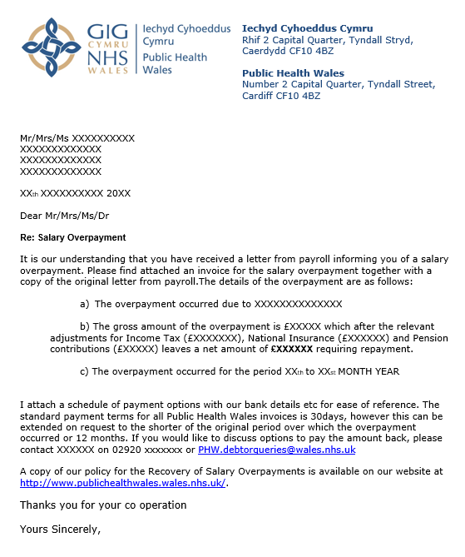

Appendix 5 – Salary Overpayments Recovery Stage 2 Letter

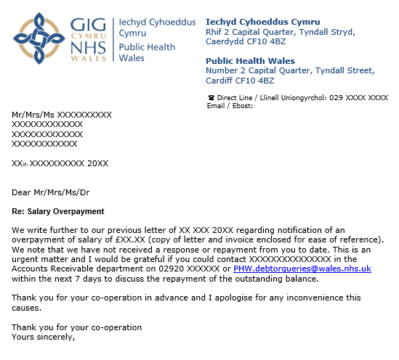

Appendix 6 – Salary Overpayments Recovery Stage 3 Letter

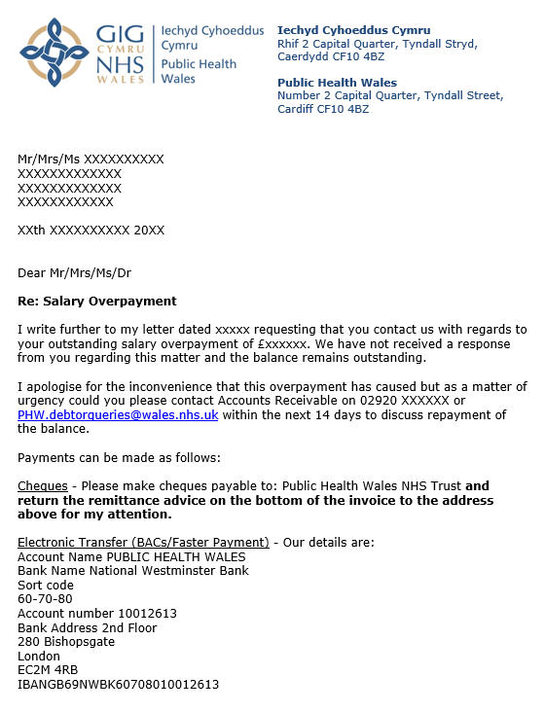

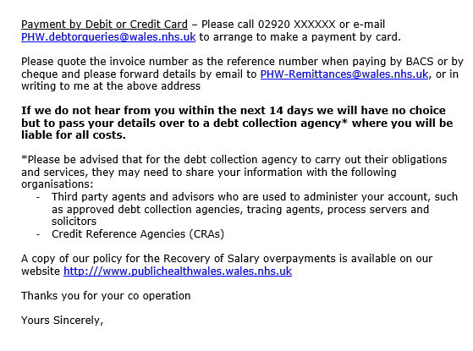
Appendix 7 – Line Manager Notification of Overpayment Letter

