l

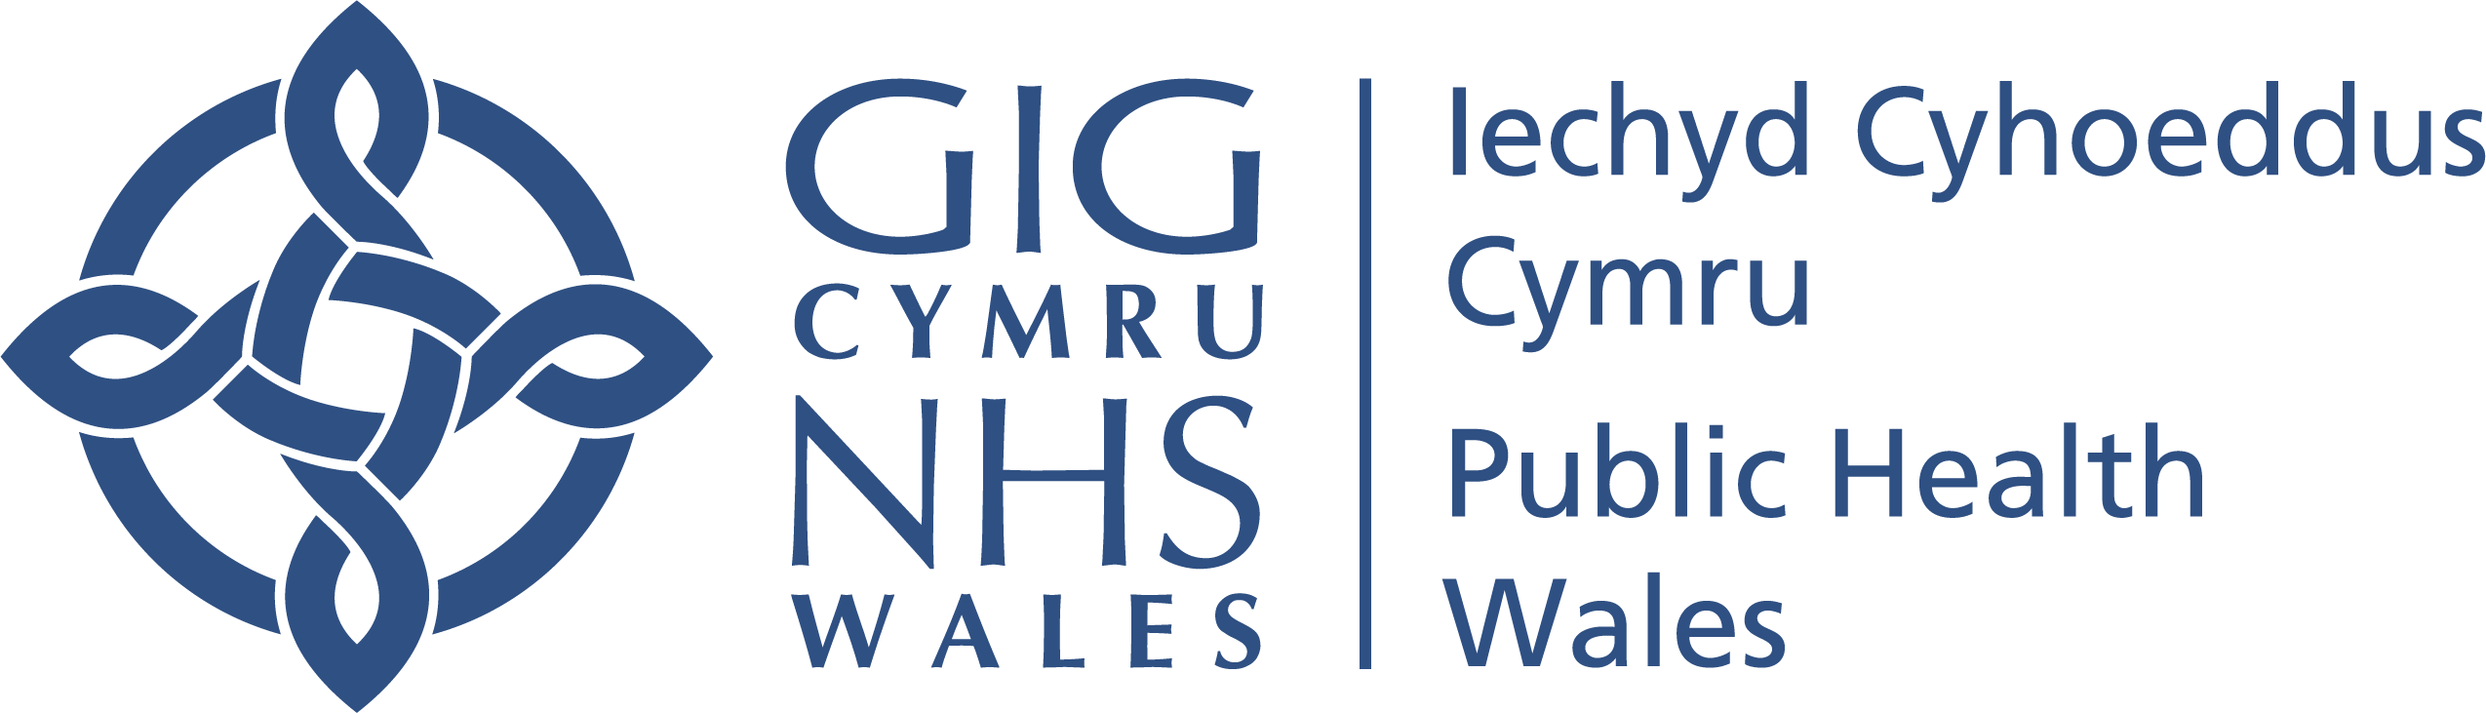

PROTOCOL FOR RESERVING MATTERS TO A PRIVATE BOARD (and Committee) MEETING

July 2023

Version 4

Introduction

In accordance with Public Health Wales’ Standing Orders (SOs), the Board holds its formal Board meetings in public. The Sos provide, at paragraph 7.5.2, the basis to meet and discuss relevant items in private. This is sometimes known as a ‘Private Board meeting’. The legal basis of this section of the Sos is The Public Bodies Act (Admission to Meetings) Act 1960, section 1 (2).

There will be occasion when aspects of the organisation’s business is considered more appropriately in private session; this is to avoid prejudicing the public interest – in other words, to avoid any undue harm or unfair influencing of the public.

This Protocol identifies the different rationales that apply to material considered in private sessions.

Public Health Wales’ Values and Transparency

Our values are ‘working together, with trust and respect, to make a difference’. The Board operates on the basis that transparency and openness are at the heart of its governance and decision-making approach; and that Board members debate everything in the Public Board meeting unless there is a specific reason not to do so.

Factors to consider when reserving a matter for a Private Board meeting

In deciding whether to reserve a matter for the Private Board agenda, there are a number of factors to consider, including:

- Whether the item or materials include personal data;
- Is there confidential or commercial sensitivity;
- Would the item undermine public confidence or cause undue concern or potential harm to the public;
- Are there reputational issues to consider – either for Public Health Wales or other individuals, partners of stakeholders;
- Are the documents in draft for future publication;
- Does the item include legal advice is it legally confidential or is it subject to legal privilege;
- Could the matter be prejudicial to the conduct to affairs;
- Is the disclosure of the matter inhibited by law.

The list is not exhaustive and sets out to give examples of key considerations. The Board considers a number of papers in draft form in private session, before taking the final version at meetings in public.
The following categories will be used for each agenda item on the Private Board Minutes:
- Commercially Sensitive – Procurement
- Confidential – Information Governance
- Confidential – Cyber Security
- Confidential – Workforce
- Legally Privileged
- Summary of Private Committee / Sub Group Meetings ‐ subject matter confidential
- Undue concern or harm to the public ‐ Health Protection Update
- Draft Report – To be published at later date

Management of Board meetings held in Private
When the Board comes together for formal meetings, the Public Board agendas set out the majority of the business under consideration. Board papers will include a formal rationale for taking any item in private session. Public Health Wales publishes the agenda for both Public and Private Board meetings on the website.

There may be occasions when the Board needs to convene in private session, without public notice, to consider urgent business associated with its legal and statutory roles.

Decision to consider items in private session

The Chair, with the support for the CE, takes the final decision on whether to discuss a matter in private or public session , following advice from the Board Secretary and Head of Board Business Unit and lead Executive Officer, in accordance with this Protocol. The Chair may also seek advice from any other member of staff or professional advisor, including the Chief Risk Officer, the designated Data Protection Officer for the organisation.

The reporting of items considered in private session

The Chair of the Board will produce a summary report of any items taken in private session and include this on the agenda for the next Board meeting in public session.

Review of this protocol and Feedback

The Board will review this Protocol annually, to ensure that it continues to meet the needs of the organisation and remains consistent with the spirit of Regulations and SOs. The Board Secretary will maintain a log of items considered in private session and produce an analysis to inform the annual review.

We welcome any feedback about this Protocol and are happy to respond to any queries in relation to it. Please email the Board Secretary and Head of Board Business Unit at PHW.Board.Business@wales.nhs.uk

