 |  |  |  |  | Name of Meeting  Board
Date of Meeting
24 November 2022
Agenda item:
5.2
Performance and Insight Report

Executive lead: | Huw George, Deputy Chief Executive/ Executive Director Operations and Finance
Contributors: | Huw George, Deputy Chief Executive and Executive Director of Operations and Finance; Meng Khaw, National Director of Screening & Health Protection; Neil Lewis, Director of People and Organisational Development; Rhiannon Beaumont-Wood, Executive Director of Quality Nursing and Other Allied Health Professionals; Angela Fisher, Deputy Director of Finance; Ioan Francis, Head of Performance
Approval/Scrutiny route: | Business Executive Team (15 November 2022)
Purpose
Our Performance and Insight Report focuses on delivering actionable insights whilst identifying areas for further improvement across the following key performance themes;

- Maintaining a healthy and sustainable workforce
- Achieving value and impact through innovation
- Delivering organisational wide quality and access to high quality services
- Improved population health and well-being

The report is designed to be read in conjunction with the Performance and Assurance Dashboard and Public Health Rapid Overview Dashboard.

Annex A within the report provides an update on progress made against our agreed IMTP accountability conditions that were set out as part our IMTP approval. The accountability conditions form an integral part of providing assurance to our Board and Welsh Government.

Annex B within the report sets out feedback received from Welsh Government in relation to mandated requirement to submit bi-annual progress reports on Foundational Economy and De-carbonisation in line with the mandated NHS Wales Performance Framework.

Recommendation:
APPROVE |  | CONSIDER |  | RECOMMEND |  | ADOPT | ASSURANCE
The Board is asked to:

- Discuss and scrutinise the paper and provide feedback and comments;
- Note the proposed approach to fulfil our mandated reporting requirement for the remainder of 2022/23 to ensure compliance with the NHS Wales Performance Management Framework.
Link to Public Health Wales Strategic Plan

Public Health Wales has an agreed strategic plan, which has identified seven strategic priorities and well-being objectives.

In order for Public Health Wales to deliver the strategic plan, effective performance management arrangements need to be in place to monitor and report on progress against achieving our strategic priorities to improve health outcomes. This intelligence is used to draw the Board’s attention to areas of underperformance and is fundamental for effective and efficient decision making.

This report contributes to the following:
Strategic Priority/Well-being Objective |  |  | All Strategic Priorities/Well-being Objectives
Summary impact analysis

Equality and Health Impact Assessment |  |  | An Equality and Health Impact Assessment is not required. Equality and Health Impact Assessments will be completed as part of delivery of the specific actions within the Plan.
Risk and Assurance |  |  | Our Strategic Risks are detailed within Our Strategic Plan and the Implementation Plan for the Test Trace Protect Strategy.
Health and Care Standards |  |  | This report supports and/or takes into account the Health and Care Standards for NHS Wales Quality Themes
 |  |  | All themes
Financial implications |  |  | An update on the organisation’s financial performance is enclosed
People implications |  |  | An update on the organisation’s people performance is enclosed

- Purpose / situation

Our Performance and Insights Report focuses on delivering actionable insights whilst identifying areas for improvement across the following key performance themes;
  - Maintaining a healthy and sustainable workforce
  - Achieving value and impact through innovation
  - Delivering organisational wide quality and access to high quality services
  - Improved population health and well-being

This approach supports the Board and its Committees in discharging their responsibilities. The reporting of the four key themes will see us align to the Welsh Government’s A Healthier Wales quadruple aims and key measures set out in the 2022/23 NHS Wales Performance Framework.
The report is designed to be read in conjunction with the Performance and Assurance Dashboard (PAD) and the Public Health Rapid Overview Dashboard. The themes are demonstrated throughout this month’s report and are also reflected in the PAD.
Annex A within the report provides an update on progress made against our agreed IMTP accountability conditions that were set out as part our IMTP approval. The accountability conditions form an integral part of providing assurance to our Board and Welsh Government.
Annex B within the report sets out feedback received from Welsh Government in relation to mandated requirement to submit bi-annual progress reports on Foundational Economy and De-carbonisation in line with the mandated NHS Wales Performance Framework.

- Background

Access to high quality, timely and robust performance information is essential in providing assurance to our Executive Team and Board on our ongoing COVID-19 recovery, delivery of public health services and functions, and our role in improving population health and well-being.
Having strengthened our performance arrangements over the last 12-24 months through the successful development of the PAD we recognised the need to strengthen the accompanying Performance and Insight Report.
The November 2022 PAD can be accessed using the following Link, or by navigating from specific areas of interest in the report by selecting the following symbol , thus enabling direct access to the latest available performance information.
In addition, during the June 2022 Board development session we identified the need to bring forward the latest data from the Public Health Rapid Overview Dashboard.

- Description/Assessment

Key points to consider in this month’s Performance and Insight Report are:
- Good progress continues to be reported in the delivery of our Strategic Plan milestones at month 7. 54% (201) of milestones are reported on track, and 41% (154) complete. 2% (8) of milestones have the potential to fall behind schedule and 3% (10) are rated red and behind schedule. A total of nine milestones were completed in month 7.
- Sickness absence has remained stable over the last three months with latest data for October 2022 at 4.17%, and the 12-month rolling sickness absence at 4.5%. The highest rates of sickness absence for October 2022 were within Health Improvement (7.4%), and Microbiology (5.3%).
- A new Influenza and COVID-19 autumn booster vaccine uptake dashboard in Public Health Wales (PHW) staff has been developed by the Health Protection Division. Latest available data shows that around a third of PHW staff have received the flu vaccine with uptake among front-line slightly lower at 32.3% (up from 25.4% and 26.3% respectively at the same period last year). Nearly 40% of PHW staff have received the COVID-19 booster with uptake at 45.6% for front-line staff.
- Appraisal compliance for October 2022 has increased to 69.5%, reflecting a 12% improvement since April 2022. However, appraisal compliance remains below the 85% Welsh Government target. With pay progression coming into force in October 2022, part of the criteria to be put forward for an increment is staff needing to have an appraisal date entered into ESR within the last 12 months, which has had a positive impact on appraisal compliance figures thus far.
- Our cumulative reported position at month 7 2022/23 is a net surplus of £192k, with an anticipated breakeven position at year-end. Our capital funding for 2022/23 totals £6.444m with year to date spend at £1.963m. Forecast capital spend is £4.481m in Months 8-12 (of which £2.041m of orders have already been placed) in addition to our year to date spend of £1.963m in order to deliver our breakeven position at year-end.

- Performance for our year to date Public Sector Payment Policy is above the statutory target at 96.43% (96.16% in month 7) and is expected to remain above target. Year to date agency spend as a percentage of total pay equates to 3.3% with a year-end forecast of 3.4%.
- No significant COVID-19 incidents or outbreaks have been reported this month. Lateral flow positivity and incidence show a slight decrease with the focus remaining on rolling out the autumn booster. No new variants have been detected but close watch being kept on other sub-lineages such as BQ.1 and BA 2.75. Changes are being put in place following a slight drop to 86% within 12 hours turnaround compliance for non-rapids reflecting some issues of flow of low numbers into IP5 rather than more local laboratories.
- Screening recovery plans continue to be progressed and active mitigation undertaken to maintain service provision. The planned Royal Mail strikes in November will cause considerable disruption to timeliness of receipt of newborn bloodspot screening cards and urgent consideration of alternative delivery method is being made to mitigate and reduce clinical risk to newborn babies. There is also a risk of increased bowel screening sample reject rate due to transport delays.
- Performance for agreed non-COVID microbiology indicators continues to be positive in Quarter 2 2022/23 with all indicators achieving or within 10% of target.
- The Strategic Risk Register and the Corporate Risk Register are being continually updated to determine the risk scores, controls and actions. A delivery confidence assessment has been included in the report and further work will be undertaken to ensure mitigating actions are up to date and being progressed.

Further insights from the Performance and Assurance Dashboard can be found on page 2 – Key Performance and Insights Summary.
Performance and Assurance Dashboard (not publically available)
https://phw-tableau.cymru.nhs.uk/t/CorporateAnalyticsPreProduction/views/RecoveryDashboardLandingPage/LandingPage?:linktarget=_self&:embed=yes#1

Public Health Rapid Overview Dashboard (not publically available)
Public Health Rapid Overview Dashboard

- IMTP Accountability Conditions

Public Health Wales is required to provide regular updates on progress made against the IMTP accountability conditions that were set out as part our IMTP approval. The accountability conditions form an integral part of internal monitoring and Board assurance.
The accountability conditions will also form the basis of the discussions at our upcoming mid-year Joint Executive Team (JET) meeting with Welsh Government on 19 December 2022, alongside other planning and delivery meetings throughout the year.
Annex A within the report provides an update on progress made against the following key accountability areas:
- Screening delivery and funding
- Workforce recruitment exercises including specialist roles, and ensuring mitigation actions are developed and agreed
- Programme for Government requirements are planned and delivered; including:
  - Sexual Health and HIV
  - Public health system leadership on climate change
  - Commitments relating to obesity, tobacco, and mental health and well-being
- Financial monitoring of assumptions including future testing policies for Wales
- Transformational approach to vaccination

- Well-being of Future Generations (Wales) Act 2015

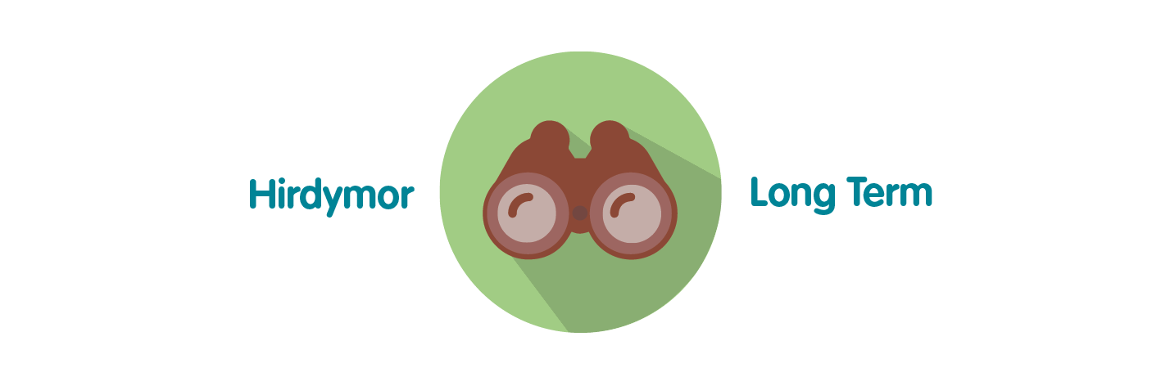 | Ensures Public Health Wales is able to successfully monitor the delivery of its functions; assess areas of underperformance; and can use this intelligence and knowledge to aid decision making.
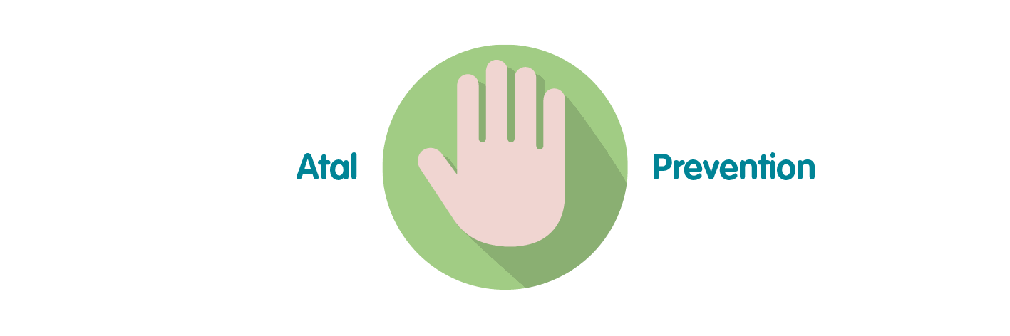 | Effective and efficient decision making by senior managers, Executive Team and the Board is paramount to successful performance of the organisation in order for it to achieve its purpose, whilst preventing the potential to cause harm through underperformance.
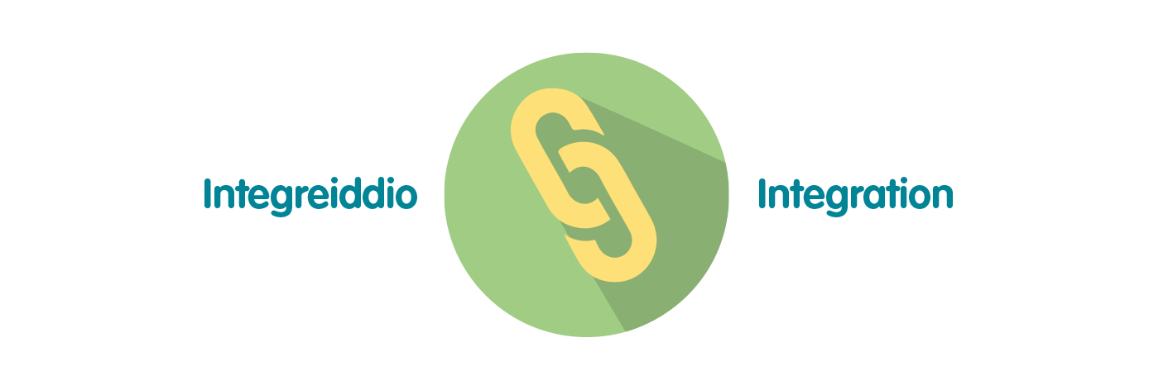 | The development of Public Health Wales’ Long Term Strategy and Integrated Medium Term Plan has been grounded in collaboration and integration across our workforce. To demonstrate that the organisation is achieving what it set out to achieve over the short, medium and long term, high quality monitoring and reporting of information is essential through the integrated performance report. This approach has been reflected in the approach to the pandemic response.
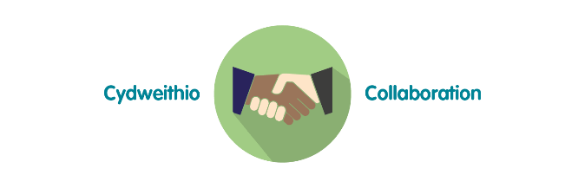 | Reporting of data and information through the integrated performance report requires collaboration across the organisation to ensure timely delivery of key service, quality, workforce and financial data. The potential for the development of business intelligence tools will require close working relationships with Directorates and especially Informatics to maximise potential.
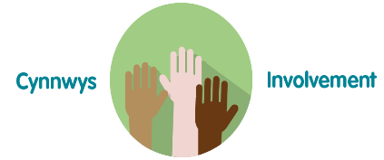 | To ensure compliance with the Welsh Audit Office Structured Assessment, agreeing and reporting Division / Directorate level performance measures will require involvement across the full breadth of the organisation. Monitoring and reporting against the strategic plan will involve working closely with staff to ensure accurate and timely intelligence for the Executive Team and Board.
- Recommendation

The Public Health Wales Board is asked to:

- Discuss and scrutinise the paper and provide feedback and comments;
- Note the assurance provided in relation to progress made against our IMTP accountability conditions which will form part of discussions at our mid-year JET meeting with Welsh Government on 19 December 2022.

