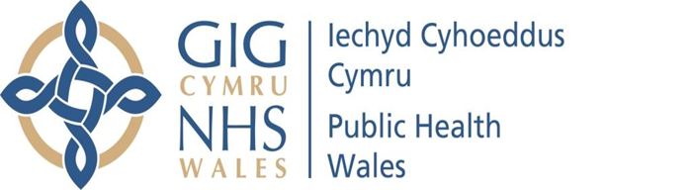

Quality and Improvement Strategy
(2021 – 2030)

DRAFT
Public Health Wales board 27/5/21

Contents
Executive Summary
Section 1: Introduction 4
1.0 Our Purpose 4
1.1 What do we mean by quality? 4
1.2 Implementing our Quality and Improvement Strategy 6
1.3 Quality and Improvement Driver Diagram 6
1.4 “Our Vision” for developing and implementing enabling foundations 8
1.5 Organisational culture 10
1.6 Planning for quality 11
1.7 The legacy of a global pandemic 12
Section 2: The enabling foundations 13
2.1 Enabling Foundation 1: High Performing Organisation 13
2.2 Enabling Foundation 2: Quality and improvement driven. 15
2.2.1 Model for quality and improvement 15
2.2.2 Quality and improvement measures 16
2.3 Enabling Foundation 3: Creating the conditions 18
2.3.1 Our values 18
2.3.2 Skills and capability 19
2.3.3 Where are we now on our improvement journey? 19
2.3.4 Establishing and embedding our Quality and Improvement Hub 20
2.4 Enabling Foundation 4: Learning organisation 22
2.4.1 Workplace culture 22
2.4.2 Learning from our customers. “Our approach to engagement” 23
Section 3: Next steps 24
3.1.0 Next steps 24
References: 25

Executive Summary

As the Public Health Institute for Wales, we already achieve a great deal, but this Quality and Improvement Strategy has the potential to enable us to take the organisation further forward in achieving our strategic aims, as identified in our Long Term Strategy. Demonstrating success and achieving outcomes will require effective leadership, coordinated effort and commitment from the Board, the Executive and buy in from all our staff. Existing evidence shows us that through cultural change and the application of improvement science, it is possible to achieve considerable measureable improvements and impact in improving the health of populations.

The impact of the COVID-19 pandemic on our services, programmes and functions has been unprecedented and we need to ensure that we can support the organisation to ‘recover to a new future’. This strategy and supporting plans are intended to take this opportunity to embed a culture of quality and continuous improvement, recognising a proportionate approach during our recovery phase.

This strategy and in particular the four enabling foundations identified at figure 2, are informed by the latest quality and improvement evidence base. In order to apply this evidence, change will be incremental and we will measure milestones of success for the duration of the strategy and provide annual reporting on progress.

To ensure the quality and improvement strategy actually does drive and shape our culture and approach, it needs to be clear to staff how they contribute to, and shape the overall implementation. To that end we want to progress the implementation of this strategy by taking an integrated approach to engaging with our staff, recognising that there are a number of enabling strategies which need to come together.

This is our opportunity to adopt and embed the vision outlined in this strategy, making quality and improvement an integral part of our organisational culture, being able to demonstrate a quality approach in all that we do and improved outcomes which bring benefit to the population that we serve.

Section 1: Introduction

1.0 Our Purpose

Public Health Wales, is the Public Health Institute for Wales and is ‘Working to achieve a healthier future for Wales’.

This is achieved through the delivery of our ‘Long Term Strategy’ and our ‘Strategic Priorities’ working together with our partners.
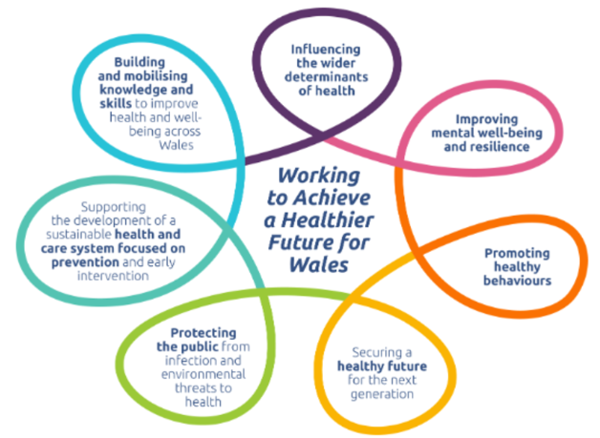

1.1 What do we mean by quality?

We often refer to quality in everyday language to signify excellence in a product or service, although people may have their own interpretation of what quality means at an individual level.

It is helpful to have an agreed definition of quality for the purposes of providing clarity for the implementation of this strategy and there are some definitions referred to here.

For example;

a) The Institute of Medicine¹ identified six domains of quality (safe, effective, patient-centred, timely, efficient and equitable) which is often referred to and applied within healthcare settings.

This definition is used in the Welsh Government’s A Healthier Wales² and within the Health and Social Care (Quality and Engagement) (Wales) Act 2020³.

However, it could be argued that not all these domains are easily transferred into our Public Health Wales context.

Therefore, as an alternative in the U.S.A. one definition used for quality in Public Health is;

b) “Quality in public health is the degree to which policies, programs, services, and research for the population increase desired health outcomes and conditions in which the population can be healthy.(Department of Health and Human Services USA 2008)⁴.

The diverse nature of the functions, services and programmes within Public Health Wales, suggests that both definitions are relevant depending on the context.

Achieving quality will mean different things for different aspects of the work of Public Health Wales, and there will be specific public health frameworks, standards and methods which will be used to drive quality in the organisation.

At a high level, we can identify what we do into these five distinct areas:

We will need the leadership of the organisation to consider how to support quality and improvement across all of the above areas. The definition referred to in definition ‘b’, appears to align more closely to these five areas. However, in our Screening programmes both definition ‘a’ and ‘b’ could be argued to be applicable.

Improvements in quality, outcomes and impact do not occur by chance, they come from focused and harnessed actions of staff, who are equipped with the skills required to bring about change, supported by leaders at all levels. This cultural and organisational change will require investment and commitment in leadership, time and resource, in order to incrementally succeed. We will of course need milestones which can inform staff, the wider organisation and the Board where we are on the stages of implementation.

1.2 Implementing our Quality and Improvement Strategy

Building on our previous organisational Quality and Impact Framework⁸, it is now timely and essential to move to our next level of maturity through the implementation of this Quality and Improvement Strategy for the period 2021 – 2030.

This Quality and Improvement Strategy is intended to be an underpinning enabler for the organisation, in supporting us to strive to be the best that we can possibly be.

The introduction and implementation of this ‘Quality and Improvement Strategy’ together with our ‘People Strategy’⁶ and ‘Integrated Governance Model’ will act as key enablers to take us further forward as a high performing organisation.

This strategy signals an intent by the Public Health Wales Board and Executive to strengthen and further embed quality improvement within our organisational culture, and across all the domains of public health activity. This requires further focus and emphasis to provide reliable high quality public health advice, interventions and services, informed by evidence and data to protect and improve the nation’s health and tackle inequalities across the life course.

These intended approaches apply equally to all of our enabling functions.

1.3 Quality and Improvement Driver Diagram

A useful way to capture the requirements to implement this strategy is to present them in a simple diagrammatic format. The main aim and the change that this strategy is seeking to achieve, is provided within the driver diagram in Figure 1, this helps to translate the high level aim into practical steps to be implemented.

The primary drivers are lifted from “Our Vision” which is described in Figure 2 and the secondary drivers provide the detail of the necessary change.

Figure 1: Quality and Improvement Driver Diagram
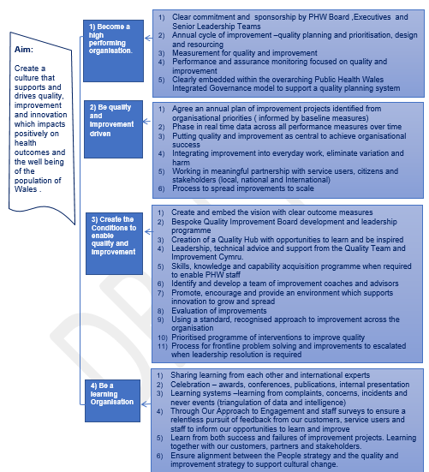

1.4 “Our Vision” for developing and implementing enabling foundations

Over the period of this strategy (through the implementation) we will demonstrate how quality and improvement is integral to all that we do, with a relentless focus on improving quality and our approach in achieving outcomes in our seven priority areas.

Below in Figure 2, we have identified four key enabling foundations (informed by evidence), required to create a culture that will enable continuous quality and improvement for the benefit of the people of Wales.

Figure 2: ‘Our Vision’: Four key enabling foundations that will underpin the Quality and Improvement Strategy
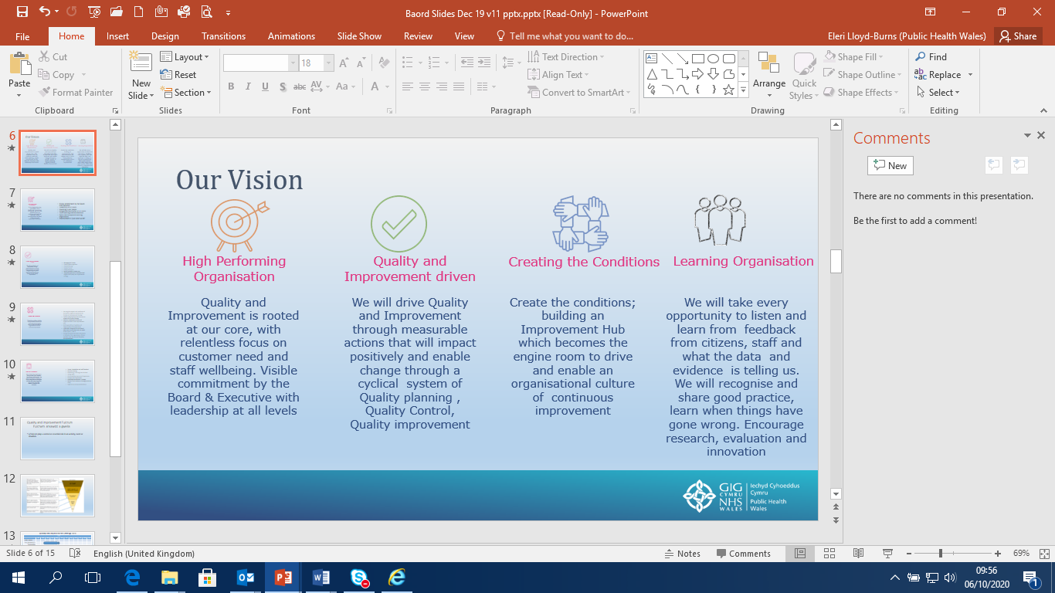
In supporting ‘Our Vision’ for this strategy; we intend to underpin our approach with the Quadruple aim⁵, which is an internationally recognised concept which Welsh Government also refer to in a Healthier Wales². Figure 3 has been slightly adapted from the Welsh Government themes, to provide better organisational alignment for Public Health Wales.

Figure 3 Quadruple Aim adapted for Public Health Wales

The four elements of the ‘Quadruple Aim’⁵, can mainly be understood by the words provided within each segment of Figure 3, with the exception of ‘Higher Value interventions’, which benefits from more explanation. High value in this context means achieving excellent outcomes and better experience in the most efficient way, which includes reducing costs where possible.
To align to the quadruple aim⁵ and ensure quality is central to the culture of the organisation, we need to:-

- Focus on system errors rather than ‘people’ errors
- Amplify the voice of the person, community or population
- Recognize and celebrate success and learn from failure
- Embed coaching into everyday practice and foster compassionate leadership
- Recognize and value the contribution of all staff to the quality agenda
- Collaborate and work in partnership with individuals, people, communities and stakeholders to design and implement interventions that meet identified needs
- Work collaboratively with health boards, local authorities, voluntary organisations and academia, to agree shared outcomes which are measurable and aligned to prudent health principles.
- Value, listen and support staff, providing resources and an environment where they can develop confidence and skills, to be able to influence improvement in their own work.

1.5 Organisational culture

The focus on organisational culture is key to building a sustainable approach to improvement, through learning and sharing with each other, with the public and other key stakeholders, at regional, national and international levels. We need to increase our opportunities to celebrate success while being very open to sharing and learning from our failures which is very important to our overall quality, safety and success.

Our people strategy⁶ is also a key enabler to ensure we support our staff to have the right working environment, skills and knowledge for our workforce to deliver on organisational priorities.

The Integrated Governance Model places particular emphasis on culture and engaging the whole organisation and aims to:

- Enable directorates, divisions, teams and individuals to conduct their work in pursuit of Public Health Wales’ strategic objectives and where required in compliance with regulations, policies and procedures.

- Promote improvement in the efficiency and effectiveness of our ways of working through continuous learning and feedback.

- Ensuring that people working in the organisation are supported in effectively managing risk, incidents and concerns, with robust improvement actions to mitigate risk where appropriate and prevent repeat incidents from occurring.

We will need to maximise opportunities available through the digitalisation of our systems, processes and ways of working, both to improve the experiences of our stakeholders and for the experiences of our staff. We want to make it easier for people to have access to the information and data which they need, to be able to have more direct influence over the improvements they can make in driving quality and improvement. The Digital Strategy⁷ will therefore also play an important role in the realisation of this Strategy.

The implementation of this Quality and Improvement Strategy also provides us with an organisational road map to take forward the expectations identified within the Health and Social Care (Quality and Engagement) (Wales) Act^{3.} This legislation places an additional duty of quality on Public Health Wales as it does for all NHS organisations in Wales. Therefore this strategy will support us in evidencing how we take forward the essence of the Act, which is intended to strengthen the existing duty of quality beyond compliance with standards, to a system-wide way of working to provide safe, effective, person (population)-centred, timely, efficient health care in the context of a learning culture³.

In addition the Welsh Government National Clinical Framework: A Learning Health and Care System⁹, will be used to inform the implementation of this strategy, in particular for improving how we support the wider NHS in taking a life course approach to improving service delivery, which is aligned to the burden of disease and also how we take into account this framework as we seek to improve our own more clinically orientated services, functions and programmes.

We will be supported by Improvement Cymru who will share their expert knowledge, improvement leadership and networks to inspire and enable us to learn from the best.

This strategy takes into account the Social Services and Well-being (Wales) Act 2014¹⁰, and the Well-being of Future Generations (Wales) Act 2015¹¹, which are designed to be key enablers and place renewed emphasis on the importance of involving and listening to the people of Wales. In addition the socio-economic duty and the public sector equality duty¹², requires public bodies to have due regard to the need to deliver better outcomes for those who experience socio-economic disadvantage and eliminate discrimination, advance equality of opportunity and foster good relations between different people when carrying out their activities. Through this Strategy and the three year implementation of the already approved ‘Our Approach to Engagement’ we will utilise the benefits of this legislation in contributing to a ‘More Equal Wales’¹¹.

The organisation now needs to take responsibility for an integrated approach to implementing enabling strategies to ensure a coherent organisational understanding for our workforce.

1.6 Planning for quality

This strategy focuses on driving quality and improvement and needs to be sustained by an organisational planning system that “plans for quality”, together with the development and implementation of an Integrated Governance Model. This will support and embrace a culture where staff understand what they are expected to do and how they contribute to quality, improvement and compliance, demonstrated by achieving key milestones and outcomes.

As the main premise of this strategy is based on cultural change and increasing staff skills; knowledge and application of quality and continuous improvement is an essential component and inextricably linked to creating the right environment for this strategy to gain the necessary traction. Workforce education and training plans for quality and improvement must be properly developed, planned and resourced.

Matrix working with the planning and performance team is key to ensuring that we are able to deliberately plan for our improvements, and be able to present and utilise real time data to understand how and if we are making expected progress.

We will identify our strategic quality and improvement priorities (based on our seven strategic priorities)¹³ within the planning cycle, and can therefore resource identified areas for improvement effectively, with a clear view to scale and spread with the support of specialist improvement knowledge and expertise.

We will use the current Health and Care Standards¹⁴ (or any Welsh Government renewed version of the standards), in a more dynamic and regularised way to drive improvement in standards and approaches to our work.

This Strategy will be subject to annual review through the implementation plan, to ensure that it continues to be informed by the most up to date evidence and that we are on target to achieve what we set out to achieve.

The three-year implementation plan will focus on a high level view of the next three years, with a more detailed annual plan showing delivery against the four elements of the vision of this strategy as identified in Figure 2.

To ensure the quality and improvement strategy actually does drive and shape our culture and approach, it needs to be clear to staff how they contribute to, and shape the overall implementation.

1.7 The legacy of a global pandemic

We know that now, more than ever, the need for robust and excellent public health interventions are needed by the people of Wales.

We must take this opportunity to strengthen and improve in order that we can serve the public well now and into the future. The burden of disease is likely to have worsened, the halting of our services, functions and programmes in Public Health Wales and in other organisations has introduced a back log which is likely to have a negative impact on the health of the nation for years to come.

The pandemic has been a crisis, the legacy will be enduring. However, this presents even more of an opportunity, to be more effective and ensure we achieve excellent quality, reliability and safety at the core of all that we do. We need to further strengthen our organisational approach, robust systems in place to plan for quality, monitor our performance for quality control, and ensure this informs and drives our processes to support quality improvement.


Section 2: The enabling foundations

This section onwards offers more detail on the content of the enabling foundations referred to in Figure 2 (and below).

2.1 Enabling Foundation 1: High Performing Organisation

Figure 2

Public Health Wales seeks to be a high performing organisation achieving excellent results and sustained improvements by determining and focusing on what is important organisationally and what matters to people and our population.

Our Board, executives and senior leaders have a vital role to play in setting the tone and organisational culture and expectations of continuous quality and improvement as outlined in this Quality and Improvement Strategy. Strong leadership is required to maintain consistency of purpose and demonstrate compassion and a shared understanding that to change complex systems is difficult.

Consistent, visible leadership and communication that reinforces this vision and implementation of the primary and secondary drivers is key to success on this improvement journey. Ensuring the executive and senior leaders have regular opportunities to share and learn from failure and celebrate success to have a better understanding of the context our staff are working in.

Whilst consistent and visible leadership is a key factor for high performing organisations, staff within Public Health Wales are our most important asset and each person must play their part in contributing to the success of the organisation in achieving improved health outcomes for the people of Wales.

Quality and improvement is a continuous process and a long-term commitment that requires a change in culture (the way we do things). The change in culture will rely on a shift in the way we think, act and organise our work; enabling all staff to lead and take responsibility for their contribution to drive quality and improvement.

We will produce an annual progress report on the implementation of this strategy and ensure evaluation is built into significant improvement projects.

What we will focus on:
- Secure the support and confidence of the Board to agree and promote the Quality and Improvement Strategy
- Produce and report an Annual Quality report
- The Board commits to a development programme focused on quality as a business strategy
- Through effective integrated governance, the Board will guide the organisation in taking forward improvement activities that are aligned with our strategic priorities
- Select a few important improvement projects as part of the annual planning cycle
- Visible leadership from the Executive Team to support the Quality and improvement Strategy
- Time Series Data on quality and improvement available to the Board and Executive to be fully informed on how the organisation is performing

What does success look like?

By 2030 we will have quality and improvement rooted at our core, with visible and focused leadership at all levels. This will be accompanied by effective integrated governance, and, wherever possible, real time data to ensure all improvement activities are aligned with the organisation’s strategic priorities.


2.2 Enabling Foundation 2: Quality and improvement driven.

2.2.1 Model for quality and improvement

Public Health Wales strives to be evidence informed and to utilise different methodogies to inform different forms of work.

The organisation has had many successes working with internationally and nationally recognised partners, using public health science, and research and empirical methodologies. Improvement approaches can supplement and complement these methodologies.

We will adopt a proven and standardised, organisation-wide approach to quality and improvement, always recognising that there are many methodological approaches, which can be applied.

We will engage and learn from staff, stakeholders and citizens who have the ‘lived’ knowledge and experience, their perspectives and contextual understanding will be included in all improvements, and where possible embedded into a research based approach.

Throughout the process, we will continually question:

- What is the outcome we are we trying to achieve? (What is not working as it should be and what needs to be improved?)

Figure 4: The three fundamental questions for achieving quality improvement
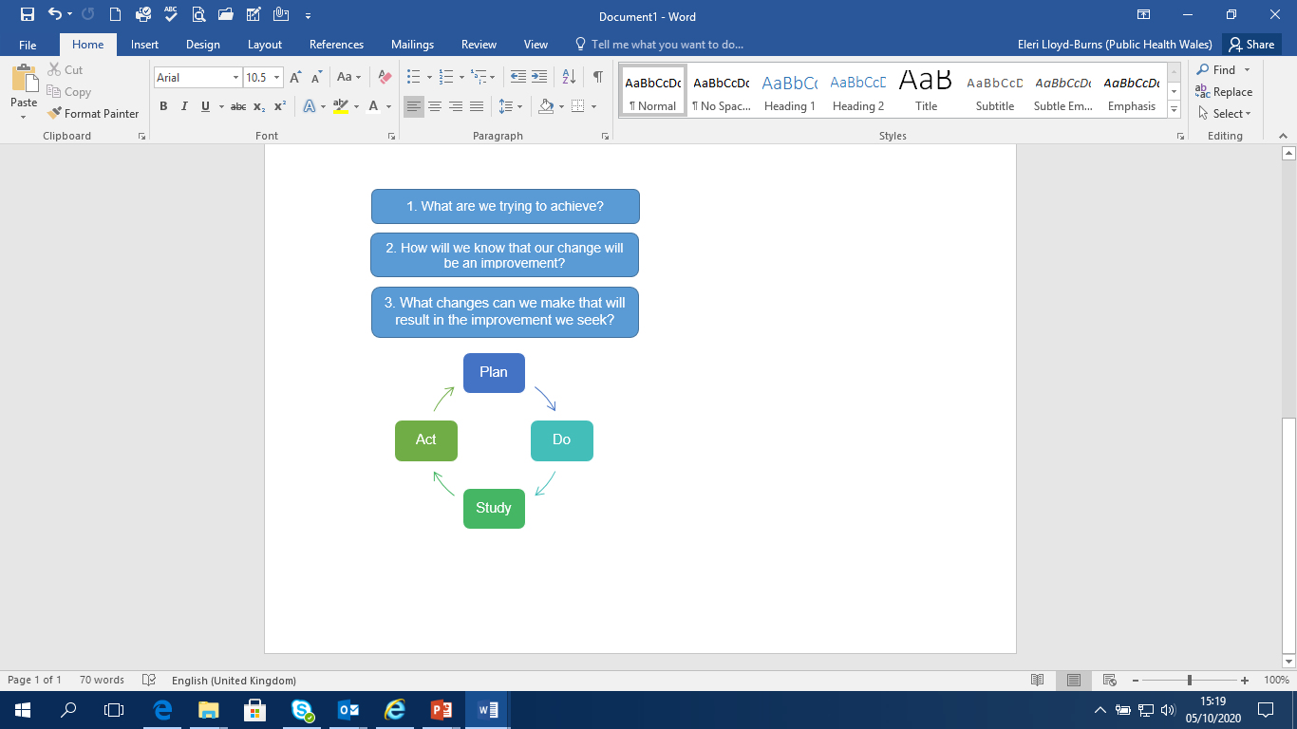
The three fundamental questions for achieving improvement:

2.2.2 Quality and improvement measures

Public Health Wales is a complex organisation that provides a wide variety of services, programmes and functions. Our products, approaches and delivery methods need to demonstrate impact, improved population outcomes with timely measurement, including in real time wherever possible, which can inform whether improvement is happening over agreed time frames. This will require the development of a mixture of outcome and process measures.

These measures inform whether improvements are being achieved and when plans and approaches need to be revised. Data is a key enabler for improvement and we have progress to make in ensuring our data is developed, produced, presented and available in the most advantageous and interactive way. We will build on recent work undertaken by our Corporate Analytics Team to develop interactive dashboards to visualise our performance information in a way that allows staff at all levels of the organisation to make effective decisions and drive improvements.

We must focus on increasing the amount of good quality and timely information, which is available to all levels of the organisation. It is of equal importance that the Board is looking at the right information to take assurance or to offer constructive challenge, as it is for individual members of staff and teams to have easy to access data so they are able to own their own improvement actions. This will move us away from a focus on retrospective quality assurance which may be of limited value, to increased use of timely data on quality, improvement and performance.

Getting the right measurements, requires us to do the right thinking and planning around what outcomes we are trying to achieve, and then ensuring that we develop indicators that will tell us whether we are making the improvements we want. We need to support teams with the right level of expert support at all stages of this process.

What needs to happen?

- Develop Quality Measures and incorporate into the Performance and Assurance Dashboard iteratively
- Data made readily accessible to teams to inform their improvement work and ensure they can measure progress as part of their Plan Do Study Act cycles.
- We will develop our capacity and knowledge using improvement methodology (Model for Improvement) to ensure our quality measures focus on outcomes, process and balancing measures.
- Develop and implement an annual plan of improvement projects
- Engage and learn from staff, stakeholders and citizens who have the ‘lived’ knowledge and experience, their perspectives and contextual understanding will be included in all improvements, and where possible embedded into a research based approach.

What does success look like?

By 2030 our organisation will have cutting edge analytics platforms and meaningful measures which can track performance across all aspects of our business in real time, allowing our teams to have control of the data, with elevated positioning of data quality to drive improvement and outcomes. Our systems and infrastructure will provide staff and teams with data, intelligence and resources necessary to plan and deliver sustained improvement.


2.3 Enabling Foundation 3: Creating the conditions

2.3.1 Our values

The Board sets strategy and organisational tone, which then needs to be implemented by everybody working in Public Health Wales.
Our organisational values¹⁵, assist us in understanding the culture and environment we are aiming to create, together with the approaches and ways of working identified in our People Strategy 2020⁶.

Figure 5. Public Health Wales’ values
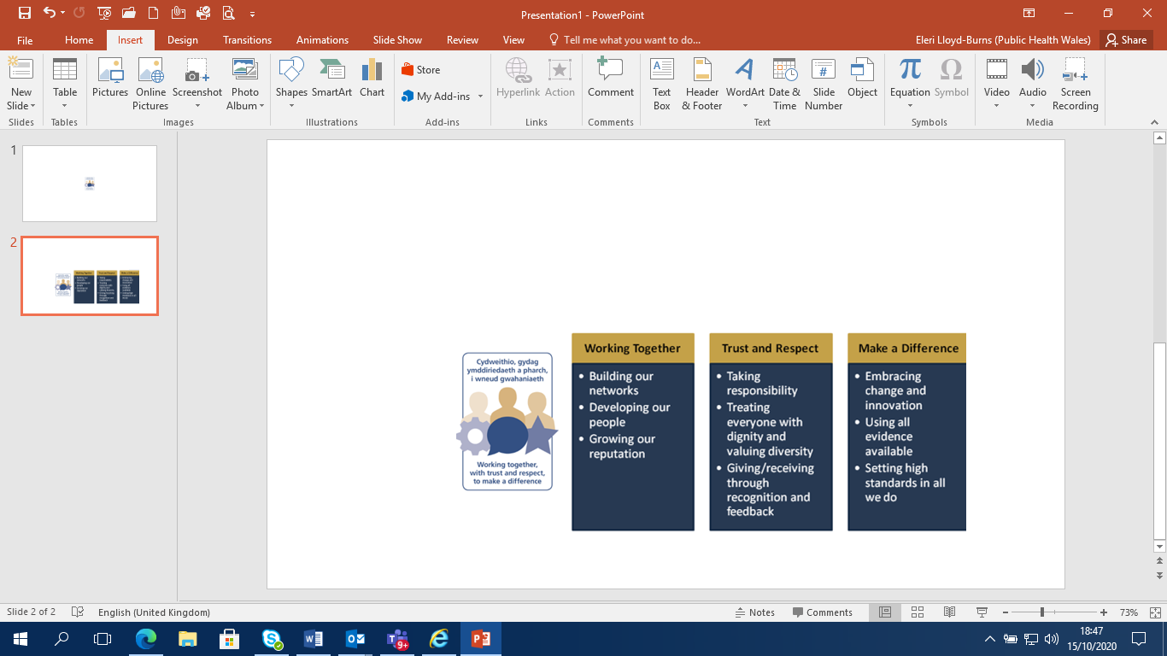

Our values depict what everybody in our organisation should expect to see, hear and feel. In addition to these values, the organisation and its leaders have a duty to provide the right leadership, conditions, supporting environment and skills to be able to engage effectively in quality improvement in their daily work. Easy access to improvement tools and support from improvement coaches to put skills into practice in their work environment is essential in supporting this.

Fostering an open culture of learning and improvement is a key domain for quality (and, in particular, quality improvement). The Board and leaders within the organisation will also need to be equipped with skills to interpret improvement results and understand normal variation. Equally, requirements for increased capability within the workforce, extends to all our staff to ensure we can support system-wide improvements.

We fully recognise that there will be challenges to overcome in our organisational journey in quality improvement – ranging from the diverse nature of the organisation, staff capacity and capability, cultural change, external relationships, meaningful measurement, rebalancing quality control at the frontline and providing the right level of quality assurance to the Executive Team and the Board.

“For improvement to flourish it must be carefully cultivated in a rich soil bed (a receptive organisation), given constant attention (sustained leadership), assured the right amounts of light (training and support) and water (measurement and data) and protected from damage.”¹⁶

Innovation is on a continuum of improvement, and we need to encourage our workforce to become more curious about innovation, providing encouragement and practical support to nurture innovation and share learning and success with wider partners both within Wales and further afield. Collaborating with other key stakeholders, which will require the development of a process for scale and spread of improvements and innovation, to optimise opportunities to deliver our strategy through timely and high value interventions.

2.3.2 Skills and capability

Skills and capability building to create a culture of quality and improvement at all levels will require a phased approach over the period of this strategy. A training needs assessment will be undertaken to inform what knowledge and skills we have as a base line and what development programmes will be required to move us further forward. Further periodic review of training needs will also be undertaken.

In addition to support building improvement skills and capability within the organisation, we will also foster a systems level leadership approach. Key individuals will be identified who can catalyse, enable and support the growth of quality improvement within Public Health Wales (see Figure 6).

We will need to invest in improvement development and leadership skills of our central quality and improvement team as well as improvement leaders and coaches across all Directorates.

Figure 6 Key roles to support quality improvement

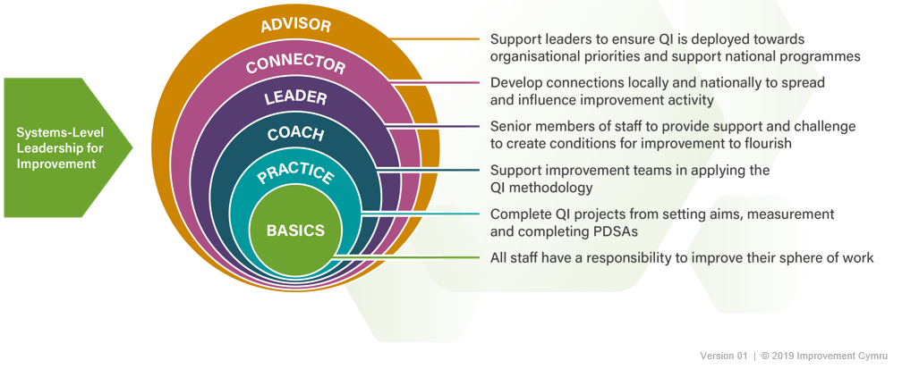

2.3.3 Where are we now on our improvement journey?

Our assessment is that we are currently at the foundational level of our improvement development and that significant commitment and incremental investment in quality and improvement will be required to progress upwards on the improvement steps. (See Figure 7).

Based on evidence from other organisations, we know that building capability and capacity in quality and improvement can take many years to achieve success. During the next three years it is envisaged that as an organisation we will be at the ‘Building Stage’ of our improvement journey.

Leadership and organisational buy-in is imperative for success and we will need to invest in capacity and capability building as part of the implementation of this strategy.
The diagram below shows the steps towards increasing organisational capability.

Figure 7: Steps towards organisational improvement capability

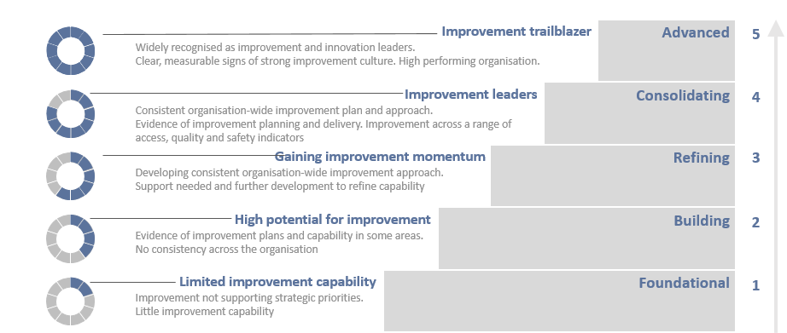

2.3.4 Establishing and embedding our Quality and Improvement Hub

The importance of an Improvement Hub as a key enabler is essential to support organisational capacity and capability building, and is well referenced across many organisations who are achieving different stages of success. We therefore see the creation of a Quality and Improvement Hub becoming the engine room to inspire staff, senior leaders and the Board through an annual programme of expert led events. These events will provide opportunities to share knowledge and improvement ideas. Attendees will engage with one another and learn from the best in quality improvement. The ‘Hub’ will promote and actively encourage people to share and reflect on failures and celebrate achievements and success.

Our Improvement Hub will provide information, techniques, tools and resources to support the organisation in applying quality improvement into our daily work and strategic planning. It will also provide support in developing measures which can be regularly reported and will actively engage with expert knowledge.

We will measure the impact of the Quality and improvement hub and learn from the best examples to improve.

What needs to happen?

- Develop improvement leadership and capability in the central quality and improvement team and at all levels across the organisation in driving quality and improvement
- Assess current resources, capacity and capability and develop a plan that can support cultural change for our staff to flourish in quality and improvement with access to a range of quality and improvement tools
- Provide an annual Improvement Hub programme to inspire and drive forward an improvement culture
- Identify resource investment to drive and support the work of the Improvement Hub
- Undertake a diagnostic assessment to understand where we are and where we can expect to be at milestone points over the period of the strategy.
- Build an easy to access repository of knowledge that can inform future projects (along with available quality improvement tools)

What does success look like?

By 2030 we will be widely recognised as an organisation of improvement and innovation leaders. The Improvement Hub will have:

- established quality and improvement annual programmes to continually build capacity and capability, celebrate success and learn from failures
- trained staff across the organisation to lead and facilitate improvement work
- supported the organisation in embedding a culture of continuous improvement.

2.4 Enabling Foundation 4: Learning organisation

2.4.1 Workplace culture

Being a learning organisation is fundamental to our success and ability to continually improve. The presence of a supportive, collaborative and inclusive workplace culture and a learning climate in which teams have time and space for reflective thinking and can feel psychologically safe to raise questions and concerns is a prerequisite for a high performing organisation focused on improvement. Through compassionate and supportive leadership and organisational tone, we must create an environment to share and test ideas, understand and learn from things when they go wrong or when projects have not been successful. This is crucial to learning and improving. Failing safely is an important part of improvement and project planning to optimise our opportunities to succeed.

High performing organisations are those which are open and honest when mistakes or errors occur, and can demonstrate learning and improved outcomes as a result¹. We seek to support an open and learning environment and not a blame culture, we have a great deal of expertise within the organisation and sharing this expertise through a matrix approach means we can call on others to help and support. Asking for help should never be seen as a sign of weakness, collective efforts are much more likely to help us succeed. We don’t have to be experts in everything, however we do need to recognise when support and assistance from others will assist us in overcoming hurdles which we are bound to encounter.

The emphasis should always look to systems failures not individual failures. There are many tools we can use from the wider quality and improvement toolbox that can be used to support findings when things go wrong, e.g. Fishbone, 5 whys¹⁷.

There are many ways to identify where we need to improve, including the duty of candour and our learning systems under Putting Things Right regulations¹⁸, which require us to learn from complaints, incidents, concerns and claims. Data, performance data, audits, project closure reports are other examples of rich sources of information which can be used to determine where we need to improve.

2.4.2 Learning from our customers. “Our approach to engagement”

Public Health Wales provides a range of services, programmes and functions at an individual and population level.

We have commenced implementation of ‘Our approach to Engagement’ which commits to improving how we engage with the public and our service users. The engagement approach further supports the aims of this quality and improvement strategy.

People and the publics experience and views of our how we operate our programmes, functions and services are extremely important, as the key stakeholders for whom we seek to positively impact to improve the health and wellbeing of the population of Wales.

Wales is an ideal size to work together with the population, communities and individuals to build a collation for change. Tackling health inequalities, and improving health outcomes in collaboration with the public and service users allows us to seek opportunities for engagement, generate feedback and meaningfully involve them in the design and delivery of improved services, programmes and functions. We should therefore aim for a relentless pursuit of feedback from our customers, and service users through proactive and reactive feedback as this provides us with information that is arguably the most important feedback we should be obtaining. This can be through a range of approaches working directly with people and the population and through recognised third sector organisations e.g. focus groups, engagement surveys, service user questionnaires, social media analysis.

We need to understand the impact of our approaches for those with protected characteristics under the Equality Duty and for those who are socio economically disadvantaged. This will enable us to ensure that we are not further contributing to widening the inequalities gap, and instead are purposefully designing programmes, functions and services to tackle and improve upon the inequalities which currently exist. This needs good quality data which in some cases needs to be established.

What needs to happen?

- Identify ways to better understand the need and views of people/public and stakeholders
- Focus on driving down inequalities and ensuring equity of access and experience across diverse groups
- Co-produce clear system-wide priorities (based on the above needs) and define the desired future state from our citizens, stakeholder and staff perspective.
- We will share ‘what good looks like’ across the organisation so we can learn from one another
- Embedding of an effective learning system to support planning
- Develop and implement approaches to review failure for the purpose of learning
- Review program on an annual basis

What does success look like?

By 2030 we will have:

- strong collaborative and inclusive values that support an open and transparent culture
- a well-established learning system that reviews success and failure, and supports effective planning
- a learning climate, with mature systems of feedback that inform improvement, and enables teams to innovate and test new ideas.

Section 3: Next steps

3.1.0 Next steps

To commence on our quality and improvement journey the following next steps will be taken forward:-

- Achieve Board approval

- Develop a high level 3 year implementation plan, with a more detailed plan for year one

- Led by the Executive Director for Quality, Nursing and Allied Health Professionals, the Executive Team will play a key role in ensuring that the implementation and milestones are being achieved

- Develop measures to monitor progress of implementation of the strategy and provide an annual report on progress

- The Quality, Safety and Improvement Committee will provide Board level oversight and will receive assurance regarding implementation

- We will work with other key leads from enabling functions and Directorates to take an integrated approach to implementation of this strategy where there are clear interdependencies, to achieve better coordination and alignment in our approach

- We will communicate and engage staff as part of year one of the implementation of this strategy

- Undertake a training and resource needs analysis to recommend future resource and investment requirements

- Establishment of a Quality Improvement Hub, with a programme which supports the strategy implementation

References:

1. The IHI Triple Aim Initiative. Better care for individuals, Better Health for Populations, and Lower per capita costs
The IHI Triple Aim | IHI - Institute for Healthcare Improvement

2. A healthier Wales: long term plan for health and social care. Welsh Government. (2018)
A healthier Wales: long term plan for health and social care | GOV.WALES

3. Health and Social Care (Quality and Engagement) (Wales) ACT.
Explanatory Memorandum incorporating the Regulatory Impact Assessment and Explanatory Notes. Welsh Government. (June 2020).
health-and-social-care-quality-and-engagement-wales-act-explanatory-memorandum.pdf (gov.wales)

4. Consensus Statement on Quality in the Public Health System .U.S. Department of Health and Human Services Office of Public Health and Science Office of the Assistant Secretary for Health Public Health Quality Forum. (August 2008)
Consensus Statement on Quality in the Public Health System (apha.org)

As cited in:
Toward Quality Measures for Population Health and the Leading Health Indicators. Committee on Quality Measures for the Healthy People Leading Health Indicators; Board on Population Health and Health Practice; Institute of Medicine. Washington (DC): National Academies Press (US); 2013 Apr 9.
Introduction and Context - Toward Quality Measures for Population Health and the
Leading Health Indicators - NCBI Bookshelf (nih.gov)

5. Quadruple Aim. A Healthier Wales: Our Plan for Health and Social care. (June 2018)
A Healthier Wales (gov.wales)

As cited in:
NHS Wales Planning Framework 2019/22
Item 5.1.1 NHS Wales Planning Framework 2019-22.pdf

6. Public Health Wales People Strategy 2020-30. Our workforce to achieve a healthier future for Wales
PHW People Strategy 2020-30_E (web).pdf (wales.nhs.uk)

7. Digital strategy for Wales. How we will use digital, data and technology to improve the lives of people in Wales. Welsh Government
Digital strategy for Wales [HTML] | GOV.WALES

8. Quality and Impact Framework. Public Health Wales
FINAL PHW Quality and Impact Framework E(4).pdf (wales.nhs.uk)

9. National clinical framework: a learning health and care system. Guidance on how to plan and provide local and national clinical services. (March 2021)
National clinical framework: a learning health and care system | GOV.WALES

10. Social Services and Wellbeing (Wales) Act 2014
Social Services and Well-being (Wales) Act 2014 (legislation.gov.uk)

11. Well-being of Future Generations (Wales) Act 2015
Well-being of Future Generations (Wales) Act 2015 (legislation.gov.uk)

12. The Public Sector Equality Duty (PSED). Equality and Human Rights Commission
Public Sector Equality Duty | Equality and Human Rights Commission (equalityhumanrights.com)

13. Public Health Wales .Our priorities.
Our Priorities - Public Health Wales (nhs.wales)

14. Health and Care Standards. Welsh Government
Health standards framework english (gov.wales)

15. Our Values. Public Health Wales
Our Values - Public Health Wales (nhs.wales)

16. Shortell et al, 1998. Shortell SM, Bennett CL and Byck GR (1998)
Assessing the impact of continuous quality improvement on clinical practice: what it will take to accelerate progress. The Milbank Quarterly 76(1):593-624.

As cited in:
Building capacity and capability for improvement: embedding quality improvement skills in NHS providers (IHI)

17. NHS Improvement. ACT. Online library of Quality, Service Improvement and Redesign tools. Root cause analysis using five whys
Layout 1 (improvement.nhs.uk)

18. NHS Wales complaints and concerns: Putting Things Right. Governance e-Manual
Governance e-Manual - NHS Wales Shared Services Partnership

