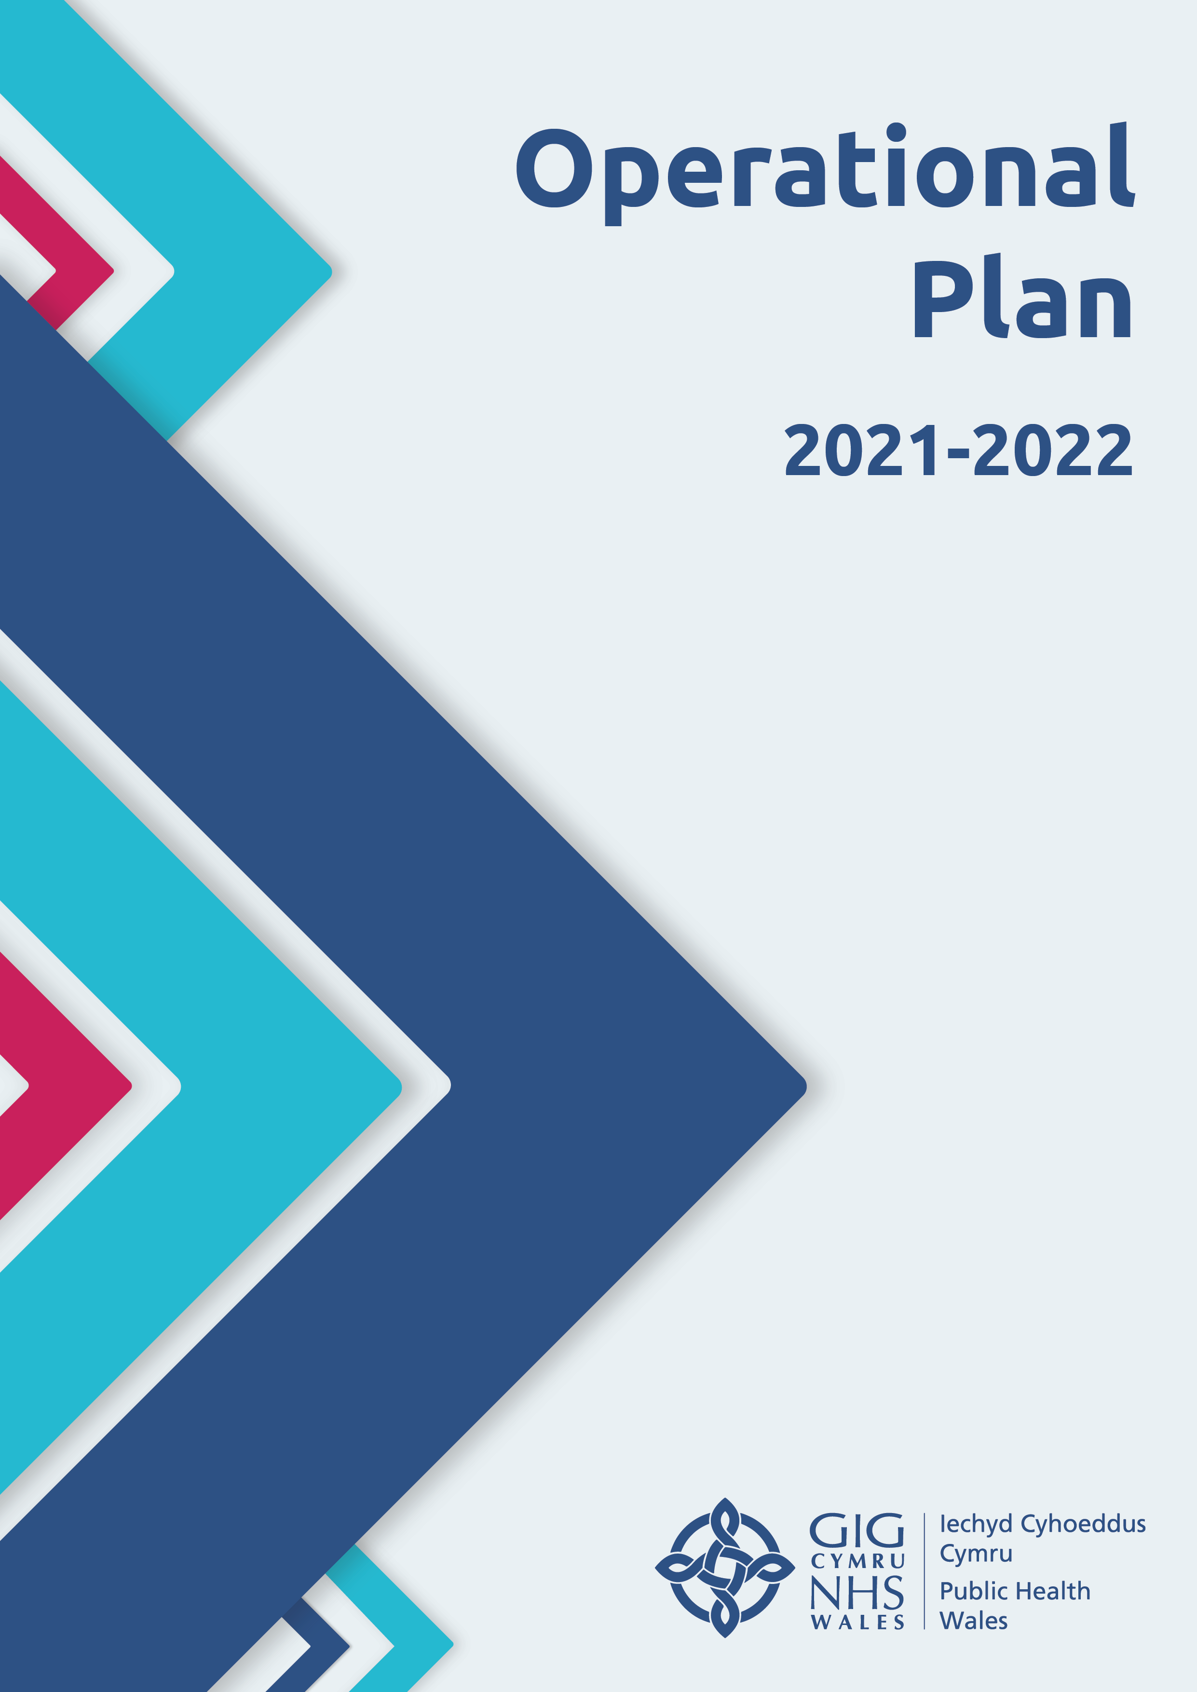
Contents

Executive Summary | 3
Part 1 - Introduction  Plan on a Page | 6  9
Part 2 - Our Priority Areas
2.1 Health Protection Response | 11
2.2 Population Health | 16
2.3 Reactivating our Public Health Functions, Programmes and Services | 21
2.4 Organisational Learning | 25
2.5 Enabling Recovery | 27
Part 3 - Enabling the Organisation
3.1 Our Financial Plan | 33
3.2 People and Organisational Development | 35
3.3 Quality, Safety and Improvement | 38
3.4 Performance and Delivery | 39
3.5 Concluding Remarks | 41

Executive Summary
Public Health Wales has mounted an unprecedented health protection response to the coronavirus pandemic since early 2020. This has been in support of the policy direction set by the First Minister of Wales in Leading Wales out of the Coronavirus Pandemic, and delivery of the Welsh Government’s Test Trace Protect Strategy. The nature of our, and the wider system’s, response has evolved significantly during this time and has been delivered in the context of the United Kingdom’s exit from the European Union and additional investment in public health.
The response to the pandemic has involved the mobilisation of the full weight of the organisation’s resources and been our highest priority. Alongside this, we also commenced work around the longer-term direct and indirect public health implications on the people of Wales. This was reflected in our in-year Operational Plan 2020/2021, which was agreed in October 2020. The Plan focused on maintaining the primacy of our ongoing health protection response, while undertaking clearly defined key population health activity within a small number of areas. Our in-year Operational Plan, and this updated version for 2021/2022, sets out the variation to our previously approved plans, particularly our Strategic Plan (otherwise known as our Integrated Medium Term Plan).
During early 2021, we have refreshed our Operational Plan to ensure that it clearly articulated the planned action on our agreed priorities. As part of this process, we validated our existing priorities and refreshed the underpinning milestones to ensure that we were delivering maximum value in our role as the National Public Health Institute for Wales. This has been guided by our long-term strategy Working to Achieve a Healthier Future for Wales, and a number of key strategic prevention-focused drivers, particularly the Well-being of Future Generations (Wales) Act and the upcoming Socio-economic Duty.
Our progress to date is a result of the efforts and commitment shown by our staff, particularly over the last year as we have worked tirelessly in response to the coronavirus pandemic. We have seen staff mobilised from across the organisation to support our direct response, which has allowed us to draw on a range of public health, leadership and management skills. We recognise the impact that this has had, both personally and professionally, and our focus is on ensuring that we continue to prioritise and support our staff’s well-being, welfare and resilience. Our approach to this is set out within the People and Organisational Development chapter of this plan.
While our focus will continue to be on ensuring the delivery of an effective and sustainable response to COVID-19, we also recognise the importance of undertaking work on the wider population health implications for the people of Wales. It is critical that we are able to understand fully the broader impacts (both positive and negative) of COVID-19, including on vulnerable groups and in relation to health inequalities. Following work undertaken during late 2020 to reactive our screening programmes, we will continue to prioritise, as the pandemic response allows and depending on the speed of additional recruitment into our enhanced health protection response, the reactivation of our essential public health functions, programmes and services in a planned way.
It is also vital that we continue to capture learning from the rapid delivery of our response to COVID-19. We have evaluated our activity to-date, identified lessons and begun to systematise processes to share this learning. We will build on this as we deliver this plan, including continuing to develop our organisational narrative in relation to the COVID-19 pandemic.
Our enabling functions are the engine room of the organisation and will support us as we ‘recover new’ from the pandemic, along with playing a key role in the delivery of our public health priority areas. A key element of this work will be the review of our long-term strategy and completion of work to develop a small number of population health outcomes by which we will measure progress. We will also commence, in early 2021/22, an organisational-wide discussion with staff about future ways of working.
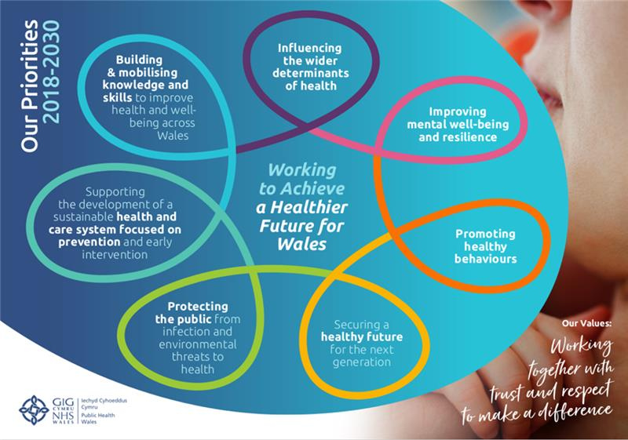
The action that we will take within each of these areas is set out in this refreshed Operational Plan for 2021/22. Their delivery is guided by our long-term strategy and seven strategic priorities, which are set out in the diagram below:


Part 1 – Introduction
1.1 Overview
The purpose of this Operational Plan is to set out the activity that Public Health Wales will deliver in 2021/22. The development of the plan has been informed by our long-term strategy, key public health challenges facing Wales and a number of strategic drivers.
In developing the plan, we recognise that its delivery will need to be subject to ongoing review and dependent on:
- the need to meet potential future COVID-19 surges or peaks
- our ability to recruit sufficient numbers of suitably qualified staff as part of the implementation of our recently approved Health Protection Business Case.
We therefore need to ensure that we have robust arrangements in place to manage delivery and make decisions over potential in-year changes to this plan. These arrangements are set out within the Performance and Delivery section of this plan.
1.2 Strategic direction and outcomes
Our existing long-term strategy and key legislation, such as the Well-being of Future Generations Act (Wales) 2015 and forthcoming Socio-economic Duty, have informed and guided decisions that we have made around the delivery of our COVID-19 response to-date and the actions set out within this plan. We have used these to ensure that we maintain our focus on key long-term prevention, including the wider impacts of COVID-19, while effectively responding to the immediate demands of the pandemic.
We recognise that, in light of the seismic changes resulting from the pandemic in Wales, we need to review our long-term strategy and this is a key part of our recovery work. It will assess whether our current strategy remains valid or needs to be revised/refreshed in light of the experiences and learning from COVID-19 and horizon scanning of future opportunities and challenges. Aligned to our strategy refresh, we will also complete the work commenced in late 2019 - put on hold as a result of COVID-19 - to develop and agree a set of population health outcomes. These will guide and inform our future activity and allow us to assess progress in the delivery of our strategy.
1.3 Shaping our priorities
A number of strategic and policy drivers have shaped and informed the development of our priorities, including key legislation, mitigating the ‘four harms’ stemming from COVID-19 and delivering against key Ministerial priorities. Through the delivery of our priorities, we will deliver demonstrable contributions to these. Since its launch in 2015, we have used the Well-being of Future Generations (Wales) Act as a guiding compass to direct our long-term direction of travel and approach. This is reflected in our long-term strategy and the work that we have undertaken since 2018 to implement it. We see the upcoming Socio-economic Duty as complementary, framing for our work and commitment to address the wider inequalities of health. We are also in the process of considering the implications of the Draft Social Partnership and Public Procurement (Wales) Bill and will be submitting a response to the current consultation.
How we will contribute to each of the four harms and Ministerial priorities, through the delivery of our external public health priorities, is illustrated in the diagram below with further detail provided on the key areas within this plan.
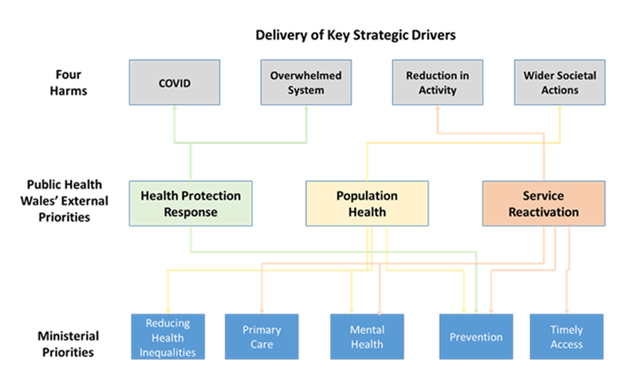
As we emerge from the pandemic, our key focus will be on prevention, sustainability and building the health and resilience of our communities. We will do this through working with our partners to strengthen the wider determinants of healthy life expectancy. We will seek to influence healthy behaviours through targeted public health programmes and continue to restore and develop each of our screening programmes with a focus on delivering effective and timely access to these services.
With over a third of years of life lost related to deprivation in Wales, we know the importance of addressing health inequalities of outcome. An essential element of this operational plan is the work of our population health priority. Through this priority, we will work to influence the wider determinants of health and their impact and mitigate the syndemic insult that COVID-19 has generated by developing essential knowledge, including the Welsh Health Equity Status Report initiative.
Population approaches to improving mental well-being help individuals realise their full potential, make healthy choices, cope with the challenges that life throws at them, work productively and contribute to their family life and communities. There is strong evidence that the impact of social isolation arising from lockdown and social distancing measures due to the pandemic, have had significant adverse effects on mental health and well-being at a population level, particularly on younger age groups; hence the clear focus on these areas within the plan.
As we reactivate our core primary care work programmes, we will work with the system to consider the harms and learning from COVID-19 and the cluster action that can be taken forward to addresses inequalities. Our priorities will include supporting the system to achieve equality of COVID-19 vaccine uptake and action to tackle obesity.
1.4 Operational Plan for 2021/22
We have drawn upon a number of strategic and operational drivers to develop our Operational Plan for 2021/22, which are set out above. These drivers have informed the identification of a small number of priority areas for Public Health Wales, which will be our focus for the next 12 months.
These are:
- Continue to deliver and evolve an effective and sustainable health protection response to COVID-19
- Understand and advise on the mitigation of the broader population health impacts
- Effectively reactivate our prioritised public health functions, programmes and services
- Capture, share and develop organisational learning, knowledge and our COVID-19 narrative
- Enable our effective organisational recovery
For each of these areas, we set out within the plan:
- The specific strategic context that has led to us identifying it as a priority
- The scope of the work that we will undertake
- The high-level milestones that we will deliver
Overleaf is our plan on a page that provides a visual summary of our priority areas and key deliverables.

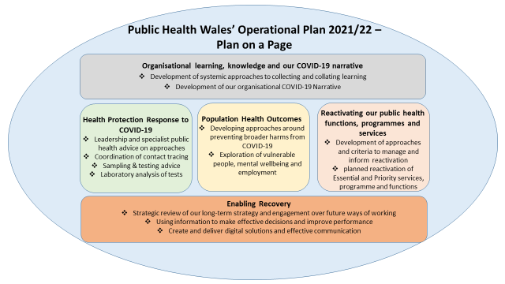



Part 2 – Our Priority Areas

Health Protection Response
2.1.1 Scope of priority
This priority captures all elements of our COVID-19 response into a single coherent plan, aligned with the Test Trace Protect Strategy (TTP). The priority is framed within the context of our roles and responsibilities described in the Welsh Government’s Coronavirus Control Plan for Wales (August 2020).
2.1.2 High level strategic objectives for 2021-22
In October 2020, the organisation moved to an in-year variation of the Operational Plan for the COVID response services, balanced with the resource requirements for organisational recovery and service reactivation. These activities remain in place during the roll-out of the vaccination programme and will continue during 2021-22. The strategic objectives are:
- Successfully implementing the recently approved health protection business case and the rapid recruitment of additional staff into the response
- remodelling the current National Health Protection Response Cell into a COVID-specific response workforce that supports the regional response and provides specialist support to Incident Management and Outbreak Control Team arrangements across Wales
- learning lessons from the delivery of the National Contact Centre function during the COVID-19 response and integrating relevant professional advice support into the national acute response delivery model
- ensuring resilient surge capacity is secured and available to support our system response
- providing ongoing leadership and specialist advice into the national and regional TTP structure, including guidance, training and strategies for prevention and behaviour change
- continuing to support the roll-out of the COVID vaccination programme, including: monitoring public attitudes; engaging with Black, Asian Minority and Ethnic (BAME) communities; addressing hesitancy; e-learning on new vaccines; and measuring vaccine effectiveness and safety outcomes
- delivering surveillance data products to support the national, regional and local response
- developing a resilient port health and cross border specialist and support capability
- improving laboratory resilience and turnaround times for testing
- continuing to take forward the transformative actions, enabled by increased investment from Welsh Government, leading to a more resilient and sustainable microbiology laboratory network to support testing and genomic sequencing infrastructure in Wales
The recent approval of the Health Protection Business Case is pivotal in ensuring the strategic relisience of the organisation. We will need to recruit additional employees at pace in order to ensure we have a resilient and sustainable Integrated Health Protection Division that is able to meet any future health protection requirements. In addition, we need to give our employees, who have been fully engaged in the response for over a year, some time to recover, and then to repatriate all of our employees who were mobilised into the response, back into their core roles within the organisation. This is essential if we are to reactivate the core functions of the organisation that have been paused during the pandemic.
2.1.3 Progress to date
The majority of milestones identified within the 2020-21 Operational Plan have been met or are on target to be met by the end of March 2021. During 2021/22 we will continue to maintain and develop the activities of the previous year, with Quarter 1 and 2 focussing on maintaining activities of the previous year, and with Quarter 3 and 4 being more of a return to ‘business as usual approach’. This will include rapid scaling up and down of services as required. It will be important to carefully manage the health protection response as the mobilised staff return to their existing roles within the organization, and new staff are appointed as part of the investment from the recent business case.
Integrated Health Protection Business Case
In early February 2021, Public Health Wales received investment from the Welsh Government for over 100 new posts. This will strengthen our integrated health protection service and enable us to deliver a leading edge service by optimising a new multi-professional workforce and adopting new ways of working to respond in an agile and effective way to new public health challenges. This will also be a critical enabler and a rate determining factor in our ability to repatriate our non-health protection staff back to their normal roles and reactivate our core public health functions. The implementation of the business case is a substantial change management programme in its own right, which will be managed through a programme managed approach.
Integrated Health Protection Division
The division comprises the key functions of infection prevention, management and control including a network of microbiology laboratories. Work will continue to further strengthen the integration of microbiology and health protection services.
Microbiology
Our Microbiology Division has received investment from the Welsh Government for a new laboratory and workforce for PCR antigen and antibody (serology) testing in Imperial Park 5 (IP5), Newport and also for a series of transformative actions leading to a more resilient and sustainable laboratory network that has delivered:
- testing capacity of 15,000 daily tests in NHS Wales laboratories
- rapid (<4 hours) testing capacity for COVID-19 on all acute hospital sites
- timely (<12 hours) high throughput testing regionally: 80% of samples <12 hours
- operationalised Laboratory 2 in IP5 for PCR antigen and antibody testing
- 24/7 working in UHW, Singleton and Rhyl laboratories
- 14 ‘hot labs’ in acute settings
- timely high-throughput testing regionally

Pathogen Genomics
The Pathogen Genomics Unit of Public Health Wales has been a global leader in the number and proportion of positive SARS-CoV-2 samples that have been sequenced. Typically the service has been sequencing around 2,000 samples a week following initial investment by the Welsh Government. A business case for expansion to be able to sequence over 7,000 samples per week has been submitted to the Welsh Government. If approved, the service will rapidly undertake further recruitment of staff as well as procurement of specialist equipment.
The provision of sequencing data and subsequent bioinformatics analysis has proved critical in understanding the course of the pandemic, surveillance for variants and mutations of concern as well as supporting specific outbreaks.
Population Surveillance
The need for timely surveillance and epidemiology data support to the COVID-19 pandemic has far exceeded anything previously experienced. Our Communicable Disease Surveillance Centre (CDSC) has also kept other essential surveillance schemes running, re-prioritising, reducing or enhancing as appropriate, and targeting analytical resource. However, re-prioritisation can only be a temporary solution and the longer other surveillance activities are de-prioritised the greater the risk of missing other infectious disease outbreaks or significant changes to the incidence of other important infections.
CDSC staff have led the development and roll-out of new surveillance systems and also played a key role in the development of procedures and systems to support a range of COVID-19 responses. These include rapid surveillance of mortality in hospitals; contact tracing data systems; development of Tarian (the in-house communicable disease case management system); convalescent plasma and serosurveillance studies; surveillance of Variants and Mutations of Concern; and supporting a COVID-19 vaccine trial.
To achieve this, the organisation has mobilised analytical resources from outside the department. There is a need to increase the substantive analytical resource within CDSC and this is being expedited through the implementation of the health protection business case.
    - What will be achieved?
At the end of 2022/2022 the following will be achieved:
National Health Protection Service
- recruitment of 109 new Whole Time Equivalent (WTE) posts, at pace, to ensure a resilient health protection service and enable the repatriation of mobilised staff to their core roles within the organisation
- maintain the operational response to the COVID-19 pandemic including Whole Genome Sequencing as required by the TTP Strategy
- implement a new governance structure, developing integration between health protection and microbiology that brings together the oversight of pandemic response and ‘business as usual’ activities
- continue to develop the related governance processes and relationships between corporate and service to provide ‘patient / bench to board’ oversight
- maintain non-COVID Infection Prevention and Control activities
- maintain preparation for High Consequence Infectious Diseases
- enhance the resilience, capability and capacity of the service consistent with the investment from the health protection business case
- establish a programme managed approach to support service change, organisational development and benefits realisation of the Health Protection business case
- maintain operational response to other threats including TB, Legionella and environmental incidents
- reinstate business as usual services as agreed by the organisational process, as and when resources can be released from COVID related activities.
Population Surveillance
- continue to build resilience around COVID and non-COVID requirements in response to demand
- continue to respond reactively as needed, developing trigger points for effective planning
- implement COVID vaccine effectiveness and safety surveillance, in collaboration with Secure Anonymised Information Linkage Databank
- deliver new interventions to address vaccine hesitancy and reduce inequalities, including in BAME communities.
Microbiology
- continue the integration and development of hot lab functions across the network and develop proposals for expansion of non-COVID targets
- continue training new staff to ensure competency beyond COVID
- develop an outline business case for the long-term utilisation of the IP5 laboratories
- support the Laboratory Information Network Cymru Programme to deliver a new Laboratory Information Management System
Prevention Cell
The prevention cell will use epidemiology and behavioural science approaches to develop new insights to inform new and existing policy, guidance and messaging to the public to strengthen efforts to prevent and control the spread of COVID-19. Using the information gained during the last year, we will aim to target those populations at greatest risk using the behavioural insights we have gathered, to tailor messages.
A further work stream has been developed jointly with Welsh Government to explore the public’s motivations and willingness to comply with necessary behaviours in relation to contact tracing e.g. testing, self-isolating.
We are working in partnership with Health and Care Research Wales to deliver COVID-19 vaccine research across Wales. We have signed a Strategic Service Provisions Agreement for COVID-19 Vaccination Trials which sets out our respective roles and responsibilities.
    - Success
A benefits realisation of the Welsh Government investment received for microbiology, and for the newly approved business case will be undertaken. The implementation plan will include key measurables to ensure that the benefits of the investment can be demonstrated. Success in relation to this will be recruitment to posts, leading to a transformed and more resilient workforce. This will also support the transition to ensure transition of the COVID response into the health protection business as usual functions and the ability to scale back up to delivering a world class health protection response, working closely with the wider system with a strong focus on prevention and inequalities.
In terms of the Well-Being of Future Generations (Wales) Act 2015, the Health Protection response will contribute towards a healthier and a more resilient Wales. The investment in the Health Protection business case will strengthen our resilence to respond to any future health protection threats and will support new ways of working across Wales through the focus of prevention and collaboration. During this year we will be engaging with partners and stakeholders to ensure there are clear plans for an integrated health protection response that is consistent across Wales.
    - Engagement
Oversight of the health protection response is through the Incident Management Team, Gold Group and the Executive Team. Arrangements to further evolve the governance around the response were considered by the Gold Group in early 2021 and are in the process of being implemented. The Gold Group also undertook a ‘lessons learnt’ and forward look review in February 2021, and the Executive Team in March 2021, to identify areas of good practice and areas where arrangements could be strenghtened, and these are being developed for the next stage of the response.
Externally, the engagement link with the TTP Programme Board and other strategic partners will continue. As part of the implementation of the Health Protection business case, a communication and engagement plan will be developed internally and externally to engage with employees and partners to agree strategic aims and outcomes.
    - Milestones
Level 0 Milestone | Delivery Date
TTP agreed plan for COVID testing capability and capacity for 2021/2 | 30/04/21
Review the function and operation of the National Contact Centre in order to develop and implement exit / step down strategy in relation to this element of the response | 30/06/21
Embed improvement techniques across Public Health Wales Microbiology laboratories to improve resilience | 30/06/21
Design and develop a Testing Surge Plan with clear criteria for reactivation | 30/06/21
Scope and agree timescales to implement a national results delivery solution | 30/06/21
Develop an exit plan to transition ‘Testing’ workstream to business as usual | 30/09/21
Complete, maintain and improve surveillance outputs in various settings and ensure there is a focus on addressing inequalities. | 30/09/21
Establish a comprehensive Genomics surveillance programme | 30/09/21
Develop threshold methods and clear processes for Cluster outbreaks and detection | 30/09/21
Deliver wider surveillances: flu and respiratory surveillance including SARI surveillance; monitoring of COVID-19 vaccine uptake/effectiveness/safety; surveillance of anti-microbial usage and resistance; pandemic impact assessment, to now include Surveillance population immunity, variants and testing surveillance (i.e. PCR/LFT) | 30/09/21
Deliver epidemiological studies to enhance understanding of COVID-19 | 30/09/21
Implement new services for vaccine hesitancy and BAME outreach | 30/09/21
Undertake an engagement of key stakeholders, local UK and International Level to better understand their surveillance needs and implement an improvement plan, taking this forward for capacity building and IT solutions | 30/09/21
Implement Health Protection Business Case – appoint 90% of approved posts | 31/08/21
Implement first year of Health Protection Business Case programme deliverables | 31/03/22

Population Health

2.2.1 Strategic Context
The spread of COVID-19 has been syndemic with the virus taking advantage of existing health problems along with poor living and working conditions to infect more people and cause greater ill-health. The COVID-19 syndemic has continued to have a profound effect on people across the world, as well as in Wales. Both the virus and control measures are causing wide-ranging harms, such as: ill health and reduced well-being; significant social and economic negative impacts and exacerbating existing health inequalities as well as disproportionately impacting specific groups such as those with health problems and specific population groups including BAME communities. It is therefore critical that we continue to fully understand the broader impacts of COVID-19, including the consequences of actions to control its transmission. Such knowledge needs to underpin policy decisions and joint multi-disciplinary cross-sector efforts to prevent future harms to health and aid recovery.
As we emerge from the COVID-19 pandemic we need to identify and support new opportunities to improve health and reduce inequalities; ensuring we improve on, rather than return to, our population health status before the pandemic. We will support this through utilising resources within the Population Health Strategic Group and where necessary and subject to additional funding, through the commissioning of additional external capacity to undertake the delivery of a number of milestones within our plan. To support TTP during 2020-21, we have already been informing policy options for an optimum balance between virus control measures and the potential negative impacts of COVID-19 with a particular focus on the following priorities:
- Mental Well-being
- Vulnerable Groups
- Employment
To understand the trends and learning, through systematised intelligence and monitoring we have continued our focus on a number of key areas of knowledge and intelligence:
Priority 1: National Public Engagement Survey to understand public acceptance, compliance and broad impacts of COVID-19 measures across Wales and in specific population groups
Priority 2: International Horizon Scanning to build strong links with international agencies and partners to develop insight and learning from other countries
Priority 3: COVID-19 Health Impact Assessments (HIAs) to promote a whole of government and whole of society approach to COVID-19 recovery planning and interventions
Priority 4: Developing a dashboard of broader health trends in health and well-being (COVID-19 Recovery Profile)
Through our research and evaluation work programme, we also focused on generating insights and evidence needed to inform timely action and to better understand the direct and indirect impact of COVID-19 on health in Wales. This was achieved through three priorities:
Priority 1: Understanding the efficiency and effectiveness of Public Health Wales’ contribution to TTP
Priority 2: Generating new knowledge on the indirect impact of COVID-19 on health and communities
Priority 3: Supporting Public Health Wales to contribute to the international knowledge on COVID-19 through research

Scope
We developed an approach to understand and prevent the broader harms relating to COVID-19 and other key drivers of policy health and inequalities in Wales. Our previous work on unemployment and its relationships with poor health and well-being has exposed strong relationships between employment status, life limiting health conditions and mental well-being. The impacts of COVID-19 on employment in Wales are already becoming apparent. Through our national population surveys and other sources of intelligence, evidence continues to emerge on the impact of the pandemic and related restrictions on mental well-being. Fear of infection and lockdown measures lead to uncertainty about the future whilst isolation and interruption of social, educational and employment aspects of life, all represent on going threats to mental health and well-being across Wales. Furthermore, we increasingly understand how children and young people have been especially impacted by the pandemic and its restrictive measures; particularly due to school closures, social isolation and youth (un)employment.
Based on work over the past 12 months we have prioritised these issues and aligned our key priorities with the challenges which we expect to face in the coming year. The importance of preventing non-communicable diseases means we must return to their prevention as an urgent priority. This is due to their immediate impact on health and their contribution to vulnerability to infection with COVID and other diseases. Consequently, the cross cutting themes for our work in population health during 2021-22 will be:
- Mental Well-being
- Children and Young People
- Employment
- Drivers of Non-Communicable Diseases (NCDs)
We will tackle these themes with three cross-cutting ambitions
- To inform policy
- To generate knowledge and intelligence for system use
- To aid a sustainable and fairer recovery from COVID-19
Our approach has been identified through undertaking a validation exercise utilising our internal expertise and our shared working and learning through connections with key stakeholders. Our process has been informed not only through consideration of the impacts of the pandemic but also by aligning with other key challenges to health likely to emerge in coming months. These include ongoing developments arising as a result of our exit from the EU. Our Health Impact Assessments on EU transition suggest that employment, mental well-being and children and young people are all aspects likely to be impacted by the withdrawal from the EU and our work, wherever possible, will consider COVID-19 issues in the context of our exit from the EU and, adopting a Well-being of Future Generations approach, sustainable development.
We will continue to monitor the impact through our intelligence and insight work by collating and analysing its use in policy development and in the strategy and direction of those across all public sectors. Our aim is to produce work that can inform the public health challenges faced now and help predict and prepare for those likely to emerge in coming months.
As sustaining the health protection response to the pandemic has been the key priority for Public Health Wales, we developed a three tiered approach for delivery:
- Tier 1: Work that can be delivered within existing finance and people resources
- Tier 2: Work that can be delivered within existing financial resources, but ONLY if redeployed staff are returned.
- Tier 3: Work that can be delivered ONLY if additional financial resources are secured
We will continue to seek additional funding opportunities, which may enable us to commission out aspects of our work under the tier 2 and tier 3 categories whilst prudently using our in-house expertise to maintain direction, quality and timeliness of our outputs.
To deliver the work aligned to our priorities, we will:
- examine both the negative and positive impacts of COVID-19 and related response measures on broader population health and inequalities
- through research, economic analyses, modelling and other techniques, identify those impacts from COVID-19 and related control measures that may result in the greatest health harms and inequalities and that can be also mitigated
- identify health and well-being action to mitigate harmful effects of COVID-19 and related response measures, as well as to capture and support potential positive consequences, over immediate, mid- and long- term time scales
- utilise international evidence on COVID-19 and related control measures to help inform public health activity and decision-making processes in Wales
- assess and respond to major interdependent issues (e.g. EU transition) which can affect how COVID-19 impacts health and inequalities
- provide analysis and evidence-based policy advice to Welsh Government and other key stakeholders in order to inform action aimed at reducing ill health and inequalities resulting from COVID-19
- respond to specific questions/queries on the socio-economic impact of control measures from policy leads in Welsh Government and other key stakeholders; and where appropriate
- evaluate measures undertaken to control the broader health harms resulting from COVID-19 and measures implemented to control its spread
- strengthen public health leadership and sustainable investment to develop an ‘Economy of Wellbeing’ following COVID-19 and our exit from the EU

What will success look like?
By the end of March 2022, we will have a well-developed and widely used set of intelligence tools that better describe the impacts of COVID-19 and related control measures on the broader population health; and provide evidence informed approaches to prevent or mitigate against their impacts. Where possible, we will also capitalise on our externally funded supportive programmes to further strengthen our insights drawing on linked data in Wales to inform longer-term action and develop platforms to evaluate the impact of actions to improve population health. The combined intelligence from these developments will:
- be embedded by Public Health Wales, inform decisions made by the Welsh Government, the wider health sector and other stakeholders, including the voluntary and academic sectors, into planning to mitigate broader health harms related to COVID-19
- allow high level monitoring of trends in broader health harms and effectiveness of policy and service actions to reduce them
- support planning to avoid ill health where possible and respond to unavoidable ill health and other consequences emerging from the pandemic and related control measures
- identify the extent of and trends in health inequalities resulting from COVID-19, the policy areas affecting such trends and the options to reduce such inequalities.
We will be a regular and established source of policy analysis and briefings examining how interactions between COVID-19 and our exit from the EU may impact the well-being of the Welsh population. Our partners will better understand the contribution of EU Transition and related trade negotiations to population health though our briefings, training sessions and other communications. We will have mapped the relationships between communicable disease health protection and wider public health issues such as obesity, smoking, poverty and other socio-economic factors affecting disease transmission. We will have examined the impact of the response to a pandemic on non-COVID public health services and differences across vulnerable groups. This information will be informing how we work as an effective single organisation tackling communicable diseases and other non-communicable threats to public health in an integrated fashion.

Milestones
Milestones | Date
Synthesize and share national and international learning, intelligence and monitoring to understand the trends, wider impacts and harness opportunities through the International Horizon Scanning, Public Engagement Survey and the COVID-19 Recovery Profile | 31/03/22
Strengthen Wales’ role as an influencer and live innovation site for health equity and wellbeing, supporting sustainable and fairer recovery from COVID-19 in Wales and beyond | 28/02/22
Strengthen public health leadership and sustainable investment towards building an 'Economy of Wellbeing' post-COVID-19 and following our exit from the European Union | 31/03/22
A review, mental wellbeing impact assessment, and series of reports on the broader impacts of COVID-19 in relation to domestic abuse, Adverse Childhood Experiences (ACEs), Mental Wellbeing and violence across vulnerable groups and required policy and service responses | 28/02/22
Analysis and assessment of impacts of EU transition, COVID-19 and climate change on population health and wellbeing | 31/03/22
Supporting 'COVID-19 Green Recovery' by identifying opportunities to support population health, with a focus on children and young people, employment, mental wellbeing and addressing drivers of NCDs, through sustainable means | 31/03/22
Informing and supporting policy implementation to optimise population wellbeing and reduce inequalities | 31/03/22
Build HIA and spatial planning knowledge, capacity and skills, to enable a health in all policies approach | 31/03/22
Developing and implementing a community of practice to establishing trauma informed communities in Wales, responding to COVID 19 and the impact on vulnerable groups, mental wellbeing and the context of poverty | 31/03/22
Review, mental wellbeing impact assessment, and series of reports on the broader impacts of COVID-19 in relation to domestic abuse, ACEs, Mental Wellbeing and violence across vulnerable groups and required policy and service responses | 28/02/22
Generate knowledge on the impact of COVID-19 on employment and health, including the healthcare workforce, in Wales to inform policy and prioritise support | 28/02/22
Examine the impact of COVID-19 on unpaid carers, generating a Carers electronic-cohort (e-cohort) to inform longer term decision making | 31/12/21
Deliver insight on the impact of COVID-19 on the mental wellbeing of the most vulnerable, and approaches to sustain community response and resilience. | 28/02/22
Insight and promising interventions report relating to improving the life chances of future generations in Wales through mitigating the effects of the COVID-19 related employment changes | 31/05/21
Engagement plan for influence on employment changes | 31/03/22
Refine blueprint for community of change following initial testing as part of development of the Public Health Network Cymru | 31/01/22

Reactivating our public health functions, programmes and services
    - Overview
Since October2020, a robust process has been established for the continuing reactivation of functions, programmes and services, including systematic identification and management of risk. Despite some significant challenges, good progress has been made overall. In particular, that all:
- essential services have been reactivated to the previously identified target level (with the exception of the National Exercise Referral Scheme).
- priority services have been reactivated, although some have struggled to maintain their levels, and there has been growing external pressure to reinstate services further in some areas which has so far not been possible.
Meeting the workforce requirements of our Health Protection Response whilst further reinstating our core public health activities, improvement system leadership and our statutory functions, will continue to be challenging through the year. A number of significant programmes of work that we would normally be expected to provide, have been only partially reactivated or have remained wholly on hold. Throughout, we have sought to keep the Welsh Government and our other key stakeholders fully apprised of the current position, and exploit tactical opportunities for returning staff to core business where possible. In refreshing this Operational Plan, the Reactivation priority will continue to include all Public Health and improvement-related core activity that is not included in the Health Protection Response, defined aspects of Population Health, enabler or learning activity. To provide further clarity, this includes functions and programmes, as well as services.
We are continuing to define particular functions, programmes and services as ‘essential’ (life-saving or life impacting based on a Welsh Government definition) or ‘priority’ (additional high risk services for Public Health Wales). Each function, programmes and service operates at a defined level of activity (Level 1: Minimal; Level 2: Partial; Level 3: Full Service) and has a standardised risk profile aligned with the corporate risk framework.
Given the continuing level of uncertainty regarding the onward course of the pandemic and a lack of clarity on what a ‘new normal’ operating environment will look like for public health, plans and underlying planning assumptions will continue to shift. Our ability to reactivate as an organisation will be determined by the effectiveness of the national COVID-19 vaccine programme, the progression and impact of new variants of concern, and continued behavioural compliance of the public. This will require us to maintain ongoing vigilance and ensure that reactivation of staff and services is subject to ongoing review through the year. That said, it is also important for this plan to demonstrate a level of ambition which has the potential to be realised so that our staff and stakeholders are clear on the direction of travel.
This section of the Operational Plan can only be delivered if the current reliance on supplementary staff to support the Health Protection Response significantly reduces. Our Consultant and wider specialist workforce are critical to leading and delivering the broader range of public health and improvement interventions which are necessary to improve and protect the nation’s health. It is imperative to allow our staff to have a period of restoration, to rest, recharge and reconnect/relearn the skills needed for their substantive work. There will need to be effective co-ordination between this priority and the health protection business case implementation to ensure that staff are able to return to their normal roles in a managed and supported way.
    - Reactivation aim
The aim of this section of the plan is to achieve further reactivation of Public Health Wales’ core functions, programmes and services by March 2022 to enable the organisation to focus on mitigating the indirect COVID-19 harms and pursue its long-term strategic objectives.
It is already evident that the pandemic has hit our poorest communities the hardest and meant that existing health inequalities across Wales are now even more pronounced. By releasing and shifting the resources into the delivery of this plan we will be able to identify opportunities for interventions which could mitigate further avoidable harms and help develop greater community resonance to both communicable and non-communicable disease.
The plan will be achieved through:
- Integrated governance -continuing to prioritise functions, programmes and services (as essential/ priority/ other), track service levels, and assess risks and benefits in order to guide Executive decision-making on which areas need to be restored first, as well as ensuring a fully co-ordinated approach with the Health Protection response.
- Improving and transforming -as part of the reactivation process, it is now timely to assess whether there are opportunities to improve and/or transform how our functions, programmes and services are currently performed, in order to support the public health outcomes we are striving towards and better meet the needs of the citizen or population.
- Defining clear success measures - as and when we are able to reactivate, it will be important that we are able to clarify what a successful outcome will be by the end of the plan (and beyond) for each function, programme or service being reactivated so that progress can be effectively tracked. As specific reactivation timelines become clearer, we will work with each area to define success measures
- Supporting our staff - in returning to their normal roles, there will be a need for a strategic approach to supporting staff in making this transition (in conjunction with People and Organisational Development), in order to rebuild confidence, skills and competence which may have waned during this extended period of time. A redefining of operational objectives will be required, together with an assessment of re-induction support needs.
The key planning assumptions are that:
- the duration of this plan is likely to be split into two distinct halves as more resource becomes available with the potential to accelerate restoration in the second half of the year.
- for a considerable time to come, the process of reactivating functions, programmes and services will inevitably be consumed with addressing the direct and indirect public health impacts of COVID – meaning that there will be no automatic resumption of pre-COVID work priorities and work programmes.
    - What we are seeking to achieve during 2021-22
Responding to the direct and indirect impacts of COVID-19 has already had a significant effect on Public Health Wales’s core functions, programmes and services. Many have been able to continue but at a reduced and restricted level, and with a heavy focus on the pandemic, whilst some have been suspended entirely. The deployment of senior staff from other Directorates to the Response continues to be significant. In this context, a key objective of this plan is for as many staff as possible to have returned full time to their substantive roles, and that they have the necessary direction, capabilities and motivation to work productively.
It is suggested for this plan that the dual mission to address the indirect effects of COVID, as well as refocus on our existing long-term strategic priorities, should provide a framework for the ongoing reactivation of functions, programmes and services – as set out below in Figure 1:

Figure 1: Strategic framework for reactivating functions, programmes and services
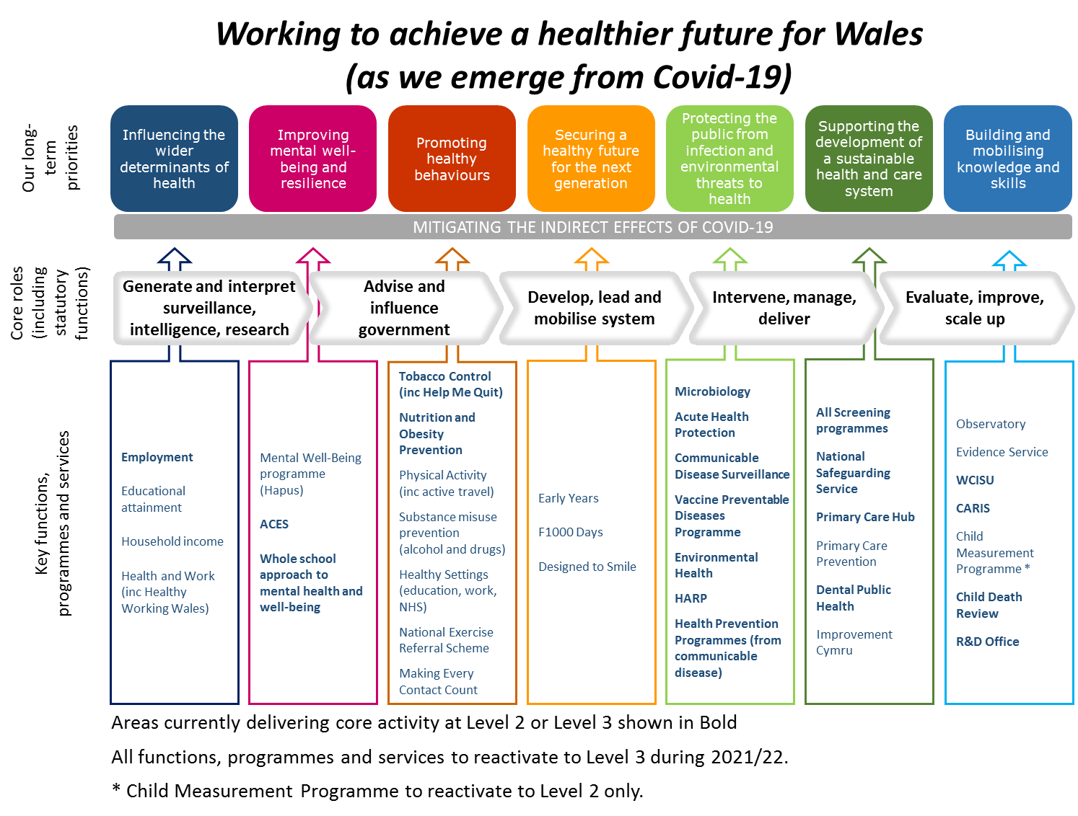
    - Milestones
The following milestones are proposed:
- a proxy indicator for reactivation, given that Consultants need to be in place in all areas for reactivation to happen
- recognition of the interdependency between implementation of the Health Protection business case and our ability to restore staff to their core roles outside the Response.
- tracking progress towards reactivation of Essential, Priority and ‘Other’ functions, programmes and services.
Each of these milestones are based on indicators that can be tracked on a monthly basis.
Aim | Level 0 Milestone | Delivery Date
Restoration of Consultant capacity | Total Consultant WTE capacity (WTE) restored to substantive posts across PHW | 1/8/21
Completion of critical recruitment | All critical recruitment complete (Band 8a and above, based on planned WTE recruitment at 01/04/21) | 1/8/21
Reactivation of essential functions, programmes, services | All Essential Services reactivated to Level 3  (Screening programmes, Health Protection functions, Safeguarding, Help Me Quit, National Exercise Referral Scheme) | 31/3/22
Reactivation of priority functions, programmes, services | All Priority Services reactivated to Level 3 | 31/3/22
Reactivation of ‘other’ functions, programmes, services | All ‘Other’ services reactivated to Level 3 | 31/3/22

    - Dependencies, risk and resources
In developing this plan, a number of dependencies, risks and resource implications have been identified. These largely relate to the future course of the pandemic and its implications/risks in relation to our ability to restore staff to normal roles and recruit to key vacancies, and the readiness of the wider system to engage. Enabling support will also be required to support staff transition and required business change. The specific dependencies, risks and resource issues will be managed through our internal priority, and Operational Plan, governance arrangements.

Organisational Learning
    - Strategic context
In line with our Vision for Knowledge Mobilisation (2020-25) and the work of the Knowledge Directorate, our aim is to maximise knowledge mobilisation. The pandemic has changed what we do and how we do it, which means that we have significant opportunity to capture learning and use it to shape future services and processes. It is also important that we can demonstrate a coherent narrative on our role and actions during the pandemic evidenced by our decisions, performance and management. This will be particularly important for supporting any public inquiries and future research.
During the pandemic, we introduced new services and roles and have changed our work practices. Some of our programmes and services have been paused and will need to be reactivated using new ways of working. Many different opportunities for learning have arisen and it is important that we capture this knowledge and why and how we made decisions, so that we can use it as the demands and requirements on us change.
This plan focuses on continuing to collect and synthesise learning gathered during the COVID-19 pandemic. It will agree methods to share learning within the organisation and, where appropriate, with external stakeholders. The scope of the plan also includes the need to capture in a repository, the information, actions and decisions made by the organisation and will form the basis an organisational narrative around COVID-19.
    - Objectives and Scope
The objectives in this plan are set out below; progress has been made across all areas:
- establishing a systematic approach to operationalising the Learning Framework by collecting, collating and disseminating learning on the pandemic
- demonstrating how learning is shared internally and, where appropriate, to external stakeholders
- internally assessing the dissemination of learning identified
- establishing and using a searchable repository for COVID-19 records that supports the production of a timeline of key events and decisions; subject reports, themed analyses and an underpinning narrative.
The scope of the work is limited to the learning and information relating to COVID-19, produced during the pandemic. Our planning assumptions are that:
- this work will inform the ongoing Vision for Knowledge Mobilisation and, as such, will be ongoing and will include an evaluation of its effectiveness
- specialist expertise will be needed and we will seek to secure people who have the necessary skills and knowledge
- the work is dealing with the collection, use and dissemination of COVID-19 related information and therefore information governance will be important at all levels. The Operational Board will include a member with expertise in this field
- the repository will be an important resource in helping to support future Public Inquiries and research
- the establishment of the COVID-19 repository will be enhanced through the development of specific narratives on particular areas and themes, which together will form a narrative of our overall response to the pandemic.
- the team will access communications and engagement expertise as required
    - What does success look like?
Key benefits include:
- organisational learning: organisational learning will be captured internally and fed into the organisational narrative. This will enable lessons learnt to be shared both internally and externally on COVID-19 and where appropriate improve decision making by utilising the evidence and knowledge identified
- organisational narrative: the development of an overall organisational narrative with associated repository will enable the organisation to systematically record and store related COVID-19 information. This will assist with future research and in responding effectively to a Public Inquiry
- organisational influence: greater ability to influence and provide specialist advice to the UK and Welsh Government through learning identified
- enhanced professional development: through developing a systematic way to capture learning, the organisation will increase its reputation as a learning organisation which will enhance professional development
- informing our future: capturing changes made to workforce policies, ways of working, roles and responsibilities to support our response to COVID-19 will allow us to describe where we were, where we are and where we could be as an employer. This learning can be used to inform and direct our recovery and the future of work in Public Health Wales in ways aligned to our People Strategy
- organisational culture: we will continue to create the conditions for effective knowledge mobilisation as set out in our Vision
- organisational processes: we will be able to demonstrate the importance of operating effective and efficient processes for learning and records management
    - Milestones
Milestone | Delivery Date
Operational Manager and Archivist in post | 30/04/21
Project plan completed and systems are fully operational | 31/05/21
Narrative on a minimal of two key areas (deep dives) completed and delivered quarterly | 31/03/22
Two six-monthly audits of chronology entries completed | 31/03/22
Two virtual events held to capture informal learning | 31/03/22

Enabling recovery

2.5.1 Context
Our enabling functions are pivotal to the successful delivery of our public health priorities and in supporting wider organisational recovery. Enablers have a critical role to play in the leadership and delivery of a number of major areas of work, alongside our role in the continued response to COVID-19 and as the organisation begins to move towards recovery and in the delivery of key public health activity. As part of this work, we need to consider how we best organise ourselves to deliver on the challenges facing Wales and to support a healthy and sustainable society.
Our enabler plan has been developed through three drivers:

    - What does success look like by the end of 21/22
By the end of 2021/22 we will have:
- refreshed our long-term strategy and agreed a small number of public health outcomes
- effective systems and processes to help ensure decision making across the organisation is consistent, proportionate and data driven
- more timely and granular performance information through the utilisation of corporate analytics and business intelligence
- engaged with staff and stakeholders to inform how the organisation wants to work in the future and have developed clear visions for our estate and digital infrastructure
- continued to support staff health and well-being and delivered key elements of our People Strategy
- embedded environmental sustainability as a key part of all programmes and projects, with a particular focus on decarbonisation
- developed and implemented the Quality and Improvement Strategy, Our Approach to Engagement and our Integrated Governance model
    - Long-term strategy review
During 2021, we will assess the impact of COVID-19 on our long-term strategy and priorities through a formal strategy review. This aims to assess whether our current strategy remains valid or needs to be revised/refreshed in light of the experiences and learning from COVID-19 and horizon scanning of future opportunities or challenges. As part of this work, we will also agree our outcome measures to demonstrate delivery of our strategy.
Milestone | Delivery Date
Long-term strategy review
Strategy review engagement completed | 31/08/21
Executive Team and Board approval of strategy review findings | 31/10/21
Public Health Wales’ Outcomes
Population Health Wales Outcomes agreed by Executive Team and Board | 31/10/21
    - Digital Strategy
Co-creating our digital vision and strategy with stakeholders, partners and users will be a key deliverable for 2021-22. Through the implementation of the Strategy we will be seeking to make data securely accessible, enabling greater inter-operability with other systems to enable greater data driven decisions in real-time and take advantage of artificial intelligence and machine learning technologies where appropriate. This will enable the organisation to be more agile, provide greater flexibility for our staff to collaborate and deliver a greater digital engagement experience with the wider public and our own staff.
Milestone | Delivery Date
Digital Strategy overall approach agreed | 31/04/21
Digital Strategy published | 30/09/21
Digital Strategy Delivery Plan developed | 31/11/21
    - Using data to measure and manage delivery
Performance management is a key strand of our internal transformation and in delivering our long-term strategy. The vision of moving towards using more timely and granular integrated performance information, subjected to robust analysis, is key in enabling us to make effective decisions. The plan builds on progress we have made and shows how we will improve existing business intelligence products and develop new ones that meet stakeholder needs.
Milestone | Delivery Date
Directorate and Divisional Dashboard (V1) launched | 14/07/21
Performance and Assurance Dashboard (V4) launched | 14/09/21
Directorate and Divisional Dashboard (V2) launched | 14/12/21
Performance and Assurance Dashboard (V5) launched | 14/03/22
    - Informed Decision Making
We want to ensure that decision making across the organisation adapts as we continue to progress through the pandemic and is consistent, proportionate, clear, timely, quality and data driven and taken at the appropriate level. We will build on the progress we have made so far to embed securing value, benefits realisation, quality and improvement and taking a strategic approach to risk as cornerstones within the decision-making framework.
Milestone | Delivery Date
Quality and Improvement strategy implementation year 1 actions delivered | 31/03/22
Integrated governance model year 1 actions delivered | 31/03/22
Risk management continues to mature and is embedded in the adaptive decision making framework – this includes a review of both the strategic and corporate risk approaches | 30/09/21
The decision making framework is continually developed (this will include a series of mini milestones throughout the year) | 31/03/22
Enabler team expertise for the development of business cases and other significant developments is clearly understood and engaged early in any new development | 31/03/22
New Board members (executive and non-executive) recruited with an effective induction support package in place | 31/03/22
    - New ways of working to support organisational recovery
We aim to take advantage of the opportunities presented by how we have worked during the pandemic to design, develop and implement new ways of working as the organisation recovers. Having already gathered rich feedback from staff describing their experiences, we will build on this, through Our Conversation, an organisation-wide staff engagement exercise to help us shape our future ways of working, which will in turn support the development of both the Estates and Digital Strategies. Our Conversation will also help us understand what we need to take forward into our future to progress our People Strategy, including enabling an Inspiring Culture. In addition to this, we will also look to exploit ways of working and technology that is already in use such as Microsoft 365.
Milestone | Delivery Date
Future Ways of working
Resources and toolkit to support individual and team recovery designed and go live | 31/05/21
Develop and agree plan for Microsoft 365 priorities for 21/22 | 31/05/21
Format and approach to capturing the impact of the pandemic on skills and knowledge is agreed | 30/06/21
Our Conversation: Future Ways of Working (FWOW) phase one summit outcomes themed and shared with the Executive Team | 31/07/21
Plans to deliver work arising from FWOW summits developed and presented to Priority Team | 31/08/21
Framework to support individual and team coaching in place | 30/11/21
Estates Strategy and North Wales Our Space
Recommence North Wales Our Space and revised project plan agreed | 01/09/21
Estates Strategy published | 30/09/21
    - Helping staff, stakeholders and the public understand what we are doing and why
Our Communications and Engagement function will continue to support the enhanced Health Protection response to COVID-19 responding to future peaks, outbreaks, incidents and clusters. This includes helping to build capacity across the public sector communications community to support this. Furthermore, our focus must now encompass not just risk communications in relation to coronavirus, but making sure we communicate the wider harms of the pandemic to the health of the population in Wales. We will also continue to support staff, through our internal communications, to understand what we are doing, why we are doing it and their role in supporting delivery.
Milestone | Delivery Date
Deliver Phase 1 of the action plan: (initial actions agreed under narrative, our role, public affairs, reputation risk and evaluation | 30/04/2021
Agree priority actions from within the Strategic Communications Review action plan with Business Executive Team for Phase 2 | 31/05/2021
Agree Communications Plan for Population Health priority for 2022 | 31/12/2021
    - Organisational Design and Workforce Planning
Our People Strategy 2030 was approved in in early 2020, and we have made progress against a number of the nine themes over the last, challenging twelve months. Whilst our milestones within this plan all align to the Strategy’s themes and aims, there is specific activity set out below which will help us understand why people both join and leave Public Health Wales and to explore organisational design principles, particularly as we deliver an increased and transformed Health Protection function. Assisting wider design work, we will present options for smart systems and tools to improve our understanding of where our people are and how we may mobilise the workforce, to both support the continued response and ensure a sustainable way of meeting future needs.
Milestone | Delivery Date
Progressing Our People Strategy and Organisational Workforce Planning
Approach and timetable to capture data on organisational leavers and new starters agreed | 31/07/21
Recommendations from the Organisational Review/Workforce Analysis, principles used to support organisational design activity required to deliver the new Health Protection service for Wales implemented | 31/03/22
Options for staff mobilisation and availability system/tool scoped and shared | 31/07/21
Workforce planning toolkit, supporting resources and staff availability information distributed to the business in line with integrated planning activity | 31/10/21
    - Staff Well-being and Engagement
Our people’s health and wellbeing is imperative. Our plans will be driven from the results of our Well-being and Engagement Surveys as well as the NHS Staff Survey and outputs from supplementary engagement activity. Whilst there will be work undertaken to monitor, support and improve staff well-being more broadly, we need to agree and deliver methods of ensuring our decision making and planning processes are considerate of our people’s health and wellbeing and not putting additional delivery pressure on people already at capacity.
Milestone | Delivery Date
NHS Wales Staff Survey (Our Reflections Our Decisions Our Future) undertaken | 11/10/21
Well-being Interventions as outlined in Staff Survey Action Plan implemented | 28/02/22
Action Plan developed to address existing Gender Pay Gap and next annual Gender Pay Gap Report published | 28/02/22
Healthy Working Relationships programme implemented | 30/06/21



Part 3 - Enabling the Organisation

Our Financial Plan

Underlying Position
Public Health Wales has historically delivered financial stability with an underlying breakeven position. This underlying breakeven position continues in our 2021/22 plan. Further detail is contained within the Public Health Wales Financial Plan and Budgetary Control Framework 2021/22.

Our revenue plan
Public Health Wales has seen significant revenue growth during 2020/21 which continues into 2021/22. This is outlined in our revenue plan below:
The NHS Wales Collaborative for Health and the Finance Delivery Unit, which are hosted by the Trust, are not included in these figures and it is assumed that they will manage within their approved allocations.

Savings and investment strategy
Public Health Wales has agreed the following approach to savings in 2021/22, namely that:
- we would not set a target for additional organisational efficiency savings in 2021-22 but would continue with existing schemes and seek further opportunities as they arise
- we would not levy a Directorate 1% CIP for 2021/22. We would review and remove relevant budgets to reflect reductions in our cost base.
This approach has delivered savings of 1.148m to generate an internal investment fund.

Organisation Priorities
Whilst Public Health Wales retains a directorate based financial governance structure and budgets have been set on a directorate structure basis for 2021/22, the organisation will manage its operations through an Organisation Priority structure. A mapping exercise has therefore been undertaken to provide an indicative resource apportionment across organisation priorities which also reflects existing resource which is being redeployed to support the response:
Organisation Priority | £000
Response - WG Non-Recurrent Funded | 69,112
Response | 41,276
Essential Services | 79,968
Population Health | 14,876
Enablers and Recovery | 23,327
Organisation Learning | 3,606
Grand Total | 232,165

Risks (and Opportunities)
Public Health Wales is currently anticipating a breakeven position, in line with the 2021/22 budget setting process and detailed work of the Operational Plan. However, it is worth noting the Welsh Government assumed income, some of which relates to previous business cases and agreements, some which relates to the forecast expenditure in relation to COVID-19 costs continuing into 2021/22.

Our capital plan
Public Health Wales’ recurrent discretionary capital funding is £1.580m. Additional strategic capital of £11.37m was received during 20-21 predominantly in respect of COVID-19 developments. Meetings with Welsh Government are ongoing with regards to currently unapproved bids for 21-22 Strategic Capital requirements.
The following table summarises the strategic capital requirements for the coming year:
 | FY21-22 £000s
Transformation of Health Protection Services for Wales (approved) | 221
Genomics sequencing capacity (awaiting formal approval) | 352
Digital mammography replacement (awaiting formal approval) | 3,842
Maldi-Tof Replacement (Unapproved) | 840
Total Strategic Capital | 5,255

People and Organisational Development
The People and Organisational Development team will remain focused on enabling the delivery of the Operational Plan 2020-2022 and progressing aims within our People Strategy 2030, through ensuring we have people with the required skills, when and where we need them and whose welfare, health and wellbeing is a priority.

Inspiring Culture and Leadership
An organisation’s culture is the lived experience of its people and as such is critical to our success. During 2021-22, we will continue our engagement work with staff, through internal and broader NHS Wales surveys.
In partnership with our Communications Team, we will continue to engage our staff through a variety of engagement opportunities and our managers through weekly briefs, highlighting key messages, dates and policy updates, supporting them in carrying out their management responsibilities.
In April, we will start ‘Our Organisatonal Conversation’ with groups of staff from across the organisation participating in discussions seeking out what we have discovered works well and to consider what the future looks like in Public Health Wales. Themes identified from this work will be taken forward through the relevant leads and may include work linked to our estate, our digital strategy, the role of our managers and how we can support staff in how and where they work.

Designed to Deliver
The last year has seen our staff respond tremendously to the pandemic and adapt to working differently. Many have been redeployed and experienced a change of management relationships, others have taken on different responsibilities either within their own or another team. The outputs from Our Conversation, alongside the findings and recommendations from an Organisational Review/Workforce Analysis completed at the beginning of 2020, will allow us to consider aspects of our organisation’s design and through establishing the new Health Protection function, we will utilise opportunities to embed core design principles.

Workforce Shape and Planning
Over the past year, significant resourcing plans have been developed and implemented to support the Enhanced Response to the pandemic. Internal mobilisation has also allowed us to redeploy people to where they are needed most.
This year’s workforce plans will focus on the immediate needs of each Priority Area to deliver the activities set out in the Operational Plan. Workforce actions are anticipated to be short- to medium-term and focus on three key areas:
- Resourcing plans
- Organisational change requirements
- Identification of future skills and training requirements.
We anticipate a return to a more typical integrated planning cycle in autumn 2021, which will incorporate longer-term, strategic workforce planning.

Employee Experience
The health and well-being of our staff remains a key priority and we will continue to review and strengthen our support arrangements over the next year. We will continue to strive to be an inclusive organisation where staff feel psychologically safe, have the freedom to voice concerns and be their authentic self. We will continue to facilitate Care Space sessions across the organisation until the middle of this year, when we will pause and review.
To assist managers in understanding the well-being of both their staff and themselves we have planned several Wellbeing Workshops for Managers. Sessions aim to support line managers keep staff engaged and stay emotionally connected while many of us work differently. Having established a pan-organisation Well-being and Engagement Partnership Group, we hold monthly network meetings and liaison between enabling functions and the business, including our staff networks and trade union partners. The focus for this year will be to continue building the relationship between enabling functions and the business on wellbeing/engagement matters, and to facilitate the delivery of action plans arising from staff surveys and outputs from Our Conversation.
Healthy Working Relationships is a collaborative NHS Wales approach to help us all have better and healthier working relationships through developing a policy, resources and measures. The programme will be rolled out in April and will be monitored and reviewed throughout the year.
Diversity and Inclusion training emerged as a key theme of the consultation that was undertaken on our Strategic Equality Plan. By September, we will have reviewed and promoted training on public sector platforms and filled any gaps so that we can ensure our workforce is skilled and equipped for inclusive practice. Our Annual Equality Report and Workforce Report, detailing the work undertaken to advance equality and the diversity breakdown within the organisation will be presented to our Board, along with our Gender Pay Gap report in November 2021
We will participate in the annual Stonewall Workplace Equality Index, the annual benchmarking exercise used to drive improvement across all equality strands. Seeing this work taking place, and our continuous improvement instils confidence in our staff and builds our reputation as an inclusive employer. Our five Staff Diversity Networks continue to grow and provide peer support and comradeship to members. More activity is planned to raise the profile of the groups through the Wellbeing and Engagement Partnership Group, Our Conversation and wider organisational development.
As part of our obligations under the Welsh Language Standards, we are in the process of developing a Clinical Consultation Plan, which will be published in December 2021.

Harnessing Data and Exploiting Technology
People and Organisational Development are working with the Corporate Analytics Team to inform the development of Division/Directorate-level dashboards to help managers make business decisions and inform workforce planning. The teams are scoping the development of automated business solutions and developing analytical capability within the team. The development of these products will reduce staff time spent on non-value added processes, increasing quality our time to add insight and analysis, and reducing the scope for error.

Optimising Relationships and Partnerships
There has been, and continues to be, a system-wide response to the pandemic. Colleagues across the organisation have had to utilise existing relationships and build new ones both within Public Health Wales and externally, from Local Authorities, Academia, health boards and beyond. We will start to understand what this means for skills development and how we communicate and collaborate with others, including global partners.
We are committed to working in partnership with Trade Unions in promoting and ensuring an open and transparent culture and effective staff engagement. This partnership has proved even more critical during our response to the COVID-19 pandemic. We have worked jointly with our Trade Unions to strengthen our Facilities Time agreement and additional budget and resources have been made available for 2021/22 in recognition of our commitment in this area.

Attracting and Recruiting Talent
Recruitment has been challenging, with every health organisation worldwide seeking the same skill set in order to respond to the global pandemic. We have benefited from standard recruitment approaches and built our workforce though alternative routes. Partnerships have been formed with academia to increase our flexible workforce. The relationships forged out of need during the pandemic have given way to increased partnership opportunities, which offer the potential scope in future to ring-fence employment opportunities with specific higher education programmes and develop direct talent pipelines.
We will continue to enhance the current establishment where required, review the needs of the proposed Health Protection business case and, through workforce planning, ensure we are proactively recruiting in line with business needs. We note below our growth to date and what is anticipated by the end of March 2022. Please note all figures represent our total establishment and bank additional hours.
March 2020 (actual) | March 2021 (actual) | March 2022 (planned)
1711.3 | 1948.3 | 2153.7
Moving forward, resourcing our organisation with the right people who have competency, capability and commitment will strengthen our promise in delivering for the people of Wales. By investing in the time in our hires will enable the organisation work towards the status of being a true employer of choice.
We have recruited to over 200 new vacancies in 2020/21 and the team will support the recruitment requirements as part of the Health Protection Business Case in 2021/22. As part of this recruitment we will continue to develop a workforce that is inclusive and reflective of the demography and ethnicity of Wales. Induction, training and additional support will be in place for current and new staff in what will be another hugely challenging and demanding year, additional investment has been made available to support in this area.

Skills for the Future
As we prioritised our response to the pandemic, many of our learning and development plans and opportunities were cancelled. During the course of the coming year, we will reintroduce existing development opportunities (including management development) and prioritise programmes needed most to support our operational plan.
We will explore the impact of the pandemic on our staff’s skills and knowledge, both those feeling/being de-skilled as a result of redeployment to different roles and those who have gained new skills and knowledge. Through Our Conversation, we will discuss how learning is enabled and delivered in the future – how do we further blend our approaches to learning, and what learning may be a priority? As we anticipate the way we work in the future being different to the way we have worked in the past, we will start to determine what this means for the role of the manager, and the skills they will need to support and lead the workforce in future.

Quality, Safety and Improvement
We have set out our ambition to be a high performing organisation, which continues to be our intention despite the challenges of COVID-19. During the pandemic, we have had to reprioritise where we focus our collective efforts. However, we recognise that it is more important than ever to continue to drive quality and improvement to support and enable organisational recovery, informed by available evidence and proven methodologies. Planning and delivering services, programmes and functions which are safe, effective and achieve outcomes and impact, measured wherever possible through real time data. It is also key to identify mechanisms to obtain continuous proactive and reactive feedback from the public and our stakeholders to inform planning and improvement.
Over the coming months, we will:
- implement our Quality and Improvement Strategy and supporting Implementation Plan
- deliver the ‘Our Approach to Engagement’ Implementation Plan
Detail on the key milestones we will deliver is included in section 2.5.6

Performance and Delivery
The section below sets out the proposed performance and delivery arrangements, including relevant controls, to manage the delivery of our Operational Plan.
    - Integrated Governance Model
We have recently agreed a new integrated governance model, which will be implemented in a phased manner during 2021/22. We see this as a key enabler to Public Health Wales becoming a high performing organisation and in reaching our next level of maturity. Embracing this approach will ensure that we have a holistic and joined-up approach to our systems, procedures, reporting and outcomes.
Over the coming months we will:
- implement an integrated governance model focused on a cultural approach to organisational governance
    - Priority approach
Our Operational Plan is structured around five priority areas, which each have an agreed Senior Responsible Owner and defined governance arrangements. Oversight of the priorities will sit with the Executive Team, with progress reported through our Performance and Assurance Dashboard.
This will allow us to maintain strategic oversight of delivery and therefore effectively manage any changes, particularly in relation to the reallocation of resources. This will be essential during our ongoing response to COVID-19, which is likely to experience surges during the life of this plan.
    - Plan refresh and baselining
Between January and March 2021, we developed our Operational Plan for 2021/22, which aligns with the development of our budget strategy. As part of our plan refresh, we undertook a rapid validation exercise of the priorities we agreed in October 2020. This aimed to identify any potential changes to the scope and/or deliverables for each, plus any new work that has been identified. The outcomes of this are reflected in the priority plans set out within this document.
    - Performance management and change control
Progress against the plan will be reported to the Executive Team and Board on a monthly basis through our Performance and Assurance Dashboard. This will include the ratings for each milestones and exception reports for those where issues have been identified. A control process will be used for managing changes, particularly in relation to milestone delivery.
    - Risk Management
Over recent months, a series of activities have taken place to ensure that our strategic risks are continually reviewed; remaining current and appropriate to the challenging environment the organisation is operating within. The current strategic risks are set out in the table below. In April 2021, further work is planned to revisit the strategic risks with executive team and Board and this will be a regular feature throughout the year.
There is a risk that Public Health Wales will be unable to fulfil its strategic objectives because it does not have the correct numbers of people with the right skills, attitudes and behaviours.
There is a risk that Public Health Wales will cause significant harm to patients, service users or staff members. This will be caused by misdiagnosis or incorrect identification of serious health conditions, timeliness of service provision, the provision of inappropriate clinical advice or the failure of staff to follow correct procedures.
There is a risk that Public Health Wales will fail to deliver a sustainable, high quality and effective infection and screening services. This will be caused by a lack of sufficient workforce capacity; over-reliance on existing systems/procedures, lack of sufficient change capacity and an estate and infrastructure which is not fit for purpose.
Suffer a major IT security breach resulting in a failure to service delivery and/or loss of personal data.
There is an increased risk as a result of COVID-19 that Public Health Wales will fail to provide the level of system leadership needed to deliver the population health gains articulated in the long term strategy. This insufficient capacity/ resource within the organisation, policy and prioritisation decisions of external agencies and wider social, economic and environmental factors.
There is a risk that Public Health Wales will fail to secure and align resources to deliver its statutory functions including its response to the COVID-19 pandemic. This will be caused by funding cuts or inability to make required savings, secure funding (replaced generate income) or move resources within the organisation
There is a risk that Public Health Wales will fail to deliver and effectively present accurate, relevant data/ statistics and/ or evidence based research/ evaluation to dynamically and actively inform and maximise the impact of public health action especially relating to our response to COVID-19. This will be caused by a lack of workforce capacity with the relevant skills and knowledge to rapidly respond to changing and increasing demands of COVID-19 and technological advances in data science; staff having an over-reliance on existing systems/procedures and a lack of sufficient change capacity.
There is a risk that Public Health Wales will fail to effectively discharge its statutory responsibilities in protecting the public during the COVID-19 pandemic and ensure the organisation has an effective plan for recovery as the pandemic recedes
This will be caused by:
Failure to ensure that our role and responsibilities are clearly laid out, effectively communicated to partners and the public and that we frame our response and actions in accordance with these. This will require us to not accept activities that fall outside of our role that result in us vicariously accepting responsibility and accountability for actions that we do not have the authority to enact.
- Failure to sufficiently scale up our core response activities during the recovery phase of the pandemic in order to effectively support the system in Wales to protect the public, optimise outcomes for individuals and the population, facilitate the functioning of essential services and support the Welsh Government in the reviewing of social restrictions.
- Failure to effectively balance the dynamics between responding to the ongoing pandemic- which remains the key priority of the organisation, fulfilling our broader statutory functions in relation to the population health (including the safe reactivation of services and functions), whilst preparing and responding to any resurgence in the transmission of coronavirus.
- Failure to effectively support the health and wellbeing of our staff within the current working environment and the challenges to remote working.
- Failure to sufficiently influence policy and public health interventions.
There is a risk that Public Health Wales will fail to sufficiently consider, exploit and adopt new and existing technologies. This will be caused by the inability to keep up to date with relevant new and emergent technologies, their potential application and having insufficient skills to develop the case for investment.
Each priority area has also identified potential risks and dependencies to their successful delivery. These have been developed as part of the planning process and demonstrate a number of common themes, which map to the strategic risks, including:
- Resources (people and finances), staff wellbeing and recruitment
- Business continuity and data access/quality
- Partners and stakeholders
Following approval of the plan, the respective priority area risks will be recorded within relevant risks registers and managed in line with our organisational approach to risk management, including within the respective priority area governance arrangements. We will also assess the priority area against our existing Corporate Risks and update accordingly. Risks will be escalated through to the (Business) Executive Team as required, in line with our existing arrangements.

Concluding remarks
We have set out ambitious plans for the delivery of key public health work over the next 12 months. This is not only focused on the direct and immediate requirements to continue to effectively respond to the coronavirus pandemic, but also in relation to the wider impacts of COVID-19, the reactivation of services and our organisational recovery. However, we recognise, in developing this plan that we will be operating in a challenging and unpredictable environment. As a result, we will need to regularly review the feasibility of the plan, informed by the ongoing evolution of the pandemic, our ability to recruit additional staff into our health protection response and our ability to reactivate our core public health functions.
The plan is built upon the commitment, professionalism and tireless efforts of all staff who have worked to tackle the unprecedented public health challenges faced by Wales. Their efforts will allow us to continue to meet these challenges head-on.

https://phw.nhs.wales/about-us/our-priorities/
For example, a Chief Executive Accountable Officer letter sent to the Director General for Health and Social Services/NHS Wales Chief Executive on the 30 December 2020.
milestones linked to Health Protection Business Case TBC

