Name of Meeting
Board
Date of Meeting
25 June 2020
Agenda item:
5.6
Public Health Wales
Workforce Report
Executive lead: |  | Rhiannon Beaumont-Wood, Executive Director, Quality, Nursing and Allied Health Professionals
Author: |  | Neil Lewis, Deputy Director of Workforce and OD  Karen Williams, Asst. Director of People (Interim)  Lisa Whiteman, Asst. Director of OD  Chris Orr, Head of Estates and H&S
Approval/Scrutiny route: |  | Business Executive Team meeting on 23 June 2020.
Purpose
This paper provides the Board with an overview and assurance on a range of workforce issues that will assist and enable the organisation to continue to deliver the Health Protection Response and also now to begin supporting the implementation of Recovery Plans.
Specifically, assurance is provided in respect of the following:
- Employee Well-Being and Support;
- Response Plan Resourcing;
- Workforce Information.
APPROVE | CONSIDER |  | RECOMMEND |  | ADOPT | ASSURANCE
The Board is asked to take assurance in respect of the following workforce areas:

- Employee Well-Being and Support;
- Response Plan Resourcing;
- Workforce Information.

Link to Public Health Wales Strategic Plan

Public Health Wales has an agreed strategic plan, which has identified seven strategic priorities and well-being objectives.

This report contributes to the following:
Strategic Priority/Well-being Objective | 7 - Building and mobilising knowledge and skills to improve health and well-being across Wales
Strategic Priority/Well-being Objective | 5 - Protecting the public from infection and environmental threats to health
Strategic Priority/Well-being Objective | Choose an item.
Summary impact analysis

Equality and Health Impact Assessment | An Equality and Health Impact Assessment has not been undertaken
Risk and Assurance | There is a link to Risk 1 in the Corporate Risk Register.
Health and Care Standards | This report supports and/or takes into account the Health and Care Standards for NHS Wales Quality Themes
 | Theme 7 - Staff and Resources
 | Choose an item.
 | Choose an item.
Financial implications | It is important that all workforce planning is within available budgets
People implications | It is vital that PHW has the right staff with the right skills in the right place to deliver the Response and Recovery Plans

Purpose
This paper provides the Board with an overview and relevant assurance on a range of workforce issues that will assist and enable the organisation to continue to deliver the Health Protection Response to the COVID-19 pandemic and also to now begin supporting the implementation of the organisation’s internal Recovery Plan.
Specifically, assurance is provided in respect of the following:
- Employee Well-Being and Support;
- Response Plan Resourcing;
- Workforce Information.

Background

Public Health Wales has experienced extremely challenging and unparalleled circumstances over the last three months, where we have had to very quickly change and adapt our workforce to respond to the global Coronavirus pandemic.

Employees across the organisation have risen to this challenge and we have put in place a number of mechanisms to enable this to happen, as well as providing staff with support measures to assist them in these unprecedented circumstances.

Description/Assessment

3.1 Employee Wellbeing and Support

This section provides an update on employee well-being and support activities within Public Health Wales, together with our immediate focus linked to the organisational recovery plan and also summarises the findings of the recent Tell Us How You Are Doing – Internal Communications and Wellbeing Survey.

Continued funding of the Covid 19 response has presented challenges in terms of the budget. We are currently looking at how we will continue to fund essential wellbeing support, mental well-being training (including for line managers) and statutory training for colleagues in Screening programmes. This has been discussed at Business Executive Team and we are now looking into alternative sources of budget for these services.

Tell Us How You Are Doing
Members of the Communications and Organisational Development teams developed an Internal Communications and Well-being Survey in order to understand colleagues’ views about:

- The effectiveness of our staff communications during the lockdown period;
- The wellbeing resources we’ve provided;
- Working practices during the Covid-19 pandemic.

The survey ran for a two-week period between 30 April and 14 May with a response rate of 40.8%, meaning that the data is statistically robust (see Appendix A). Further in depth and comprehensive analysis of our results has enabled us to make data-driven decisions in identifying next steps, leading to the development of an organisational level action plan addressing four areas:

- Feeling safe in the workplace
- Access to sufficient information about additional Health and Wellbeing support
- Support and communication from divisional senior management teams
- Maintaining a healthy work life balance whilst working from home.

We have also commenced analysis of the results by directorate and division and will be working with identified leads within each functional area as well as Trade Union partners, in order to develop a series of local actions, through setting up a Wellbeing and Engagement Partnership Group (approved 16 June 2020).

Supplementary Workforce Support
At the beginning of May 2020, two additional support services have been available to colleagues:

Coaching for Line Managers:
A small cohort of trained and qualified coaches have convened to provide one-two support sessions for line managers who may need help building confidence to manage what could be new and/or challenging times with teams.

Listening Service:
The Listening Service aims to bridge a gap between debriefing/manager support and external employee assistance programmes. Provided by colleagues with a post-graduate level coaching qualification or a diploma in counselling, it is available to colleagues working in: the National Contact Centre. Microbiology, active screening programmes and public-facing communications.

Both services are short interventions and will not form a contracted relationship; boundaries for both services have been discussed and agreed which respect codes of ethics and practice.

These services are supplementary to other resources such as:

- SilverCloud CBT (continued access to the extended app will be dependent on budget)
- Care First Employee Assistance Programme –counselling and lifestyle app (ongoing budget required)
- Health for Health Professionals
- How Are You Doing campaign
- Wellbeing Wednesday topics

Personal Risk Assessments
A Personal Risk Assessment tool, developed by a working group commissioned by the Welsh Government, has recently been rolled out to all staff in Public Health Wales. The tool aims to identify high-risk individuals in high risk settings so that action can be taken to adapt their workplace or move them into a lower risk environment, such as working from home. This is being rolled out as follows:

- W/c 8th June – Group 1: Staff in the Laboratories, Testing Centres/Screening Services, staff redeployed into Patient Facing roles in Heath Boards, any other non-office based setting
- W/C 15th June –Group 2: staff who are physically attending work in an office setting/Contact Centre
- W/c 22nd June – Group 3: remaining staff who are working from home.

Arrangements are being put in place to add the risk assessments as a competency on ESR, which will show up on the compliance bar to encourage managers to complete it. This also enables monitoring and reporting. Any workplace adjustments must be reported to the Head of Estates, Facilities and Health and Safety, and any workforce issues need to be discussed with the relevant People Business Partner.

Health and Safety
Work is ongoing within the estate to ensure it is safe and complies with social distancing regulations. Specific actions have been undertaken within our contact centres, including:

- Decommissioning workstations so staff are spaced 2m apart at all times
- Standing up additional workstations to spread contact centre staff over a larger area
- Removing chairs that are not in use
- Use of tape to remind staff where to walk and use of arrows to limit staff coming into close proximity with one another.

Health and Safety risk assessments have also been undertaken for both contact centres operating out of CQ2 and Matrix House and for the testing site at Cardiff City Stadium prior to handing it over to Cardiff and Vale Health Board.

Staff who can work from should continue to do so for the next six months, to reduce the risk of spreading infection and ensure that those who do need to be in the workplace remain as safe as possible. Over 60% of staff have a VPN token enabling them to work remotely and guidance has been provided to managers and employees through the staff bulletins and internet pages to aid remote working and staying connected. As services start to reactivate, action across the wider estate will be prioritised as required.

We have established a process for loaning equipment and, to date, 136 requests for equipment (total of 212 pieces of equipment) have been provided to staff. A process for loaning additional pieces of equipment will be made available shortly alongside communicating the process for Display Screen Equipment assessment. Personal Protective Equipment continues to be managed and distributed across the organisation as required.

Welsh Language
Whilst the Welsh Language Standards (Wales) Regulations 2018 make provision for non-implementation of the standards in the context of circumstances relating to the Civil Contingencies Act 2004 and the Public Health (Control of Diseases) Act 1984 we have acknowledged the continuing importance of Welsh language service provision and our approach has been to implement the Welsh Language Standards as far as is possible. For example:

- All public information, guidance and support available to the public is always available in both English and Welsh
- Despite the pandemic staff are still attending Welsh classes via Skype or other language learning methods which will help with our Welsh language provision going forward
- Although we have had to pause our screening services at the moment we are however, still drafting our Clinical Consultation Plan in accordance with Standard 110
- Any Welsh speaking staff who have volunteered to act as call handlers are encouraged to provide the service in Welsh. All call handlers have also been provided with guidance in relation to delivering bilingual telephone greetings, and our out of hours automated telephone responses are bilingual.

Performance and Development
We have continued to ask colleagues and managers to hold My Contribution meetings virtually, to recognise contribution and ‘close off’ last year whilst at the same time, noting what may need to be picked up/carried forward as we return slowly to business as usual. Performance against My Contribution is also a personal objective for each Director.

We are aware, through both local reporting and the output of the recent internal audit, that completion rates are noticeably below expectations and a separate paper has been prepared to address the actions required. Notwithstanding the extreme challenges and pressure generated from our response to the coronavirus pandemic, that does not replace the need for a check-in discussion on the working time and changes in activities for our people.

The principles of My Contribution will be critical to supporting our people as we move into the recovery phase – clear expectations and regular dialogue. We know that uncertainty and lack of connection can trigger neuroscientific ‘threat’ responses, which increase the likelihood of anxiety and may cause ill health. We have adapted the year-end and objective-setting My Contribution processes (subject to Executive Team approval) whilst still:

- ensuring that everyone is clear on their role and responsibilities both in our response to COVID and our business as usual operational priorities
- listening compassionately to individual concerns and personal matters that may impact how well colleagues can continue in temporary roles and/or move back to previous
- discussing what may have changed and what may need to change, including place of work (longer term need for homeworking), new skills obtained and/or required and personal circumstances. For many, this period will have been an opportunity to review what is important in their lives
- discussing wellbeing; colleagues may be vulnerable to ongoing infection risks, physical wellbeing may have been impacted during the lockdown period, colleagues may have identified the need to address lifestyle changes (potential support through Time To Move initiative) and there is likely to be the need to support mental wellbeing for all
- ensuring the business is clear on what work may carry over into this (or future) operational years.

Due to the financial challenges we now face as a result of COVID-19, all Directorate budgets are impacted. Clearly, this will impact on our ability to commit to career, professional and personal development (or any learning which comes at cost), including but not limited to funding for new/ongoing higher education, the continuation of the public health practitioner registration programme and WEND events. We will of course encourage staff to access other, non-cost learning wherever possible.

We will soon be linking with Health Education and Improvement Wales (HEIW) to explore digital learning platforms, as well as our Office 365 project teams, to maximise the opportunity to use technology such as Microsoft Teams in creating virtual classrooms and learning opportunities. These solutions will be essential to connecting colleagues (and in part addressing some of the feelings of isolation noted in the Tell Us How You Are Doing survey) and facilitating learning, including essential management workshops and engaging staff in recovery-based conversations.

3.2 Public Health Wales Test Trace Protect Implementation Plan (Stage 2 Plan) - Workforce Resourcing

The Workforce workstream, as an enabling workstream, identified three priority areas; staff wellbeing and engagement, workforce resourcing and sustainability, to ensure that focus has been put on important workforce related activity. This has included the provision of staff/manager information, workforce tools, policy adaptations and direct People Business Partner support to the four main workstreams. The People Business Partners have been heavily involved in developing and implementing recruitment and mobilisation plans to ensure that each workstream has or will have the resources required; as well as advising on other aspects of people management and organisation development.
Detailed below is a resourcing update from each of the four workstreams:
Sampling and Testing
22 posts, comprising 51 WTE, are required to staff the laboratory testing (virology) work. These positions will be filled through a combination of (i) internal Expressions of Interest for permanent positions where we will be making use of our existing talent (ii) highly regarded candidates who recently applied for externally advertised posts and where we were overwhelmed by applications (iii) a network of ex-Services personnel. For posts requiring a skills set that we are unable to identify through such resources, a smaller number of externally advertised roles will ensure all vacancies and subsequent backfills are resourced accordingly.

To date, a number of appointments, across bands 3-7 made up of Biomedical Scientists, Associated Practitioners and Biomedical Support Workers have already been made and others are on track to be appointed in the forthcoming weeks. This has been achieved through internal Expressions of Interest, direct hire of students and ex-Services personnel. Some of these will provide immediate and short-term cover until September, by which time we will have concluded advertising and appointed to the majority of posts on a permanent basis.
Surveillance
Within the surveillance workstream, all initial posts that required internal mobilisation, apart from 2 Consultants, have been worked through and assigned. The Consultants are part of a wider discussion organisationally. In terms of posts requiring recruitment, the workstream has 14WTE vacancies. Of these, 2 have now been filled, 8 are currently out to advert, a further 3 are being worked through in terms of developing scope of the roles and job descriptions, and 1 post (Consultant Epidemiologist) is being revisited in July as a result of not being able to appoint following external advertisement.

A Workforce Resource, Allocation and Wellbeing Task Group is being set up and will potentially look at how to support the Directorate on aspects which may include; work allocation process; annual leave booked for staff/rotas; well-being and resilience within the team.
Contact Tracing and Case Management
Public Health Wales is providing a key leadership role, co-ordination, expert advice and support on outbreak management, contact tracing methods and priorities to the regional arrangements that are delivering contact tracing. To fulfil this national role, Public Health Wales is responsible for the:

- implementation of the operating framework for contact tracing that enables specialist public health protection advice and support to be available and accessible at a regional level, through the establishment of a national Health Protection Response Cell
- process to establish an evaluation framework for contact tracing case management across Wales.
- enhanced support for highly complex enclosed setting clusters and specialist support to Contact Centre
- National Contact Centre to provide general telephone advice and signposting in relation to COVID-19 enquiries and when the Welsh Government policy position changes, to process self-reporting.

This requires significant workforce internal mobilisation and some recruitment as well as the ongoing commitment of our staff to scale up Public Health Wales’ response in order to continue to support the delivery of the Test Trace Protect (TTP) strategy.

Recruitment to these roles has in the main been achieved through internal mobilisation of staff. The mobilisation process continues on an ongoing basis in order to achieve greater resilience for these roles.

National Health Protection Cell:
To support the Consultant in Communicable Diseases (CCDC) and Health Protection Nurse establishment we have now developed additional capacity through internal mobilisation. We are also recruiting to fixed term contract posts and utilising the Bank. We now have an established rota for the Adviser Plus role and recently made significant progress within the Consultant rota, within the cell.

National Contact Centre:
Rotas have now been established as per the requirements of the operating framework.

Communications and Engagement Workstream
The focus for the Communications and Engagement Workstream, following the publication of the Test Trace Protect Strategy, centres on the dissemination of key information, behavioural insights and evaluation; proactive external communications with the public and stakeholders, the delivery of the phase 2 of the How are you doing? Campaign and on-going effective internal engagement with our staff.

The workstream has identified the addition of means, including mobilisation, bank and external recruitment.

3.3 Organisational Recovery Plan – Phase One

Our internal Organisational Recovery Plan places wellbeing at the heart of our work and where appropriate has been closely aligned to, and is a continuation of, the areas of focus in the Response plan referred to in section 3.2. The work package in phase one (up to the 3 July 2020) includes the need to ensure:
- our people policies are updated to support staff over the next 12 months
- staff are able to access the necessary training and development, particularly for those screening services that we will be reactivating in the coming weeks.

A number of workforce policies have been adjusted temporarily to support the response to COVID-19 and additional changes may be required linked to our recovery plan. For example, discussions have started to consider options for the management of annual leave, ensuring we balance the need to have the resources and resilience to deliver our recovery (and ongoing response work) and the need for our staff to take time out and rest.

As Screening Programmes are re-established, we will need to ensure the right level of knowledge can still be attained to meet statutory training requirements. Scoping work will take place to determine how this could happen, as well as what options there may be for working in partnership with Health Board colleagues.

In addition, we will be looking to support the development of an approach and process for the repatriation of staff currently providing mutual aid as well as a
Recruitment plan for business critical posts (2020/21).

3.4 Workforce Information
The Corporate Analytics Team have developed a number of interactive dashboards for Gold and the wider organisation that provide information on the Public Health Wales workforce which will inform out current and future plans.

Mobilisation
A workforce mobilisation system was developed to enable existing staff to be deployed across the organisation and indeed across the wider NHS in Wales. A team was established to manage requests for resource and this went live on 8th April 2020. Since then, the team have managed a number of requests, both internal and external, for additional resource.
66 requests have been received so far of which 5 have been declined. A total of 171 staff have been mobilised, 98 internally and 73 externally. There are a further 2 which are currently going through the process
There are a total of 298 staff within the mobilisation tool, however, this may decrease as services are reactivated. There is an increasing trend for requests to be for more specialist roles and which cannot be accommodated via the mobilisation process.
Staff Status Information
It has become apparent that, because the organisation is now operating in a fast paced and fluid environment, a system of verification is required to enable us to be confident in the workforce information we report. This system has recently been implemented and involves a process of verification by Directorate Business Leads and the People and Organisational Development Directorate.
Attached at Appendix B is an overview of our workforce status as at week ending 19 June 2020. In summary, from a total of 1607 wte:
- 1455 wte are working and 86 wte are not currently working, due to reasons outlined in the appendix (Sickness, Maternity, Shielding etc);
- 608 wte are Covid-Critical, 764 are Business-Critical and 235 wte are Non- Critical;
- 102 wte available across 6 Directorates that can potentially be redeployed. People and OD are looking into this information to explore the individuals’ circumstances.

People and OD have worked with Business Leads and others within Directorates to more accurately report on workforce information and to specifically determine what staff are currently doing and specifically their availability for deployment/mobilisation.

The information reported previously has been based on assumptions and rules for specific teams and divisions, however we are now sourcing the information directly from Directorates so we will have a more accurate and up to date picture of the workforce. This is just a starting point however, and we will continue to work with Directorate Business Leads to develop and refine this information on an ongoing basis.

For this first report we have been able to get information, by Directorate, on the following:
- staff that are working and those who are not
- for those that are working, whether they are involved in Covid Critical, Other Business Critical or Non-Critical work
- the potential availability of staff for deployment/mobilisation
- Absence reasons for those not currently working
Business Leads have in the main, actively engaged in this work and are keen to work with P&OD in improving the process for recording and reporting this information. We hope to further refine and improve the reports available, which will in turn help to better inform our strategy and workforce planning. For example, with schools now starting to reopen it will become increasingly important to know the status and availability of those staff with child care responsibilities.

In the meantime, this data already provides us with information to better deploy or mobilise staff in accordance with need and potential availability.

Agency/Bank

Attached at Appendix C is the latest information in relation to all (not just COVID-19 related) agency and bank staff costs, together with a narrative detailed below.

Agency expenditure in Public Health Services includes a significant cost pressure in relation to 3 locum Consultants in North Wales Medical Microbiology. In addition to these agency workers, 3 agency Nurses have been engaged in the North Wales Health Protection team to support the national Health Protection response to the pandemic, and a number of Healthcare Scientists and Biomedical Support Workers have been brought in to support laboratory testing throughout all regions.

The Health and Well-being Directorate’s spend is in the main related to the previous financial year and was used to deliver grants/funding that was received. Knowledge has little to no agency spend in the last two months. The reason for the last period’s spend was predominantly to cover fixed term contracts where an individual on a fixed term contract had left and there was not enough time left on the contract to recruit again, so this was covered via agency.

The data from the World Health Organization Collaborating Centre shows that there was a large spend relating to a locum consultant who is directly working on COVID related activity. There are also certain projects that were extended beyond the end of March, which led to agency staff being extended to complete the projects e.g. EAT research.

Bank staff are broken down as follows:

Call Advisors:
- 42 Call Advisors were recruited and trained in March/April but 8 have subsequently withdrawn from the Bank and there are now 34 who are ‘live’.
- 13 call advisors worked during May, 3 of which undertook Call Advisor Plus shifts and 1 undertook Call Advisor Plus as well as Professional Lead shifts.
- 21 have not carried out shifts since April and early indications are that fewer Bank employees are being utilised this month.

Microbiology:
- There are currently 15 Bank workers in Microbiology with a further 4 who are due to start. This number is likely to increase.
- Swansea have 1 x band 2 biomedical support worker, with another due to start once pre-employment checks have been completed.
- Cardiff have
- 6 x band 3 higher biomedical support workers, with another 2 due to start (these are funded from COVID recovery funding and agreed by Gold, until such time as substantive posts are recruited to in September 2020),
- 7 x band 2 biomedical support workers with another 2 due to start
- 1 x band 5 biomedical scientist
- People and OD are now supporting Micro with on-boarding their new bank workers.

Other:
- 1 Communications bank worker
- 1 Professional Lead in Improvement Cymru
- 3 x Consultants in Public Health

Overtime
The table below provides a high level overview of COVID-19 related overtime hours taken to date:

 | Paid April (worked 22nd Feb - 21st March) |  | Paid May (worked 22nd March - 21st April) |  | Paid June (worked 22nd April - 21st May)
 | Hours | £ | Hours | £ | Hours | £
Enhancements | 0 |  | 2,135 |  | 3,852
Overtime | 4,169 |  | 5,983 |  | 6,006
Plain Time | 413 |  | 688 |  | 700
Total | 4,582 | 268,383 | 8,806 | 320,473 | 10,558 | 363,812

This is then broken down further by Directorate:

Directorate | Apr-20 | May-20 | Jun-20 | Grand Total
 | Hours | Hours | Hours | Hours
COVID Bank
Health and Wellbeing | 1,133 | 1,255 | 1,719 | 4,108
Hosted | 43 | 78 | 72 | 193
Improvement Cymru | 312 | 740 | 492 | 1,543
Knowledge | 273 | 190 | 211 | 674
Operations and Finance | 438 | 574 | 568 | 1,580
People & OD | 123 | 136 | 38 | 297
Public Health Services | 1,803 | 5,470 | 7,022 | 14,296
Quality Nursing & Allied Health Professionals | 203 | 168 | 164 | 535
SPRs | 61 | 58 | 180 | 299
WHO Collaborating Centre | 193 | 136 | 92 | 420
Grand Total | 4,581 | 8,805 | 10,558 | 23,944

Staff in Public Health Services have claimed a total of 14,296 additional hours worked for the period April to June 2020. This includes staff in Microbiology and Health Protection roles directly related to the COVID-19 response, such as Tactical Incident Managers, Consultants in Health Protection, and those in testing and surveillance functions such as Biomedical Support Workers and Epidemiologists. Screening colleagues have also worked hours in excess of their typical activity to support the COVID-19 Contact Centre (or ‘response line’); the Enclosed Settings Cell and Sampling and Testing at Cardiff City Stadium.

Similarly, Consultants and other staff from Health and Well-Being, WHOCC as well as staff from the enabling functions have been working additional hours, including weekends, supporting the Contact Centre, Enclosed Settings Cell and Sampling and Testing at Cardiff City Stadium.

Executive Directors have been asked to manage the levels of overtime within their respective areas through the encouragement of healthy working practices, regularly taking annual leave and so on.

At the beginning of the pandemic and due the circumstances at that time, a decision was taken to enhance overtime payments, over and above the established terms and conditions. We are now looking to revisit this and to work with the trade unions in re-establishing overtime arrangements in line with the nationally agreed terms and conditions.

3.5 Well-being of Future Generations (Wales) Act 2015

This work has been put together following the five ways of working, as defined within the sustainable development principle in the Act, in the following ways:

 | These workforce measures is vital to ensure that PHW is resourced
 | These measures will prevent PHW being unable to meet its responsibilities for resourcing now and into the recovery.
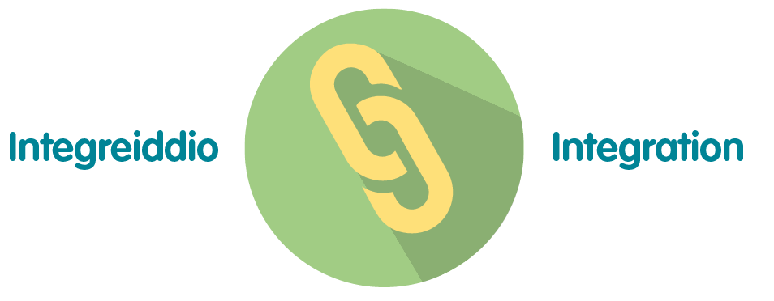 | These measures integrate with all PHW priorities in the Response and Recovery plans
 | Consultation with the Trade Unions occurs on a regular basis
 | Stakeholders across PHW involved in this work.

Conclusion and Recommendation

There is much work that continues to be undertaken both in supporting our response to the pandemic and also preparing for the organisational recovery on certain functions. However, this must be balanced with the key priority of being able to respond effectively to the health protection aspects of the pandemic and also preparing for any resurgence in the transmission of COVID-19.

Appropriate reports and assurance will continue to be provided internally through the work streams, the Delivery Confidence Assessment reported to Gold weekly and through reports to the Business Executive Team. Relevant reports will continue to be reported to the Board in the absence of the People and Organisational Development Committee.

The Board is asked to take assurance in respect of the following workforce areas:

- Employee Well-Being and Support;
- Response Plan Resourcing;
- Workforce Information.

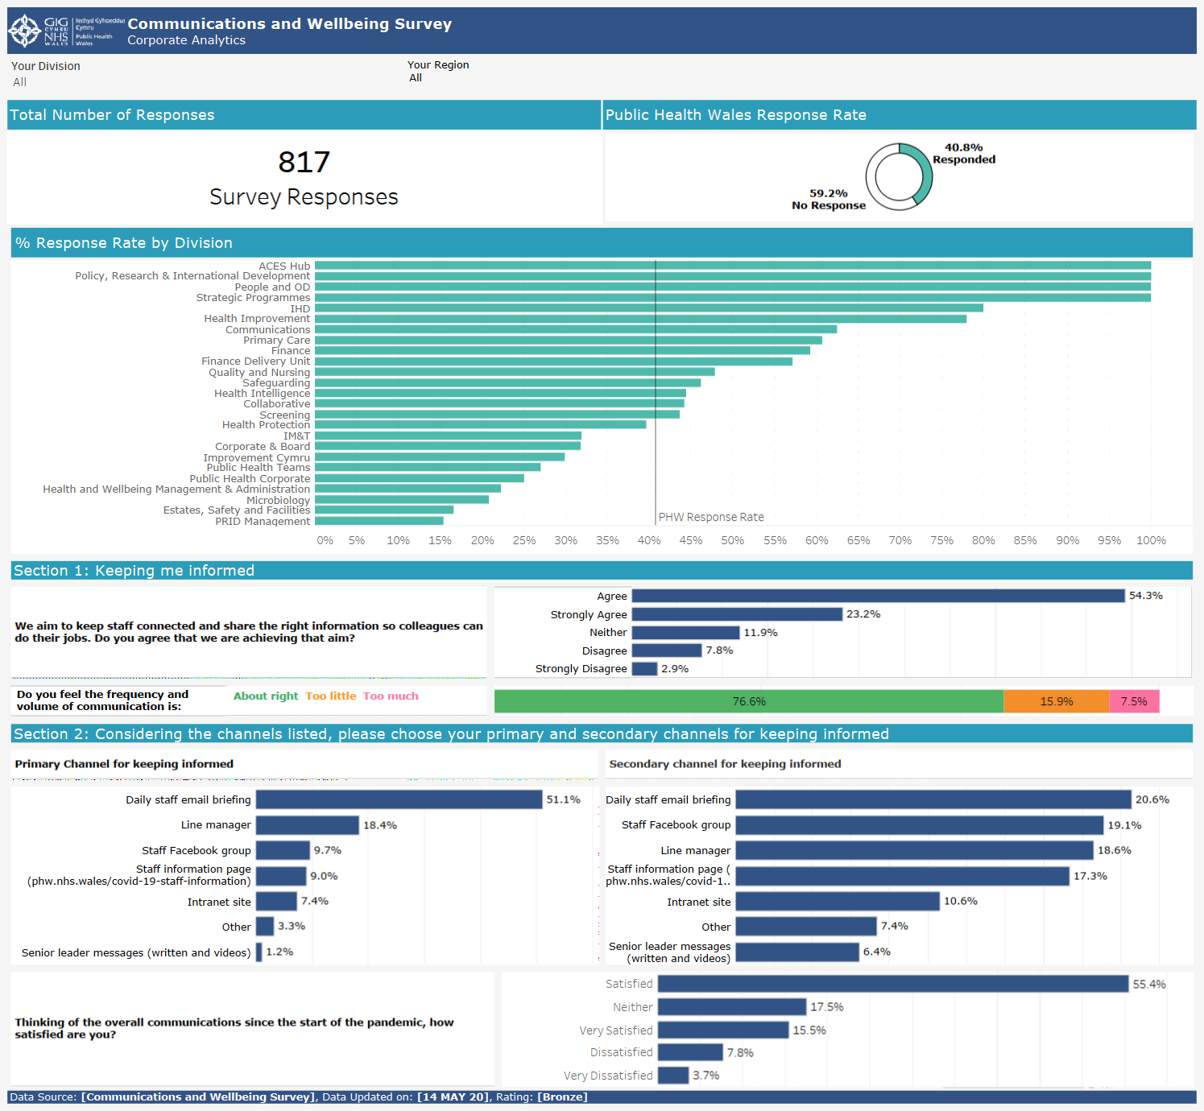
Appendix A
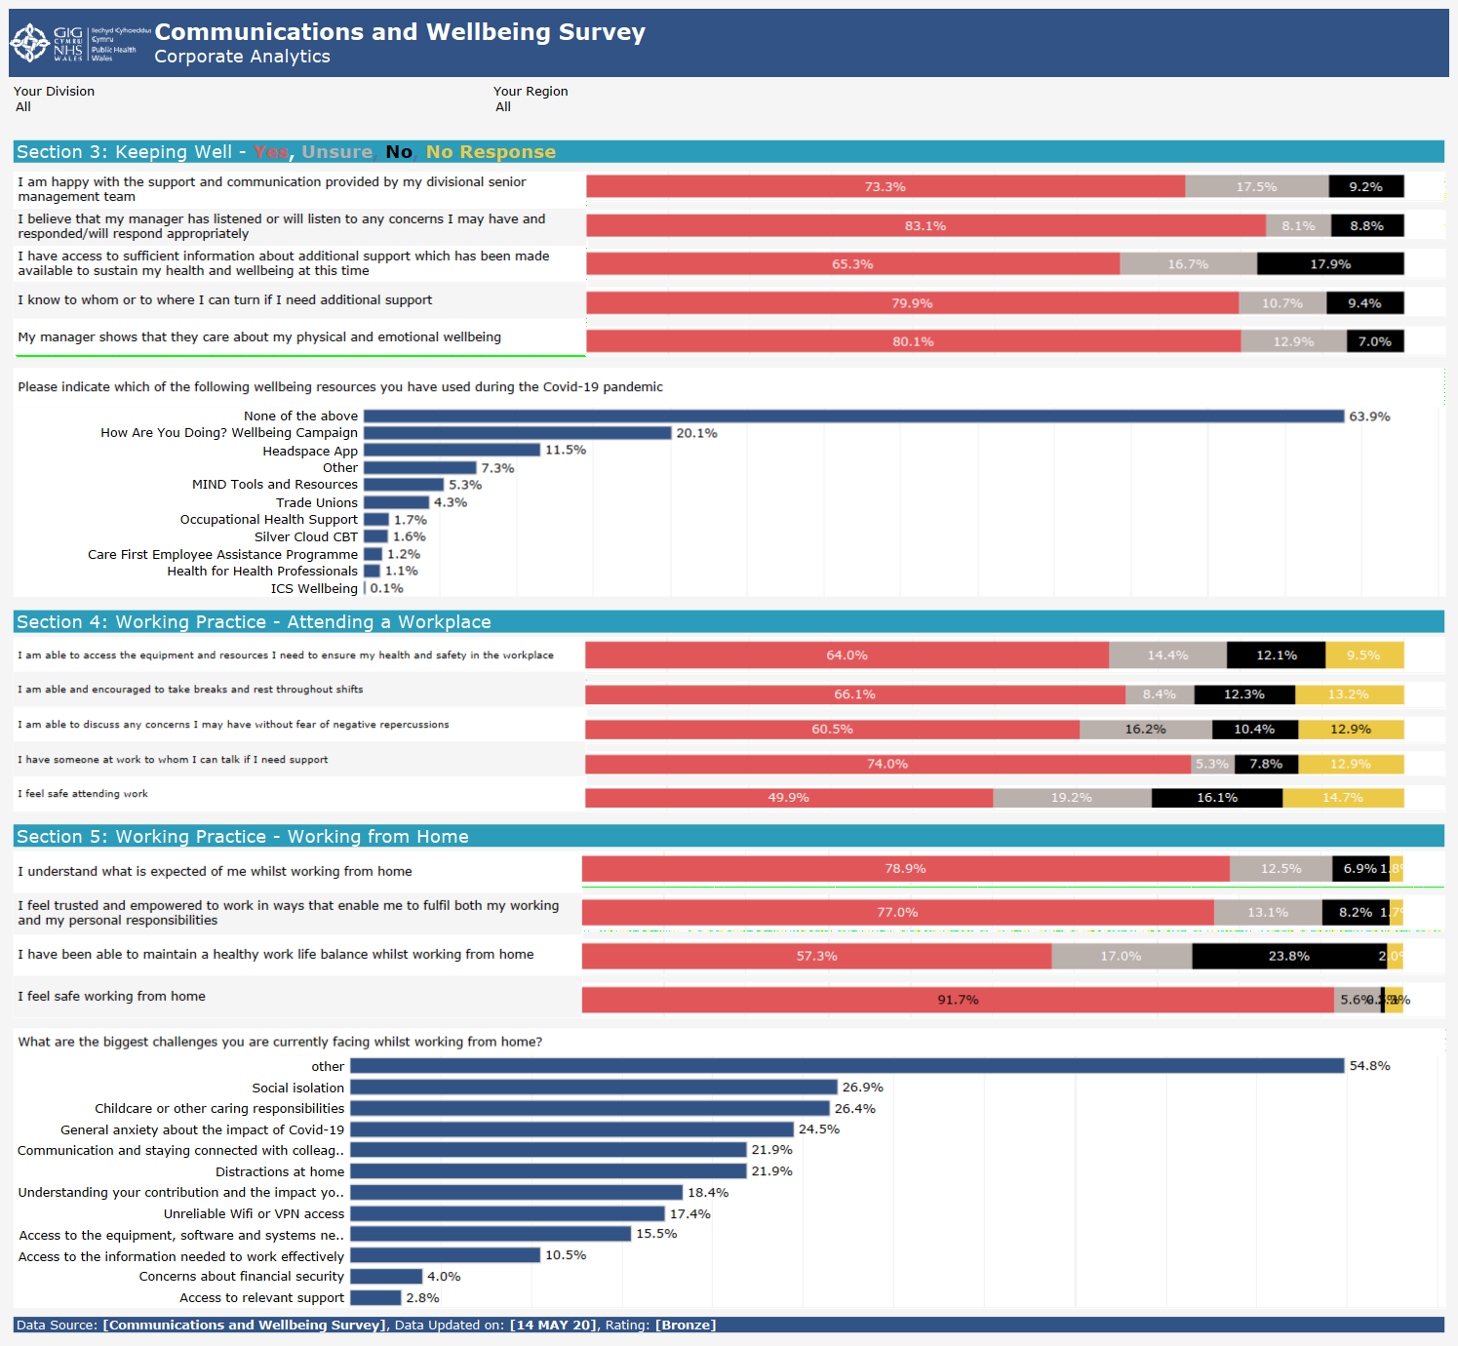

Appendix B Staff Status and Availability Data

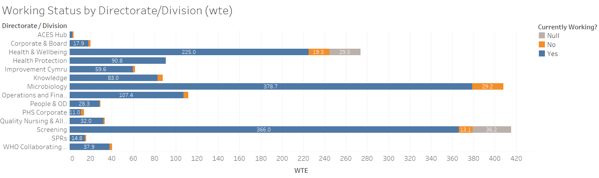

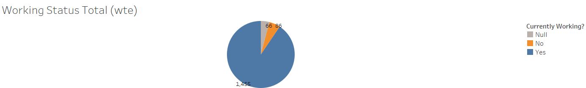

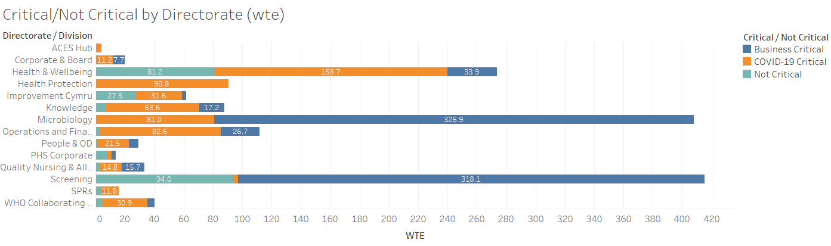

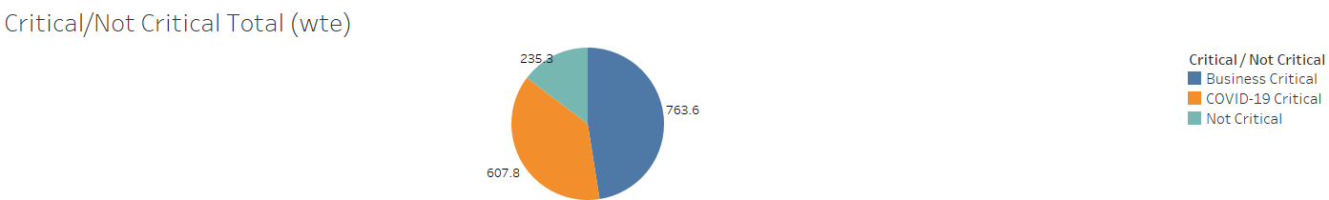

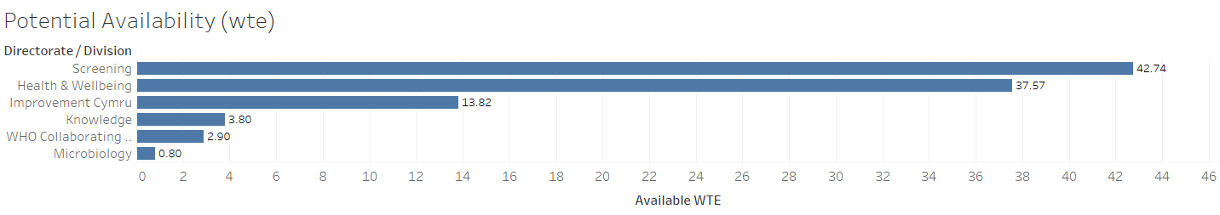

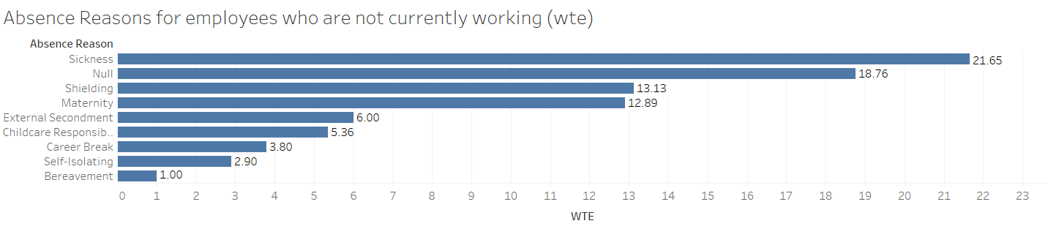

Appendix C Agency and Bank Staff Costs

Directorate | Mar-20 |  |  |  | Apr-20 |  |  | May-20
 | Agency | Bank | Locum | Total | Agency | Bank | Total | Agency | Bank | Total | Grand Total
ACE's Hub | 651 | 0 | 0 | 651 | 0 | 0 | 0 | 0 | 0 | 0 | 651
Board and Corporate | 1,320 | 0 | 0 | 1,320 | 1,942 | 0 | 1,942 | 0 | 0 | 0 | 3,263
Covid 19 | 22,580 | 174,644 | 0 | 197,224 | 2,956 | 38,824 | 41,780 | 39,205 | 50,302 | 89,507 | 328,511
Health & Wellbeing | 59,076 | 6 | 0 | 59,082 | 7,201 | 113 | 7,314 | 10,618 | (646) | 9,972 | 76,368
Hosted | 76,391 | 0 | 12,321 | 88,712 | 16,663 | 28 | 16,692 | 6,241 | (1,676) | 4,565 | 109,969
Knowledge | 7,158 | 0 | 0 | 7,158 | 202 | 0 | 202 | (827) | 0 | (827) | 6,533
Operations and Finance | 7,417 | 96 | 0 | 7,512 | 3,424 | 0 | 3,424 | 5,444 | 0 | 5,444 | 16,380
Public Health Services | 95,594 | 10,776 | 0 | 106,371 | 63,552 | 32,720 | 96,272 | 103,175 | 30,842 | 134,017 | 336,659
Quality Nursing & Allied Health Professionals | 5,745 | 0 | 0 | 5,745 | (619) | 0 | (619) | 901 | 0 | 901 | 6,028
WHO Collaborating Centre | 36,011 | 0 | 0 | 36,011 | 20,426 | 0 | 20,426 | 33,511 | 0 | 33,511 | 89,947
Grand Total | 311,944 | 185,522 | 12,321 | 509,787 | 115,747 | 71,685 | 187,432 | 198,268 | 78,823 | 277,090 | 974,309

