Name of Meeting
Board
Date of Meeting
24 September 2020
Agenda item:
5.7 24092020
Public Health Wales’ preparations for the end of UK transition period after Brexit
Executive lead: |  | Dr Quentin Sandifer, Executive Director of Public Health Services  Professor Mark Bellis, Director of Policy and International Health, WHO CC
Author: |  | Sumina Azam, Consultant in Public Health  Mariana Dyakova, Consultant in Public Health  Dr Quentin Sandifer, Executive Director of Public Health Services
Approval/Scrutiny route: |  | Business Executive Team – 14 September 2020
Purpose
To provide assurance on Public Health Wales’ preparations and response to the ending of the UK transition period after Brexit, in the context of COVID-19 in three key areas of health securities/health protection; policy and evidence; and international health.
Recommendation:
APPROVE | CONSIDER |  | RECOMMEND |  | ADOPT | ASSURANCE
The Board is asked to:
- Receive assurance on Public Health Wales’ preparations and response to the ending of the UK transition period after Brexit in three key areas of health securities/health protection; policy and evidence; and international health.

Link to Public Health Wales Strategic Plan

Public Health Wales has an agreed strategic plan, which has identified seven strategic priorities and well-being objectives.

This report contributes to the following:
Strategic Priority/Well-being Objective | 5 - Protecting the public from infection and environmental threats to health
Strategic Priority/Well-being Objective | 1 - Influencing the wider determinants of health
Strategic Priority/Well-being Objective | 7 - Building and mobilising knowledge and skills to improve health and well-being across Wales
Summary impact analysis

Equality and Health Impact Assessment | An Equality and Health Impact Assessment has not been undertaken for this paper as the contents are based on the findings of a series of Health Impact Assessments on Brexit and COVID-19
Risk and Assurance | Brexit has been on the Corporate Risk Register and is recognised as a strategic risk to population wellbeing
Health and Care Standards | This report supports and/or takes into account the Health and Care Standards for NHS Wales Quality Themes
 | Theme 2 - Safe Care
 | Theme 3 - Effective Care
 | Theme 1 - Staying Healthy
Financial implications | Some proposed activities may have additional financial implications; activity can be adjusted to resources available.
People implications | Staff will prioritise this work alongside current work on COVID-19. Additional capacity may be required for some actions; options such as the mutual aid process will be explored.

Purpose
To provide assurance on Public Health Wales’ preparations and response to the ending of the UK transition period after Brexit, in the context of COVID-19 in three key areas of health securities/health protection; policy and evidence; and international health.

Background
Prior to the COVID-19 pandemic, Public Health Wales identified the UK’s exit from the European Union (EU) (Brexit) as having a significant impact on population health, wellbeing and equity.
On 31 January 2020, the UK left the EU and entered a transition period during which it would remain in the EU’s customs union and single market but would no longer be a member of the political structures and decision making. Since entering the transition period, the UK and EU have been carrying out negotiations on the nature of the future relationship in areas such as trade, law enforcement, fisheries and level playing field for open and fair competition. The deadline for extending the transition period was 30 June 2020; the two sides now need to ratify any agreement by 31 December 2020 in order to begin 2021 under a new relationship.

Our role and approach to date
Since June 2016, Public Health Wales has provided system leadership in relation to population wellbeing issues in the context of Brexit. This has been carried out through a Brexit programme, which was established with four workstreams:
- Emergency planning and business continuity
- Wider public health impacts
- Health security
- People and resources
Since June 2016, Public Health Wales’ role has included:
- Providing system leadership in relation to health securities and health protection, including working with UK Government and other Devolved Nations
- Leading work on behalf of the Welsh civil contingencies system, as part of preparations for a potential ‘no-deal’
- Enhancing and expanding our international role, learning and collaborations through developing new and strengthening existing partnerships, including:
  - Being designated a World Health Organization (WHO) Collaborating Centre on Investment for Health and Wellbeing (WHO CC), opening further international opportunities
  - Enabling, promoting and supporting Wales’ international role as an Influencer Nation for health equity, through facilitating a Memorandum of Understanding (MOU) between Welsh Government and WHO Regional Office for Europe and establishing a Welsh Health Equity Status Report initiative (WHESRi) to inform sustainable solutions for policy action and investment
  - Fostered Wales/WHO collaboration, organising two high level WHO visits to Wales; supported Ljubljana Statement on Health Equity; and enabled Welsh Ministerial participation in the Ljubljana Conference on Health Equity and the WHO Regional Committee for Europe in 2019
  - Strengthening Wales’ role and impact in the global Violence Prevention agenda, through undertaking UK data coordination role for the WHO; co-authored a Practical Handbook with WHO, UNICEF and UNESCO; and contributed to publications and workshops
  - Gaining a leading role in the International Association of National Public Health Institutes (IANPHI), chairing its European Region and taking an active part in its network of 114 members in 99 countries
  - Maintaining and advancing active participation in the WHO European Regions for Health Network, EuroHealthNet and other key international networks and registries
  - Increasing visibility and strengthening relationships with our UK partners and networks, as well as with the Wales for Africa Programme through our International Health Coordination Centre (IHCC)
- Developing an Addendum to the International Health Strategy: the Potential Implications of Brexit for Public Health Wales International Health Strategy 2017–2027 (2019), outlining key challenges and ways forward
- Providing research and evidence to inform key decision makers and the wider system including
  - The Public Health Implications of Brexit in Wales: A Health Impact Assessment Approach (January 2019), followed by a rapid review and update (September 2019)
  - Supporting farming communities at times of uncertainty (2019)
  - The health and wellbeing of young people in Wales. Do they think Brexit will make a difference? (2019)
  - Regional funding for Wales after Brexit. Understanding what the ending of access to European Union Structural Funds will mean for the health and wellbeing of local areas (publication pending).
- Strengthening public health knowledge and skills required to understand the negotiation of future trade deals through a Health and Trade Symposium; and a Trade Agreements and Health Masterclass (November 2019)
In May 2019, an end of phase review was carried out, which resulted in
- Ongoing Brexit preparatory work being embedded as part of business as usual e.g. Brexit was considered by each of the Strategic Priority groups and embedded in IMTP and operational plans
- The development of ‘No deal” activation plans, with the intention of being implemented if needed in September 2019
- A ‘stock take’ of organisational emergency planning and business continuity arrangements
Following the successful passage of the Withdrawal Agreement Act, the preparatory work for a potential ‘no-deal’ on 31 January 2020 was de-escalated.

4 Our future role
With the passing of the deadline to extend the UK transition period, there is a need for Public Health Wales to reassess its preparations for the possibility of a ‘no deal’ future relationship scenario. In addition, it is important to consider our organisational role during trade negotiations with non-EU countries. This should be carried out with the lens of COVID-19, which has exacerbated and highlighted a range of issues such as increasing poverty and inequity, rising concerns about unemployment, worsening population mental wellbeing and impacts on specific groups such as those with a low income, children and young people and people from BAME backgrounds.
The following section summarise Public Health Wales’ plans to respond to growing concerns related to UK transition, in the context of COVID-19. Some actions are dependent on capacity and resources; it is anticipated that this work will be aligned and integrated with the emerging workplan of the COVID-19 Population Health Strategic Group and the Health Protection Group.

4.1 Public Health Wales’ Preparedness and System Leadership for Health Securities/Health Protection
The UK’s exit from the EU is taking place at the same time as the entire European continent is grappling with the biggest public health emergency the world has faced in more than a century. The challenges and impacts arising from COVID-19 demonstrate powerfully the case for international collaboration.
Public Health Wales will formally restart its preparedness work in September 2020, through to re-establishment of our internal Brexit Programme and the Health Securities Group that we lead on behalf of Welsh Government.
The Health Securities Group, which includes representatives from key public sector organisations across Wales (e.g. Food Standards Agency, Welsh Local Government Association), will meet for the first time on 14 September. Public Health Wales has maintained close contact with the other UK countries as well as the Republic of Ireland throughout 2020, the most recent meeting taking place on 28 July 2020. The collective view of the four UK public health agencies is that the previously assessed risks to health security have not changed and therefore previous mitigations apply. These are both internal, for example, assuring supplies, and external, for example, maintaining bilateral and multilateral relationships with other national public health institutes in Europe. Work will be undertaken during October and November to review these risks, with appropriate internal and external input, and ensure appropriate mitigations are in place, where possible.
Public Health Wales has planned an internal programme of business impact and risk-based business continuity assessment over the next three months alongside reassessment of stocks and supplies, and contingency planning for critical supplies like culture media. This will be led by a Senior Responsible Officer and managed through a formal programme of work. A plan is being finalised, which is informed by Public Health Wales’ ‘No-Deal’ Activation Plan agreed in July 2019. This focuses on three key stages for our preparedness:
- Planning (September – November 2020)
- Shadow Response (4 weeks from 31 December)
- Response (2 weeks from 31 December)
At the UK level the two key issues of interest remain as before: access to the European Warning and Reporting System (EWRS) – EU partners see the mutual benefit in this – and any future relationship with the European Centres for Disease Control and Prevention (ECDC).

4.2 Policy and evidence
There is a growing appreciation of the importance of rapidly strengthening knowledge and understanding within the public health workforce and the wider system in Wales, regarding areas such as the Brexit process; trade and trade deals; and the potential implications for Welsh population health and wellbeing. This needs to be undertaken in the context of COVID-19 and COVID-19 recovery planning and will need to utilise data and intelligence already available from both within the organisation and stakeholder organisations.
A broad approach to addressing this (capacity and resources allowing), is the production of a suite of documents, which cumulatively strengthen knowledge and understanding over the coming months:
- Undertaking a rapid review and analysis of population impacts of Brexit on health and wellbeing. This would provide an update on previous Health Impact Assessment (HIA) reports (underway)
- A series of policy briefs, on topic areas such as the impacts of trading using World Trade Organisation terms for Welsh population health and wellbeing; and mitigation measures for communities that are likely to be most affected by dual impacts of altered trade patterns and the wider harms of COVID-19
- “Insight reports” on topic areas identified from the initial rapid review and analysis. These insight reports will aim to identify solutions at a policy and practical level, drawing from international literature and evidence.
- Increasing knowledge and skills regarding trade and trade deals, for example through a webinar/online workshop. Trade and trade agreements were identified in the Brexit HIA as a key determinant of health. Although negotiations will be led by UK Government, Welsh Government will have its own position and will continue to seek to influence such discussions. Of note, Public Health Wales has previously been asked to provide rapid public health evidence to inform various Welsh Government positions on trade negotiations; these requests have spanned across the domains of public health (and the organisation), with short timeframes for response.
- As part of the COVID-19 health protection plan approved by Welsh Government, there is a commitment to conduct an analysis of the potential impacts of Brexit, COVID-19 and climate change. This report will utilise emerging evidence from the above actions, as well as drawing upon HIAs on COVID-19 (currently underway) and climate change (currently underway). The report will integrate knowledge and will help to identify and plan support for those most affected by multiple issues, whilst also recognising potential opportunities from this triple challenge (e.g. investment in environmentally sustainable recovery models).
- The Brexit HIA identified research priority areas such as mental well-being, community resilience and cohesion, and specific groups and communities such as children, rural communities and those from BAME backgrounds; ongoing analysis of evidence is likely to identify further research needs. Although capacity is very limited to undertake Brexit research, this may become increasingly important due to emerging evidence or following urgent requests, for example from Welsh Government.

4.3 Brexit and international relations
Public Health Wales’ role, vision and impact on the European and global health agenda, as well as benefits and opportunities from international work, are challenged by Brexit. It is vital to maintain and strengthen further our international partnerships, mitigating Brexit threats and enhancing opportunities. Areas where further work would be beneficial (capacity and resources dependent) include:
- Enhance and utilise the full potential of our existing strategic partnerships, particularly with WHO and IANPHI:
- Support and deliver on the MOU between WHO and Welsh Government, strengthening Wales’ Influencer role and impact
- Progress the WHESRi, developing a Health Equity Solution Platform and other products, as part of a global Health Equity Alliance
- Continue and expand the WHO CC leading role on investment for health and wellbeing, sustainable development and building individual, community and system resilience, and social value
- Utilise our active leadership role in IANPHI, learning, sharing and innovating
- Maintain active membership in the WHO Regions for Health Network and EuroHealthNet, learning from and sharing experience and opportunities
- Strengthen and expand our strategic partnerships and utilise funding opportunities across the UK, including with Public Health England, the Faculty of Public Health, and the Foreign, Commonwealth & Development Office.
- Expand and develop new international links and opportunities, for example with bi-lateral collaborations
- Ensure opportunities for staff development and mitigate workforce issues
- Update our Addendum to the International Health Strategy, looking into further implications, threats and opportunities, e.g. horizon scanning

Well-being of Future Generations (Wales) Act 2015

 | The focus of the report is to improve population health and wellbeing for the short, medium and longer term.
 | The work programme seeks to prevent and mitigate any negative impacts of Brexit.
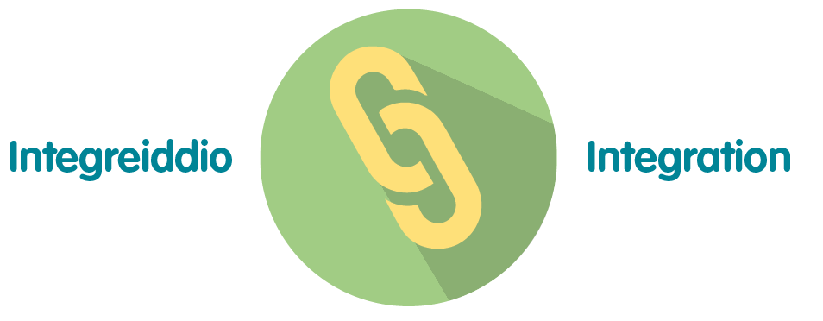 | The impacts of Brexit are being viewed from an integrated perspective, with consideration of the wider determinants of wellbeing.
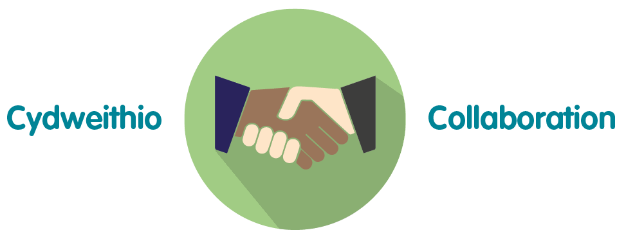 | The paper has been developed through collaborative discussions across Directorates.
 | Much of the work programme is based on the findings of a HIA, which has involved key stakeholder.

Recommendation
The Board is asked to:
- Receive assurance on Public Health Wales’ preparations and response to the ending of the UK transition period after Brexit, in the context of COVID-19 in three key areas of health securities/health protection; policy and evidence; and international health.

