 |  |  |  | Name of Meeting  Board
Date of Meeting
24 September 2020
Agenda item:
5.6 24092020
Public Health Wales
Workforce Report
Executive lead: |  | Neil Lewis, Acting Director of Workforce and Organisational Development
Author: |  | Karen Williams, Asst. Director of People (Interim)  Lisa Whiteman, Asst. Director of OD (Interim)  Joe O’Brien, Workforce Information and Development Manager
Approval/Scrutiny route: |  | Neil Lewis, Acting Director of Workforce and Organisational Development
Purpose
This paper provides the Board with an overview and assurance on a range of workforce issues that will assist and enable the organisation to continue to deliver the Health Protection Response and support the priorities identified within the Operating Plan.

Specifically, assurance is provided in respect of the following:
- Employee Well-Being and Engagement
- Workforce Information/Recruitment
- Partnership Working
APPROVE | CONSIDER |  | RECOMMEND |  | ADOPT | ASSURANCE
The Board is asked to take assurance in respect of the following workforce areas:

- Employee Well-Being and Engagement
- Workforce Information/Recruitment
- Partnership Working

Link to Public Health Wales Strategic Plan

Public Health Wales has an agreed strategic plan, which has identified seven strategic priorities and well-being objectives.

This report contributes to the following:
Strategic Priority/Well-being Objective | 7 - Building and mobilising knowledge and skills to improve health and well-being across Wales
Strategic Priority/Well-being Objective | 5 - Protecting the public from infection and environmental threats to health
Strategic Priority/Well-being Objective | Choose an item.
Summary impact analysis

Equality and Health Impact Assessment | An Equality and Health Impact Assessment has not been undertaken
Risk and Assurance | There is a link to Risk 1 in the Corporate Risk Register.
Health and Care Standards | This report supports and/or takes into account the Health and Care Standards for NHS Wales Quality Themes
Health and Care Standards | Theme 7 - Staff and Resources
Health and Care Standards | Choose an item.
Health and Care Standards | Choose an item.
Financial implications | It is important that all workforce planning is within available budgets
People implications | It is vital that PHW has the staff with the right skills in the right place to deliver the Response and Recovery Plans, whilst at the same time ensuring their health and well-being.

Purpose
This paper provides the Board with an overview and relevant assurance on a range of workforce issues that will assist and enable the organisation to continue to deliver the Health Protection Response to the COVID-19 pandemic and also support the priority areas identified within the Operating Plan.
Specifically, assurance is provided in respect of the following:
- Employee Well-Being and Engagement
- Workforce Information/Recruitment
- Partnership Working

Background

Maintaining and continuing our response to the COVID-19 pandemic and the Test Trace Protect Protect programme remains the key priority for the organisation. Staff continue to rise to this challenge and we have put in place a number of mechanisms to enable this to happen, as well as providing staff with support measures to assist them in these unprecedented circumstances.

People and OD are currently supporting the planning work for the new priorities within the Operating Plan, the workforce needs for each priority will be determined and workforce plans developed and implemented.

Description/Assessment

3.1 Employee Wellbeing and Engagement

This section provides an update on employee well-being and support activities. Work in relation to resilience has also commenced with the Business Executive Team, additional work in this area is currently being scoped.

Tell Us How You Are Doing #1 – Internal Communications and Wellbeing Survey

Organisational Action Plan
The plan agreed to address organisation-wide improvements is complete, additional guidance and information required for staff and managers is live.

Wellbeing and Engagement Partnership Group

The first group meeting took place on 17 September 2020, chaired by the Acting Director of People and Organisational Development. The meeting provided an opportunity for shared updates on local action plans; an update on the second Tell Us How You Are Doing survey and broader NHS Wales staff survey plans. It provided an extremely positive forum to share best practice, colleagues from Staff Diversity Networks and Trade Unions are also part of this forum.

Tell Us How You Are Doing #2 – Wellbeing and Engagement Survey

The second internal staff survey went live on 17 September. Designed in partnership with colleagues in Research and Evaluation, the survey focuses on Wellbeing and Engagement. This survey takes a ‘deep dive’ into our staff’s wellbeing, utilising the validated Warwick-Edinburgh Mental Wellbeing Scale as a measure. We anticipate results at organisational level will be shared by the end of October.

3.2 Performance and Development (My Contribution)

As at the end of August 2020, all due actions within the action plan were complete and/or on track to be completed within the target dates. Organisational compliance, a key area for improvement, has increased to just over 70%, a notable improvement but under the required 85% target.

Data entry support from People and Organisational Development has been extended until the end of September, however, there are a considerable number of appraisals outstanding, key areas of concern are Health Protection, Screening Services, Microbiology and the local public health teams.

3.3 Workforce Information – Staff Status

Staff Status
The information attached at Appendix A shows the staff status and availability data as at the beginning of September 2020.
From a total of 1591.9 wte staff:
- 90% of our workforce, that is 1419.75 wte, are currently working, with only 102.74 wte not currently working. Although 102.74 wte are not currently working, the data shows that they are unavailable due to reasons of sickness, maternity, shielding, external secondment etc.

- It should be noted that we have not received data for 69.39 wte and we are working with the Directorates to ensure we receive this data.

- 618.4 wte are in Covid-Critical roles, 778.5 wte are in Business Critical roles and 174.1 wte are not critical. 96.1 wte of the employees whose substantive posts are not critical have been redeployed into other critical roles.

- The data shows that there is currently a total of 72.61 wte who are available for redeployment/mobilisation. This is comprised of 55.51 wte staff who are working in non-critical roles and 17.1 wte staff who are in critical roles but have availability for a proportion of their time.

- The majority of available staff are employed within Screening, therefore this number is likely to decrease as Screening programmes are reactivated

- Moving forward, staff status information will be recorded in line with the agreed priorities in the new operating plan

3.4 Overtime

From a high in June 2020, there was a slight decrease over the summer months, which reflects the general situation with regards to the Covid response. With cases now increasing we can reasonably expect overtime figures will again increase. Overtime is discussed and monitored on a monthly basis.

Directorate | Apr-20 | May-20 | Jun-20 | Jul-20 | Aug-20 | Sep-20 | Grand Total
Directorate | Hours | Hours | Hours | Hours | Hours | Hours | Hours
Health and Wellbeing | 1,133 | 1,255 | 1,719 | 1,635 | 2,308 | 2,052 | 10,103
Hosted | 43 | 78 | 72 | 69.41 | 0 | 96.25 | 359
Improvement Cymru | 312 | 740 | 492 | 326.72 | 108.4 | 196.15 | 2,175
Knowledge | 273 | 190 | 211 | 62.05 | 71.1 | 113.25 | 920
Operations and Finance | 438 | 574 | 568 | 310.24 | 381.92 | 87.68 | 2,360
People & OD | 123 | 136 | 38 | 49 | 0 | 14.5 | 361
Public Health Services | 1,803 | 5,470 | 7,022 | 6,778 | 5,039 | 3,234 | 29,346
Quality Nursing & Allied Health Professionals | 203 | 168 | 164 | 197.3 | 55 | 57 | 844
SPRs | 61 | 58 | 180 | 234.45 | 84.5 | 130.21 | 748
WHO Collaborating Centre | 193 | 136 | 92 | 0 | 24 | 3 | 448
Grand Total | 4,582 | 8,805 | 10,558 | 9,662 | 8,072 | 5,985 | 47,664

  - Recruitment Update

Surveillance work-stream required 17 WTE to be filled. 14 WTE have now been appointed, work ongoing on 3 WTE unfilled roles.

Sampling and Testing work-stream required 49 WTE to be filled. 43.4 WTE have been appointed to accounting for 89%. Work ongoing into the remaining 5.6 WTE posts.

National Contact Centre required Consultants. Fixed Term and Permanent appointees were required, only 1 WTE permanent appointment was made during the Advisory Appointment Committee (AAC) panel convened 16th September.

Hot labs and TAT recruitment require 162 WTE roles to be filled.
- All shortlisting was completed by 11th September
- Interviews 14th September - 25th September.
- Offers will be issued and pre-employment checks will begin in late-September, with the first candidates in post at the start of November (earlier if internal), depending on notice periods.

3.6 Workplace COVID-19 risk assessment

Public Health Wales procured an external company to assess our estate on the suitability of measures in place to manage the transmission of COVID-19 virus. The assessment covered 28 premises and included a mixture of office buildings, laboratories and screening buildings.

Highlights from the report include-
- Acknowledges that in general, systems for communicating with staff and service users were used to good effect, however greater consistency on signage across the estate would be beneficial. There was also good evidence of regular engagement with employees informing them of changes to the workplace and the measures that have been implemented.
- Report recognises that due to the nature of the estate, facilities and associated services would be at different stages of application of control measures.
- Laboratories have continued to provide services whilst managing the implementation of guidance measures. This has been done well despite the additional complexity of challenges due to age and nature of the estate.

A number of recommendations were included in the report. This includes developing local action plans to take forward the findings within each of the premises.

3.7 Partnership Working

Throughout the COVID-19 period we have continued to work in partnership with both Agenda for Change and Medical and Dental trade union colleagues.

There are fortnightly meetings with the chair and vice chair of the Local Partnership Forum in addition to wider monthly meetings to which a larger group of trade union representatives are invited. The last meeting of the monthly LPF was 16 September 2020.

Some of the current issues under discussion are:
  - Taking of annual leave and carry over (agreed)
  - Results of the Well-Being survey and actions arising (agreed)
  - Change Management Principles (agreed)
  - Overtime (agreed)
There are also weekly catch ups with the chair of the Joint Medical and Dental Committee in addition to quarterly meetings of that Committee. The external British Medical Association representative attends this meeting as do Executive Team members.

The last meeting of the Joint Medical and Dental Committee was held on 7th September 2020 at which the following was discussed:
- Overtime payments and WG advisory notice (agreed)
- On Call rota – capacity and equity (Ongoing – November implementation)
- Annual Leave – carry over and time off in lieu (agreed)
- Indemnity (agreed)
- Salary Scales(ongoing)
- Job Planning Training (ongoing)
- Microbiology capacity (discussed and plan in place)
- PPE in BTW (meetings taken place)

These arrangements are expected to continue for the foreseeable future.

3.8 Well-being of Future Generations (Wales) Act 2015

This work has been put together following the five ways of working, as defined within the sustainable development principle in the Act, in the following ways:

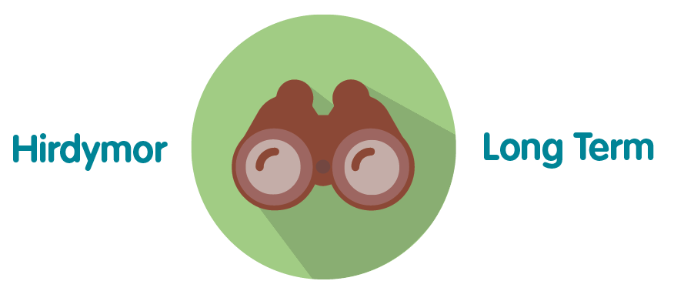 | These workforce measures is vital to ensure that PHW is resourced
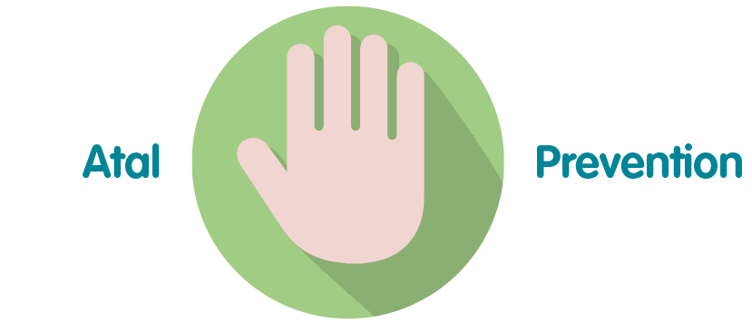 | These measures will prevent PHW being unable to meet its responsibilities for resourcing now and into the recovery.
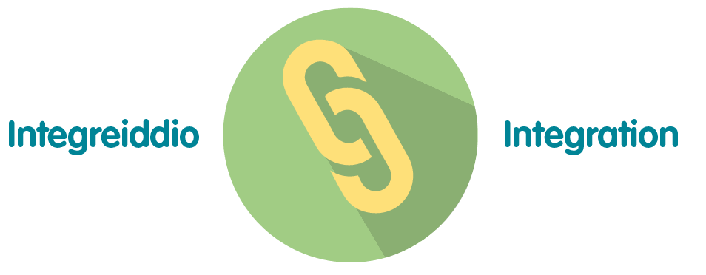 | These measures integrate with all PHW priorities in the Response and Recovery plans
 | Consultation with the Trade Unions occurs on a regular basis
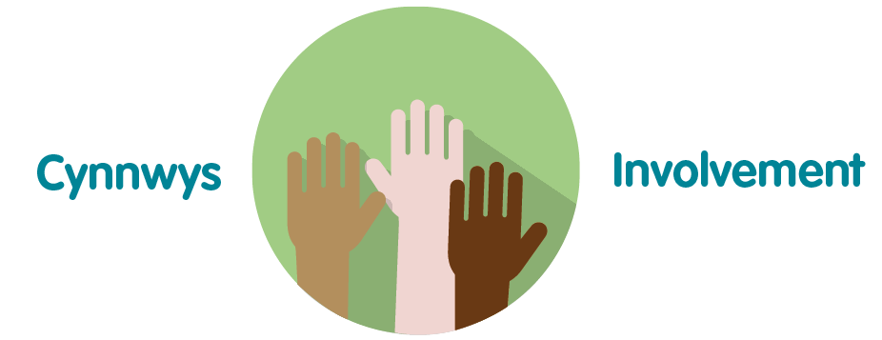 | Stakeholders across PHW involved in this work.

Conclusion and Recommendation

There is much work that continues to be undertaken both in supporting our response to the pandemic and also preparing for the organisational recovery on certain functions. However, this must be balanced with the key priority of being able to respond effectively to the health protection aspects of the pandemic and also preparing for any resurgence in the transmission of COVID-19.

Appropriate reports and assurance will continue to be provided internally through the work streams, the Delivery Confidence Assessment reported to Gold weekly and through reports to the Business Executive Team. Relevant reports will continue to be reported to the Board in the absence of the People and Organisational Development Committee.

The Board is asked to take assurance in respect of the following workforce areas:

- Employee Well-Being and Engagement
- Workforce Information/Recruitment
- Partnership Working.

Appendix A
PHW Staff Availability Data (as at September 2020)
Current Working Status
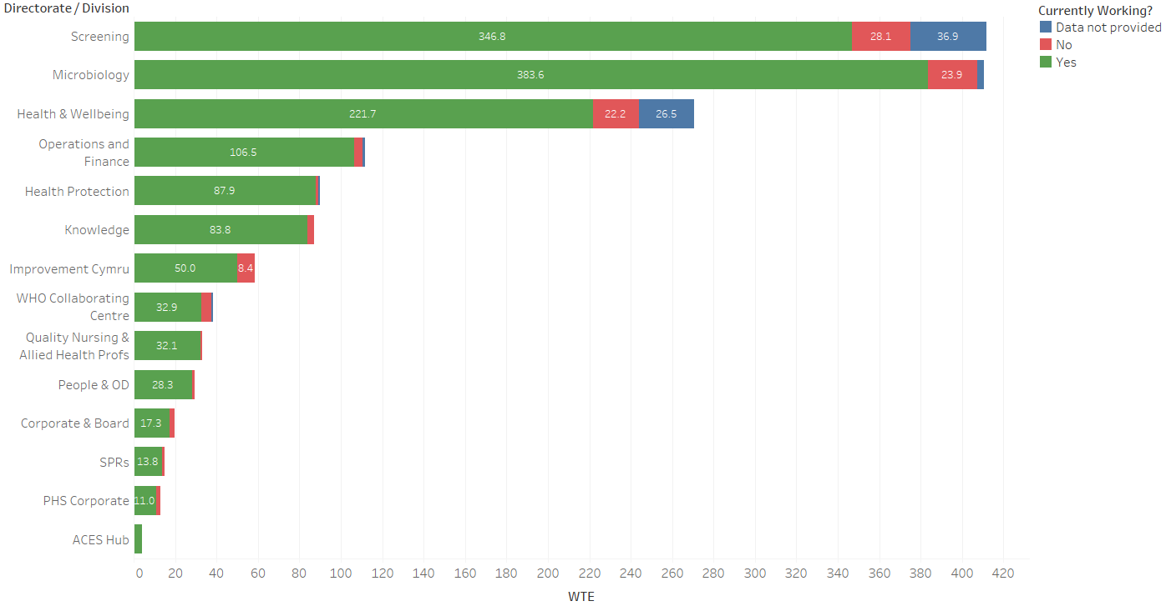

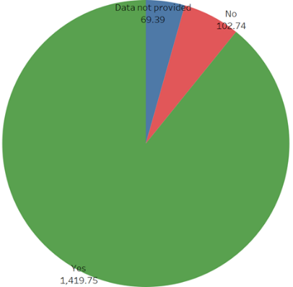

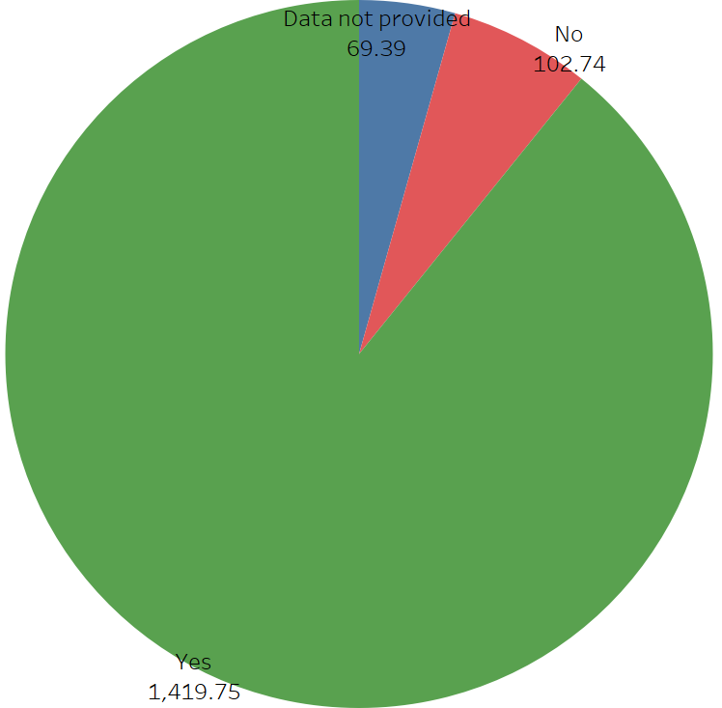

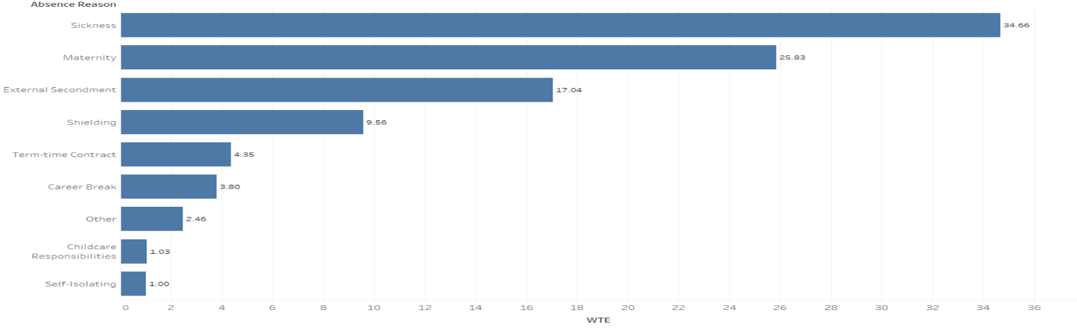
Reasons for not working

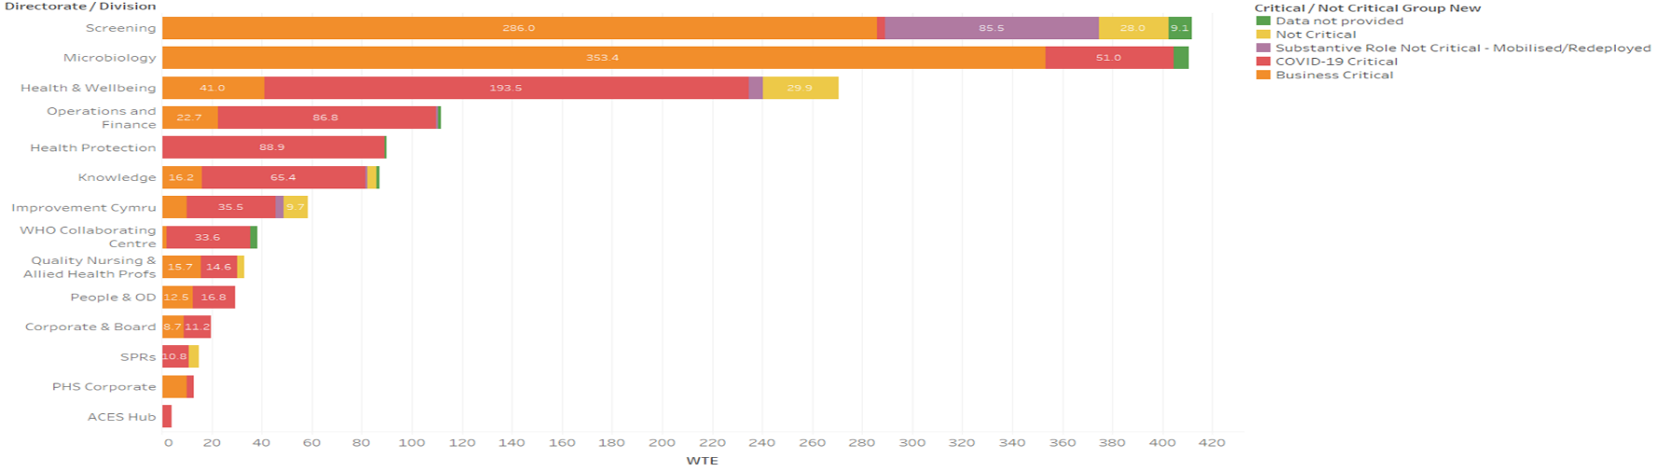
Critical / Not Critical Status

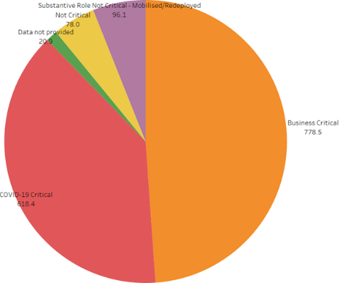

Potential Availability
