 |  |  |  |  | Name of Meeting  Board
Date of Meeting
24 September 2020
Agenda item:
5.2 24092020
Performance and Assurance Report

Executive lead: | Huw George, Deputy Chief Executive/ Executive Director Operations and Finance
Contributors: | Huw George, Deputy Chief Executive and Executive Director of Operations and Finance; Executive Director of Public Health Services/Medical Director; Neil Lewis, Acting Director of People and Organisational Development; Rhiannon Beaumont-Wood, Executive Director of Quality Nursing and Other Allied Health Professionals; Angela Fisher, Deputy Director of Finance; Ioan Francis, Head of Performance; Sally Attwood, Deputy Director, Strategic Planning and Performance
Approval/Scrutiny route: | Business Executive Team - 14 September 2020
Purpose
The purpose of the Performance and Assurance Report is to provide an update on Public Health Wales’ performance, including:

- our COVID-19 response
- Financial performance – month 5 2020/21
- Workforce performance and COVID-19 related absence
- Operational performance including indicators within the NHS Wales Delivery Framework
- Quality – Putting Things Right

Please note that in light of significant organisational wide support being provided to the COVID-19 response, some performance related information was not available at the time of reporting.
Recommendation:
APPROVE |  | CONSIDER |  | RECOMMEND |  | ADOPT | ASSURANCE
The Board is asked to:

- Discuss and scrutinise the paper and provide feedback and comments
Link to Public Health Wales Strategic Plan

Public Health Wales has an agreed strategic plan, which has identified seven strategic priorities and well-being objectives.

In order for Public Health Wales to deliver the strategic plan, effective performance management arrangements need to be in place to monitor and report on progress against achieving our strategic priorities to improve health outcomes. This intelligence is used to draw the Board’s attention to areas of underperformance and is fundamental for effective and efficient decision making.

This report contributes to the following:
Strategic Priority/Well-being Objective |  |  | All Strategic Priorities/Well-being Objectives
Summary impact analysis

Equality and Health Impact Assessment |  |  | An Equality and Health Impact Assessment is not required. Equality and Health Impact Assessments will be completed as part of delivery of the specific actions within the Plan.
Risk and Assurance |  |  | Our Strategic Risks are detailed within Our Strategic Plan and the Implementation Plan for the Test Trace Protect Strategy.
Health and Care Standards |  |  | This report supports and/or takes into account the Health and Care Standards for NHS Wales Quality Themes
 |  |  | All themes
Financial implications |  |  | An update on the organisation’s financial performance is enclosed
People implications |  |  | An update on the organisation’s people performance is enclosed

- Purpose / situation

The purpose of the newly developed Performance and Assurance Report is to provide the Board with an update on Public Health Wales’ performance. As a result of the current pandemic and to mobilise an effective response, the arrangements underpinning the implementation of our long term strategy have been stood down.

The Performance and Assurance Report (attached) includes:

- information on our COVID-19 response
- financial performance – month 5 2020/21
- workforce performance and COVID-19 related absence
- operational performance including indicators within the NHS Wales Delivery Framework
- quality – Putting Things Right

In light of significant organisational wide support being provided to the COVID-19 response, some performance-related information may not be available at the time of reporting.
- Background

Access to high quality, timely and robust performance information is essential in providing assurance to our Executive Team and Board on our ongoing COVID-19 response, delivery of public health services and statutory responsibilities. A key element of the arrangements set out as part of our organisational recovery is the development of our new interactive Performance and Assurance Dashboard and supporting report. The newly developed dashboard provides an update on the latest available performance across the organisation to aid effective and efficient decision making. The Performance and Assurance Report replaces our existing Integrated Performance Report and pulls together key information from the interactive dashboard. In line with our response to the pandemic, further enhancements will be made over the coming weeks and months, as our services and programmes are reactivated.

- Description/Assessment

The newly developed Performance and Assurance Dashboard highlights the latest available performance across a number of key areas within the organisation in an interactive format. The supporting Performance and Assurance Report provides a summary of key information including performance highlights, trends and issues and should be read in conjunction with the interactive dashboard. The dashboard and supporting narrative gives the Executive Team and Board timely and robust performance information to provide assurance during our enhanced response to the COVID-19 pandemic. An executive summary highlights the key areas identified from latest available data to help stimulate discussion and inform decision making.

In developing our Performance and Assurance Dashboard, we have worked to recognised quality standards. Each data sources used to create one of our interactive dashboards is assessed and given a rating (Gold, Silver, Bronze). This is detailed at the bottom of each dashboard, along with the specific data source and when the information was extracted. Any data source that does not meet the standard is not included until improvement have been made.

The dashboards have been developed to recognised Alteryx and Tableau (our business intelligence tools) standards. This relates to not only how we have visualised the information provided but also in terms of the data flows that sit behind each dashboard.

A demonstration of the new dashboard was delivered to Non-Executive Directors in advance of its formal launch. This provided an opportunity to familiarise colleagues with the new system, gather feedback and identify potential areas for future developments.

Links to the dashboards are below for information:
Performance and Assurance Dashboard (not publically available)
https://phw-tableau.cymru.nhs.uk/#/site/CorporateAnalyticsPreProduction/views/RecoveryDashboardLandingPage/LandingPage?:iid=1

PHW Rapid COVID-19 surveillance (publically available)
https://public.tableau.com/profile/public.health.wales.health.protection#!/vizhome/RapidCOVID-19virology-Public/Headlinesummary
COVID-19 Staff Absence Dashboard (not publically available)
https://phw-tableau.cymru.nhs.uk/#/site/CorporateAnalyticsPreProduction/views/COVID-19StaffAbsenceDashboard/COVID-19SicknessAbsence?:iid=1
- Scope of future developments
As a result of Public Health Wales’ ongoing response to COVID-19, we need to adapt our performance and assurance arrangements to reflect the priorities and key areas of focus for the organisation, during the remainder of 2020/21. This needs to demonstrate our performance across a range of areas, including: delivering statutory functions and critical services; our ongoing COVID-19 response; and supporting organisational recovery. As an example, work is ongoing to develop indicators of quality/success for our four public health workstreams in the pandemic response programme; and the development of our organisational Operating Plan for 2020/21.
Assurance in relation to these areas will be provided to the Board, its Committees and the Executive Team through a number of sources, including: regular performance reports, service/area specific reports and regular updates produced as part of our response, such as our weekly response programme Delivery Confidence Assessment.

- Well-being of Future Generations (Wales) Act 2015

 | Ensures Public Health Wales is able to successfully monitor the delivery of its functions; assess areas of underperformance; and can use this intelligence and knowledge to aid decision making.
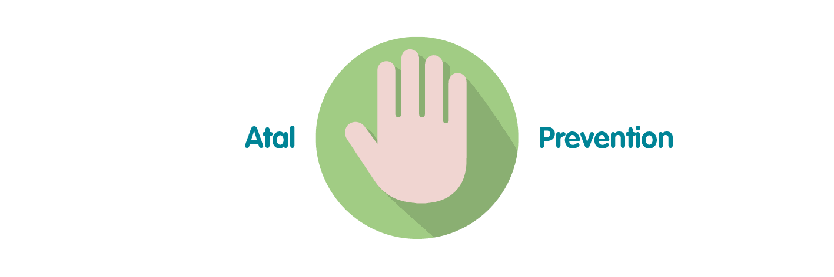 | Effective and efficient decision making by senior managers, Executive Team and the Board is paramount to successful performance of the organisation in order for it to achieve its purpose, whilst preventing the potential to cause harm through underperformance.
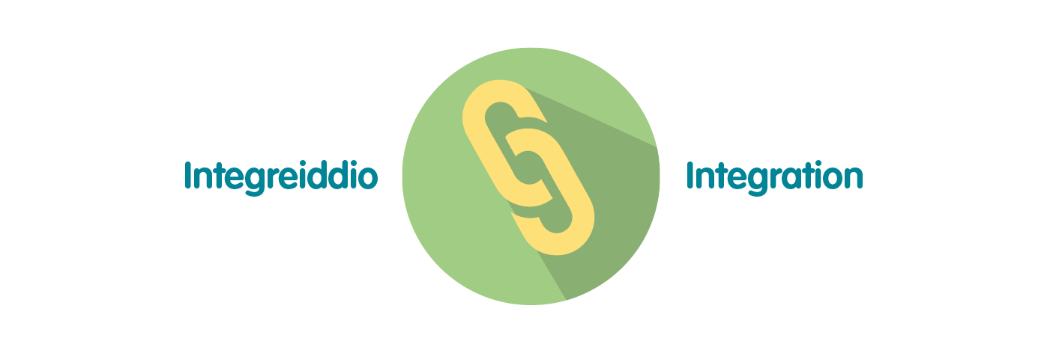 | The development of Public Health Wales’ Long Term Strategy and Integrated Medium Term Plan has been grounded in collaboration and integration across our workforce. To demonstrate that the organisation is achieving what it set out to achieve over the short, medium and long term, high quality monitoring and reporting of information is essential through the integrated performance report. This approach has been reflected in the approach to the pandemic response.
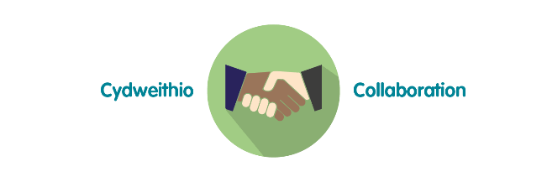 | Reporting of data and information through the integrated performance report requires collaboration across the organisation to ensure timely delivery of key service, quality, workforce and financial data. The potential for the development of business intelligence tools will require close working relationships with Directorates and especially Informatics to maximise potential.
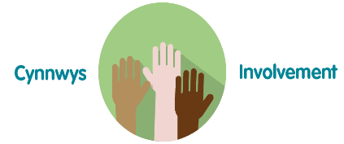 | To ensure compliance with the Welsh Audit Office Structured Assessment, agreeing and reporting Division / Directorate level performance measures will require involvement across the full breadth of the organisation. Monitoring and reporting against the strategic plan will involve working closely with staff to ensure accurate and timely intelligence for the Executive Team and Board.
- Recommendation

The Board is asked to:

- Discuss and scrutinise the paper and provide feedback and comments.

