Name of Meeting
Board
Date of Meeting
30 May 2019
Agenda item:
10.2.300519
Accountability Report –
- Corporate Governance Report
- Remuneration and Staff Report
- Long Term Expenditure Trends
- National Assembly for Wales Accountability and Audit Report 2017/18

Executive lead: | Huw George, Executive Director of Operations and Finance and Deputy Chief Executive  Helen Bushell, Board Secretary and Head of Board Business Unit
Author: | Corporate Governance Report: Eleanor Higgins, Corporate Governance Manager  Remuneration Report: Lucy Day, Business and Policy Support Manager  Long Term Expenditure Trends: John Baker, Finance  National Assembly for Wales Accountability and Audit Report: John Baker, Finance and Angela Fisher, Deputy Director and Head of Finance
Approval/Scrutiny route: | Draft Corporate Governance Report, Remuneration and Staff Report approved for submission to Welsh Government by Audit and Corporate Governance Committee on 2 May 2018
Purpose
Public Health Wales is required to provide an Accountability Report as part of the Annual Report and Accounts for 2017/18. Guidance on how to complete and display this report has been issued by Welsh Government in the Manual for Accounts, and by HM Treasury in the Financial Reporting Manual (FReM). This report introduces the final reports.
Recommendation:
APPROVE | CONSIDER | RECOMMEND |  | ADOPT | ASSURANCE
The Board is asked to:
- Approve the Accountability Report.
- Once approved, it will be submitted to Welsh Government on 31 May 2019

Link to Public Health Wales Strategic Plan

Public Health Wales has an agreed strategic plan, which has identified seven strategic priorities and well-being objectives.

This report contributes to the following:
Strategic Priority/Well-being Objective | 7 - Building and mobilising knowledge and skills to improve health and well-being across Wales
Summary impact analysis

Equality and Health Impact Assessment | A formal Equality and Health Impact Assessment is not required on this governance document. The Annual Governance Statement includes an overview of Equality, Diversity and Inclusion for 2017/18.
Risk and Assurance | N/A
Health and Care Standards | This report supports and/or takes into account the Health and Care Standards for NHS Wales Quality Themes
 | Governance, Leadership and Accountability
Financial implications | There are no direct financial implications.
People implications | There are no direct people implications, although the reports contains details pertaining to the Board members.  The Corporate Governance report also provides an overview of the business considered by the People and Organisational Development Committee in 2017/18.

Purpose / situation

Public Health Wales is required to provide an Accountability Report as part of the Annual Report and Accounts for 2016/17. Guidance on how to complete and display these reports has been issued by Welsh Government Manual for Accounts, and by HM Treasury in the Financial Reporting Manual (FReM).

The Audit and Corporate Governance Committee considered an earlier draft of the Corporate Governance Report and Remuneration and Staff Report at its meeting on 2 May 2018. Following the meeting, this was submitted to the Welsh Government and the Wales Audit Office for review. Comments were received from Welsh Government and Wales Audit Office and have been incorporated into the final draft. The final drafts would be considered by the Audit and Corporate Governance Committee on 30 May 2019 for recommendation to the Board for approval.

Background

NHS bodies are required to publish, as a single document, a three-part annual report and accounts which includes:
- The Performance Report, which is still in development and will be submitted to Welsh Government in mid June. This report must include:
- An overview
- A Performance analysis
- A summary of long term expenditure trends

- The Accountability Report, which must include:
- A Corporate Governance Report
- A Remuneration and Staff Report
- A National Assembly for Wales Accountability and Audit Report.

- The Financial Statements

The Accountability Report demonstrates how Public Health Wales meets key accountability requirements to the Welsh Government and is required to have three sections:

The Corporate Governance Report (Annexes 1-4)
This explains the composition and organisation of Public Health Wales’ governance structures and how they support the achievement of the entity’s objectives.

Remuneration and Staff Report (Annex 5)
This contains information about the remuneration of senior management, fair pay ratios, sickness absence rates etc

National Assembly for Wales Accountability and Audit Report (Annex 6)
This contains a range of disclosures on the regularity of expenditure, fees and charges, compliance with the cost allocation and charging requirements set out in HM Treasury guidance, material remote contingent liabilities, long-term expenditure trends, and the audit certificate and report.

The Corporate Governance Team is responsible for the production of the Corporate Governance Report. This has been supported by consultation with Executive Directors. The Remuneration and Staff Report has been produced by the People and Organisational Development Directorate and the Parliamentary Accountability and Audit Report has been produced by the Finance Directorate.

An agreed draft of the Corporate Governance Report and the Remuneration and Staff Report was included with the draft annual accounts when they were submitted to Welsh Government on 2 May 2019.

Description/Assessment

The Accountability Report is attached for the Audit and Corporate Governance Committee to review and recommend for Board approval.

The Manual for Accounts states that the Corporate Governance Report must include the:
- Directors’ Report (Annex 1)
- Statement of Accountable Officer’s Responsibilities (Annex 2)
- The Annual Governance Statement (Annex 3)

It also states that where information required within the Directors’ Report is disclosed elsewhere in the Annual Report and Accounts a cross-reference may be provided. As the majority of the information is contained elsewhere, the Directors’ Report is presented in the form of a table.

Since the draft version of the Annual Governance Statement was approved for submission to the Welsh Government on 2 May 2019, the document has been updated to reflect feedback from:

Wales Audit Office – external auditors reviewed the draft Corporate Governance Report and draft Remuneration and Staff report and provided feedback on 14 May 2019. Annual Governance Statement prior to its submission on 3 May 2018. Details of the comments received, and the Trust responses would be considered by the Audit and Corporate Governance Committee at its meeting on the 29 May 2019.

Internal Audit – the Head of Internal Audit reviewed the document and suggested some minor typographical corrections. The levels of assurance for the remaining internal reports has been included as well as the Head of Internal Audit Annual opinion for 2017/18.

Welsh Government – no comments have been received at time of preparation of this report.

When the information contained within these reports is formatted for inclusion in the Annual Report it may take a slightly different form. The timescale for production of the Annual Report varies from that of the Accountability Report. It must be submitted to Welsh Government on 1 July 2019 and presented at the Annual General Meeting which must be held before the end of July 2019. Further review by the Wales Audit Office and translation into Welsh must have been undertaken in advance of this.

Well-being of Future Generations (Wales) Act 2015

The Accountability Report provides the Board with assurance that the Committee’s work is fulfilling its function and terms of reference, supported by effective governance measures. The Committee’s work covers the Well-being objectives identified above.

This work has been put together following the five ways of working, as defined within the sustainable development principle in the Act, in the following ways:

 | The content of the Accountability Report includes an overview of the long-term strategy and indicates future planned work to improve the governance of the organisation.
 | The Accountability Report provides an overview of how key issues relating to the organisation’s mission, which includes prevention through improving public health.
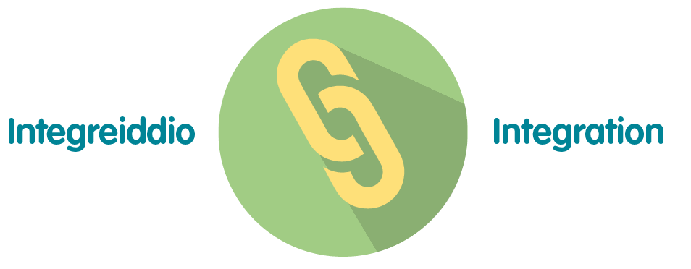 | This report provides assurance that the organisational governance structure is robust and effective in this role.
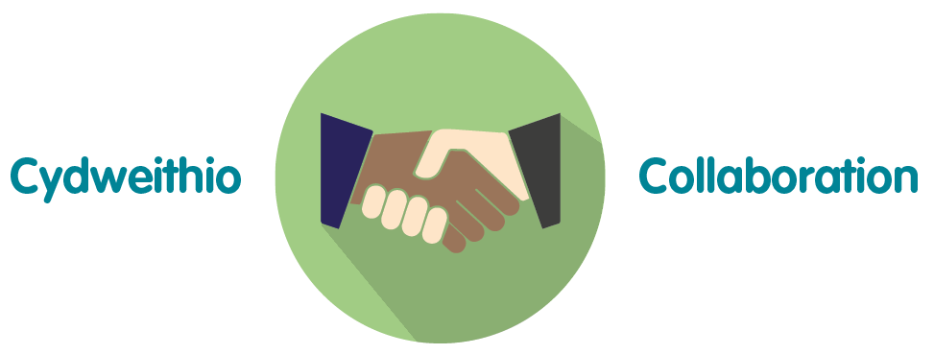 | Staff across directorates have contributed to the development of both the Accountability Report. An overview of the integrated governance structure in Public Health Wales is also provided in the report.
 | This report provides a broad overview of the main areas of the organisation’s governance for 2017/18, which includes staff and service-user engagement.

Recommendation

The Board is asked to:

- Approve the 2018/19 Accountability Report.

Once approved, it will be submitted to Welsh Government on 31 May 2019

