|  |  |  |  |  |  |  |
| --- | --- | --- | --- | --- | --- | --- |
| **Compressed Public Health Wales logo** | | | | **Name of Meeting**  Board | | |
| **Date of Meeting**  28th November 2019 | | |
| **Agenda item:**  *6.281119* | | |
|  | | | | | | |
| **Strategic Priority 3 – Promoting Healthy Behaviours** | | | | | | |
| **Executive lead:** | | Jyoti Atri, Interim Director of Health and Wellbeing | | | | |
| **Author:** | | Julie Bishop, Director of Health Improvement and Priority 3 Lead | | | | |
|  | |  | | | | |
| **Approval/Scrutiny route:** | | n/a | | | | |
|  | | | | | | |
| **Purpose** | | | | | | |
| This report provides the Board with background and assurance on Strategic Priority 3 (SP3), Promoting Healthy Behaviours. This paper describes the in-year Annual Plan progress to date against the objectives within the strategy and some of the challenges. To illustrate the range of work undertaken within the priority, and the ways of working with partners, obesity is covered in more depth in this report as a case study example. | | | | | | |
|  | | | | | | |
| **Recommendation:** (note - to mark an x in the grey box below right click on the mouse, then select “properties”, and then select “checked”) | | | | | | |
| APPROVE | CONSIDER | | RECOMMEND | | ADOPT | ASSURANCE |
| The Board/Committee is asked to receive **assurance** that the delivery of the Strategic Priority 3 Annual Plan is progressing and to note some of the challenges. | | | | | | |

|  |  |
| --- | --- |
|  | |
| **Link to Public Health Wales** [**Strategic Plan**](http://howis.wales.nhs.uk/sitesplus/888/page/64548)  Public Health Wales has an agreed strategic plan, which has identified seven strategic priorities and well-being objectives.  This report contributes to the following: | |
| **Strategic Priority/Well-being Objective** | 3 - Promoting healthy behaviours |
|  | |
| **Summary impact analysis** | |
| **Health and Care Standards** | This report supports and/or takes into account the [Health and Care Standards for NHS Wales](http://www.wales.nhs.uk/governance-emanual/how-the-health-and-care-standards-are-st) Quality Themes |
| Theme 1 - Staying Healthy |
|  |
|  |

# Purpose

This report aims to provide the Board with background and assurance on Strategic Priority 3 (SP3), Promoting Healthy Behaviours. The report describes in year progress to date against actions in the Annual Plan. The key achievements are outlined alongside some of the challenges faced in delivering this strategic priority.

Also included in the report are some of the key outcome measures that this strategic priority is seeking to influence. It also updates the Board on some recent developments, external to the organisation, that relate to the delivery of this priority. Finally, to illustrate the range of work undertaken within the priority, the close working with partners and the ways of working, the paper includes a ‘deep dive’ into Nutrition and Obesity.

# Background

Strategic Priority 3, Promoting Healthy Behaviours, is one of seven strategic priorities within the long-term strategy. The Strategy envisages that by 2030, by working with Welsh Government and others and by involving people in our decision-making, Public Health Wales will have:

* delivered year on year increases in the proportion of children and young people who are smoke free and helped an increasing number of smokers to quit
* significantly increased the proportion of children and young people in Wales who are a healthy weight when they start school and into adulthood. We will work to create co-ordinated action across the whole system to support healthy food choices and promote a more active Wales
* changed social norms about the acceptability of a range of health harming behaviours.

The topics and themes included within the strategic priority broadly fall into two areas:

* Specific behaviours e.g. smoking
* Enabling action that supports behaviour change action.

The current strategic objectives included within the priority are as follows:

* SO3.1 - By 2022 we will have worked with others to reduce the proportion of the population who smoke
* SO3.2 – By 2022 we will have supported Welsh Government to develop and implement *Healthy Weight: Healthy Wales*
* SO3.3 – By 2022 we will have worked with others towards increasing the proportion of children who are a healthy weight when they start school
* SO3.4 – By 2022 We will have worked with others to achieve demonstrable increases in the proportion of children who actively travel to school
* SO3.5 – By 2022 we will have continued to develop and deliver with Sport Wales and Natural Resources Wales a joint programme of work to promote a more active Wales
* SO3.6 – By 2022 we will have developed and begun delivery of a new comprehensive programme of prevention of alcohol related harm
* SO3.7 – By 2022 we will have developed and begun delivery of a programme to reduce the use and harm from drugs
* SO3.8 – By 2022 we will be monitoring new and emerging behaviour patterns that could impact on health and wellbeing in Wales, while continuing to explore new sources and ways to increase understanding
* SO3.9 – By 2022 we will have increased the capability and confidence of staff to apply behavioural science in public health practice across staff working in public health
* SO3.10 – By 2022 we will have worked with others to ensure that people in Wales have easy and timely access to information to support them in taking control of their own health and wellbeing

**2.1 Evidence base leading to the identification of specific behavioural factors to address**

As the Board is aware, the specific behaviours identified for action in this priority reflect the findings of the *Health and its Determinants in Wales Report[1]* based on the Global Burden of Disease Study methodology. These are demonstrated in the chart below. This identified the following as the factors with contribute most to the disease burden in Wales and therefore to healthy life expectancy and inequalities in healthy life expectancy, and to avoidable mortality:

* Smoking
* Nutrition and diet related factors including a high body mass index (BMI)
* Alcohol misuse
* Drug use
* Physical activity.

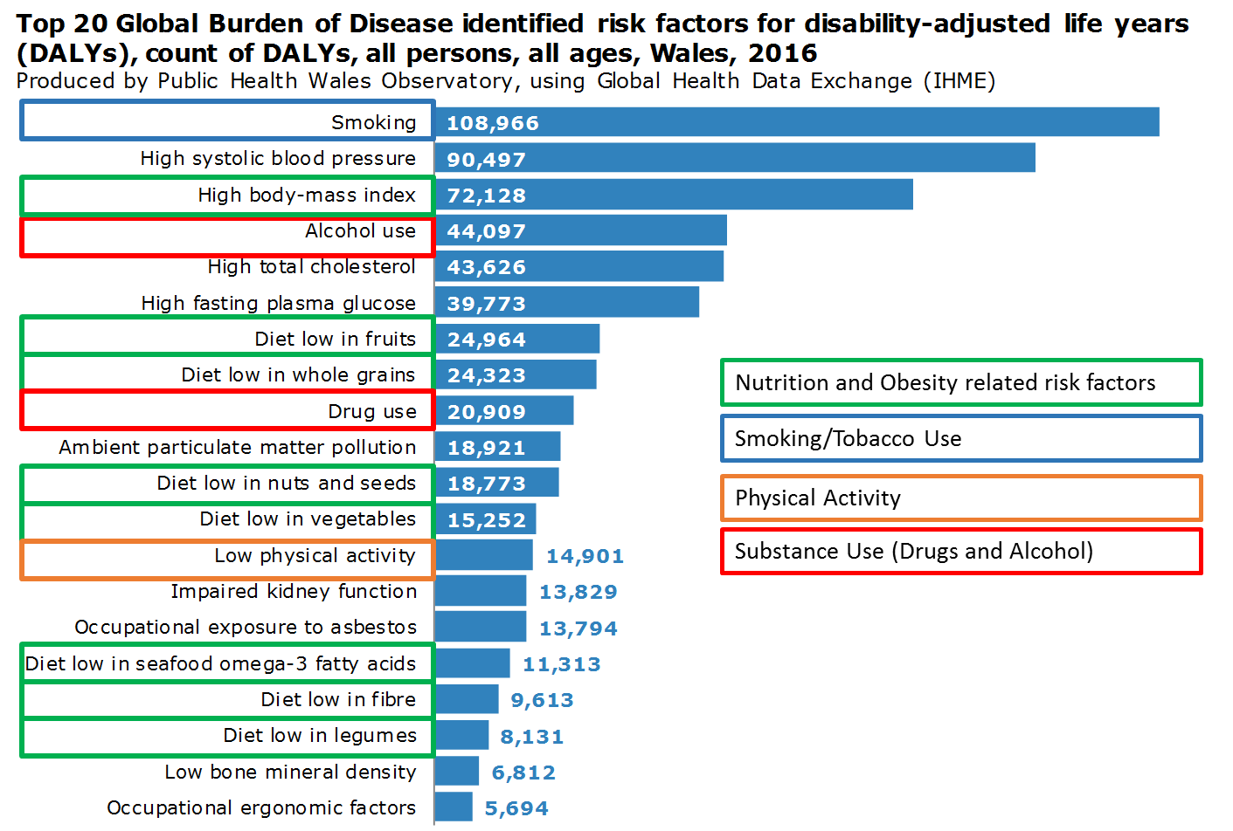

**2.2 System wide outcomes**

The Strategic Priority Group has translated these behaviours into a series of draft system goals in line with the emerging work on developing outcomes and also a selection of system wide indicators has been identified**–** these are presented in Table 1 below. Current progress is summarised below and graphs illustrating trends overtime for those indicators where information is currently collected, are presented in Appendix 1.

**Table 1 – System Wide Outcomes Strategic Priority 3**

| **System Level Goal** | **Measure** | **Targets** | **Comments** |
| --- | --- | --- | --- |
| Children are smoke free  Adults are smoke free | Percentage of the adult population who smoke (National Survey for Wales) | 16% by 2020 | Revised targets are anticipated to be developed as part of the revision of the Tobacco Action Plan in 2020. |
| Percentage of 15/16  year olds who are regular (weekly) smokers (Health Behaviour of School Children/SHRN Survey) | 5% by 2020 | Revised targets are anticipated to be developed as part of the revision of the Tobacco Action Plan in 2020. |
| Percentage of smokers treated by NHS smoking cessation services (Stats Wales) | 5% of the smoking population | Target remains. |
| Percentage of pregnant women who are smoking at 36 weeks (Maternity Indicators) | No target but a year on year decrease | Data quality improvement needed. |
| Children are a healthy weight when they start school  Adults are a healthy weight | Percentage of the adult population who are (a) obese or (b) overweight or obese (National Survey for Wales) | No targets have been set | Welsh Government and the Minister have indicated that targets will not be set as there is no reliable basis on which to do so. Goal currently is to halt the rise and reverse the trend in the life of the strategy (10 years). |
| Percentage of children aged 5 years of age who are (a) obese or (b) overweight or obese (Child Measurement Programme) | No targets have been set | Welsh Government and the Minister have indicated that targets will not be set as there is no reliable basis on which to do so. Goal currently is to halt the rise and reverse the trend in the life of the strategy (10 years). |
| Children are active  Adults are active | Proportion of the population achieving the CMO guidelines for physical activity by age group (National Survey for Wales) | No targets have been set | Cannot currently be monitored for all groups. |
| Children do not drink alcohol  Fewer people (adults and children) experience harm from drunkenness | Percentage who drink anything alcoholic at least weekly (SHRN/HBSC Years 7 – 11) | No target but guidelines recommend children should not drink alcohol under the age of 15 years | Lifetime reported consumption of alcohol by age not currently reported. |
| Lifetime (young people) or recent experience (adults) of intoxication (not currently measured for adults; HBSC/SHRN for young people) | Identified as a priority but cannot currently be monitored by routine surveys for adults | Data development need. |
| Children are drug free  Fewer adults experience harm and early death from drug use. | Percentage who have ever used cannabis (SHRN/HBSC Years 7 – 11)  No measures identified to date – will be identified during 2020 | No targets exist | Indicators for adults not yet agreed. |

Each of these goals requires multi-component, multi-level system wide action to achieve change. SP3 covers a number of behaviours each of which is determined by its own complex range of influences; the design and implementation of interventions to achieve change, and its measurement, is of equal complexity.

The trend data highlights that rates of smoking among adults and young people have fallen substantially over time but the rate of decline in both groups has slowed slightly.

Levels of overweight and obesity have shown a steady upward trend which is projected to continue.

The measure used for physical activity has changed in recent years which makes trend data difficult to interpret; however, the available data suggests that rates have remained largely static in both adults and children.

Reducing frequency of intoxication due to alcohol has been identified as a priority area for action but there is currently no routine measure of this for adults. Reported lifetime (4 times or more) drunkenness among young people has fallen as has weekly consumption of alcohol by this group.

The outcomes and measures for drug use have yet to be finalised, however, young people being drug free and adults experiencing harm or early death from drug use have been identified as draft outcomes.

**2.3 Building a Healthier Wales and additional investment for prevention**

Since the development of the long-term strategy, there have been significant developments that have an impact on the delivery of this strategic priority. In 2018, the Board received a paper that provided advice to Welsh Government on evidence based areas for investment in prevention. This subsequently led to the establishment of *Building a Healthier Wales*, a multi-sectoral partnership, designed to make a concerted shift towards prevention. The partnership was developed in response to challenge from Welsh Government to bring about large scale systems change and is overseen by a Building a Healthier Wales Coordination Group and supported by Public Health Wales.

*Building a Healthier Wales* identifies Enabling Healthier Behaviours as one of its five priorities for action and will therefore be complementary with the achievement of this strategic priority.

We have recently received confirmation of additional investment for prevention from Welsh Government. There is an additional £7.2m allocation being made available for partners through Health Boards for the priorities identified in Building a Healthier Wales, of which £1.08m will be coming to Public Health Wales. A considerable amount of this funding will be used to support a range of our strategic priorities including this priority including work to strengthen tobacco related social marketing through Help Me Quit and the delivery of the 10 Steps to a Healthy Weight Programme to prevent childhood obesity at age 5 years.

# Public Health Wales Contribution to Promoting Healthy

## Behaviours

As with a number of our Strategic Priorities, the outcomes we seek to influence are not within the direct influence of Public Health Wales but are the product of collective action by the whole system. The role of Public Health Wales in this context is to provide system leadership and support for implementation. In rare cases, we deliver direct action where we are best placed to do so.

In broad terms, the Public Health Wales contribution will be through working with others to:

* Develop strategic partnerships for health improvement across sectors and aligned to outcomes e.g. Wales Physical Activity Partnership; National Alcohol Misuse Prevention Partnership
* Agree shared priorities and areas for action across key outcomes with our partners e.g. Integrated smoking cessation system with Directors of Public Health; Substance Misuse Programme Board
* Set ambitious targets for change for key outcomes, advice to Welsh Government on policy and strategy
* Develop national brands to mobilise and unite action and social marketing to motivate change e.g. Help Me Quit; 10 Steps to a Healthy Weight
* Implement effective action at scale where people live, work, learn and play e.g. Healthy Working Wales, Welsh Network of Healthy School Schemes
* Establish robust monitoring and evaluation of impact of public health action and of the wider system e.g. School Health Research Network
* Deliver health promotion action only where it makes sense to do so e.g. JUSTB
* Supporting the development of policy or legislation e.g. Healthy Weight: Healthy Wales.

This work involves taking action to:

* Review and disseminate evidence on what works e.g. Obesogenic Environment Evidence Reviews
* Identify high impact change e.g. delivering 16% smoking prevalence modelling of action required
* Identify indicators for monitoring change across the system e.g. Tobacco Action Plan; Healthy Weight: Healthy Wales indicators
* Undertake insight work with communities e.g. Use of smoking cessation services to inform Help Me Quit; Insight with professionals in primary care on referral to smoking cessation; parental attitudes and beliefs on obesity
* Co-produce interventions e.g. parent information project
* Develop and implement programmes of social marketing e.g. Help Me Quit
* Deliver agreed health improvement action within agreed quality standards e.g. JUSTB
* Monitor change and evaluate action Healthy Schools Review; National Exercise Referral Scheme review; Smoking and Alcohol Profiles
* Develop and test new and innovative approaches e.g. hyper-local marketing approaches
* Define benchmarks and criteria for self- assessment and planning local action e.g. revision of Healthy Working Wales criteria; Revision of Healthy Schools Criteria.

# Delivery Against the Annual Plan

## 4.1 Key Achievements

Some of the key achievements within this Strategic Priority during the year to date are as follows:

* 2018/19 was the fourth consecutive year of growth in the numbers of smokers treated by Help Me Quit cessation services.
* Help Me Quit has been acknowledged through the campaign winning the 2019 Public Sector award at The Drum Marketing Awards.
* Successful transfer of local smoking cessation services to Local Health Boards from 1 October 2019
* Collaboration with Welsh Government on the final draft of the Healthy Weight Healthy Wales Strategy and the first of five 2-year delivery plans
* Uptake for the Just B Smoke free programme from September 2018 to July 2019 exceeded target, with 65 schools receiving the programme and 1,675 Year 8 pupils trained as smoke-free ambassadors
* The 200th school in Wales has achieved the Welsh Network of Healthy Schools Scheme National Quality Award
* A survey to understand the use of behavioural science in Public Health Wales’ work has been developed and launched for about 600 staff across the organisation.
* Physical Activity - 15 of the 17 Healthy and Active Fund projects have been activated after extensive joint working from PHW, Sport Wales and WG.
* *Alcohol in Wales* web profile including evidence map published
* Beta version of *Smoking in Wales* web profile (including evidence map) published.

**4.2 Delivery**

Action within Strategic Priority three sits primarily within the Health Improvement Division within the Health and Wellbeing Directorate who work closely with internal and external stakeholders through a range of partnership mechanisms for each of the behaviours.

Partnership and joint working with the Directors of Public Health is critical to this work and the local and national leads groups form the basis of much of the work that contributes to this priority. There is also a strong contribution from the Knowledge Directorate across the programme areas and from Health Protection in relation to work on substance use.

The Health Improvement Division is structured into four broad teams to provide the maximum flexibility. All of these teams contribute to delivery within Priority 3. These are as follows:

* *Programme Development Team* – this team includes the Consultants and Principal Practitioners who are dedicated to a programme of work (Tobacco Control, Nutrition and Obesity Prevention, Substance Use, Physical Activity) and Senior Practitioners, Practitioners and specialist roles (19 WTE) who work on a matrix basis to support across Priority 1, 2, 3, 4 and 5.
* *Healthy Settings Team* - includes the cross topic delivery platforms such as the Welsh Network of Healthy School Schemes and Healthy Working Wales
* *Public Information and Social Marketing Team*
* *Business and Administration Support Team.*

Each of the programme areas in Priority 3 has an establishment of one dedicated Consultant in Public Health and a Principal Public Health Practitioner.

**4.3 In-year Performance**

The current performance report (a summary of which is demonstrated below) shows a number of actions which are behind schedule. Two of these, currently rated amber, are currently being worked on and will be completed slightly behind schedule but will completed within the year (OP 87 and OP 91). The delay has been due to long-term sickness absence within the team.

|  |  |  |
| --- | --- | --- |
| **Table 2: Annual Plan Actions in Strategic Priority 3 that will not be delivered as planned** | | |
| OP/74 | Priority areas for action to prevent alcohol related harm agreed with partners |  |
| OP/75 | Programme of work to prevent alcohol related harm agreed with key stakeholders |  |
| OP/76 | Resource needs identified to deliver a programme of work for the prevention of population harm from alcohol, and a business case developed to secure them |  |
| OP/77 | Risk and protective factors to prevent substance related harm identified |  |
| OP/78 | Evidence review on effective interventions to prevent substance related harm completed |  |
| OP/79 | Programme of work to prevent substance related harm developed |  |
| OP/80 | Business case produced to secure resources for the delivery of priority actions to prevent substance related harm |  |
| OP/87 | Applied behavioural science training needs for Public Health Wales described |  |
| OP/91 | Quality standards for health promotion information for the Welsh public agreed |  |

The actions rated as red in the annual plan all relate to Strategic Objectives 3.6 on Alcohol and 3.7 Drug Use. There are multiple actions associated with each piece of work and a delay in one has an impact on the subsequent deliverables which are listed in Table 2 below.

These relate in part to the development of a cross organisation programme of work that is being taken forward through a working group led by the Assistant Director of Policy and International Health (OP 79). This group has been meeting frequently and is nearing a conclusion to their work on agreeing joint priorities, which will enable the subsequent actions to be completed (OP 77, 78, 80). This has however taken longer than anticipated due to the complexity of the work and the limited resources available to support its delivery.

The second area of work is being taken forward in partnership with the Alcohol Misuse Prevention Partnership and there have been difficulties in finding suitable dates for the group to meet (OP 74, 75 and 76).

The remainder of the delay has largely been attributable to difficulties in recruiting to vacant posts within the Health Improvement Division which currently has no staff in this programme of work. A Principal Public Health Practitioner role has been vacant for most of the year and two attempts at recruitment have failed to secure a suitable candidate. A range of options has been explored to address this gap including secondments and commissioning work; but to date no solution has been identified. As a result this programme of work is currently suspended to allow a solution to be identified.

In addition to the Principal Public Health Practitioner lead role, which has been advertised twice, the Health Improvement Division is currently operating with 46% vacancies (5 posts)in its Senior Public Health Practitioners within the Programme Development Team. This has arisen due to the promotion of staff to more senior roles and the inability to recruit staff with the required training and experience to fill these vacancies which appear to have arisen in part as a result of historical organisational decisions to stop routinely funding Masters in Public Health courses for public health practitioners

The Health Improvement Division has been working with the People and Organisational Development Team for nearly 12 months to secure a solution including the development of a trainee advanced practitioner role that we have been unable to progress further following an initial attempt to recruit. We have also experienced some significant long term sickness. This group of staff make up the bulk of the delivery capacity in the Division and the low level of capacity places a number of actions at risk within this strategic priority and in priority 2 and 4.

**Summary of Performance Strategic Priority 3**

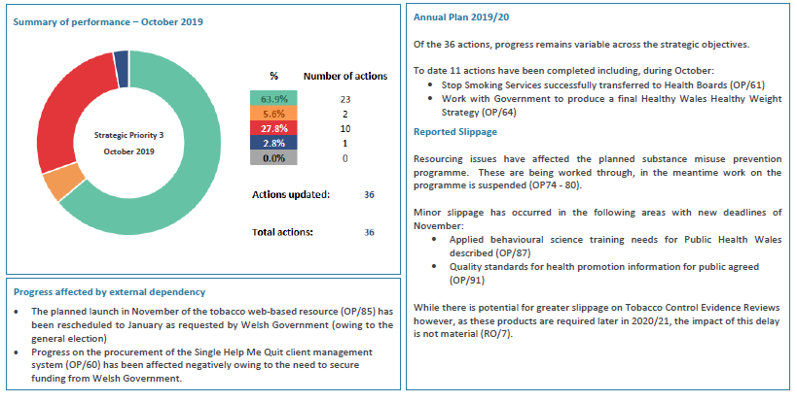

## 4.4 Tobacco Control

In broad terms public health action on tobacco involves action to stop young people starting to smoke; helping smokers to quit and the introduction of a range of wider environmental, legislative and fiscal measures which act collectively to 'denormalise' smoking. Welsh Government has recently consulted on measures to restrict smoking in outdoor areas in hospitals, schools and playgrounds. There are also plans to introduce a tobacco/nicotine products retail register.

The tobacco control landscape internationally has been greatly influenced by the introduction of e-cigarettes and a range of other technologies such as 'heat not burn' tobacco devices, as less harmful alternatives.

Public Health Wales' work on tobacco is linked to the Welsh Government Tobacco Control Strategic Board and Action Plan. Public Health Wales and Health Boards are both accountable for the delivery of action within this plan. Increasingly, this is delivered through a joint programme of work agreed with the Public Health Directors Leadership Group and includes partnerships with the Directors of Public Protection in Local Authorities, ASH Wales and the Wales Tobacco and Health Alliance, Royal College of Physicians, Royal Pharmaceutical Society and Universities.

The majority of the focus in recent years has been on work to support those who wish to quit, and to meet the Welsh Government target to 'treat' 5% of the smoking population by NHS Stop Smoking Services. The development of Help Me Quit as the single overarching brand has been successful in increasing the numbers (and overall proportion) of smokers who are ‘treated’, with year-on-year increases from 2.6% ‘treated’ in 2016/17 to 3.2% in 2018/19. There is also some evidence of a reduction in inequalities in smoking rates between the most and least disadvantaged groups. The most recent National Survey reported that the gap between adult smoking prevalence in the 3 most deprived quintiles compared to the 2 least deprived quintiles (a Welsh Government metric) had reduced by a statistically significant amount. Work to develop a high quality integrated smoking cessation continues with efforts now focused on agreeing and implementing minimum service standards and a universal client management system for referrals, recording and reporting.

In the last 12 months preparation for the transfer of face to face smoking cessation services to Health Boards has dominated the work of the team. This was successfully completed on 1st October 2019.

The Wales Tobacco Action Plan ends in 2020. Public Health Wales will be working to support Welsh Government to develop a new plan. Our aim will be to ensure that Wales sets ambitious goals for a smoke free future generation. In keeping with best practice internationally this is likely to include further measures to address price, promotion, use and supply.

## 4.5 Physical Activity

Increasing levels of physical activity is important for both physical and mental wellbeing. Population levels of physical activity have remained largely static for a number of years.

Levels of physical activity are influenced by a range of complex and inter-related factors in our built and natural environment as well as individual motivation to be active.

Future work on Physical Activity will be led strategically by the Healthy Wales: Healthy Weight Strategy and the associated delivery structures that will be established to support implementation.

Public Health Wales has established the Wales Physical Activity Partnership (WPAP) with Sport Wales and Natural Resources Wales to provide system leadership to increase levels of physical activity in Wales. It is anticipated that the partnership will link directly into the Strategy implementation process and will the charged with the delivery of specific actions. The three organisations in turn work with a range of other partners across the Sport, Outdoor Recreation, Local Government and third sector.

A review of the early development of the Partnership was undertaken during this year by a Masters student from Maastricht University, on placement with the Health Improvement Division, focusing on collaborative governance. A series of recommendations was made to strengthen the work.

The initial priority areas identified by WPAP for action have continued to be developed. This has included the development of a Physical Activity Observatory and work to consolidate our collective offer to schools.

The development and implementation of the Healthy and Active Fund has been the major area of joint work. The successful projects are now beginning to establish and we are working to ensure that evaluation is built into each of them.

The second phase of development and testing of the ‘Hands Up Survey’ to support action to promote active travel to school in primary schools has been completed in advance of a full roll out next year.

Working with the WPAP the priority will be to implement the key actions in the Healthy Weight: Healthy Wales Strategy and further develop an integrated programme of work to promote physical activity.

## 4.6 Alcohol

Alcohol related harm impacts in a number of ways on individuals and through harm to others for example as a result of alcohol related injury or violence.

The alcohol related programme of work is less well established than other areas within this strategic priority area. This reflects the limited focus on alcohol as a population health issue within the national strategy.

Patterns of alcohol consumption are changing with an increasing number of people choosing not to drink at all. However, those drinking at levels that are potentially harmful or hazardous to health remain a concern.

Public Health Wales has established the National Alcohol Misuse Prevention Partnership with representation from Welsh Government, Health Boards, British Liver Trust, Alcohol Change Wales, Welsh Local Government Association and the Police.

The group has been considering the available evidence of harm and using this to agree joint priorities for action.

Work in this area has been limited due to vacancies in both of the posts related to this programme during the year. However, work has been commissioned to support the development of local licensing policy informed by public health goals. The first area to implement this approach has been in Gwent and feedback has been positive. We hope to be able to provide the same level of support to other areas as their local licensing policies come up for renewal.

## 4.7 Use and Misuse of Drugs

Additional priority has been given to drug misuse in the long term strategy as a result of evidence to show that it contributes significantly to years lived in poor health and that this may be increasing.

Unlike alcohol, the focus in this area has been on treatment and harm reduction in addition to prevention.

A cross organisational group has been established chaired by the Assistant Director of Policy and International Health. The group has been reviewing the available evidence relating the harm arising from the use and misuse of drugs and is using this work to agree a joint programme of work.

The focus of work has been on developing the joint programme of work. There are now some emerging priorities for action relating to primary prevention with young people recognising concern about an upward trend in drug use, particularly cannabis, in some groups and the link this may have to smoking rates. The burden of disease arising from opioid use is significant and is likely to be a priority. Recognising the relationship between drug use and adverse childhood experiences is also important with vulnerable young people, particularly those in the looked after system a further priority. Finally there is a need to reduce the levels of drug related deaths which are above average in Wales.

The group will finalise its work and develop a longer term plan during this year.

## 4.8 Enabling Action for Effective Behaviour Change

The strategic priority includes a range of actions that support and enable wider action by individuals and the system to promote change. This work typically crosses the individual behaviours.

### *4.8.1 New and emerging behaviours and the use of data*

There are increasing opportunities to utilise new sources of data to understand behaviours and therefore develop more effective action. In addition increasing emphasis has been placed on maximising the utility of existing data sources.

The Observatory Analytical Team in the Knowledge Directorate has developed and tested new methods for developing profiles on key behaviours which enable the user to explore a wider range of data and the inter-relationship between different factors. Work has been completed this year on Alcohol and Smoking.

### *cid:image001.png@01D59FBA.DF5216904.8.2 Public Information*

Public Health Wales has worked with partners from across the third and public sector to consider new ways of providing public information. This has included work with the producers of information and separately with the distributors.

The work is exploring ways of facilitating access to high quality public information that reduces duplication and utilises new methods of delivery.

### *4.8.3 Behaviour Change*

Behaviour change is the basis of everything Public Health Wales does and it is critical therefore that this work is based on the best available international evidence base. During the last year we have continued to develop our approach to behavioural analysis so that we understand as much as we can about the underlying drivers of the behaviour and use this knowledge to inform action. The improvements in uptake of smoking cessation services through Help Me Quit have been informed by this approach.

We have also been developing our understanding of current knowledge, skills and confidence to use behaviour change techniques among our workforce. We will use this information to develop a programme of training and development.

The Health and Wellbeing Directorate was successful in securing £311,457 of internal additional investment for a Behaviour Change Unit. The Unit will support the further delivery of this strategic priority as well as other strategic priorities. We are currently out to advert for a Programme Director for the Behaviour Change Unit and are in discussion with a number of potential partners to support us in developing capability and capacity in this area.

**5 Nutrition and Obesity Case Study**

Tackling the increasing number of people who are overweight or obese is probably the single greatest current public health challenge. This challenge is shared by a number of countries globally, but not all; and few have been able to achieve a change in outcomes at a population level. Where most progress has been made is in halting or reversing the rise in childhood obesity levels.

The obesity system map (Figure 1) illustrates the complexity of the system wide factors which contribute to overweight or obesity. Influencing such a complex system to achieve change will require very long term and sustained action. Evidence from the international literature demonstrates that those areas which have begun to see a decline in rates of childhood obesity have typically been working on a whole system multi-level strategy for at least 10 years.

The strategic priority has two broad objectives in this arena. The first is to develop and then support the Obesity Prevention and Reduction Strategy, Healthy Weight: Healthy Wales and the second to continue development and implementation of the 10 Steps to a Healthy Weight programme to increase the proportion of children who start school a healthy weight.

## 5.1 Development of Healthy Weight: Healthy Wales

The development of the Healthy Weight: Healthy Wales Strategy commenced in October 2017 with the first meeting of the Obesity Strategy Board chaired by the Chief Medical Officer. During 2018, Public Health Wales undertook a series of joint events with Welsh Government to set out the case for action and the gather views on the priorities of the strategy moving forward. These events were attended by representatives from across the system, including the private sector.

In parallel with this work Public Health Wales invested in additional capacity within the Health Intelligence Division to support a series of evidence reviews and the collation of a range of data and information on all aspects of the food and physical activity environment. In addition, the Health Improvement Division in the Health and Wellbeing Directorate undertook some rapid reviews of the International Policy and Strategy Landscape and work on Ultra-processed Foods in addition to translating the evidence synthesis into recommendations for action. The result of this work was a suite of 11 publications which were launched alongside the consultation on the Healthy Weight: Healthy Wales Strategy in January 2019.

Public Health Wales also attended and jointly facilitated a series of regional and sector specific evening meetings during the consultation period with Welsh Government colleagues.

Since April, we have been working closely with Welsh Government colleagues to consider the feedback from the consultation and draft the final version of the Strategy document which was launched by the Minister at the Welsh Public Health Conference in October.

We are currently working to support the development of a draft delivery plan for consideration by the Implementation Board in January 2020.

**Figure 1 – Foresight Obesity System Map**



## 5.2 Obesity Pathway Review

In parallel with the strategy development Public Health Wales has been leading a review of services for individuals who are overweight or obese in Wales. The review had two components, a review of level 4 services i.e. bariatric surgery, which are commissioned by the Welsh Health Specialised Services Committee (WHSSC), and a review of services at level two and three provided by Health Boards. The findings of the review are currently being finalised but it is clear that there is significant variation in relation to equity of access to evidence based services across Wales.

A previous review undertaken by Public Health Wales had identified that the Wales Obesity Pathway was no longer appropriate as a result of the development of the Strategy and the evolution of the evidence base. It was also recognised that greater clarity was required about the services that should be provided at each level so that greater consistency could be achieved in providing services and in reporting activity across Wales.

Public Health Wales, on behalf of Welsh Government, has convened two working groups comprising clinical representatives from across Wales and across the different service tiers, including primary care to develop standards and definitions for services for adults and children. This work will also include the development of a minimum data set for reporting. This work is due to be completed at the end of the year.

## 5.3 10 Steps to a Healthy Weight

Public Health Wales developed the 10 Steps programme to galvanise and align action across the system to reduce levels of overweight and obesity in five year olds starting school. A series of behavioural analyses is being undertaken to ensure that we fully understand the drivers of each of the behaviours and can use this insight to inform action which may include legislation, policy development, social marketing or a range of other approaches.

One of the 10 Steps is Breastfeeding and this has been a significant area of work during the last year on which we have worked with Welsh Government, Swansea and Cardiff Universities, Royal College of Paediatrics and Child Health, Health Boards and parents. A behavioural analysis has been completed and used to inform the development of a Breast feeding action plan which was launched by the Minister in the summer. We have also participated in an international benchmarking project developed at Yale University and led within the UK by the University of Canterbury. The Becoming Breastfeeding Friendly report was also launched in June and has helped to inform the development of the plan. We have also commissioned research on the evidence base for action to improve breastfeeding in low prevalence communities.

As part of the plan Public Health Wales worked with a range of partners to undertake an option appraisal on the future approach to breastfeeding benchmarks for NHS Wales. This work was completed and reported at the Breastfeeding engagement event in March jointly organised between Welsh Government and Public Health Wales.

## 5.4 Future Priorities

Work will commence in 2020 to support the implementation of the delivery plan. While we are aware of some of the draft content we do not yet have confirmation of what will be included or the role that Public Health Wales will be asked to play.

We hope that learning from the international evidence of what leads to effective change Public Health Wales will be asked to take on the following roles:

* a system leadership role working closely with the Directors of Public Health
* translation of evidence into practice, including development of tools and guidance to support local action
* research and evaluation support for local action
* support to national action such as legislation and national communication activity.

However, we did not receive the level of funding that had been hoped for through the Early Years and Prevention funds and we are currently not clear whether any additional funding will be made available to support the implementation of the strategy and whether any funds that are identified will be for Public Health Wales.

This uncertainty is making future planning very challenging and we have been unable to make any specific commitments in our Integrated Medium Term Plan for 2020 -22. If additional resources are not forthcoming, Public Health Wales will need to have detailed discussions with Welsh Government to identify what contribution is most appropriate for the national specialist public health agency.

# 6 Recommendation

This report has provided a year-to-date overview of the work being undertaken in Priority 3 – Promoting Healthy Behaviours. It has set out the extensive partnership arrangements that have been put in place to support the delivery of the Strategic Priority and set out the national strategies that Public Health Wales plays in key role in developing and implementing.

Work on the key behaviours are at different stages of development with work on Tobacco and Obesity being the most advanced. There is considerable work to do in relation to alcohol and drug use which has been delayed in part by staff vacancies.

The enabling actions which support the system to deliver effective action on behaviour change are progressing well and the foundations have been laid for the development of a dedicated behaviour change unit.

**The Board is asked to:**

**Receive this report and consider the assurance it provides in relation to the year-to-date delivery of the Strategic Priority 3 annual plan and the actions to mitigate the challenges that exist.**

Percentage of Welsh adults who report daily smoking, never smoking and former smoking 2003/4 – 2015 (Welsh health Survey) and 2016/17 – 2018/19 (National Survey of Wales).

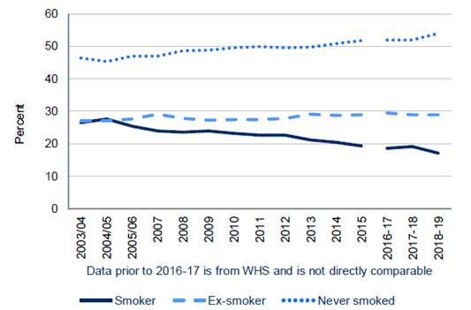

1 Health behaviour of School Children (HBSC) and School Health Research Network are representative surveys of children aged 11 – 16 years however sample size does vary over time

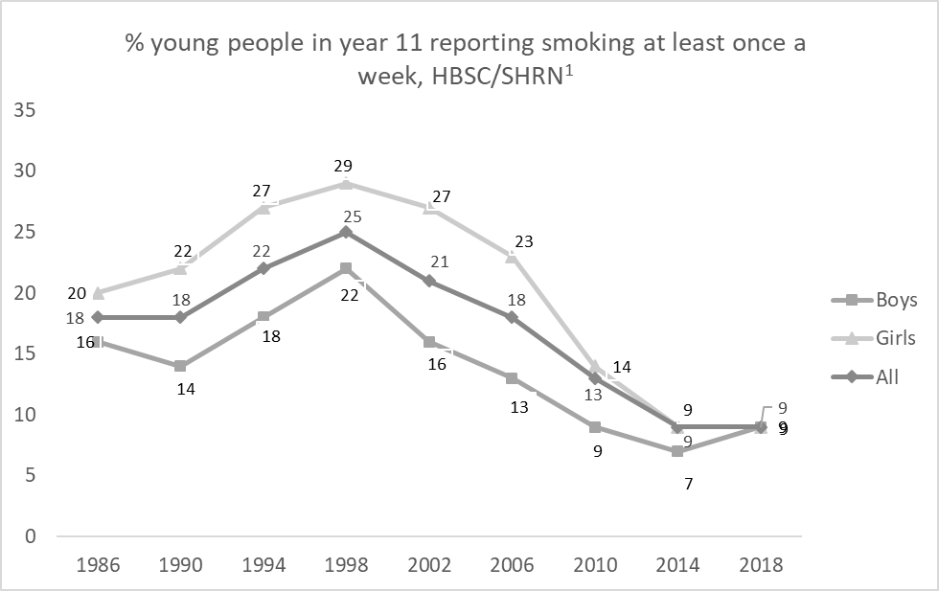



1 Health behaviour of School Children (HBSC) and School Health Research Network are representative surveys of children aged 11 – 16 years however sample size does vary over time

1 Health behaviour of School Children (HBSC) and School Health Research Network are representative surveys of children aged 11 – 16 years however sample size does vary over time

1 Health behaviour of School Children (HBSC) and School Health Research Network are representative surveys of children aged 11 – 16 years however sample size does vary over time

1 Health behaviour of School Children (HBSC) and School Health Research Network are representative surveys of children aged 11 – 16 years however sample size does vary over time

1. http://www2.nphs.wales.nhs.uk:8080/PubHObservatoryProjDocs.nsf/85c50756737f79ac80256f2700534ea3/99a9490d2e6d05268025820b005851de/$FILE/Health&determinantsinWales_Report_Eng.pdf